Version 1:

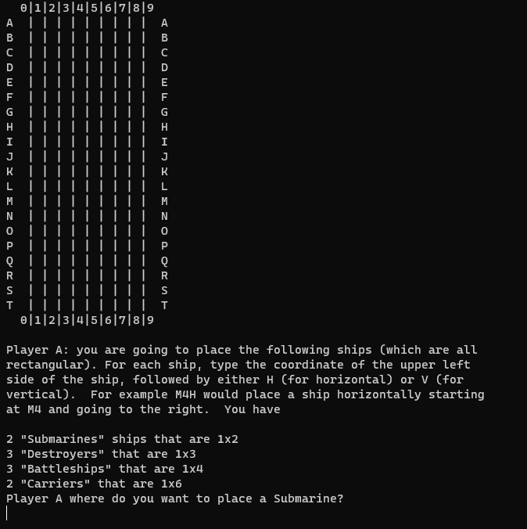 Print the empty board; Print the placement phase information;

Here are several invalid inputs to check the placement checker, the second last one is checking for collision, and the last one is checking for out-of-bound. Because I wrote a check for placement and coordinate, they won’t accept characters less than “A” and numbers less than “0”, going off the top and going off left won’t happen. The last one also shows that I place a submarine successfully. 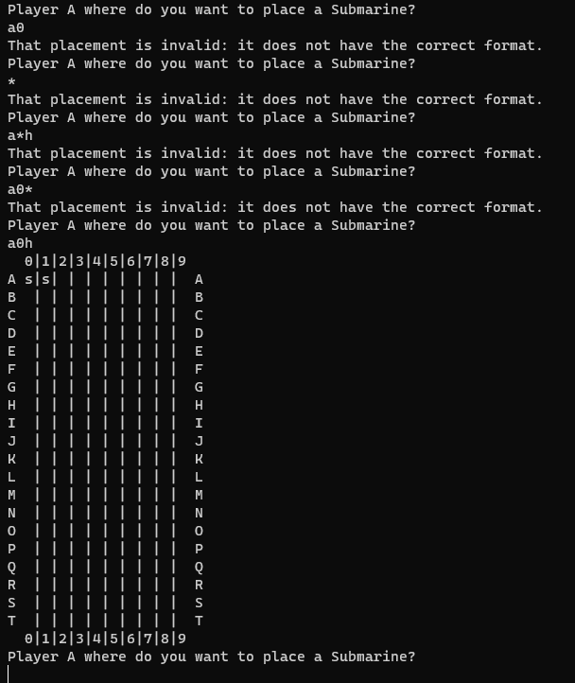

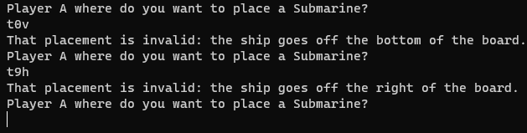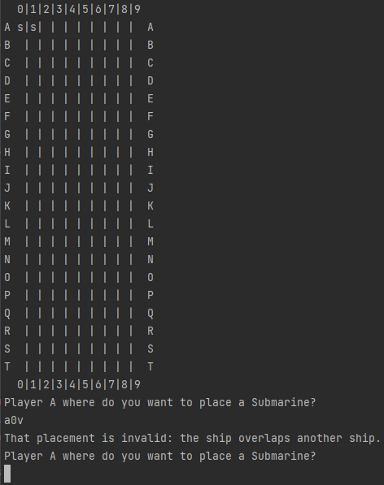

This picture shows that I build the 4 kinds of ships correctly for version 1. It shows when player 1 finishes its turn to place the ship.

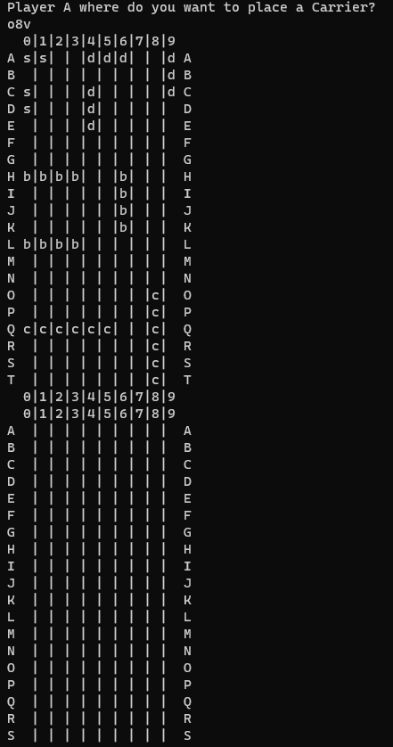

This picture shows it is the player 2’s turn to place the ship

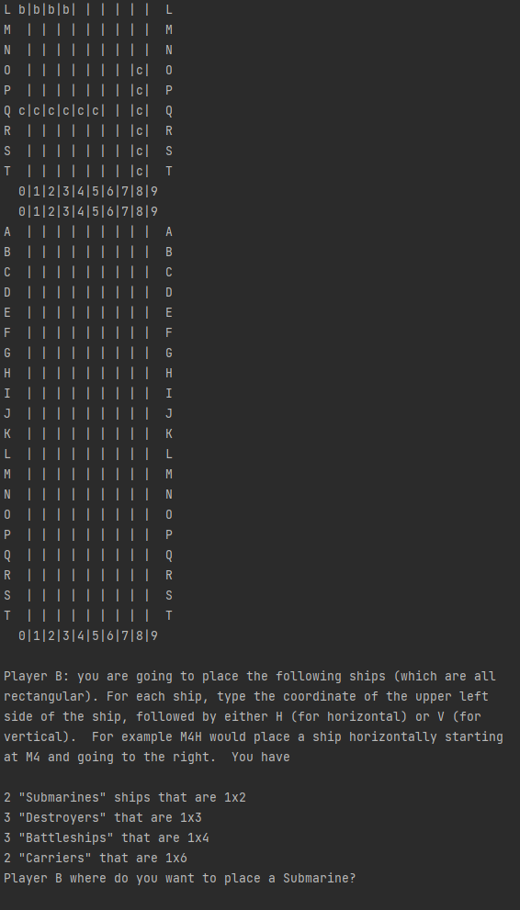

Here is when player 2 finish placement

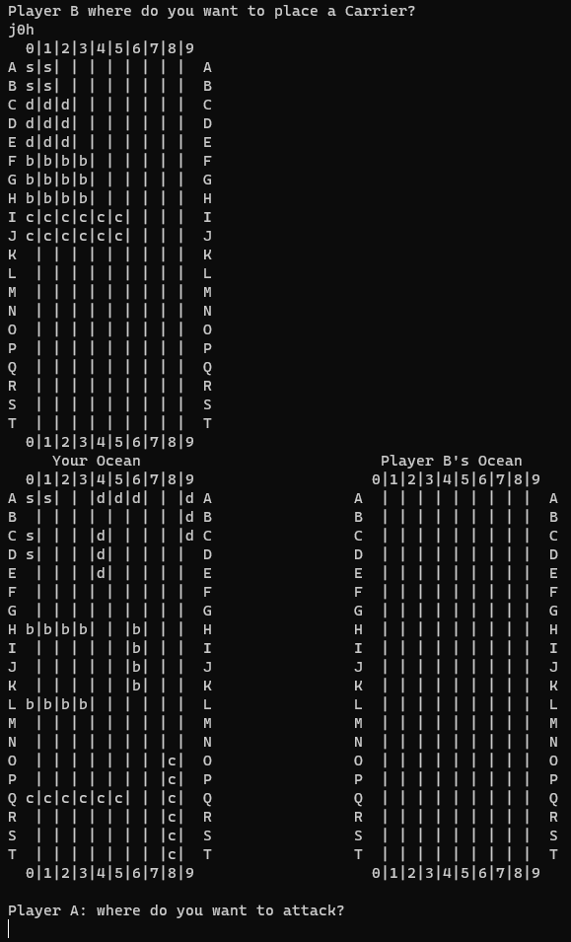

This picture shows hit and miss display for both player

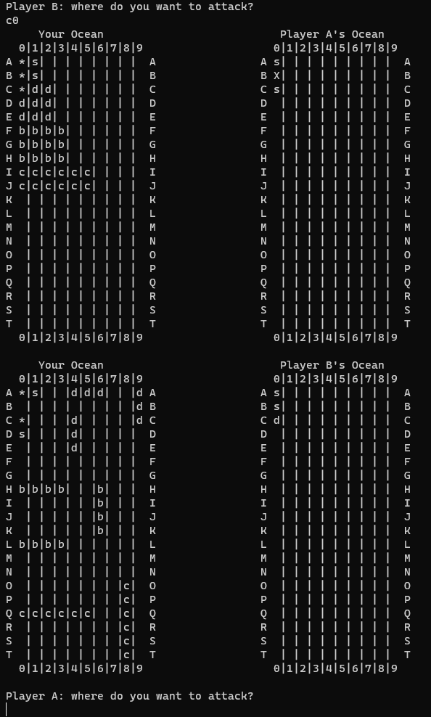

This picture shows the end of the game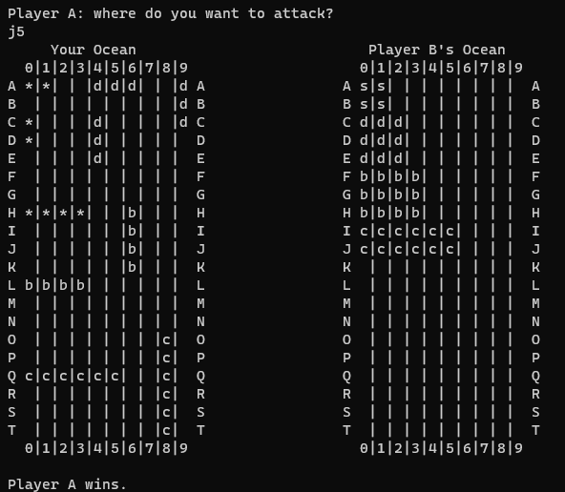

Version 2:

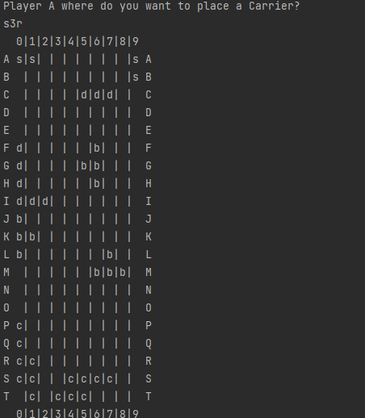New kind of ships:

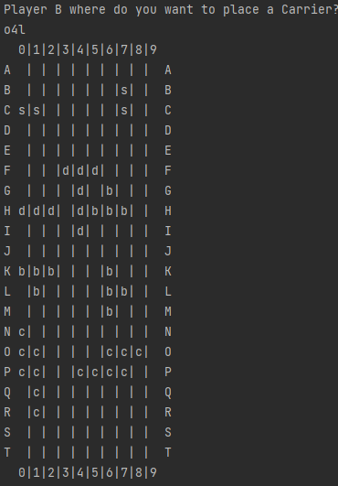

Added action: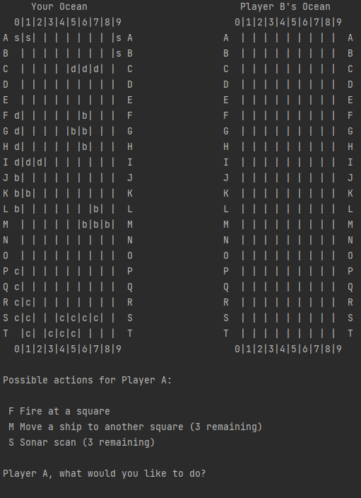

Move ships: (This is a new game, just for display the action move, the board is show after this picture)

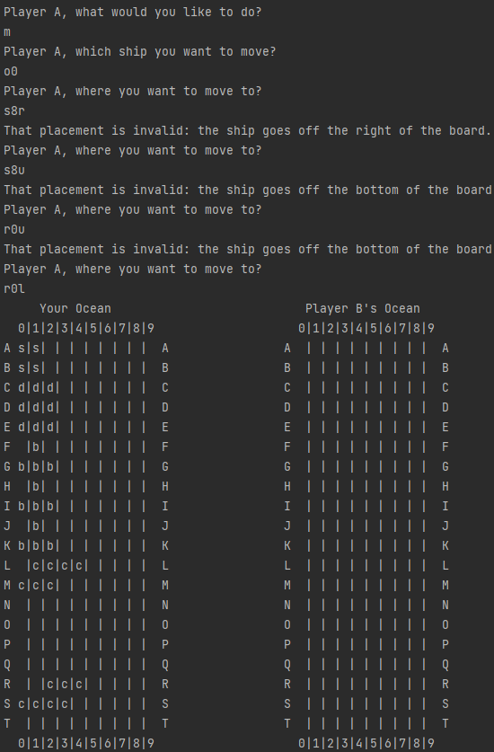

Original board:

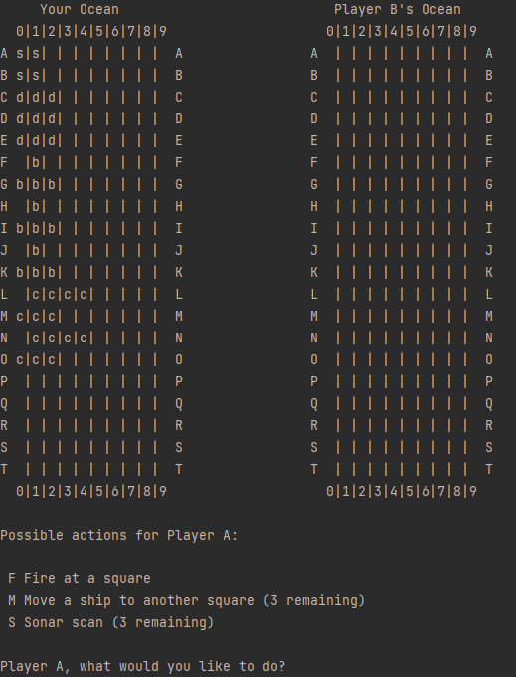

Here is a new board for displaying the move action. The moved ship has hit a block. In the enemy view, there is no information to know player 1 move the ship

Original board:

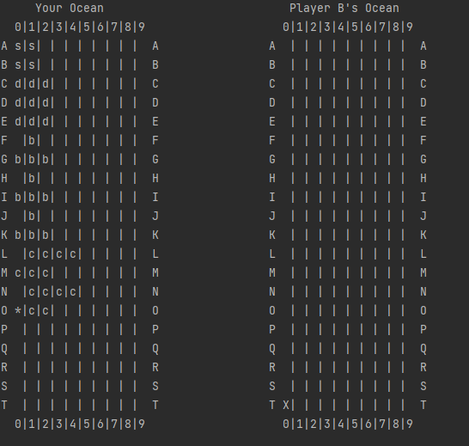

Move result:

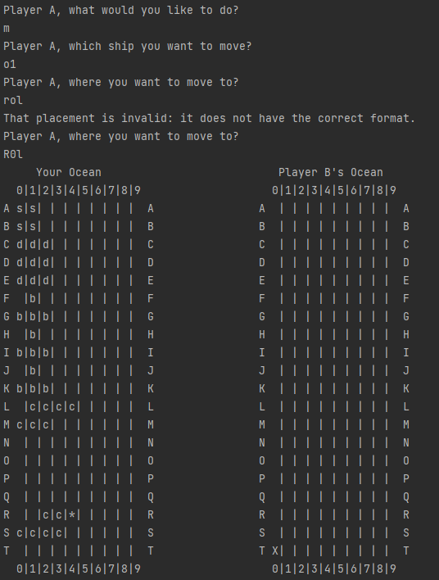

Enemy view:

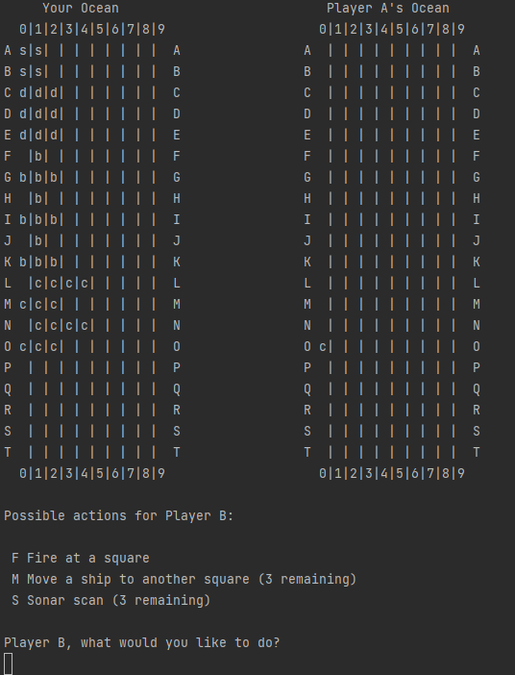

Scan (back to the board before moving):

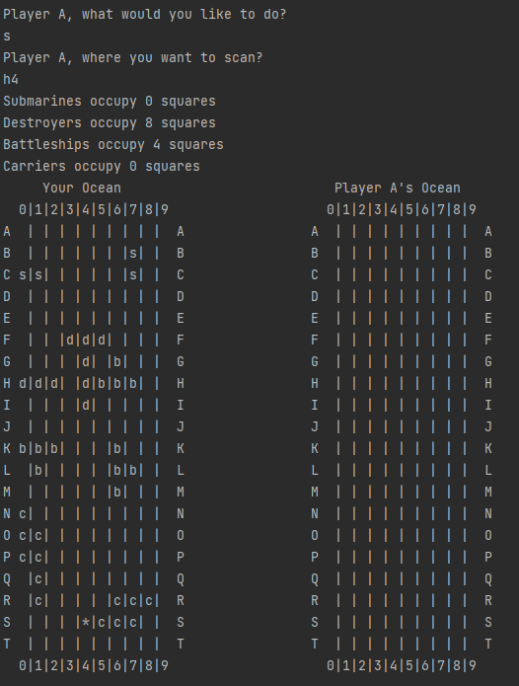

Add computer player:

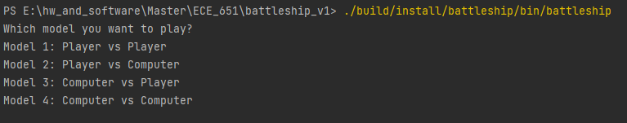

Model 1 is shown before.

Model 2, after type 2 and finish placement of A:

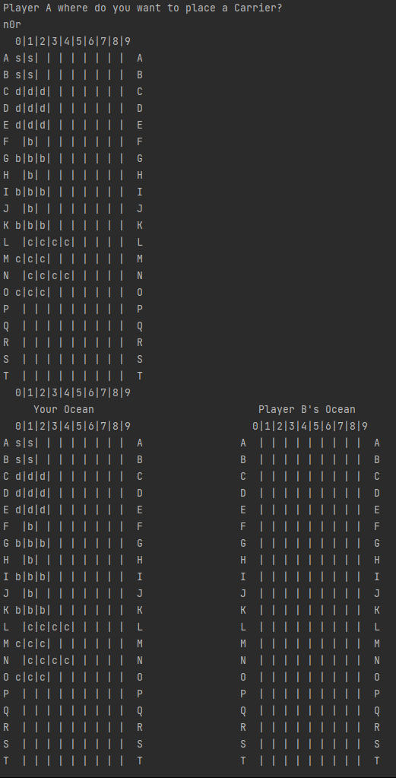

Model 3: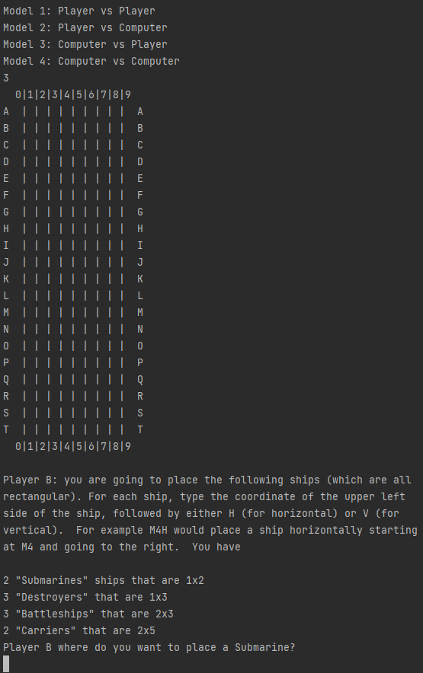

Computer player attack:

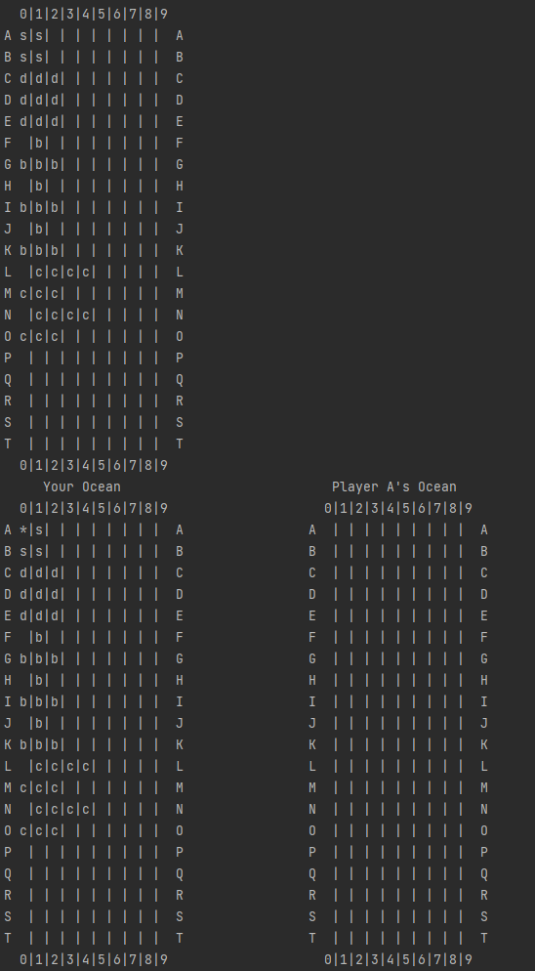

Model 4:

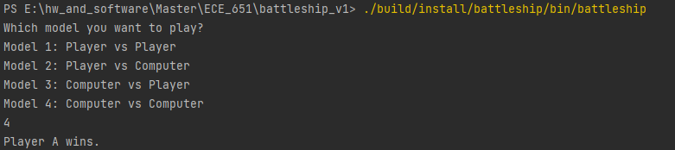

Since the computer player only attack row by row, the first player will win.