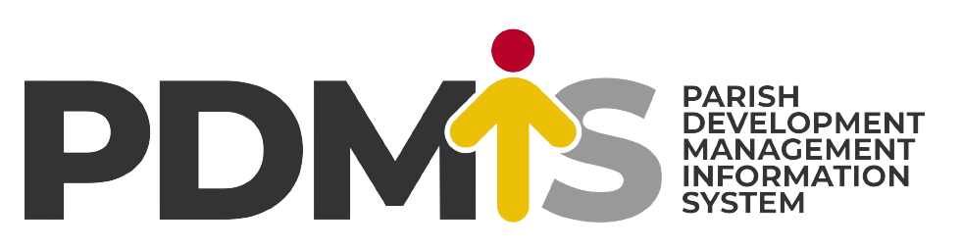
{d.district.name:upperCase()}
INFORMATION TECHNOLOGY
(IT) OFFICE
{d.district.votePhysicalAddress}, {d.district.votePostalAddress}, {d.district.name}. Tel: {d.itOfficer.telephone}. E-mail: {d.itOfficer.email}

{d.name:upperCase()}
In reference to the Parish Development Model and Re-stocking, this document shows you an extract of all the beneficiaries in {d.name:ucWords()}. Note that, this is for official use only.
Metadata for the whole Sub-county Vs that of the Parish
BIO - DATA | Sub-county: LIRA CITY WEST |  | My Parish: {d.name:ucWords()}
PARISHES | 34 parishes |  | 1 parish (this one)
VILLAGES | 39 villages |  | {d._count.villages} of 39 villages
GROUPS | 34 groups |  | 2 of 34 groups
BENEFICIARIES | RECEIVED PDM | N/ RECEIVED PDM | RECEIVED PDM | N/ RECEIVED PDM
 | 34 (45%) | 34 (56%) | 34 (45%) | 34 (56%)
 | FEMALE | MALE | FEMALE | MALE
 | 34 (45%) | 34 (56%) | 34 (45%) | 34 (56%)
 | ELDERLY | YOUTH | ELDERLY | YOUTH
 | 34 (45%) | 34 (56%) | 34 (45%) | 34 (56%)
 | 3,900 beneficiaries in total |  | 3,900 beneficiaries in total
Table 1 Showing metadata of the whole sub-county versus that of {d.name:ucWords()}(Parish) as of {d.dateNow}. Complied by {d.itOfficer.name}, IT Officer, {d.district.name:ucWords()}.

Order of Beneficiary Extraction for {d.name:ucWords()}
The list of Beneficiaries takes the following form;
- Sub-county: This is the top most hierarchy in the beneficiaries’ list extraction.
- Parish: After the sub-county in the hierarchy, is the Parish (ward)
- Village: Village criteria show all the groups in the village alongside its beneficiaries (Those that have received and not received PDM loan).
- Group: The group contains the list of the beneficiaries in its minutest grouping.
- Not-received PDM: This will represent all the beneficiaries that have not received any PDM loan.
- Received PDM: This will represent the list of beneficiaries that have already received the PDM loan.

{d.villages[i]} VILLAGE: {d.villages[i].name:upperCase()}
Located at {d.villages[i].parish.name:ucWords()}, {d.villages[i].parish.subCounty.name:ucWords()}, {d.villages[i].parish.subCounty.district.name:ucWords()}. The village has {d.villages[i]._count.saccoGroups:formatN(0)} registered groups.

{d.villages[i].saccoGroups[i]} GROUP: {d.villages[i].saccoGroups[i].name:upperCase()}: {d.villages[i].name:upperCase()} (Village/Cell)
This group has a total of {d.villages[i].saccoGroups[i]._count.beneficiaries:formatN(0)} beneficiaries.
List of Beneficiaries with an Active PDM Loan
s/n | FULL NAME | M/F | CONTACT & NIN | CREATED ON | STATUS | CHOOSE
{d.villages[i].saccoGroups[i].activeBeneficiaries[i]} {d.villages[i].saccoGroups[i].activeBeneficiaries[i].number:formatN(0)} | {d.villages[i].saccoGroups[i].activeBeneficiaries[i].fullName:upperCase()} | {d.villages[i].saccoGroups[i].activeBeneficiaries[i].gender} | {d.villages[i].saccoGroups[i].activeBeneficiaries[i].contact}  {d.villages[i].saccoGroups[i].activeBeneficiaries[i].nin:upperCase()} | {d.villages[i].saccoGroups[i].activeBeneficiaries[i].createdAt} | {d.villages[i].saccoGroups[i].activeBeneficiaries[i].status}
{d.villages[i].saccoGroups[i].activeBeneficiaries[i+1]}
Table 2 Showing list of beneficiaries that have Received the PDM Loan from {d.villages[i].saccoGroups[i].name:ucWords()}, {d.villages[i].parish.name:ucWords()}, {d.villages[i].parish.subCounty.name:upperCase()}, {d.villages[i].parish.subCounty.district.name:ucWords()}.
List of Beneficiaries without an Active PDM Loan (They have not yet gotten PDM Loan)
s/n | FULL NAME | M/F | CONTACT & NIN | CREATED ON | STATUS | CHOOSE
{d.villages[i].saccoGroups[i].inActiveBeneficiaries[i]} {d.villages[i].saccoGroups[i].inActiveBeneficiaries[i].number:formatN(0)} | {d.villages[i].saccoGroups[i].inActiveBeneficiaries[i].fullName:upperCase()} | {d.villages[i].saccoGroups[i].inActiveBeneficiaries[i].gender} | {d.villages[i].saccoGroups[i].inActiveBeneficiaries[i].contact}  {d.villages[i].saccoGroups[i].inActiveBeneficiaries[i].nin:upperCase()} | {d.villages[i].saccoGroups[i].inActiveBeneficiaries[i].createdAt} | {d.villages[i].saccoGroups[i].inActiveBeneficiaries[i].status}
{d.villages[i].saccoGroups[i].inActiveBeneficiaries[i+1]}
Table 3 Showing list of beneficiaries that have NOT Received the PDM Loan from {d.villages[i].saccoGroups[i].name:ucWords()}, {d.villages[i].parish.name:ucWords()}, {d.villages[i].parish.subCounty.name:upperCase()}, {d.villages[i].parish.subCounty.district.name:ucWords()}.

{d.villages[i].saccoGroups[i+1]}

{d.villages[i+1] }

