Vault App
General description and Software Requirement Specification
Version 0.2 – 2026-01-08
Robert Zondervan
Conduction

Vault App
General design and Software Requirement Specification
Table of Contents
General description 3
Functionality 3
Creating secrets 3
Sharing secrets with other users 3
Sharing secrets with applications 3
Sharing secrets with link 3
Registering an (external) application 3
Multiple encryption suites (advanced functionality) 4
API (advanced functionality) 4
Encrypted mail (future development) 4
Certificate Authority (future development) 5
Data model 6
Encryption 7
Accessing encrypted data 8
Nextcloud users 8
Internal applications 8
External applications 8
Software Requirements Specification 9
Functional Requirements 9
Key Generator 9
Configuration fields 9

General description

Functionality
The vault app is a Nextcloud application for storing and sharing secrets with other users or applications. This means that the vault is usable as a key store for applications, but also as password manager.
The application stores encrypted secrets in the database (for the way this works, see the chapter Encryption.

Creating secrets
In creating a secret the secret must have a name (which is stored unencrypted) a key (password, api key, etc., stored encrypted) and may have a login field (username, client id) and additional fields (all stored encrypted, additional fields will be stored as an encrypted json blob).
The backend provides a generator for secrets which can be configured with the call from frontend to backend to fit the requirements of the user. (See Key Generator for the requirements for the key generator).

Sharing secrets with other users
Secrets can be shared with other users, by doing this the secret will be copied, and its fields will be encrypted for the user the secret is shared with. When either user changes the secret, this will be written also to the secrets that are shared from the original secret.

Sharing secrets with applications
Secrets can also be shared with either internal and external applications (this functionality does not differ for internal and external).
When sharing the secret the user must have been granted access to share secrets with that application. The user can then either share a secret in their own vault to the application, or write a new secret for the application. When using this last functionality, note that the user can never read the secret after storing it, although they can override it by saving the secret anew.

Sharing secrets with link
The third way to share secrets is with a secret link. This will generate a link for external parties to fetch the secret, and a password that has to be entered by the user to decrypt the encrypted secret. The user can set the amount of times the password can be used, after that the shared secret is removed.

Requesting secrets
Users and applications can request secrets. A new secret is created without contents, and a link is created where anyone can fill out the requested fields. This way, a user that needs info can request the secret info in a way that the data is immediately stored safely, preventing sensitive information being sent over an uncontrolled channel, and in the case of an application, enabling the administrator to request the secrets of that application to be filled out by the provider of the secrets, without the administrator having the need or ability to see the information (and becoming either a point of failure, or a potential point of leakage).

Registering an (external) application
Registering an application can be done by any user, and even anonymous. However, if the user is not the administrator of the Nextcloud instance or an app administrator of the vault, the application will be placed in a queue to be activated by the app administrator. Until that moment no secrets can be attributed to the created application.
When registering an application it is possible to upload an Certificate Signing Request. When doing so the Vault will use the public key in this CSR to encrypt passwords and will not store a private key to decrypt the passwords (for more information on how passwords are encrypted and decrypted, see the chapter Encryption). This means that only encrypted passwords can be returned and that when a new private key is used, it is up to the application to reupload the passwords to the vault.

Multiple encryption suites (advanced functionality)
Multiple encryption suites can be attributed to the same user. In normal use cases only the most recent will be used.
There are two use cases (for which there will be an automated flow) in which the user will use two encryption suites:
- The current encryption certificate is about to expire and the private key is renewed
- The private key has been flagged as compromised by either the user or an admin
In both cases a new encryption suite will be made and the secrets will be migrated from the old to the new encryption suite by decrypting using the old private key and encrypted using the new certificate. However, in the second case all secrets will be flagged (including in all shared versions) as vulnerable and have to be replaced.
Also, in both cases, after the keys have been migrated, the old encryption suite will be removed.

API (advanced functionality)
The vault app is not only accessible through its user interface, it also has an API. This API can be accessed with two authentication methods: logging in using base auth, or using OAuth.
When using base auth the master password must be entered into the user session using the call given in the API specification. The base auth authentication can only be used by nextcloud users.
OAuth can be used by either Nextcloud users or external applications. When the external application has its secret key stored in the vault app, it will need to set the X-Vault-Password header to be able to decrypt passwords. If this field is not set, the secrets will be returned encrypted and decrypting them is left up to the receiving application.
Note that the API is also used by the application itself, so all functionality described is also present in the API.

Uploading CA chain (advanced functionality)
When using the quick setup of the application, a new CA chain containing a root certificate and an intermediate certificate will be generated to sign the certificates in the encryption suites of users. However, if the administrator has a private Certificate Authority in place and wishes to use this authority, the administrator can upload the Root certificate and intermediate certificates to the application. The intermediate that will be used to sign the user certificates will have to have a private key. It is recommended to only use this intermediate for the vault app.

Encrypted mail (future development)
A desired functionality but not scoped at this moment is to add the functionality of mail encryption. This has to be integrated with the Nextcloud Mail app, and will store the mail encrypted in the Vault application and send only the link to the message to the receiver of the mail.
After sending the mail the sender will be prompted with the password of the created share link of the secret message, that can be sent over via another medium to the receiver.
If the receiver uses Nextcloud with the vault app, the mail application has to recognise the link and request the mail to be send over encrypted with the public key of the receiver.
This transaction has to be done in real time so that the sender can mandate the message to be sent over to the vault app at the side of the receiver. If this is mandated, the message will be sent to the receiving vault, the share link will be invalidated and the password will disappear from the screen.

Certificate Authority (future development)
As can be seen from the Encryption chapter, the encryption methods of the Vault application have a lot in common with a certificate authority. The user certificates are signed by an intermediate certificate which is in turn signed by a root certificate. Usually these certificates are generated, but they can also be uploaded (see Uploading CA chain (advanced functionality)).
This means that it is quite a small step to also run a Private Root Certificate Authority from the vault app. The most important parts are that we enable endpoints to upload a certificate signing request (for users with the mandate to do so), sign a certificate signing request (also, for users with the proper mandate to do so) and download the signed certificate. This also needs a UI off course.
In addition, we also need to publish the certificates that have been revoked and the reason. Because we need functionality to revoke certificates already (see Multiple encryption suites (advanced functionality) for example), this means that this only has to be extended by providing an certificate revocation list and publish this CRL in an endpoint.

Data model
In the most basic form the data model is as follows:
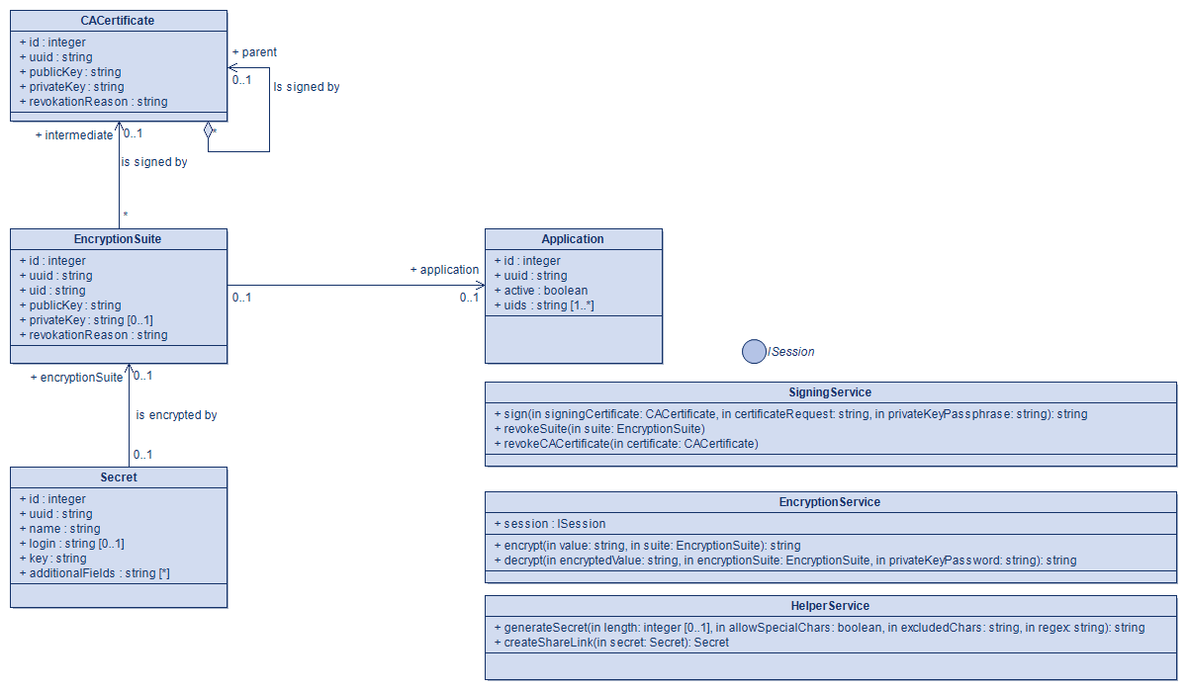

Encryption
Encryption in the vault app happens through a public/private key pair in which the public key is a certificate signed by the private certificate authority within the application (this might be a generated private CA at startup, but also an uploaded certificate chain with a signing intermediate. This means that the secrets are encrypted with RSA encryption.
Keys are always encrypted with the public key, and only be decrypted by the private key. The private key in turn is AES encrypted with a passphrase and can only be decrypted by entering this password. This password will reside either in a header on the HTTP request to the API (when using an application) or in the session of the user.
The public/private key pairs are stored in ‘encryption suites’ that reside in the application database. These suites can be revoked for various reasons, such as when the private key has been leaked, but also for less severe reasons, such as revoking the access of a user to the application. The passphrase of the private key is not stored within the application and has to be stored safely by the user in order to retain access to their secrets.
When the passphrase of the private key is lost, the user no longer has access to the stored secrets.
Also, this asymmetrical encryption means that a user can write secrets to the vault of another user (or application), without being able to read them after saving.
The application generates Private Keys of at least 4096 bits (4096 being its system default at the time of design, and that is only allowed to be increased).
Underwater the code will rely on OpenSSL for the encryption, decryption and Certificate Authority settings, making it compatible with ‘normal’ OpenSSL instances.

Accessing encrypted data

Nextcloud users
When a Nextcloud user opens the vault app they will be prompted to enter their master password (which is the password of their private key). This will be stored in the user session either for the duration of the session, or for a set amount of time (either 10 or 30 minutes).
How this password is used see Encryption.

Internal applications
How internal applications store their master password is yet to be designed.

External applications
External applications do not use a session, but the master password has to be given in the X-Vault-Password header to be able to decrypt the secrets.
If the external application administrates the private key itself, the secret will be returned encrypted and it will be up to the application to decrypt it.

Comparison to other applications

Passwords
At this point in time there is an existing password manager for Nextcloud, Passwords, which includes the possibility to use an API to access passwords.
However, as far as we can see this password manager does not contain heavy duty encryption on its database, and henceforth is not suitable for storing enterprise grade secrets in our opinion.

Software Requirements Specification

Functional Requirements

Key Generator

Configuration fields
The key generator takes the following fields:
- length (int, default 16)
- special characters included (bool, default true)
- excluded characters (string, default “”)
- regex (when valid, overrides the settings above)
The input is considered valid if the set length of the key is greater than 8 (to accommodate older type systems that do not take more than 8 characters for a password).
The regex is considered valid if, and only if:
- The length of the key is defined in the regex
- The allowable characters are defined
So, for example ^\S{16}$ is a valid regex, as is ^[^\s<>]{16}$. However, ^[^\s<>]$ is not, for it does not contain the exact length of the key to generate.
If no regex is given, the key generator will generate a regex from the other input fields (that are all defaulted) and return a key corresponding to the given configuration.

Challenges
There are a number of challenges we have to consider when implementing this application. Some of which are mentioned in the document already.

Encryption algorithms
At the point in time this document is written, we are bound to use a combination of RSA and AES algorithms to encrypt secrets (RSA) and private keys (AES). That is for the most part sufficient, but as quantum computing evolves it might not be sufficient in the future.
Work has been done on post-quantum cryptography, however this is not yet incorporated into PHP or usable PHP libraries at the point of time. This has to be investigated further before implementing it into our application, but would be a huge asset to the application when functioning properly.

Encryption chunks
Usually data has to be chunked into a maximum number of bytes that can be encrypted by a private key (being the number of bits of the key -1 bit and minus padding algorithm space (-11 bytes), which results in a cap of 500 bytes per chunk.
We have to decide how we properly chunk the data of larger amounts of data (the field additional values for example), so there is a unified way of encrypting and decrypting these larger data values. The PHP methods using OpenSSL do not accommodate chunking by themselves.
We will have to figure this out before supporting additional fields, but especially before we are implementing encrypted mail.

File encryption
As stated above: larger amounts of data can only be encrypted using chunking of the data, which limits the ability of encrypting files.
Moreover, where are we going to store encrypted files. I’d strongly advice against storing them in the database. A more logical location would be in the Nextcloud filesystem, possibly in a hidden folder.
If we are not hiding the files we write we should at least mark them with a label that the file is encrypted. If we are choosing this route, it would also be a nice feature to create an plugin to the WebDAV/Files app to decrypt files directly in the files app when the user is logged into their vault.

Master password for internal applications
Encrypting the Private Key using a passphrase is a well known method of protecting private keys from unauthorised access, and this works well for the use cases where users or external applications are retrieving their passwords. It especially provides the possibility of an external application to be able to decrypt the data by themselves if the application itself stores its private key (whether or not it has been stored in the application).
However, this is a challenge for internal applications (applications within Nextcloud), as they are not communicating using a user session or a http header. Furthermore, I’m not aware of any way of storing a master password within a Nextcloud application without breaking the seal of not having the private key and its password in the same location unencrypted.
This should not be a problem if the application is solely triggered by a http request (from UI or API) for in those cases the application can use the session of the logged in user (and only access their vaults), but when system wide variables are involved, or the application runs from a cronjob, the solution should be an application vault, where we arrive back at this issue.
At this point I am unwilling to compromise the security of the application over functionality, but I am stuck in finding a way to do this properly. The only way out I can think of is to lower the security standard for this type of application only (which should be possible, if we restrict internal applications to only use written secrets (so, no sharing between users and internal applications), and either refrain from setting a passphrase for the private keys of these applications (which would be undesirable, because it requires the encryption/decryption implementation to be different for internal applications), or writing the passphrase into a file in the service account of the application or another safe location in the folder of the application.

At this moment in time, a browser plugin for autofill is not in scope of the project, but a desirable stretch goal
It might be desirable functionality to be able to generate a CSR from the application that can be signed by either the root certificate, or an intermediate below the root certificate. This way, the certificate that is generated will only be usable by the application as only the application has the private key.
Research is being done into supporting post-quantum encryption. However, at the time of writing this document such encryption is not yet available in PHP.
Postquantum.com | Post-Quantum Cryptography (PQC) Standardization – 2025 Update

