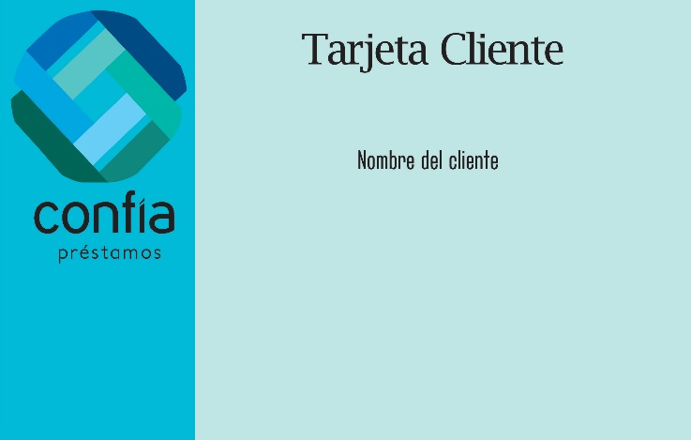ADRIAN ISAI MEJIA MIER