win+r

cmd

enter

cd C:\Users\Zhenqi Jing\Desktop\creative-ai

python -m venv env

env\Scripts\activate

pip install --upgrade pip

将creative_ai_master解压到creative_ai文件夹中

见下图（我的project的name是python project，和你的不一样，你只要让creative_ai_master和env文件夹在同一层目录下就行）

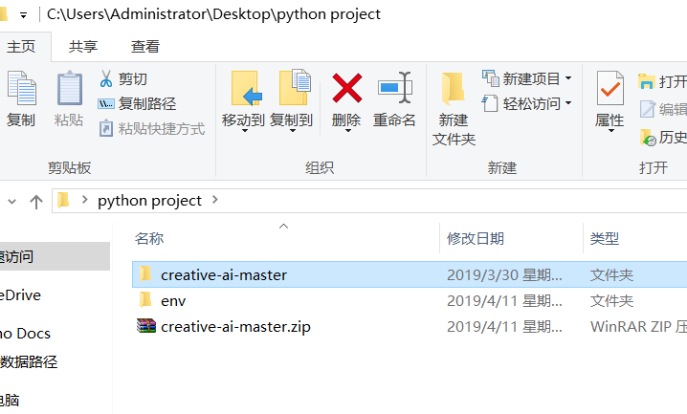

cd creative-ai-master

pip install -e .

cd creative_ai

python generate.py

import sys

sys.path.append("C:\\Users\\Administrator\\Desktop\\python project\\creative-ai-master\\")