TEST PROJECT
IT SOFTWARE SOLUTIONS
FOR BUSINESS

Module 4

WSC2017_TP09_M4_actual

Submitted by:
WorldSkills International
Independent Test Project Design Team

Contents
This Test Project proposal consists of the following documentation/files:
- WSC2017_TP09_S4_EN.pdf (Session 4 instructions)
- SurveyResults_05_2017.csv (Survey Results for May 2017)
- SurveyResults_06_2017.csv (Survey Results for June 2017)
- SurveyResults_07_2017.csv (Survey Results for July 2017)
- SampleSurveyForm.pdf (Sample survey form for reference)

Introduction
Customer satisfaction surveys help you identify the overall level of satisfaction and assist with finding your happiest and unhappiest customers. Feedback from a survey gives you the opportunity to follow up with your happiest customers (to turn them into advocates), and your unhappiest customers (to fix problems and retain their business).
AMONIC Airlines has been using customer satisfaction surveys since May of 2017 to optimize its services. The surveys are now brought together and the company needs a solution to create some reports from them.
In this section the main tasks asked for are as follows:
- Create the database and make any tables needed to import survey data.
- Make a summary report to characterise the data present in the database.
- Create and display a detailed report with charts to visualise the data.

Description of project and tasks
In submitting your solution, please make sure the deliverables conform to the basic guidelines drawn out by different departments at AMONIC Airlines:
- There needs to be consistency in using the provided style guide throughout your work
- All software modules asked for, must have applicable and useful validation and error messages as is expected in the industry.
- Any form or report created, once in focus needs to be displayed in the centre of the screen.
- When a form or a dialogue is in focus, operations on other forms need to be suspended.
- The caption of Delete and Cancel buttons need to be in red to help with accidental mishaps.
- When using colours to differentiate between rows or records, there needs to be visible clarification on the screen as to what they stand for.
- The wireframe diagrams provided as part of this document are only suggestions and the solution produced should not in any way mirror what has been pictured.
- Time management is critical to the success of any project and so it is expected of all deliverables to be complete and operational upon delivery.

Instructions to the Competitor

4.1 CreatING the database
Create a database by the name of “Session4” in your desired RDBMS Platform (MySQL or Microsoft SQL Server). This will be the main and only database you will use in this session.

4.2 Creating the database structure
Depending on your preferred RDBMS platform, you will need to make the data structure needed to complete the task. This entails making the tables and linking the tables to make it normalized as required. The raw data provided are representative of the sample survey name “Sample Survey Form”. Here is your guide to the provided data:
- The data is compiled in a single file in csv format at the end of each month. The data file is then submitted to the software developer to generate reports. Since this is the first time we are trying to generate, the files for the last three months are produced.
- Here is how the associations between the data files and the survey data form:
Query code in the summary file (CSV) | The text of the query
Q1 | Please rate our aircraft flown on AMONIC Airlines
Q2 | How would you rate our flight attendants
Q3 | How would you rate our inflight entertainment
Q4 | Please rate the ticket price for the trip you are taking
- Based on the filled out forms the values that are assigned to each of the items listed as ratings are as follows:
Value in data | value in the data
1 | Outstanding
2 | Very Good
3 | Good
4 | Adequate
5 | Needs Improvement
6 | Poor
7 | Don’t know
- If the participants in the survey do not choose to answer any of the queries and they are left blank a value of 0 is saved for their column.
- The form also asks for people to let the airline know more about who they are. As this is an anonymous survey, only a passive inquiry is made.
  - The fields asked for as shown in the sample survey are gender, age, their flight path (departure and arrival airports) and their cabin type. All the fields provided need to be present in the database and can be asked on each report if they are there on the mockups.
  - As it is common with customer surveys, the survey participants may choose to omit their personal information. The data collected will have blank fields under the column in which the passengers choose not to answer.

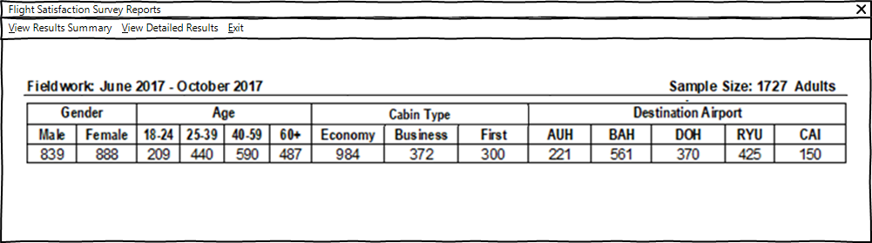

4.3 Generating summary results
The initial form the management needs to view is the summary report. On this form, the following pieces of information are made available:
- The top menu which the option to view detailed report and to exit this part of the application.
- Fieldwork which states the results from which months are currently available in the database.
- Sample size is the total number of records on the database
- Summary of all the results per each of the groups and categories included in the survey:
  - To classify participants based on their age, they are arranged into four levels that are important to the airline. The 18-24 age group, the 25-39, the 40-59 and finally the 60+.

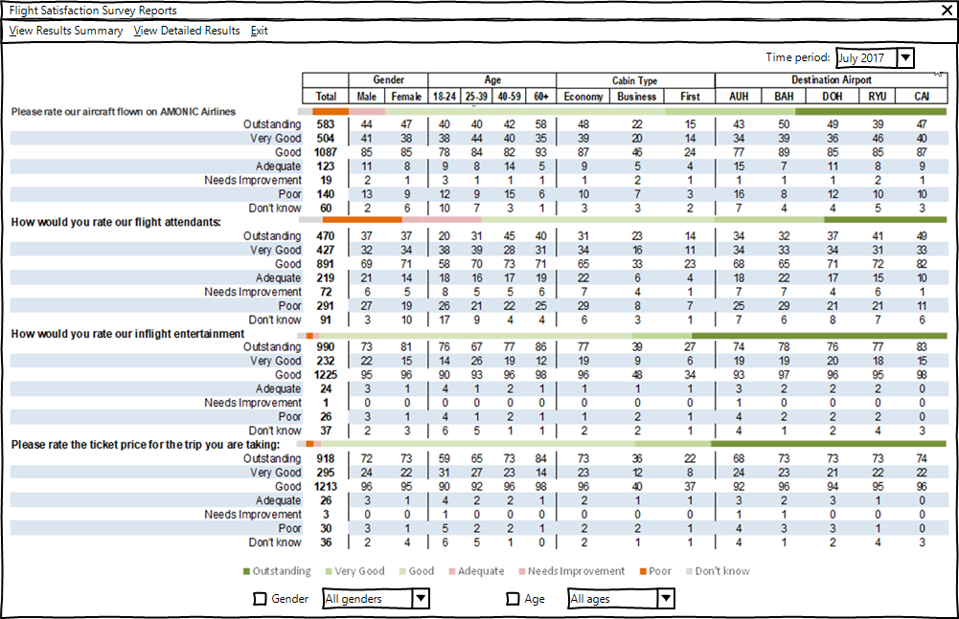

4.4 Generating detailed results
The detailed report generated, will help the user view the total results and to customize it to fit their needs. Here are some characteristics of the report to consider:
- Each query or question has seven possible outcomes and they need to be itemized for better clarity.
  - To improve readability different colors are used as background for odd and even rows.
- The report also needs different columns for each category of the personal information gathered like gender, age, destination (arrival) airport, and cabin type.
  - To classify participants based on their age, they are arranged into four levels that are important to the airline. The 18-24 age group, the 25-39, the 40-59 and finally the 60+
- The total of all the columns or categories displayed on the report is shown at the very left side.
- Because the surveys are handed over monthly, the management has asked to be able to evaluate performance over time. As shown on the picture a combo box can be used to generate reports based on time periods (in months). There should also be an option in the combo box to have this filter disabled so that records from all the dates in the database are included in the report.
- The management also needs to generate reports with different categories and group of categories. For example if they want to know how male correspondence between the ages of 18-24 without any preference on their cabin type think about one of the queries, they can use this component to do that. The suggestions of the IT department to implement this functionality are listed below:
  - As pictured, the user can use combo boxes for gender and age groups with the categories listed under them and check marks next to them.
  - If the user does not need the group displayed or affect the totals, they can use the checkmark positioned next to the combo boxes to have them removed.
  - It goes without saying that the combo box corresponding to the two groups of categories needs to be disabled and the columns removed on the report in case they are taken out (the check mark removed) of the report.
  - The combo box should include an option that using, one can include all the categories or columns in the report.
  - If one of the categories is selected, the other columns will not be shown on the report and they will not count in the totals.
  - By default and upon initiation of the form, all the checkmarks are enabled (all groups and columns are displayed) and the combo boxes are set to display all the categories.
- Create a stacked bullet graph for each query or question with the following specifics:
  - The said graph is recommended to be placed on the row in front of each query or question.
  - The data used to draw, is based on the total for each rating for the said question.
  - There’s no preference of what colors are used to represent each of the ratings but there needs to be a legend placed at the bottom of the report to indicate how they are associated.

