TEST PROJECT
IT SOFTWARE SOLUTIONS
FOR BUSINESS

module 6

WSC2017_TP09_M6_actual

Submitted by:
WorldSkills International
Independent Test Project Design Team

Contents
This Test Project proposal consists of the following documentation/files:
- WSC2017_TP09_S6_EN.pdf (Session 6 instructions)
- Session6-MySQL.sql (SQL Script to create tables with data for MySQL)
- Session6-MsSQL.sql (SQL Script to create tables with data for Microsoft SQL)
- CaseStudy.rtf (Case study for the presentation)
- AMONIC Airlines Overview.rtf (Overview of the airline to be used in presentation)

Introduction
The management at AMONIC Airlines has requested a form to get a quick review of the airline activity. The items and aspects selected are those deemed most useful to be on display at the request of the members.
There are also instructions to produce technical presentation based on the case study provided and present it to a panel of judges.

Description of project and tasks
In submitting your solution, please make sure the deliverables conform to the basic guidelines drawn out by different departments at AMONIC Airlines:
- There should be consistency in using the provided style guide throughout development.
- All required software modules must have applicable and useful validation and error messages as expected by the industry.
- The use of valid and proper naming conventions is expected in all material submitted.
- Any form or report once created should be displayed in the centre of the screen.
- When a form or a dialogue is in focus, operations on other forms need to be suspended.
- The caption of Delete and Cancel buttons need to be in red to help with accidental mishaps.
- When using colours to differentiate between rows or records, there needs to be visible clarification on the screen as to what they stand for.
- The wireframe diagrams provided as part of this document are only suggestions and the solution produced does not have to be, in any way, mirror what has been pictured.
- Time management is critical to the success of any project and so it is expected of all deliverables to be complete and operational upon delivery.

Instructions to the Competitor

6.1 CreatING the database
Create a database by the name of “Session6” in your desired RDBMS Platform (MySQL or Microsoft SQL Server). This will be the main and only database you will use in this session.

6.2 ImportING database structure
Depending on your preferred RDBMS platform, a SQL scripts is made available. The said scripts consists of the database structure and data required to complete the required tasks. The data needs to be imported to the database created for this session named “Session6”.
As instructed by the designers, the database structure provided for the purpose of this section cannot be altered. This applies to removal of tables, adding or deleting any fields on the tables or of change in their data types.
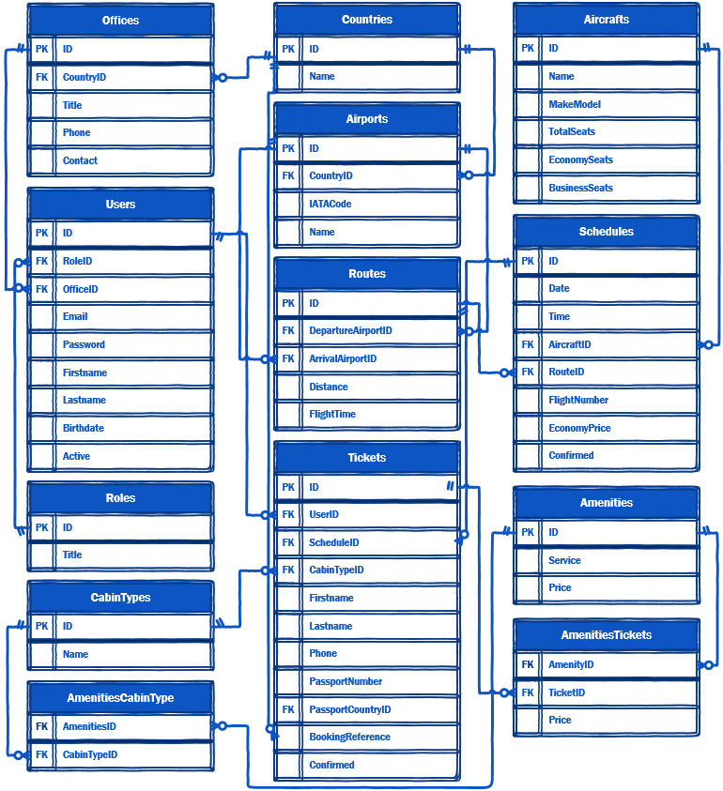
To help further perceive the thinking behind the structure of the database, the database designers provide an Entity-Relationship Diagram (ERD). The aforementioned diagram explains the conceptual and representational model of data used in the database.

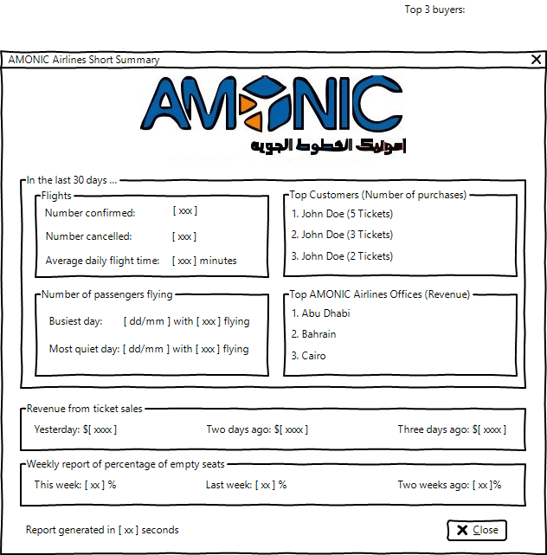

6.3 SHort summary
To provide a live overview of the more important operational factors the department managers need to keep their eye on, the management has ordered for the following list of information to be presented as a form:
- Number of confirmed and number of cancelled (not confirmed) flights in the last thirty days.
  - The thirty days starts from the hour the form is opened to thirty days ago this same hour.
- The busiest and the quietest day (number of passengers) of the last thirty days.
  - Two dates are expected in which on those dates, the most number and the least number of passengers have had confirmed tickets on AMONIC Airlines.
  - The dates in which the airline has not had any flights on should not be included in this report.
- Name of the top three passengers that have purchased the most number of confirmed tickets in the last thirty days.
  - The report should indicate the revenue from the tickets sold for flights that have been running in the last thirty days.
- The average of daily flight time our aircrafts have flown in the last thirty days.
  - The number here should indicate the average of the daily flight times.
  - There is no need to provide the average daily flight time for each aircraft individually, but for all the aircrafts, the airline operates.
- Weekly report of percentage of empty seats of the last three weeks as shown.
  - There is no need to provide data on each cabin type and aircraft.
  - The start of the time we need to go back three weeks from is from 12 midnight the night before when the form is opened.
- The top three AMONIC Airlines offices with the most sales in the last thirty days.
  - This refers to the tickets sales of the flights running in the last thirty days.
- Comparison of the amount of revenue from ticket sales of the three days before today as shown.
  - The report should indicate the revenue only from the tickets sold for the flights.
  - Any income from sale of amenities or other overages should not be included here.
  - The report should take note of the different prices for business and first class seats. The price of business class seats has 35% premium over economy and first class flights are 30% more expensive than those of business class seats. In case you do not come up with rounded numbers, you can round the numbers down to their nearest whole number.
The list is generated as soon as the form is opened and the time it takes for the system to come up with the results (seconds and milliseconds) is shown on the form.
Please note that if not specified, the start of the time we need to create our report of is from 12 midnight the night before when the form is opened.

6.4 creating presentation
The IT Department at AMONIC Airlines is asking for a presentation for another team of developers. The subject of the presentation is the application that needs to be developed for the department which is going to be the next addition to our integrated software system.
The case study of the said department has already been provided and as part of another task, you were asked to draw diagrams based on your analysis of the study. You may reuse the diagrams you have already created in previous sessions.
You may also use wireframes made with MS Visio or other tools to define what you want to have done. Furthermore you can use this document provided to you as a pdf file as a reference of how your presentation should be structured.
You are asked to show your skills at time management and organization and to present what you have created in the given time of five minutes.
The following items should be in your presentation:
- Technical Diagrams (ERD, Sequence Diagram)
- Wireframes of the forms and reports required.
- The text from the case study
- Other visual aids and elements
You may produce and present the PowerPoint document in your own language.

