TEST PROJECT
IT SOFTWARE SOLUTIONS
FOR BUSINESS

Module 7

WSC2017_TP09_M7_acual

Submitted by:
WorldSkills International
Independent Test Project Design Team

Contents
This Test Project proposal consists of the following documentation/files:
- WSC2017_TP09_S7_EN.pdf (Session 7 instructions)
- API_Technical.pdf (Technical documentation for the airline’s API)
- BusinessClassSeats.png (Diagram of business class seats on an aircraft)
- FirstClassSeats.png (Diagram of first class seats on an aircraft)
- Amenities.xlsx (List of amenities for use in the application)

Introduction
For the last session, AMONIC Airlines is asking for a mobile application to both provide general information about the airline and provide limited services of convenience. The target platform chosen for this application is Android and an emulator is installed for you to test it.
The following sections are the main functionalities of the application:
- Provide public information about the airline and its flights.
- Process the API technical documentation and provide services provided.

Description of project and tasks
In submitting your solution, please make sure the deliverables conform to the basic guidelines drawn out by different departments at AMONIC Airlines:
- There needs to be consistency in using the provided style guide throughout your work
- All software modules asked for, must have applicable and useful validation and error messages as is expected in the industry.
- There is an emphasis to make the mobile application appealing and usable.
- When using colours to differentiate between rows or records, there needs to be visible clarification on the screen as to what they stand for.
- The wireframe diagrams provided as part of this document are only suggestions and the solution produced should not in any way mirror what has been pictured.
- Time management is critical to the success of any project and so it is expected of all deliverables to be complete and operational upon delivery.

Instructions to the Competitor

7.1 preparing the api for use
There’s a pdf file provided by our backend technicians that helps you set up and use the Application Programming Interface (API) in the solution. When finished studying the documents please run the server and make sure that it works as expected.

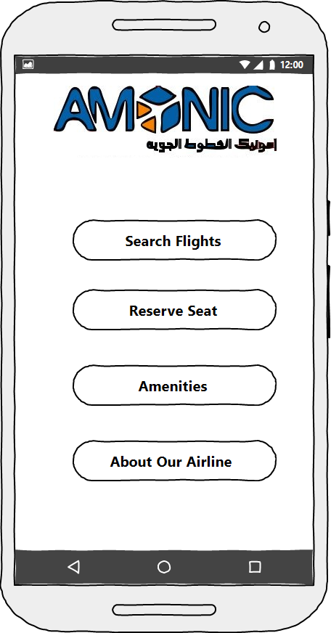

7.2 application main menu
The first screen when the application starts is the main menu. The main menu should have buttons or links that direct the user to other parts of the application.
The menu items for the first menu are as follows:
- Search Flights: helps the user find the correct flight and find information on them.
- Reserve Seat: allows business and first class passengers reserve their seat on their flight
- Amenities: gives the user a sense of what amenities are offered to improve their flight experience.
- About our Airline: will let the user find out more information about our airline and how we operate.
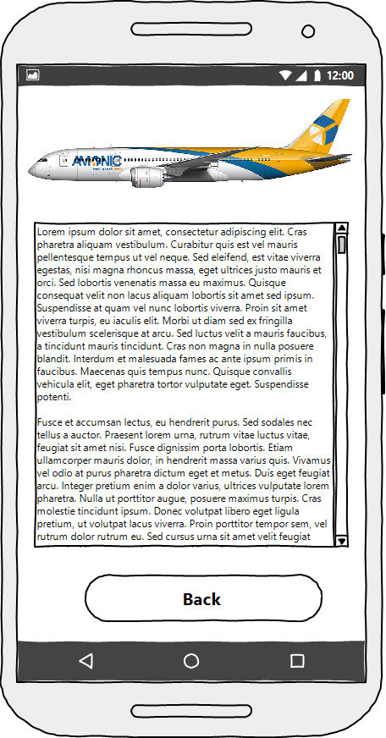

7.3 About Amonic airlines
As a new airline operating routes in the region, it is very important to provide information about the airline and how it operates.
One of the documents at your possession provides all the information the airline needs to your to present to the client.
Feel free to use other graphics and other visual elements to make this presentation of information more appealing.

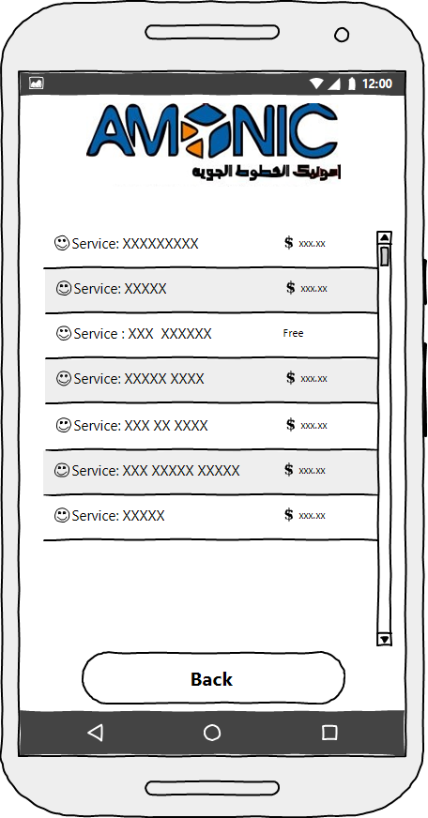

7.4 listing of amenities
The file “Amenities.xlsx” has the list of all the amenities the airline provides. It is important to have it displayed in a way that is clear and easy to read.
Feel free to use icons and other graphical assets to improve the aesthetics.
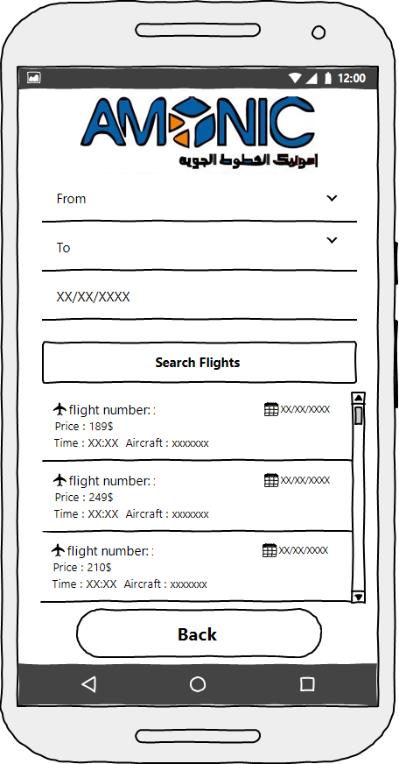

7.5 Searching for flights
In this section of the application, the application will provide a way for the users to look to see if the airline has flights on specific dates.
The data for this section is extracted by using methods on the API described in the relevant technical documentation.
The search parameters are as follows:
- From is a combo list of the airports the airline uses as departure points.
- To is a combo list of the airports the airline has flights to from the source airport.
- The date also needs to be specified for the search functionality to work.

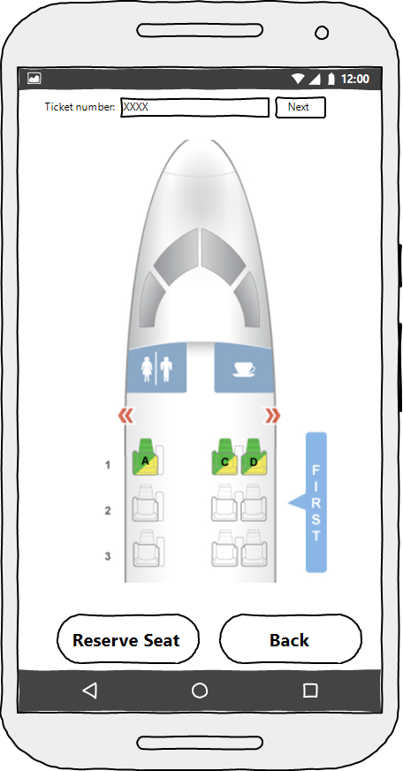

7.6 seat reservation
AMONIC Airlines is asking for an interface to enable their business and first class passengers to reserve their seats on the mobile application. Please refer to the technical documentation for the API to get more information on how to obtain backend information on the seating.
Here is what is envisioned to be included as part of this task:
- The ticket number is requested and once submitted, based on the cabin type, the application will do one these:
  - If the cabin type is business, an image of the aircraft with business class seats is displayed to the user. They can then choose one of the seats to reserve by touching them.
  - If the cabin type is first class, an image of the aircraft with first class seats is displayed. The user can then choose of the seats to reserve by touching them.
  - If the cabin type is neither business nor first class, seat reservation will not be available to the user, an appropriate message will be displayed to inform them.
  - If there has been a seat already retained for the ticket, the user may not reserve anymore. The application will need to show the user the current seat on record for the ticket.
  - Each seat can only be reserved for one passenger. Passengers can’t share seats.
- Once a seat is selected (touched) to be reserved, an appropriate message will tell the user the status of the booking.

