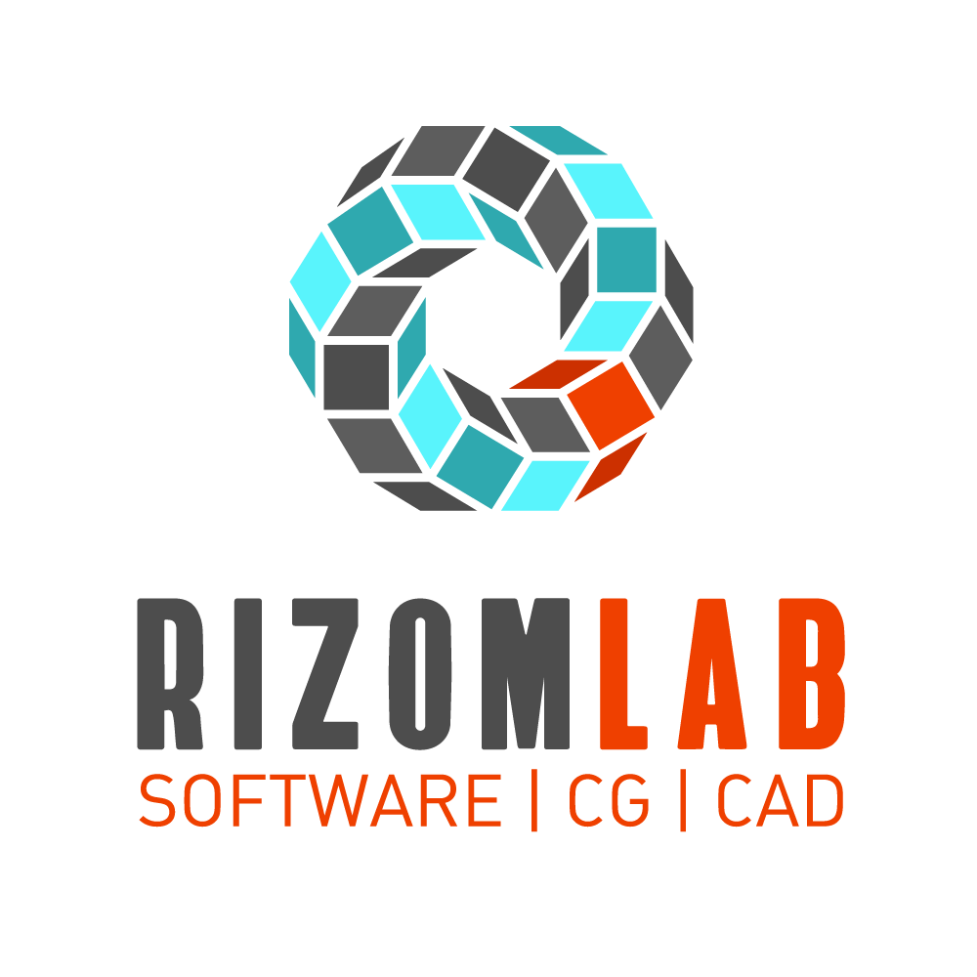

CoH Modo to RizomUV Bridge

Documentation

Contents

Installation 3

1. Installing the bridge 3

2. Removing the bridge 3

Export to Rizom 4

3. Toggle Poly Sets 4

4. Export workflow 4

Import from Rizom 5

5. Import Workflow 5

# Installation

## Installing the bridge

* Open Modo.
* Go to System > Open Content Folder.
* Drag and drop the ‘coh_rizomuv_bridge’ folder into your kits folder.
* Restart Modo.
* The kit should now be accessible under the kits pallete to the top right.

**Note:** If you are updating to a new version of the RizomUV bridge please make sure you fully remove the old version first.

## Removing the bridge

* Open Modo.
* Go to System > Open Content Folder.
* Delete the ‘coh_rizomuv_bridge’ folder from your kits folder.
* Restart Modo.

# Export to Rizom

## Toggle Poly Sets

user.value coh.polyset_toggle on

user.value coh.polyset_toggle off

As RizomUV does not support selection sets I included the ability to export your polygon selection sets as materials. This works by assigning unique temporary materials to every polygon selection set of the selected mesh items. Keep in mind that this will replace any materials already assigned to the mesh, if this is not desirable you can toggle the feature off.

## Export workflow

coh.toRizom

Select one or more mesh items and click ‘Export to Rizom’ or run the command. These meshes can have multiple UV maps, they will all be editable inside Rizom.

When you first run the command a dialog will open, navigate to the RizomUV executable you use to run the program and click ‘Open’.

coh.rizomPath

**Note:** If you select the wrong .exe file or you ever move the RizomUV installation directory you can click on ‘Update Path’ or run the command to change the path to the executable.

# Import from Rizom

## Import Workflow

coh.fromRizom

After you create your UVs in Rizom and save you can import them back into Modo. To do this make sure you have every Mesh and UV map that you want replaced selected and click on the ‘Import from Rizom’ button or run the command.

**Note:** The names of the mesh items and UV maps need to match those of the ones you exported. If you edit the meshes or UV maps in Modo before importing, the UVs will not transfer properly.