University of Calgary

2500 University Drive N.W

Calgary, Alberta

T2N 1N4

November 27, 2014

Majorie Mather, COMS 363

2500 University Drive N.W

Calgary, Alberta

T2N 1N4

Dear Ms. Mather:

**Re: Autism Asperger’s Friendship Society of Calgary Website Usability Study**

We have completed our study to assess the usability of the AAFS website, aafscalgary.com, and have attached the report: *Autism Asperger’s Friendship Society of Calgary Website Usability Study,* which includes our research, findings, and recommendations.

After identifying weaknesses in accessibility, credibility, design, and navigation on the AAFS website, we prepared an online survey via Esurv.org. We conducted this survey in order to obtain feedback from the public regarding these metrics of usability. Using results from both our survey and information from secondary research sources, we were able to make recommendations for the improvement of the AAFS website.

The following are the major recommendations we have formulated to improve the of the AAFS website:

* Consolidate repetitive information and webpages.
* Use high-quality graphics and more accommodating formatting.
* Fix navigation, design and grammatical errors.
* Review their current content management system’s applications and functions.

If you have questions or concerns regarding our usability study please  feel free to contact us at gabarnha@ucalgary.ca. We look forward to hearing back from you.

Sincerely,

George Barnhardt;

Geena Kim;

Josie Liang;

Kyle Derby-MacInnis

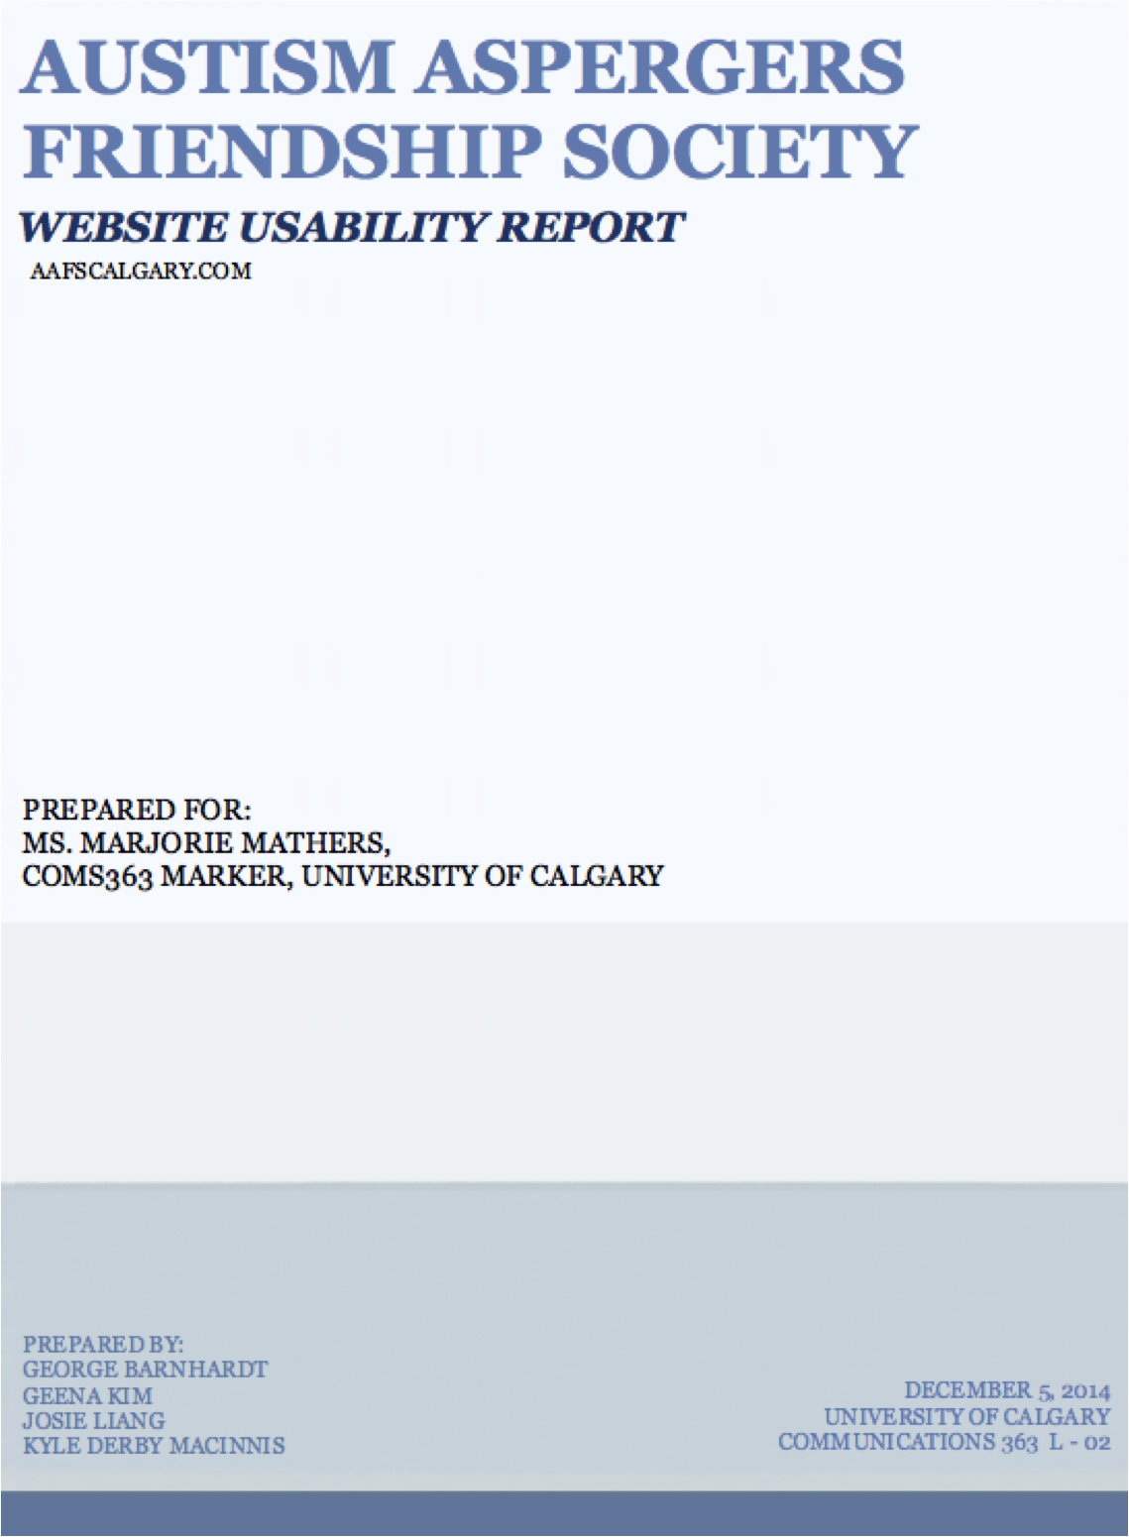

EXECUTIVESUMMARY

As an organization grows, the amount of Internet traffic increases with it. The Autism Asperger’s Friendship Society of Calgary may have started as a small organization of seven families, but has turned into a rapidly expanding community of over 500 families to a predicted number of 1500 in the next three years (AAFS, 2014). In response to the corresponding exposure, usability testing was conducted to allow AAFS to correctly respond to weaknesses in their website, aafscalgary.com, and improve their users’ experience. This report will summarize the collected research, results and recommendations of the preliminary Autism Asperger’s Friendship Society of Calgary Website Usability Study.

The secondary research consisted of both scholarly and contemporary website usability standards that reflected the goals of AAFS’s website. To determined the appropriate criteria for measuring their website, these goals were identified as industry standard usability metrics. These criteria were:

* Accessibility,
* credibility,
* design,
* navigation,

Our primary research was an anonymous usability survey about different components of their website. This survey was administered via eSurv.org over social media and to students at the University of Calgary. In total there were fourteen complete sets of data. From this data, a numerical analysis was used to determine the strengths and weaknesses of different components of their website as they relate to our criteria.

Overall, the most positive response was the amount of information provided whereas the areas that need the most work were the overall design of the website and the organization of all the information provided.

The major recommendations to improve the usability of the AAFS’s website are as follows:

1. Consolidate repetitive information and webpages.
2. Use high-quality graphics and more accommodating formatting.
3. Fix navigation, design and grammatical errors.
4. Review their current content management system’s applications and functions.

By following these recommendations, the **Autism Asperger’s Friendship Society of Calgary website, aafscalgary.com,** can provide its users with a credible, accessible, navigable, and well-designed website.

# Table of Contents

Table of Contents 3

LIST OF FIGURES 3

INTRODUCTION 4

Research Criteria 5

Primary Research 6

Secondary Research 6

Ethical Considerations 6

FINDINGS AND DISCUSSIONS 7

Credibility 7

Accessibility 10

Navigation 12

Design 13

RECOMMENDATIONS 17

Short Term Recommendations 17

Long Term Recommendations 19

REFERENCES 20

APPENDIX A: Survey Ethics Foreword 22

APPENDIX B: Survey Questions 23

APPENDIX C: Survey Results 24

Conversion Formula 24

# LIST OF FIGURES

Figure 1: Survey Critieria Summary 5

Figure 2: AAFS Usability Survey Average Percent Approval Rate 7

Figure 3: Credibility Criteria Survey Data 8

Figure 4 - Accessibility Criteria Survey Data 10

Figure 5 - Navigation Criteria Survey Data 12

Figure 6: AAFS's Navigation Bar 12

Figure 7 - Design Criteria Survey Data 13

Figure 8: AAFS Current Header 15

Figure 9: Example Colour Scheme for AAFS website 18

Figure 10: Example Header Template 18

INTRODUCTION

### PURPOSE

This report was prepared for The Autism Aspergers Friendship Society of Calgary (AAFS) in an effort to summarize and evaluate the usability of its website. This report will use researched methods and scholarly articles to analyze data collected by the preliminary AAFS website usability study in order to determine which components of the website users positively and negatively responded to and how it affects the websites usability. To quantify the user’s reactions, various components were assigned at least one particular criteria related to user experience that define usability. These criteria are credibility, accessibility, navigation, and design. This report will review AAFS’s website to these criteria and in the case of negative feedback, discuss contemporary guidelines and industry standards on the subject and recommend ways to improve the particular component and overall usability.

### BACKGROUND

“AAFS is a non-profit organization that provides respite care in a recreational environment for all individuals on the Autism spectrum. Since 2004, the AAFS has worked to facilitate recreational programs and activities to help their members develop social, life, and communication skills by providing them with the opportunity to practice these skills in a safe community (AAFS, 2014)”.

### RATIONALE

Usability testing is used to quantify how effectively a website can be used. By preforming these tests on a website, it provides an organization the ability to quantify the strengths and weaknesses of the website’s components. It is also important to be conducting usability tests throughout the lifespan of a product for maintenance and future modeling purposes. AAFS may autonomously wish to update their website as they see fit, however, without usability testing they would not understand exactly what areas need the most immediate improvement.

### OBJECTIVES

* Determine areas of negative user experiences through a usability survey, and how they impede a user’s ability to use the website effectively;
* Address these areas and produce possible low cost, high reward solutions that are supported by published literature and articles;
* Provide AAFS with viable recommendations that will improve their website usability with reference to both our primary and secondary research.

### SCOPE

As a post-production usability test, AAFS has shown that they are committed to providing the best service possible to their visitors. As such, the study was centered on four consumer related usability metrics: accessibility, credibility, design, and navigation. Each criteria is represented in the various components of a website. By using industry standard qualities of usability, AAFS is guaranteed that there are viable solutions to the identified problems and that the execution of these solutions will provide improvements to usability.

RESEARCH METHODS

Primary and secondary research was used in evaluating current and future potential usability of the AAFS website. Secondary research was used to determine that credibility, accessibility, navigation and design qualities of the website were the appropriate criteria to define this usability study. An online survey was created from these criteria to collect data regarding certain components of the website. The surveys provided us with fourteen (14) sets of positive and negative responses to website components and were then numerically analyzed. The results and recommendations of this study and were drawn from the results of the survey data and supported by the various secondary research provided. This section will discuss these methods in detail.

## RESEARCH CRITERIA

The follows criteria were used throughout our usability study to parameterize the usability of AAFS’s website. How the results from the usability survey compare to the various guidelines of each criterion will provide an outline for future potential usability. Each criteria reflects areas of usability that AAFS need to include in their website in order to make it a resource for both its members, and non members. A summary of the criteria and their main attributes can be found in Figure 1.

### CREDIBILITY

Figure 1: usability Criteria Summary

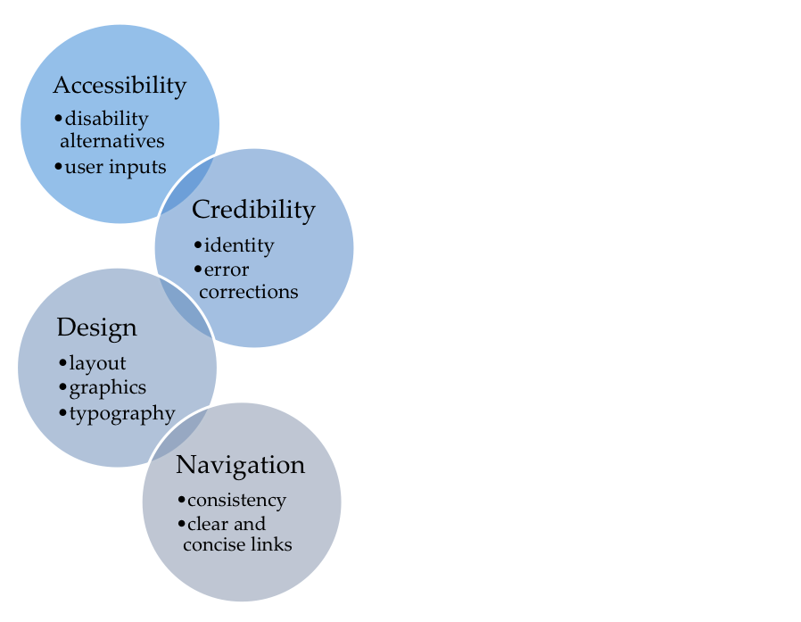Credibility was chosen because it surrounds the overall success of a website because if a web visitor can’t trust that a site is credible, they will leave and not return (Fogg, 2002). Fogg also developed Prominence-Interpretation Theory, which describes the relationship between what users believe to bring credibility to a website (Prominence), and the value they associate to the different components (Interpretation). Fogg also determines that credibility is the perceived notion of an organization as both trustworthy and having expertise in their field. Researcher’s found that “…nearly half of all consumers (or 46.1%) in the study assessed the credibility of sites based in part on the appeal of the overall visual design of a site, including layout, typography, font size and color schemes” (Fogg).

### ACCESSIBILITY

In the United Nation’s “Convention on the Rights of Persons with Disabilities, (2006)” Information and communication have been established as a basic human right. The World Wide Web Consortium (W3C)’s “Preliminary

review standards, (2014)”, covers areas such as the website’s compatibility with assistive technologies, and how well it follows the guidelines set out by the W3C will be the focus of this section in our Discussion Section.

### DESIGN

The design criteria draws heavily from Martin (2014) and the importance she places on “Visual Language” and three principles of user interface design: Organize, economize, and communicate. From these principals, major aspects of design are layout, typography, and graphics. The design criterion closely reflects the requirements of the other criterion and it will act as a summary of the previous requirements outlined by accessibility, credibility and navigation. This is done to properly outline the requirements of the website’s layout, typography, and graphics in a clear and comprehensive format.

### NAVIGATION

As described by Hartstein, (2012), navigation is a roadmap to the rest of the site. It is the organization of all the webpages into a concise and clear set up. There are specific problems associated with navigation and there is work being done to automate and quantify the effects of these problems. Problems discussed in findings will be covered in detail on how to improve AAFS’ navigation.

## PRIMARY RESEARCH

This report’s primary research includes a usability survey and two online tools to provide AAFScalgary.com specific data. The usability survey was designed to let users rate different components of the website as they relate to our selected usability metrics: credibility, accessibility, navigation, design. This survey, as seen in Appendix B, was distributed and collected through the online survey service eSurv.org. Once all data sets were collected, they were tabulated and numerically analyzed as described in Appendix C. It was completed anonymously and voluntarily. Using eSurv, we were able to distribute our website usability survey’s link to other students through social media platforms and mass emails. Participants were notified of the voluntary participation of our website usability survey. Our results came from 14 sets of answers from participants.

## SECONDARY RESEARCH

The report reviewed secondary research to establish the criteria credibility, accessibility, navigation and design as the parameters of the usability testing. By analyzing both scholarly and non-scholarly sources, we could explain the theories behind each element, and recommend solutions from contemporary website design professionals. The usability survey criteria are well documented by our sources as to define strengths and weaknesses with better precision than non researched methods, while designers offered insight into meta web tactics and organization to benefit from already established user familiarity from various sites.

## ETHICAL CONSIDERATIONS

Our study complied with the University of Calgary’s code of ethics and guidelines in order to protect the identities of the participants and maintain the integrity of the collected data. To ensure confidentiality, personal information was not requested and the survey was completed voluntarily and anonymously through a secure online survey service, eSurv.org. An introduction and description of our research and reasoning for data collection was included at the beginning of the survey (see Appendix A) to help participants familiarize themselves with the subject matter prior to the survey to maximize reliability.

FINDINGS AND DISCUSSIONS

So what did our participants think of AAFS’ website? In this section we will delve into our survey’s results and what they mean for AAFS’ website. This section has been divided to provide a clear overview of the website’s strengths and weaknesses in each criterion. To determine a general consensus of our participants we scaled their responses of 1-5 (5 being strongly agree), to reflect a 0-100 % agreement of our questions. As seen in Figure 2, the results of this calculation determined that design was the weakest part of the website at 44.04% positive user response with navigation scoring the best average user response at merely 61.4%. These numbers do not show a strong positive user experience. A question may be referenced in more than one section as the questions frequently relate to multiple criteria. This is done to reinforce that cohesion of all the elements is necessary to create an effective website. Our survey results, formulae and example calculations have been included in this report in Appendix C for reference.

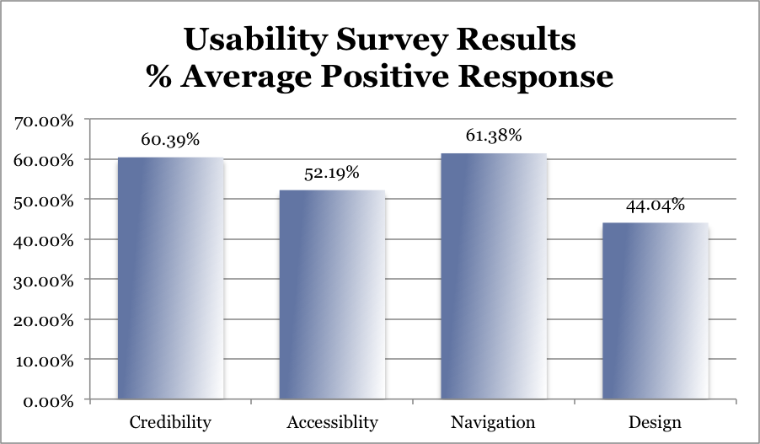

Figure : AAFS usability survey average percent approval rate

## CREDIBILITY

The credibility criterion is based on Fogg (2003), who developed a guideline of ten components of a website to improve credibility. This section will explore our data before exploring two major component failures identified in the usability testing that require immediate attention: information distribution and error correction. Before moving on to navigation, this section will discuss AAFS’s choice of the Content Management System, Wild Apricot. This software is discussed under credibility because it hosts the website and the credibility of Wild Apricot will ultimately determine if it can provide a reliable service to AAFS. Credibility also serves as a broad criterion, because while it holds special traits of its own and if areas of accessibility, navigation, or design are lagging factors of usability, they will also reduce credibility.

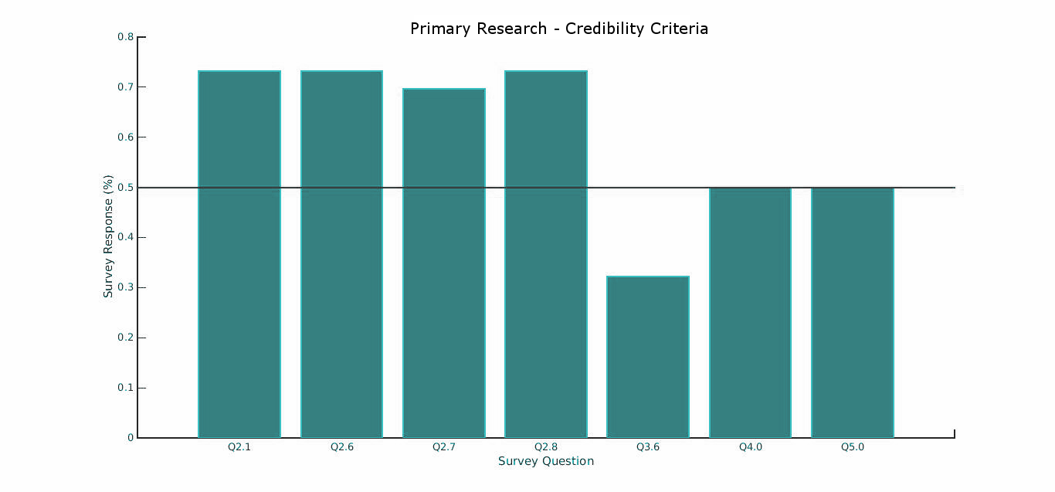

Figure 3: Credibility Criteria Survey Data

AAFS’s credibility rating was ranked second highest among the average user experience against the other criteria at 60.19%. Refer to Figure 3 for the graphical comparison of our credibility questions, these questions were (positive response % included in brackets):

* + Q2.1) "The website is easily recognized as the Autism Asperger’s Friendship Society's website." (73.2%)
  + Q2.6) "Information about provided programs is accessible." (73.2%)
  + Q2.7)"The frequently asked question page is accessible." (69.6%)
  + Q2.8) "The content is concise and informative." (73.2%)
  + Q3.6) "The graphics of the website enhance the information provided." (32.1%)
  + Q4.0) "Was the information under the headers 'What We Believe', 'AAFS Philosophy', and 'Our vision' easy to read in the current column format?" (50%)
  + Q5.0) "Is finding the contact information of the Founder and Executive Director of AAFS easy to find?" (50%)

### INFORMATION DISTRIBUTION

Information distribution is this report’s consolidation of three of Fogg’s ten guidelines:

1. Make it easy to verify information;

2. Highlight expertise and services and;

3. Make your site easy to use – and useful. (Fogg, 2002)

Credibility did well overall relative to the other criteria. However, when we look at the proportions of questions 2.1, **three people out of fourteen (3/14 = 21.43%) were not able to easily recognize the website as part of AAFS.** It is easy to consider at least one of these as an outlier in a small data set, but the chances that greater than 20% of our data is corrupt is highly unlikely. It could then be extrapolated that there is the potential for up to roughly 20% of visitors to not identify that the website is AAFS. These 20% of visitors are potential donors, future members, or event ticket sales gone just because the organization wasn’t extremely evident. Leading indicators of why this might be came from our survey and are believed to be poor organization of information (Q2.9), unhelpful graphics (Q3.6) and cluttered navigation tools (Q6.0). These are harmful to credibility in the fact that these components are typically what users rely on to navigate the website. One of the major problems of poor information communication caused as cited by Mohr & Nevin (1990), is the mutual frustration felt by both parties when neither is able to effectively communicate what they need from the other. Lack of directional tools does not provide them with the necessary information to make an informed choice, and they may wish to take their business elsewhere.

### ERROR CORRECTIONS

Broken links affect both AAFS members and nonmembers alike. One of our survey questions asked participants to answer whether or not they had found any broken links on the website. Participants rated it at 69.6% which, while higher than most of its neighboring statistics, may have been skewed by the participant’s prior inability to navigate the site or lose interest due to poor credibility. When AAFScalgary.com was checked through Brokenlinkcheck.com (2014), an online tool that checks for broken links, it reported 13 broken links for December 1, 2014, with pages ranging from AAFS’s contact page, its PayPal donation page, and two of its external links. Referring to Fogg’s (2003) criteria, these are huge problems since external and internal contact information is one of the biggest ways to prove credibility, and AAFS is a nonprofit that relies on donations, especially as it moves forward with its idea of creating a clubhouse. Broken links are dead ends, and can cause frustration with users who find themselves unable to progress any further. Ensuring that all links function correctly is very important, and care should be taken to regularily test all the links of a website to ensure they are working, especially after each update.

### WILD APRICOT

AAFS uses Wild Apricot as a Content and Administrative Management System. “Wild Apricot is web-based software for small associations and non-profits to help manage membership, website, events and other activities. It is "cloud" software, meaning it runs through a web browser without needing to install anything on your local computer (Wildapricot.com, 2014).” They can be great for creating workflows, as well as providing easy customization and upkeep from their template websites (Wildapricot.com, 2014).

AAFS is currently using one of their modifiable templates for the main formatting of their site. In Wild Apricots’ monthly customer review surveys of 170 of its clients it rates itself an average of 4.61 out of 6 in quality and reliability, and 3.92 out of 6 in ease of use, it has also won Capterra’s #1 Member Management System award twice in a row (Wildapricot.com, 2014). In a third party review of Wild Apricot by clickandcreate.us (2014), a difficulty users may face is the required technical programming knowledge in order to modify the templates to create a website that is personalized for their cause. It is this report’s belief then that Wild Apricot adds a lot of utility to managing an organization overall, it does not provide the user with any supplementary knowledge to effectively manage their site independently. In order for the AAFS webmaster to then gain the knowledge in creating an effective website outside of Wild Apricot’s templates they may need to A) hire a professional which can be costly or, B) train in house one of their employees to become equipped to handle the website. On their homepage under “History of AAFS, (2014)” on their website, AAFS proudly states that they’ve accomplished the last decade with only 2 full time, 2 part time, and a variety of seasonal staff. As AAFS grows, it will become necessary, if it isn’t already, to start building an administrative/IT department, as it frees up the time of the full time staff to do what they are truly good at.

## ACCESSIBILITY

Figure 4 - Accessibility Criteria Survey Data results

The goal of accessibility is to ensure that websites can communicate effectively regardless of who the user is. Whilst it is typically focused on users with disabilities, accessibility increases usability for all people (W3C, 2014a). In an effort to ensure that the Web remains accessible, the World Wide Web Consortium (W3C) has developed a set of universal standards called the *Web Content Accessibility Guidelines (WCAG)* (W3C, 2014b). As outlined by the W3C, the WCAG is a technical standard focused on four key principles:

**Perceivable**: Content must be presented in a way that is perceivable to a user’s senses.

**Operable**: Navigation and user interface components must be operable.

**Understandable**: Information and the operation of the user interface must be understandable to the user.

**Robust**: Content must be accessible via a wide range of technologies and must remain accessible as technology advances. (W3C, 2014b)

Consideration should be made to ensure that it does not accidently exclude potential visitors due to a poor adherence to these principles (W3C, 2014a). Eight questions were chosen from the usability survey to evaluate the AAFS website’s accessibility. Furthermore, AChecker, an online accessibility checker, was used as an objective measure of their current accessibility as per the WCAG. It identified 51 known problems on the AAFS website that did not match WCAG standards, for comparison d2l.ucalgary.ca only received seven (7). This would suggest that an in depth look is required into the details of a where they may improve their standards. (AChecker, 2014).

### PERCEIVABLE

The purpose of this principle is to ensure that content on a website is perceivable (viewable) to people with and without disabilities. Of the 51 known problems identified by Achecker.com (2014) on the website, 49 were problems associated with the perceivable principle. Images were found to be missing alternative text that is necessary for assistive technologies to properly function and various formatting for their texts and graphics were also poorly coded which added to this number of problems. By making small adjustments, the AAFS website will be one step closer to achieving proper accessibility.

### OPERABLE

The operable principle considers the functional operations necessary to navigate and interact with the user interface of the website. Four questions from our usability survey pertain to this principle. The first question, Q2.2, looked at the layout of the website and asked whether or not the participants found it user friendly. A rating of 53.2% was collected, suggesting the interface was tolerable, however room for improvement could be made. The next two questions looked at how accessible certain pages of the website were to the participants. The ratings were respectively, 64.3%(Q2.5) and 69.6%(Q2.7), suggesting that the pages were accessible by the majority of participants. Participants rated the effectiveness of AAFS’s navigation bar (Q6.0) at 42.9%, suggesting that the navigation bar is far too cluttered making it hard to find the relevant information.

Reducing the number of links in the navigation bar would aid in promoting a more operable user interface (Alves, 2011). It was also found that websites should try to maintain an informal ‘standard’ between similar organizations because they can attract similar audiences, and it saves users time if each website’s navigation is similar (Idler, 2012). In order to gauge what links are appropriate, AAFS could look at any of its partner sites or from the Foundations and Charities example websites on WildApricot.com

### UNDERSTANDABLE

The understandable principle focuses on ensuring that text is readable and understandable, as well as looking at predictability and error avoidance. Our survey consisted of four questions relating to the understandable principle: Q2.3, Q3.3, Q3.4, and Q4.0. Participants responded with ratings respectively of 53.6%, 51.8%, 53.6%, and 50% for an average of 52.25%. These questions looked at the comprehensibility of the page layout, the employed font face and sizing as well as the readability of the AAFS's mission statement. Considering the responses were of little consensus it can be expected that improvements could be made to enhance the clarity and readability of the website. Additionally, AChecker found two problems relating to this principle that did not meet the WCAG standards (AChecker, 2014). Both problems were failing to include language identifiers in the web page headers which can be resolved by adding minor HTML codes.

### ROBUST

The robust principle is there to ensure that compatibility with current and future technology is maximized. Unfortunately, this quality can only be measured as this new technology is formed. Therefore, no findings could be collected from our primary research to properly determine the effectiveness of the AAFS website in response to this principle.

## NAVIGATION

Figure 5 - Navigation Criteria Survey Data

A website’s navigation system is a road map to all the various areas within the website. Effective navigation is crucial to the continued success and usability of any website (Hartstein, 2012). Navigation criteria also takes into account the ease of navigating a website and takes into account for things like broken and redundant links talked about earlier. The main tools of navigation include links, menus and search bars. By utilizing these tools properly, the AAFS website can ensure that users can quickly and easily navigate the website and find the information they need.

Our primary research data relating to navigation consisted of 8 survey questions. The questions that were asked to participants focused on areas such as the navigation bar, ease of accessing certain pages, and the presence of broken links. Generally speaking, participants responded favorably in response to the AAFS website's navigation scheme, but that does not suggest that the website cannot be improved.

### NAVIGATION BAR

https://lh3.googleusercontent.com/4xqJwQxzLFvmza6Z_1a_TAwMzaYgz0RA6dos5WAtnH0EUXcqrlgKavb_5A-pug6aze7rWHfvDrGgxac9RmhD2J-qo6GC6nsaCatBJYmYDO7PHNrM3B0SgCRvTpzj72hLWAFigure 6: AAFS's Navigation Bar (courtesy of AAFS http://www.aafscalgary.com)

Questions 2.4 and 6.0 focused on the navigation bar of the AAFS website and asked participants to rate the user friendliness of the navigation bar, as well as asking for their opinion on the number of navigation links on the bar. Participants responded quite favourably to the navigation bar layout and rated it at 69.6% which suggests the majority of the viewers felt the navigation bar is an effective navigational tool. The participants however also stated that the navigation bar is too cluttered, rating the usefulness of the bar at 42.9%. This suggests that whilst a navigation bar is a good choice, too many links detracted from effectiveness of the navigation bar. It is generally good practice to limit the amount of links present on the navigation bar as they can overwhelm a user with too many options (Alves, 2011). Having a more concise navigation whilst maintaining the drop-down menu will enhance usability.

### NAVIGATING PAGES

Five of the survey questions focused on accessing certain pages of the AAFS website: Q2.4, Q2.5, Q2.6, Q2.7, and Q5.0. They were rated respectively, 69.6%, 64.3%, 73.2%, 69.6%, 50.0%. Four of the web pages were easily accessed, half the participants were unable to find the page containing the AAFS Executive Director's contact information. This should be corrected, and all contact information should be made accessible to the users in a single location for easy navigation that relates back to Fogg’s (2003) guidelines of credibility. This will reduce the amount of redundant links present on the website and will ensure that navigation simplicity is at its maximum.

## DESIGN

Figure 7 - Design Criteria Survey Data

An organization's website is a reflection of the organization itself. Having a poor design can negatively impact a user's opinion of the organization and may be the deciding factor in whether or not a user stays on the website. It is therefore in the best interest of the organization to ensure that it has an effective web design. According to Martin (2014) there are three fundamental principles involved in creating an effective design: Organize, Economize, and Communicate. The first principle, organize, is to provide a conceptual structure of the website. The second, economize, is to maintain simplicity without sacrificing content, and finally, communicate, is to ensure that content is communicable towards the target audience.

It is important to remember that 'effective design' is a relative term, and what constitutes a good design for one organization, may not be good for another. The target audience of this website is aimed at the various groups of AAFS members, nonmembers, volunteers, donors and their families. User-Centered Design (UCD) is one of the most common methods used to ensure usability whilst addressing the needs of the users by determining what functionality the user wants and how it will be used (Lynch & Horton, 2014). As our primary research was not targeted specifically at those with Autism, our secondary research was used to connect our primary research on aspects of design to increase usability for all visitors of the AAFS website. Wild Apricot then plays a large roll in AAFS’s design as their offered templates are the basis for what the website will look like, and depending on functionality, what can be done about it.

From the usability survey, nine survey questions were chosen to evaluate the design of the AAFS website. Participants’ responses highlighted the need for a better design as most areas received a poor rating. The key areas of concern were found to be the site's colour scheme, the graphics, layout and typography.

### COLOUR SCHEME

Question 3.2 from our survey was designed to assess the visual appeal of the current colour scheme of the AAFS website. This question received a rating of 37.5% making it one of the lowest ratings in our survey. According to Morton (2014), people make subconscious judgments of a person, environment, or product within 90 seconds and between 62% and 90% of that is based on colour alone. The current colour scheme of the website is inconsistent across different pages making the website appear unprofessional and haphazard. Additionally, too many colours are used within singular pages making it hard to quickly scan for pertinent and important information. Considering the target audience, care should be taken when deciding a new colour scheme as certain cases of ASD need 'low arousal' environments as they tend to have heightened sensory awareness (The National Autistic Society (UK), 2014). With this in mind, it is still possible to design a better colour scheme that will enhance the attractiveness of the site whilst still providing a comfortable environment for its users.

### GRAPHICS

Questions 3.5 and 3.6 of our survey questioned the participants on their opinion of the site's graphics in terms of their visual appeal and whether or not the graphics helped enhance the information provided. The average approval of 37.5% and 33.9% indicates a correlation between the two, and also makes it the category with the lowest combined ratings next to the overall visual appeal of the site. As an example of impractical graphics, the current header graphic, as seen in Figure 8 provides two graphics, and a WordArt version of AAFS’s full name overlapping the other graphics title. According to Lynch and Horton (2014), “the header graphics and text are probably the most important elements in making a collection of web pages feel like an identifiable “site” rather than a random assemblage of files.” Other aspects of professional graphics is making sure social media links in pictures are linked to the site, as the second Facebook icon on the right hand side of their header is not a link. Through the use of more consistent graphics and an improved header image, the AAFS can improve its aesthetic design.

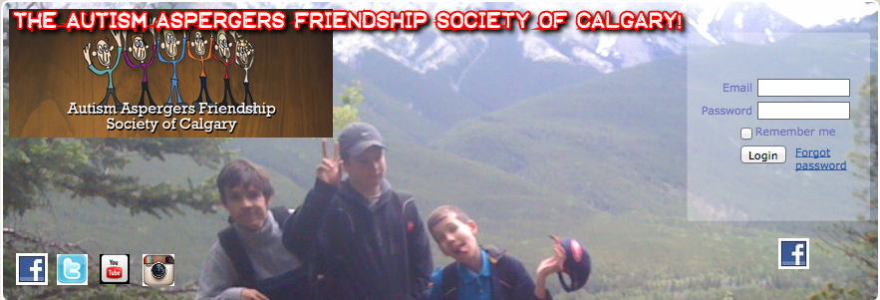

Figure : AAFS CURRENT HEADER, COURTESY OF AAFSCALGARY.COM

### LAYOUT

Three questions from our survey, 2.2, 2.9 and 4, asked participants to rate the website's organizational layout in terms of user friendliness and organizational content. The responses were respectively, 53.6%, 50% and 50%, making the results relatively inconclusive. Despite the lack of consensus, these values suggest that there is room for improvement to help ensure greater usability. A consistent design is a must for effective usability, and all pages should maintain a similar layout so as to be easily digested (Martin, 2014). The current layout is not consistent across the website. Certain pages have multiple columns, others are just a collection of paragraphs, and others are justified to the left. These variations can make it hard to quickly skim through the presented content and may lead users to skip important information. Persons with Asperger's tend to prefer symmetry, and thus the final layout design should also keep this in mind (Attwood, 2006).

### TYPOGRAPHY

Two questions from the survey, 3.4 and 3.5, focused on the typography of the site as it pertained to font face and size. The ratings were generally positive with a rating of 51.8% and 53.6%, respectively. This suggests that the current font while adequate, could be improved for higher user satisfaction. Font consistency should also be adhered to, ensuring that readability remains similar across all pages of the site. Excluding headings and titles, the font size should be kept consistent which is not the case with the current website. Finally, the font should be chosen so it is appealing to users with and without Autism and Asperger’s. Generally a non-serif font is an appropriate choice, as there are cases of ASD such as dyslexia that can cause those affected to have difficulty reading serif fonts (The National Autistic Society (UK), 2014).

CONCLUSIONS

The Autism Asperger’s Friendship Society of Calgary provides a safe and inclusive environment for individuals and their families to seek guidance and understanding. It helps promote healthy relationships in persons who may otherwise have trouble interacting with the general public. The AAFS website also serves as an information hub which provides details regarding various programs and support networks for their members.

In order to provide adequate recommendations, an anonymous survey was conducted to measure usability. The survey was designed to look at usability from four major criteria, namely: credibility, accessibility, navigation, and design. This preliminary usability test was able to perceive what we hope is a comprehensive evaluation of surface inefficiencies of the AAFS website as process or systems evaluation parameters were limited from the survey. Survey participants answered questions relating to these four criteria to help identify surface components of the website that could be improved upon. As the first usability test of AAFS’s website, it will be important to conduct subsequent tests and user surveys to evaluate the effects of each improvement. After reviewing this data, it becomes clear that each component cannot reach its full potential with out taking into account how each criterion interacts within AAFScalgary.com. It is then essential to apply each criteria’s requirements in a cohesive manner through proper visual and technical knowledge to create a high usability website.

In summary of each criterion’s interaction and its role as it pertains to usability. The credibility of the organization and its website pertains to the overall traffic a website will receive and the visitors it retains. Without it, the website would not stand the test of time as visitors would not be inclined to return, donate, or participate in future organization events. Credibility is a relative term and can be won and lost in a variety of ways as users make judgments on how a website has chosen to present itself. A few improvements to the AAFS site’s credibility were found to be error correction, organization validation, and promoting their services and expertise (effectively). To maximize this improved credibility, its important to note that almost a majority of participants gauge credibility by aesthetics (Fogg, 2002). The same correlation can be drawn between design and accessibility or navigation by the usability survey where without engaging graphics, user directing layouts, or consistent and logical layout of webpages and navigation bars, a site can be unrecognizable and inaccessible to information users are looking for. How AAFS presents itself is then further defined in the interactions of accessibility and navigation with aesthetic presentation of the various components of the website. With this idea of function as form, by simplifying the header and navigation bar; maintaining graphic and textual consistency; incorporating a simpler colour scheme; and consolidating redundant pages, the AAFS website’s usability can be improved.

These improvements are a function of Wild Apricot and its templates, and it is important to also distinguish whether the deficiencies present in the AAFS website were a product of the AAFS Webmaster, or limitations of Wild Apricot as a content management system. In either case it would be beneficial to either train existing staff or hire new staff to maintain both the administrative and content management systems that are part of software such as Wild Apricot. The benefits of using content management systems are the simplification and consolidation of operations that are combined within the software. An example being that to update the design aspects of their website such as colour scheme, typography, and layout, it can be as simple as selecting a new template. The negatives being either the limitations of the software’s utility or a lack of properly trained staff to effectively use the software. Limitations of the software are only resolvable by switching providers, however the latter can be resolved with the proper hiring or training of consultants or technical staff.

Other potential improvements to usability were identified by the usability criteria’s industry standards. It would be beneficial to review and implement W3C’s accessibility guidelines as well as Fogg’s credibility guidelines. By accomplishing these two things, they will be able to provide tangible examples of AAFS’s dedication to creating an inclusive and legitimate online community. Having a recognizable identity for AAFS is important for a website to both expand and retain its influence. Considering the AAFS is a non-profit organization, having a broad influence is ever more important as they depend on receiving charitable donations to help fund their cause. By using an effective web campaign they will extend their current circle of influence and be able to provide a much larger amount of service to its community. By adapting the website to incorporate the following recommendations in this report, the AAFS will be able to improve its online presence by promoting greater usability for the benefit of both its users as well as its organizational goals.

# RECOMMENDATIONS

This report’s recommendations have been divided into long-term and short-term recommendations that will provide meaningful enhancements to the AAFS website usability. Short-term recommendations are immediately recognizable and easily dealt with. They focus on simple addition, change or removal of certain content or a particular style. Long-term recommendations cover anything that doesn’t deal directly with content, but may focus instead on AAFS website policies or upkeep. They have been summarized as follows:

Short-term: Review available Wild Apricot templates for the included recommendations below and select one that AAFS feels best represents them. In choosing a new template, AAFS should:

* 1. Use a monochromatic color scheme;
  2. Incorporate professional graphics;
  3. Set a standardized webpage for all AAFS’s webpage tiers; and
  4. Use proper typography.

Long-term: Return the site to a state of clarity, conciseness, and free of error.

1. Delegate web administrator duties
2. Consolidate redundant information.
3. Prioritize bringing site up to industry standards.

## SHORT TERM RECOMMENDATIONS

The following recommendations are to be implemented as soon as possible in order to remediate the negative effects that they may have on usability, or any of its criteria mentioned in this report. These recommendations are broken down further to allow AAFS to distinguish what they should be looking for in each successful completion of these usability tests. The only short recommendation is to remediate the obvious problems that AAFS members were terrified.

### A. Use a monochromatic colour scheme

Monochromatic colour schemes are visually appealing and simple to implement. The colour scheme chosen should reflect the organization's identity, and can be an effective way to help ensure the organization is memorable (Fadeyev, 2008). Target audience of the AAFS are those with Autism or Asperger’s and as such, careful consideration should be made when deciding on a colour scheme. Ensuring a proper contrast is very important as many people with Autism and Asperger’s find high-contrast text to be too visually stimulating, and thus a lower contrast colour scheme should be used. Additionally, many people with Autism and Asperger’s have strong associations with certain colours, so choosing an appropriate colour can be difficult (Devine, 2014). According to Do2Learn, an educational website for those with special needs, green tends to be a colour associated with positivity and trust whilst colours such as red and orange tend to be negatively associated (Do2Learn, 2014). Implementing a monochromatic green colour scheme can help promote visual appeal whilst also being associated with positivity.



Figure 9: Example Colour Scheme for AAFS website

### B. Incorporate professional graphics

Graphics should be visually appealing and used to enhance the content of the website. Any unnecessary graphics should be removed as they can be distracting to users. The graphics should be high quality, and efforts should be made to ensure that images are not jagged, blurry, or mashed together. Transparency should be used when incorporating graphic links so they do not appear pasted on and unprofessional such as with the current social media buttons on the website. Introducing a new header image would greatly improve the appearance of the site and can help to strengthen the identity and professionalism of the organization. Incorporating the donate button into the header will also make it more visible and will associate it with the organization as well making it available on every page (Spivey, 2014). Additionally, the header and logo should be designed with a consistent theme to promote the idea of cohesion and brand identity. This theme should also work alongside the rest of the site's colour scheme.

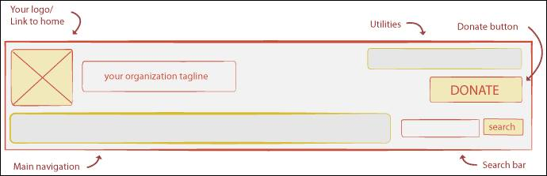

(courtesy of http://wiredimpact.com/blog/designing-nonprofit-website-header/)

Figure 10: Example Header Template

### C. Structure website using consistent layout

The purpose of an organizational layout is to structure and present the content of a website to the user. According to Lynch and Horton (2014), “for maximum functionality and legibility, your page and site design should be built on a consistent pattern of modular units that all share the same basic layout grids, graphic themes, editorial conventions, and organization hierarchies.” This consistency helps enhance user comprehension and site navigation whilst promoting a strong gestalt. The layout would benefit from symmetry as symmetry is itself a form of consistency, and would also be beneficial for those with Autism or Asperger’s (Attwood, 2006). The current layout would not have to change much for it to become more effective. Ensuring that text is formatted in a consistent way across all pages would enhance readability, and ensuring adequate spacing between sections would help separate ideas on the page and make the content easier to digest.

#### D. Choose a sans-serif font

Having a good font is very important when designing a website. The font chosen can negatively affect the usability experience if it is difficult to read, or distracting to the eye. In addition to a having a good font, ensuring that the font is consistent throughout the site is also important. Readability should not change from page to page, and emphases such as italics or bold face should only be used to highlight important information and links so they are easily seen. Using a simple sans serif font is an effective choice as it is easy to read on screen (The National Autistic Society (UK), 2014). For this reason, we suggest the use of Verdana for the website's main font.

## LONG TERM RECOMMENDATIONS

The long-term recommendations focus on the inner workings of AAFS in its regard to the website. These recommendations are not meant to be implemented right away, but are presented for consideration. As time passes the necessity to implement them may become more pertinent and these recommendations should be revisited with each subsequent usability test.

### A. Delegating Proper Web Administrator

AAFS has relied on Wild Apricot to do a majority of the work. However, during the entire study, and for an unknown period before and after, their contact page has been down. Indicating two things. First, Wild Apricot is a very good tool for building websites, however, it is not autonomous, and can’t fix 404 errors. Secondly, the current employee who oversees the webpage doesn’t have the time to fix these errors. From the Capital Campaign webpage of AAFScalgary.com, AAFS is expecting to grow to 1500 families within the next three years from 500 families. This increase may warrant looking into hiring or training someone who can focus on providing the best product possible.

### B. Reduce amount of navigation menu links

The use of a drop down menu is an effective choice for navigation, but the current layout of the navigation bar is cluttered. Reducing the number of links and ensuring that important links are labeled clearly will aid persons with Autism and Asperger’s in effectively navigating the website (The National Autistic Society (UK), 2014). By ensuring that concise, descriptive labels are used for the links users will be able to quickly scan for pertinent information. In addition to cleaning up the main links, work should be done on the drop down menu links as well as they too would benefit from a cleaner design.

### C. Bring AAFS up to Standards

As an organization focused on providing a safe and inclusive environment for persons with disabilities, a key focus of their web presence should be providing an accessible website which does not discriminate against users for any reason. By incorporating the W3C's WCAG and Fogg’s credibility standards standards into the AAFS website, the website will be more accessible and will allow for greater exposure to wider audiences which will help promote the organizations mission of inclusiveness and caring.

# REFERENCES

Aafscalgary.com,. (2014). *Autism Aspergers Friendship Society of Calgary - Home*. Retrieved 1 December 2014, from http://aafscalgary.com

Achecker.ca. (2014). *IDI Web Accessibility Checker : Web Accessibility Checker*. Retrieved 3 December 2014, from <http://www.achecker.ca>

Alves, D. (2011). *How to Design the Best Navigation Bar for Your Website*. *Mashable*. Retrieved 2 December 2014, from http://mashable.com/2011/12/08/design-navigation-bar/

Attwood, T. (2006). *The complete guide to Asperger's syndrome*. London: Jessica Kingsley Publishers.

Brokenlinkcheck.com, (2014). *Free Broken Link Checker / Online URL Validator*. Retrieved 1 December 2014, from http://www.brokenlinkcheck.com/

Devine, A. (2014). *Colour coding for learners with autism*.

Do2learn.com,. (2014). *Do2Learn: Educational Resources for Special Needs*. Retrieved 2 December 2014, from <http://do2learn.com/organizationtools/EmotionsColorWheel/index.htm>

Esurveycreator.com,. (2014). *eSurvey Creator*. Retrieved 1 October 2014, from https://www.esurveycreator.com/

Fadeyev, D. (2008). *A Guide to Choosing Colors for Your Brand - The Usability Post*. *Usabilitypost.com*. Retrieved 3 December 2014, from http://usabilitypost.com/2008/09/29/a-guide-to-choosing-colors-for-your-brand/

Fogg, B. (2002). *The Web Credibility Project: Guidelines - Stanford University*. *Credibility.stanford.edu*. Retrieved 2 December 2014, from https://credibility.stanford.edu/guidelines/

Hartstein, D. (2012). *6 Website Navigation Best Practices*. *Wired Impact*. Retrieved 2 December 2014, from http://wiredimpact.com/blog/6-website-navigation-best-practices/

Idler, S. (2012). *How To Design Effective Navigation Menus - The Usabilla Blog*. *Blog.usabilla.com*. Retrieved 3 December 2014, from http://blog.usabilla.com/how-to-design-effective-navigation-menus/

Lynch, P., & Horton, S. (2014). *Interface Design | Web Style Guide 3*. *Webstyleguide.com*. Retrieved 2 December 2014, from http://webstyleguide.com/wsg3/4-interface-design/3-interface-design.html

Martin, S. (2014). *Designing Effective User Interfaces*. *Web.cs.wpi.edu*. Retrieved 2 December 2014, from http://web.cs.wpi.edu/~matt/courses/cs563/talks/smartin/int_design.html

Mohr, J., & Nevin, J. R. (1990). Communications Strategies in Marketing Channels: A Theoretical Perspective. *Journal of Marketing* *, 54* (4), 36-51.

Morton, J. (2014). *Why Color Matters*. *Colorcom.com*. Retrieved 1 December 2014, from http://www.colorcom.com/research/why-color-matters

Spivey, R. (2013). *Designing Your Nonprofit's Website Header*. *Wired Impact*. Retrieved 3 December 2014, from http://wiredimpact.com/blog/designing-nonprofit-website-header/

The National Autistic Society (UK), (2014). *Designing websites suitable for people with autism spectrum disorders - | autism | Asperger syndrome |*. Retrieved 2 December 2014, from http://www.autism.org.uk/working-with/leisure-and-environments/designing-websites-suitable-for-people-with-autism-spectrum-disorders.aspx

UN Web Services Section. (2006). *CONVENTION on the RIGHTS of PERSONS with DISABILITIES.* Department of Public Information. United Nations.

Wildapricot.com. (2014). *Membership Software by Wild Apricot | About Us*. Retrieved 3 December 2014, from http://wildapricot.com/about-us

World Wide Web Consortium (W3C),. (2014a). *Introduction to Web Accessibility*. Retrieved 3 December 2014, from http://www.w3.org/WAI/intro/accessibility.php

World Wide Web Consortium (W3C),. (2014b). *WCAG Overview*. Retrieved 3 December 2014, from http://www.w3.org/WAI/intro/wcag.php

# APPENDIX A: Survey Ethics Foreword

The following outlines the intent of the survey done for our primary research as well as outlining the ethical considerations that would be adhered to in utilizing this data.

|  |
| --- |
| **Autism Asperger’s Friendship Society of Calgary Website Usability Survey** |
| **Purpose of study:** The goal of the project is to determine and evaluate the usability of The Autism Asperger’s Friendship Society of Calgary’s website. |
| **Your participation in the study:** Your participation will involve navigating through the aforementioned website for approximately 10 minutes, and filling out a short survey about the accessibility of information, the overall aesthetic design, the credibility of AAFS as portrayed by its website, and how easy it is to navigate the website. |
| **Publication of results:** The survey will be used as the basis for analysis by myself, and my partners. It will also be viewed by the instructor, the marker, and potentially other students in the COMS 363 course. Individual survey responses will in no way be made available to the general public. |
| **Risk to you:** eSurv does not store any personal data such as your name, email, ect. There are no risks associated to this survey. Your participation is entirely voluntary and may be cancelled prior to the end of the survey. Due to the inability to distinguish your responses after submission, any submitted responses may not be removed. |
| **Informed Consent:** Due to the nature of eSurv, I, or my group members, are unable to identify your survey after you have submitted it and we are unable to remove it. By filling out, and submitting this survey you are consenting to the use of it as part of our study. |
| **Storage of Materials:** All materials, notes, or comments my group, or our instructors may make will remain confidential. The results of this survey will remain confidential between the group, and its instructors. Any research notes and consent forms will be stored for two years under lock and key, including during the data collection phase. Your survey on eSurv may last up to twelve (12) months after the end of the survey period. |
| You are free to request more information about the study by contacting any member of our group, or our instructor Lisa Stowe at [lstowe@ucalgary.ca](mailto:lstowe@ucalgary.ca). For additional information on eSurv’s, please refer to their privacy policy. |

# APPENDIX B: Survey Questions

The following lists the questions used for the survey conducted as primary research for this report. The available answers are given as a scale from 1 to 5 in regards to how strongly they agree with the question. The survey can be found at <https://a1surveys.com/online-survey.php?surveyID=LIILIF_bd232276>

| # | AAFS Website Usability Survey Questions | 1 (strongly disagree) | 2 (disagree) | 3 (neutral) | 4 (agree) | 5 (strongly agree) |
| --- | --- | --- | --- | --- | --- | --- |
| 1.0 | **Have you ever visited AAFS’s website prior to this survey?** |  |  |  |  |  |
| 2.1 | **The website is easily recognized as the Autism Asperger’s Friendship Society's website.** |  |  |  |  |  |
| 2.2 | **The website layout is user friendly.** |  |  |  |  |  |
| 2.3 | **The website layout is easy to follow.** |  |  |  |  |  |
| 2.4 | **Navigation tools are user friendly (useful for locating information).** |  |  |  |  |  |
| 2.5 | **Contact information is easy to find.** |  |  |  |  |  |
| 2.6 | **Information about provided programs is accessible.** |  |  |  |  |  |
| 2.7 | **The frequently asked question page is accessible.** |  |  |  |  |  |
| 2.8 | **The content is concise and informative.** |  |  |  |  |  |
| 2.9 | **The content of the website was formatted in a well-organized manner.** |  |  |  |  |  |
| 2.10 | **There are no broken links.** |  |  |  |  |  |
| 3.1 | **This website is visually appealing.** |  |  |  |  |  |
| 3.2 | **The color scheme is appealing.** |  |  |  |  |  |
| 3.3 | **The choice of font is appropriate.** |  |  |  |  |  |
| 3.4 | **The choice of font size is appropriate.** |  |  |  |  |  |
| 3.5 | **The graphics of the website are visually appealing.** |  |  |  |  |  |
| 3.6 | **The graphics of the website enhance the information provided.** |  |  |  |  |  |
| 4.0 | **At the bottom of the Home page, is the three column layout easy to read?** |  |  |  |  |  |
| 5.0 | **Is finding the contact information of the Founder and Executive Director of AAFS easy to find?** |  |  |  |  |  |
| 6.0 | **Looking at the navigation bar, are the links in the navigation bar presents in a clear and logical manner?** |  |  |  |  |  |

# APPENDIX C: Survey Results

The data collected from our survey constituted our primary research for this report. In order to quantify the data in a form more easily understood, the following normalization was applied to give the questions a percent value representing their overall feedback. This scale was from 0-100% with 0% corresponding to purely negative feedback, and 100% corresponding to purely positive feedback.

## Conversion Formula

The formula used to normalize the data was as follows:

Where

## eSurv Result Summary



George, Kyle, Geena, and Josephine,

This is a very thorough and comprehensive report, and you have clearly put a lot of work into presenting the information in a professional manner. The layout, design, and use of headings are very well done (other than the rather small body font). There are some problems with primary research and the internal coherence of the report, however.

In your findings section, many questions apply to multiple criteria, sometimes in a logical fashion and sometimes for reasons that are less clear. It appears that results were selected from the primary research to be applied to each criterion, which is a less than ideal way to approach testing usability criteria. If the criteria had been clearly established and defined when your survey was created, the criterion being measured by each question would have been evident. Within the report, the definition and elements of each criterion shift; Figure 1 lists components of each criterion that are sometimes never mentioned again, and some key elements, such as Martin’s “organize, economize, communicate” and Fogg’s three guidelines, are mentioned but never really used to structure your discussion.

While the results for some criteria are reported quite clearly and precisely, other criteria are presented in a confusing or even misleading way, as when it is suggested that question 2.4 asks users about the navigation bar or that question 6 asks them to rate the usefulness of the bar. These may seem like minor distinctions, but they are significant. The survey in Appendix B is also slightly different from the survey actually sent out, which increases the confusion.

Some sections of the report are very clearly and concisely written, but other sections suffer from considerable wordiness, over-generalizing, and repetitiveness. As the report is quite long in comparison to the assignment guidelines, more work could have been put into eliminating the repetitive sections.

Marjorie

Front matter 2.25

Intro/methods 2

Findings and discussion 7

Conclusion/recommendations 3.5

Visuals and layout 4.5

19.25/25 (B)