Here is the VTC graph of the inverter. As can be seen below it does not have a symmetrical profile, but rather it has a bit of a delay on the discharging side of the graph. The very top of the graph showcases a blue line which the V­­OH ­and the yellow line is the VOL and the ride horizontal line is the VM.­ The input voltage limits, V­­IL and VIH  are both visible. The blue line also showcases the VIH and the bottom of the graph is the VIL.

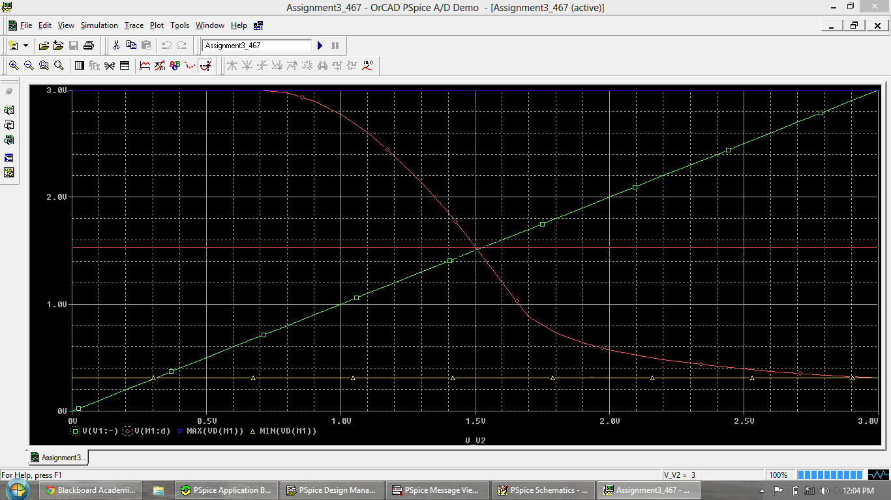

Following is the plot for the Amplitude Response for the Inverter. As can be seen it is pretty much constant all across the board. And an amplitude of around 2 or so.

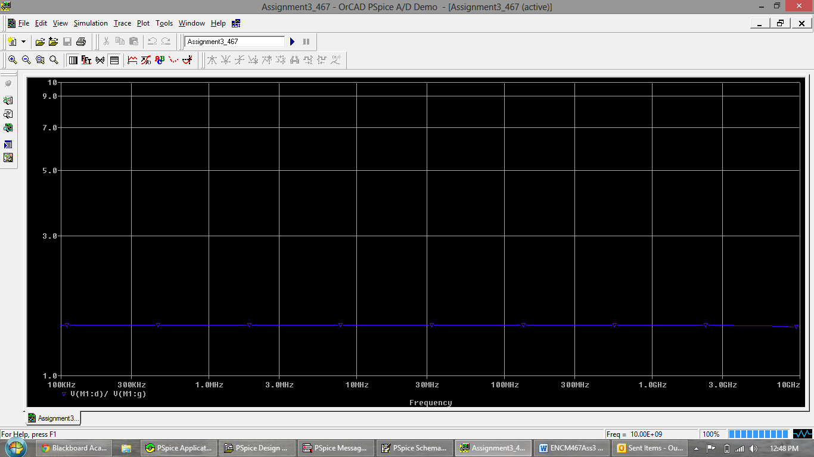

Here is the waveform of the VTC graph when the resistor has been changed from 1K Ohm to 10k Ohm. As can be seen, the delay is reduced and it takes on a distorted shape. This time it is almost preemptively falling.

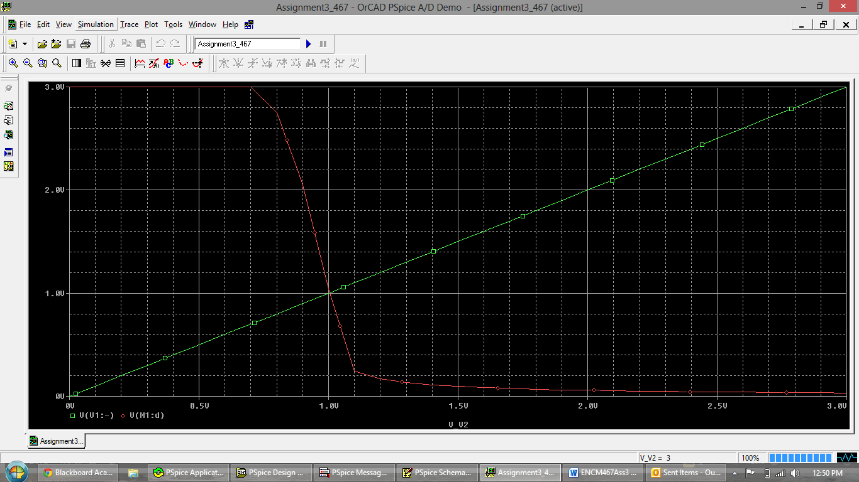

When the resistor is again changed to 0.1k Ohm it now is heavily delayed in discharging and act less and less like a pure inverter and more like a rectifier.

