April 11, 2016

Kyle Derby MacInnis

ENEL 571 – Digital Communications

Laboratory #3 – Digital Passband Transmission

# PART I – Coherent Demodulation

## A.1 Binary ASK

|  |  |
| --- | --- |
| Signal-to-Noise Ratio (dB) | Bit-Error-Rate |
| 0 | 0.237 |
| 2 | 0.185 |
| 3 | 0.158 |
| 4 | 0.132 |
| 5 | 0.099 |
| 6 | 0.083 |
| 8 | 0.036 |
| 10 | 0.013 |
| 12 | 0.002 |

Table 1 – B-ASK Coherent Detection

## A.2 Binary ASK

### a)

The carrier frequency of B-ASK signal is located at approximately **20 kHz**.

### b)

The null-to-null bandwidth appears to be about **2 kHz**.

## B.1 Binary FSK

|  |  |
| --- | --- |
| Signal-to-Noise Ratio (dB) | Bit-Error-Rate |
| 0 | 0.246 |
| 2 | 0.185 |
| 3 | 0.155 |
| 4 | 0.132 |
| 5 | 0.103 |
| 6 | 0.079 |
| 8 | 0.035 |
| 10 | 0.015 |
| 12 | 0.002 |

Table 2 - B-FSK Coherent Demodulation/Detection

## B.2 Binary FSK

### a)

There are two carrier frequencies within the spectrum of the B-FSK signal: **18 kHz** and **22 kHz**.

### b)

The null-to-null bandwidth for this signal is approximately **6 KHz** due to the presence of a guard-band within the signal.

## C.1 Binary PSK

|  |  |
| --- | --- |
| Signal-to-Noise Ratio (dB) | Bit-Error-Rate |
| 0 | 0.0778 |
| 2 | 0.0413 |
| 3 | 0.0236 |
| 4 | 0.0142 |
| 5 | 0.0062 |
| 6 | 0.0022 |
| 8 | 0.0001 |
| 10 | 0 |
| 12 | 0 |

Table 3 - B-PSK Demodulation/Detection

## C.2 Binary PSK

### a)

There is one carrier frequency present within the signal and it is located at **20 kHz**.

### b)

The null-to-null bandwidth of the B-PSK signal is **2 kHz.**

## D.1 M-ary ASK (4-ASK)

|  |  |
| --- | --- |
| Signal-to-Noise Ratio (dB) | Bit-Error-Rate |
| 0 | 0.245 |
| 2 | 0.199 |
| 3 | 0.172 |
| 4 | 0.149 |
| 5 | 0.125 |
| 6 | 0.102 |
| 8 | 0.065 |
| 10 | 0.036 |
| 12 | 0.011 |
| 14 | 0.003 |

Table 4 - 4-ASK Demodulation/Detection

## D.2 M-ary ASK (4-ASK)

### a)

There is one carrier frequency present within the M-ASK signal and it is located at **20 kHz**.

### b)

The null-to-null bandwidth of the signal is approximately **1 kHz**.

## E.1 M-ary FSK (4-FSK)

|  |  |
| --- | --- |
| Signal-to-Noise Ratio (dB) | Bit-Error-Rate |
| 0 | 0.118 |
| 2 | 0.0632 |
| 3 | 0.0348 |
| 4 | 0.0207 |
| 5 | 0.0102 |
| 6 | 0.0051 |
| 8 | 0.0006 |
| 10 | 0 |
| 12 | 0 |
| 14 | 0 |

Table 5 - 4-FSK Demodulation/Detection

## E.2 M-ary FSK (4-FSK)

### a)

There are **4** carrier frequencies present within the spectrum of the MFSK signal. They are: **17 kHz**, **19 kHz**, **21 kHz**, **and 23 kHz**.

### b)

The null-to-null bandwidth is **7 kHz**.

## F.1 M-ary PSK (4-PSK/QPSK)

|  |  |
| --- | --- |
| Signal-to-Noise Ratio (dB) | Bit-Error-Rate |
| 0 | 0.0815 |
| 2 | 0.0363 |
| 3 | 0.0256 |
| 4 | 0.0110 |
| 5 | 0.0063 |
| 6 | 0.0027 |
| 8 | 0.0002 |
| 10 | 0 |
| 12 | 0 |
| 14 | 0 |

Table 6 - M-ary PSK (QPSK) Demodulation/Detection

## F.2 M-ary PSK (4-PSK/QPSK)

### a)

There is one carrier frequency present in the spectrum. It is located at **20 kHz**.

### b)

The null-to-null bandwidth is **1 kHz**.

## G.1 M-ary QAM (16-QAM)

|  |  |
| --- | --- |
| Signal-to-Noise Ratio (dB) | Bit-Error-Rate |
| 0 | 0.0024 |
| 2 | 0.0001 |
| 3 | 0 |
| 4 | 0 |
| 5 | 0 |
| 6 | 0 |
| 8 | 0 |
| 10 | 0 |
| 12 | 0 |
| 14 | 0 |

Table 7 - M-ary QAM (16-QAM) Demodulation/detection

## G.2 M-ary QAM (16-QAM)

### a)

There is one carrier frequency and it is located at **20 kHz**.

### b)

The null-to-null bandwidth of 16QAM in the case is **500 Hz**.

# PART II – Non-Coherent Demodulation/Detection

## A.1 Binary-PSK

|  |  |
| --- | --- |
| Signal-to-Noise Ratio (dB) | Bit-Error-Rate |
| 0 | 0.2412 |
| 2 | 0.1576 |
| 3 | 0.1121 |
| 4 | 0.0732 |
| 5 | 0.0464 |
| 6 | 0.0248 |
| 8 | 0.0034 |
| 10 | 0.0002 |
| 12 | 0 |
| 14 | 0 |

Table 8 - Binary PSK (Non-Coherent) Demodulation/Detection

## B.1 Binary-FSK

|  |  |
| --- | --- |
| Signal-to-Noise Ratio (dB) | Bit-Error-Rate |
| 0 | 0.3710 |
| 2 | 0.3209 |
| 3 | 0.2843 |
| 4 | 0.2419 |
| 5 | 0.2011 |
| 6 | 0.1548 |
| 8 | 0.0832 |
| 10 | 0.0321 |
| 12 | 0.0058 |
| 14 | 0.0010 |

Table 9 - Binary FSK (Non-Coherent) Demodulation/Detection

## C.1 Binary-ASK

|  |  |
| --- | --- |
| Signal-to-Noise Ratio (dB) | Bit-Error-Rate |
| 0 | 0.4276 |
| 2 | 0.3571 |
| 3 | 0.3083 |
| 4 | 0.2753 |
| 5 | 0.2326 |
| 6 | 0.1852 |
| 8 | 0.0969 |
| 10 | 0.0456 |
| 12 | 0.0111 |
| 14 | 0.0026 |

Table 10 - Binary ASK (Non-Coherent) Demodulation/Detection

# PART III – Signal Constellations and Eye Diagrams

## A.1 Signal Constellations and Noise

### a)

The detector would probably start to make errors around **0dB** or so. At this point the constellation points are being spread rather widely. Even at 3dB or so, there is generally enough coherence between the points that they are relatively contained closer to their appropriate signal and not their adjacencies.

### b)

The signal points begin to smear around **0dB** or so. At -1 dB it is very difficult to see them except between multiple adjacencies where they tend to conglomerate. At the edges they are to spread out to define the points precisely. Anything lower and it is almost impossible.

# PART IV – BER and Bandwidth Comparison

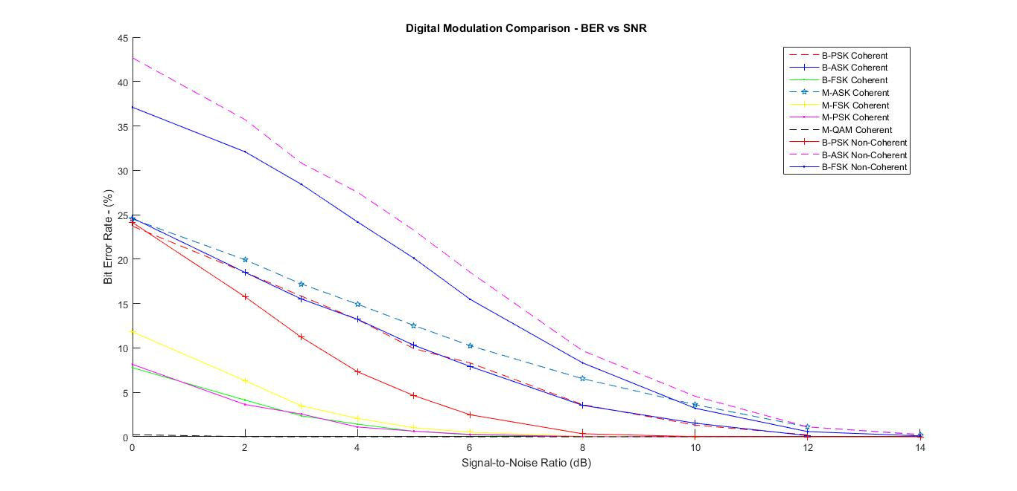

Figure - Full Comparison Between Modulation Schemes

## A.1 Binary Coherent vs Non-Coherent

### a)

Between the three types of modulation schemes, the best performed in terms of BER was **B-PSK.** It was by far the strongest of the three.

The worst BER for a fixed SNR was the **B-ASK modulation** method. It was quite a poor performer. However, for Binary – **B-FSK** was almost as bad as B-ASK and should be considered practically the same.

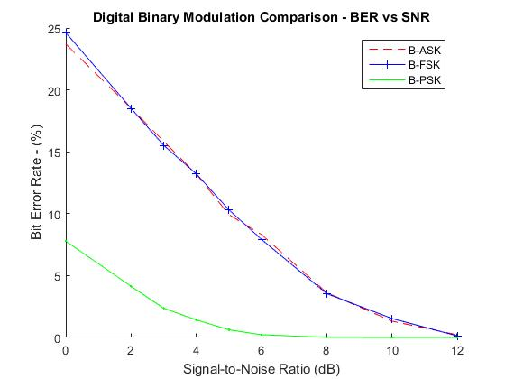

Figure - Coherent Binary Modulation Schemes

### b)

**Coherent** had the smaller BER per SNR pretty much across the board with the worst performing coherent detector was about as good as the best performing non-coherent detector.

The worst modulation scheme was **non-coherent B-ASK** out of the ones tested and it was quite noticeably worse.

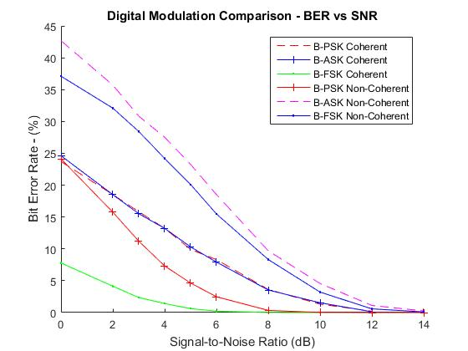

Figure - Binary Coherent & Non-Coherent Comparison

## B.1 M-ary Comparison

### a)

The modulation scheme with the lowest BER was the **M-PSK (QPSK)** scheme.

### b)

The modulation scheme with the worst BER performance was the **M-ASK (4-ASK**) scheme.

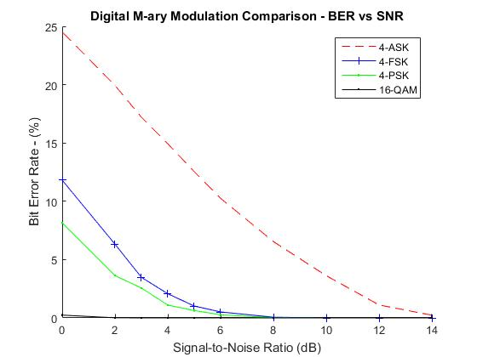

## C.1 Binary Comparison

### a)

The smallest null-to-null bandwidth was found using the **B-ASK** modulation scheme.

### b)

The largest null-to-null bandwidth was found using the **B-FSK** modulation scheme due to the presence of multiple carrier frequencies.

# PART V – Effects of Noise, Channel Bandwidth and Timing Jitter

## A.1 Eye Diagram and Noise Variance

The width and height both start to narrow as the variance goes up. Additionally, they cease to occupy fixed levels and instead begin to occupy intervals that vary around the fixed levels. By the time the variance is 6, the area is around half the size to a quarter the size it was with no noise.

## B.1 Distortion and Time Jitter

The optimum sampling time appears to be around **1ms** or so. This is a little delayed within the combined eye diagram and it is closer to **1.05-1.1ms**.

## B.2 Distortion and Time Jitter

There is not very optimum sample time at these configurations and it appears that the best time to sample would be around **1.5ms** or so for the bandwidth jitter, but the timing jitter is still 1ms by itself.

## B.3 Distortion and Time Jitter

### a)

The width has reduced slightly in the main eye diagram, but more so it seems to have shifted it quite a lot in time as well. Since the bandwidth is still decent the eye is not too narrow. The timing jitter eye diagram however is heavily affected.

### b)

The optimum sampling time has been shifted with the timing jitter eye diagram and the combined eye diagram. There is no effect to the bandwidth eye diagram. The optimum sampling time has been shifted close to 1.5ms.