ENGG 407 Assignment #2

Kyle Derby MacInnis
November 16, 2012

Question 1:

3.3 – Find the angle for which the centroid is equal to 0.75*r:

a) Calculate the centroid using the Bisection Method

Pseudo-Code Algorithm:

// Set Initial Interval Boundaries
a = 0.1 ;
b = 1.4 ;

// Set Target Centroid
Ct = 0.75*r ;

// Iterate 4 times
Loop(4)
{
// Bisect Interval
h = (b + a)/2 ;

// Calculate Centroid at Boundaries
C(a) = 2*r*sin^3(a)/(3*(a – sin(a)*cos(a))) ;
C(b) = 2*r*sin^3(b)/(3*(b – sin(b)*cos(b))) ;

// Calculate Centroid at Bisection
C(h) = 2*r*sin^3(h)/(3*(h – sin(h)*cos(h))) ;

// Output Bisected Angle and Centroid
Output( “Angle: %1 Centroid: %2”, (h, C(h)) ) ;

// If root is found, stop iterating
If ( C(h) == Ct )
break;

// Otherwise replace corresponding boundary with bisection
Else If ( [C(h) > Ct AND C(a) > Ct] OR [C(h) < Ct AND C(a) < Ct] )
a = h ;

Else
b = h ;
}

Results:

1: Angle: 0.7500 Centroid: 0.8404r
2: Angle: 1.0750 Centroid: 0.6910r
3: Angle: 0.9125 Centroid: 0.7700r
4: Angle: 0.9937 Centroid: 0.7314r

b) Calculate the centroid using the Secant Method

Pseudo-Code Algorithm:

// Set Initial points
x1 = 0.1 ;
x2 = 1.4 ;

// Set Target Centroid
Ct = 0.75*r ;

// Iterate 4 times
Loop(4)
{
// Calculate Centroid at Boundaries
C(x1) = 2*r*sin^3(x1)/(3*(x1 – sin(x1)*cos(x1))) ;
C(x2) = 2*r*sin^3(x2)/(3*(x2 – sin(x2)*cos(x2))) ;

// Calculate Slope of Secant Line
m = (C(x2) - C(x1))/(x2 – x1) ;

// Calculate Intercept of Secant Line
b = C(x2) – m*x2 ;

// Calculate new point
xi = (Ct – b)/m ;

// Calculate Centroid at new point
C(xi) = 2*r*sin^3(xi)/(3*(xi – sin(xi)*cos(xi))) ;

// Output Secant Angle and Centroid
Output( “Angle: %1 Centroid: %2”, xi, C(xi) ) ;

// If root is found, stop iterating
If ( C(xi) == Ct )
break;

// Otherwise replace corresponding point with new one
Else If ( [C(xi) > Ct AND C(x1) > Ct] OR [C(xi) < Ct AND C(x1) < Ct] )
x1 = xi ;

Else
x2 = xi ;
}

Results:

1: Angle: 0.7698 Centroid: 0.8323r
2: Angle: 0.9347 Centroid: 0.7597r
3: Angle: 0.9532 Centroid: 0.7509r
4: Angle: 0.9549 Centroid: 0.7501r

3.8 – Calculate the first two positive roots of the equation using Newton's Method

Pseudo-Code Algorithm:

// Set Starting Values for both roots
x1 = 0.1 ;
x2 = 1.4 ;

// Iterate 4 times for first root
Loop(4)
{
// Calculate Value at point
y(x1) = x1^2 + 4*sin(2*x1) – 2 ;

// Calculate Slope of Tangent Line at point
m = 2*x1 + 8*cos(2*x1) ;

// Calculate Intercept of Tangent Line
b = (y(x1) – m*x1) ;

// Calculate new point
xi = (–b)/m ;

// Calculate Value at new point
y(xi) = xi^2 + 4*sin(2*xi) – 2 ;

// Output Secant Angle and Centroid
Output( “Root: %1 Value: %2”, xi, y(xi) ) ;

// If root is found, stop iterating
If ( y(xi) == 0 )
break ;

// Otherwise replace point with new one
Else
x1 = xi ;
}

// Iterate 4 times for second root
Loop(4)
{
// Same Code, just substitute in x2
...
}

Results:

First Positive Root:
1: Root: 0.2487 Value: -0.0299
2: Root: 0.2526 Value: 0.0000
3: Root: 0.2526 Value: 0.0000
4: Root: 0.2526 Value: 0.0000
Second Positive Root:
1: Root: 1.6744 Value: -0.0192
2: Root: 1.6701 Value: 0.0000
3: Root: 1.6701 Value: 0.0000
4: Root: 1.6701 Value: 0.0000
Question 2:

3.10 – Use the fixed-point iteration method to find the root of the equation

a) Find two forms of g(x) to be used for fixed-point iteration, and determine which is correct

Equation:
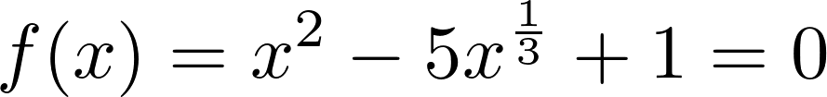

First Form, g(x):
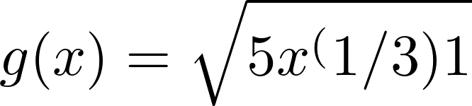

Second Form, g(x):
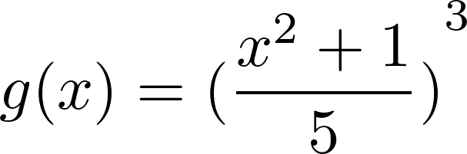

In order to satisfy the Lipschitz condition(and converge within the neighbourhood of the fixed point), the absolute value of the derivative of the form must be less than 1 around the fixed point, so lets test the forms around the neighbourhood of 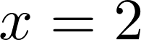 and 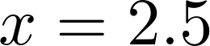:

Derivative of First Form:
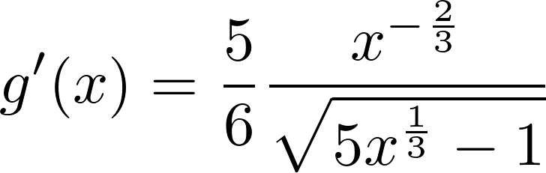

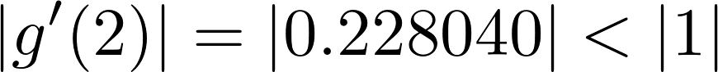

Derivative of Second Form:

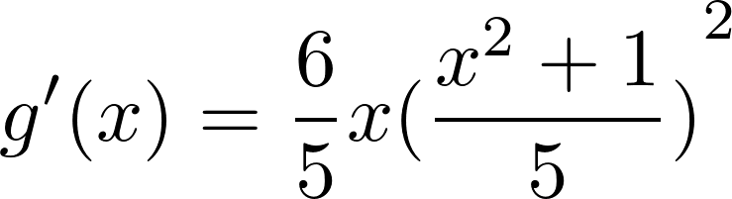

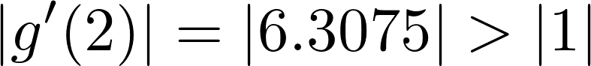

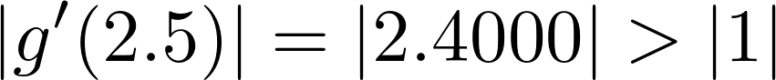

Based on the conditional analysis, it appears that the first form of g(x) is the one we must use as it will converge on the point due to satisfying the condition above.

b) Perform 5 iterations of the two forms of g(x) to confirm the correct choice

Pseudo-Code Algorithm:

// Set Starting Value
x1 = 2 ;

// Iterate 5 times for first method
Loop(5)
{
// Find g(x) at point using first form
g1(x1) = sqrt( 5*x1^(1/3) – 1 ) ;

// Set new point
x1 = g1(x1) ;

// Find value at new point
f(x1) = x1^2 – 5*x1^(1/3) + 1 ;

// Output Resulting Root and Value
Output( “Root: %1 Value: %2”, x1, f(x1) ) ;
}

// Reset Initial Point
x1 = 2 ;

// Iterate 5 times for second method
Loop(5)
{
//Substitute in Second Form
g2(x1) = ( (x1^2 + 1)/5 )^3 ;

// Set new point
x1 = g1(x1) ;

// Output Resulting Root and Value
Output( “Root: %1 Value: %2”, x1, f(x1) ) ;

// Find value at point
f(x1) = x1^2 – 5*x1^(1/3) + 1 ;
}

Results:

First Method:
1: X: 2.3021 F(x): -0.3024
2: X: 2.3668 F(x): -0.0613
3: X: 2.3797 F(x): -0.0121
4: X: 2.3823 F(x): -0.0024
5: X: 2.3828 F(x): -0.0005
Second Method:
1: X: 1.0000 F(x): -3.0000
2: X: 0.0640 F(x): -0.9961
3: X: 0.0081 F(x): -0.0042
4: X: 0.0080 F(x): -0.0002
5: X: 0.0080 F(x): -0.0002
As was expected, the first form of g(x) was indeed the correct one. It converged to the fixed point within the intended region whilst the second form led to a diversion from the intended region.

3.13 – Solve a system of nonlinear equations using numerical methods

b) Use the fixed-point interation method to solve the system of equations

Pseudo-Code Algorithm:

// Set initial Values for variables
x1 = 1 ;
y1 = 1 ;

// Iterate 5 times
Loop(5)
{
// Calculate New Point
y = (4*x1^2 + 28)^(1/3) ;
x = ( (145 – 4*y1^2)/3 )^(1/3) ;

// Set New Point
x1 = x ;
y1 = y ;

// Calculate Value at New Point
f1 = 4*x1^2 – y1^3 + 28 ;
f2 = 3*x1^3 + 4*y1^2 – 145 ;

// Output Iterated Roots
Output(“X: %1 Y: %2 F1: %3 F2: %4”, x1, x2, f1, f2) ;
}

Results:

1 X: 3.6084 Y: 3.1744 F1: 48.0922 F2: 36.2539
2 X: 3.2675 Y: 4.3097 F1: -9.3404 F2: 33.9486
3 X: 2.8668 Y: 4.1345 F1: -9.8010 F2: -5.9399
4 X: 2.9446 Y: 3.9333 F1: 1.8344 F2: -6.5191
5 X: 3.0256 Y: 3.9718 F1: 1.9588 F2: 1.1925
6 X: 3.0107 Y: 4.0123 F1: -0.3322 F2: 1.2634
7 X: 2.9948 Y: 4.0048 F1: -0.3551 F2: -0.2653
8 X: 2.9978 Y: 3.9969 F1: 0.0974 F2: -0.2810
9 X: 3.0009 Y: 3.9983 F1: 0.1019 F2: 0.0205
10 X: 3.0003 Y: 3.9999 F1: 0.0126 F2: 0.0235

As can be seen, the iterations converge to the solution of the system and and the solution is around (3, 4).

Question 3:

4.2 – Use Gauss Elimination to Solve the System of Equations

Pseudo-Code Algorithm:

// Setup Main and Temp NxN Matrix of System
A = [ [3 -2 5] : [1 -1 0] : [2 0 4] ] ;
_A = [ [0 0 0] : [0 0 0] : [0 0 0] ] ;

// Setup Main and Temp Known Vector
b = [ 14 -1 14 ] ;
_b = [ 0 0 0 ] ;

// Setup Solution Vector
x = [ x1 x2 x3 ] ;

// Size of Matrix
N = 3;

// Loop through rows with Iterator i
Loop(i:N)
{
// If Pivot Point Coefficient is zero
while ( A[i][i] == 0 )
{
// If No more rows left to switch
If ( i+1 == N )
{
// Output Error and Exit
Output( "Error: System has no unique solution" ) ;
Exit(-1) ;
}

// Switch Rows with one below
Loop(m:N)
{
// In Matrix
A_[i][m] = A[i][m] ;
A[i][m] = A[i+1][m] ;
A[i+1][m] = A_[i][m] ;

// In Known Vector
b_[i] = b[i] ;
b[i] = b[i+1] ;
b[i+1] = b_[i] ;
}
}

// Set Divisor for Row
divr = A[i][i] ;

// Loop through remaining rows with Iterator k
Loop(k:N)
{
// If Previous Rows, Skip
If (k <= i)
{
pass ;
}

// Otherwise Perform Elimination
Else
{
// Find Multiplier for remaining rows
Mulr = (-A[k][i]) ;

// Loop through columns of the matrix with Iterator j
Loop(j:N)
{
// Normalize Elements in row in respect to A[i][i]
A[i][j] = A[i][j] / divr ;

// Eliminate Elements for different rows in column
A[k][j] = A[k][j] + Mulr*A[i][j] ;

}
// Do the same for the Known vector
b[i] = b[i] / divr ;
b[k] = b[k] + Mulr*b[i] ;

// Ensure Normalization doesn't Occur again
Divr = 1.0 ;
}
}
}
// Set to Solution
x3 = b[2] / A[2][2] ;
x2 = b[1] – A[1][2]*x3 ;
x1 = b[0] - A[0][1]*x2 – A[0][2]*x3 ;

// Output Result
Output(“X = [ %1 %2 %3 ]”, x1, x2, x3);

Results:

A = : [ 1.0000 -0.6667 1.6667 ]
[ 0.0000 1.0000 5.0000 ]
[ 0.0000 0.0000 1.0000 ]

B = : [ 4.6667 17.0000 3.0000 ]

X = : [ 1.0000 2.0000 3.0000 ]

4.2 – Use Gauss-Jordan Elimination to Solve the System of Equations

Pseudo-Code Algorithm:

// Setup Main and Temp NxN Matrix of System
A = [ [3 -2 5] : [1 -1 0] : [2 0 4] ] ;
_A = [ [0 0 0] : [0 0 0] : [0 0 0] ] ;

// Setup Main and Temp Known Vector
b = [ 14 -1 14 ] ;
_b = [ 0 0 0 ] ;

// Setup Solution Vector
x = [ x1 x2 x3 ] ;

// Size of Matrix
N = 3;

// Loop through rows with Iterator i
Loop(i:N)
{
// If Pivot Point is zero
while ( A[i][i] == 0 )
{
// If No more rows left to try
If ( i+1 == N )
{
// Output Error and Exit
Output( "Error: System has no unique solution" ) ;
Exit(-1) ;
}

// Switch Rows with one below
Loop(m:N)
{
// In Matrix
A_[i][m] = A[i][m] ;
A[i][m] = A[i+1][m] ;
A[i+1][m] = A_[i][m] ;

// In Known Vector
b_[i] = b[i] ;
b[i] = b[i+1] ;
b[i+1] = b_[i] ;
}
}

// Set Divisor for Row
divr = A[i][i] ;

// Loop through remaining rows with Iterator k
Loop(k:N)
{
// If Previous Rows, Skip
If (k == i)
{
pass ;
}

// Otherwise Perform Elimination
Else
{
// Find Multiplier for remaining rows
Mulr = (-A[k][i]) ;

// Loop through columns of the matrix with Iterator j
Loop(j:N)
{
// Normalize Elements in row in respect to A[i][i]
A[i][j] = A[i][j] / divr ;

// Eliminate Elements for different rows in column
A[k][j] = A[k][j] + Mulr*A[i][j] ;

}

// Do the same for the Known vector
b[i] = b[i] / divr ;
b[k] = b[k] + Mulr*b[i] ;

// Ensure Normalization doesn't Occur again
Divr = 1.0 ;
}
}
}

// Set to Solution which is now Known Vector
x1 = b[1] ;
x2 = b[2] ;
x3 = b[3] ;

// Output Result
Output(“X = [ %1 %2 %3 ]”, x1, x2, x3) ;

Results:

A = : [ 1.0000 0.0000 0.0000 ]
[ 0.0000 1.0000 0.0000 ]
[ 0.0000 0.0000 1.0000 ]

B = : [ 1.0000 2.0000 3.0000 ]

X = : [ 1.0000 2.0000 3.0000 ]

As can be see from both methods (Gauss and Gauss-Jordan) the results are the same.

Question 4:

4.12 – Solve the system using LU decomposition with Crout's Method

Pseudo-Code Algorithm:

// Set up coefficient matrix
A = [ [2 -4 1] : [6 -2 1] : [-2 6 -2] ] ;

// Set up Lower and Upper Blank Matrices
L = [ [0 0 0] : [0 0 0] : [0 0 0] ] ;
U = [ [0 0 0] : [0 0 0] : [0 0 0] ] ;

// Set up Known and Solution Vectors
b = [ 4 10 -6 ] ;
x = [ x1 x2 x3 ];
y = [ y1 y2 y3 ];

// Set up dimensions of NxN system
N = 3;

// Loop through rows with iterator i
Loop(i : N)
{
// Set Lower First Column Elements
L[i][0] = A[i][0] ;

// Set Upper Diagonal Elements
U[i][i] = 1 ;

// Loop through columns
Loop(j : N)
{
// If First Row
If ( i == 0 )
{
U[i][j] = A[i][j] / L[i][0] ;
}
// Calculate Lower Elements
Else If (j <= i)
{
L[i][j] = A[i][j] ;

Loop(k : j-1 )
{
L[i][j] -= L[i][k]*U[k][j] ;
}
}
// Calculate Upper Elements
Else
{
U[i][j] = A[i][j] / L[i][i] ;

Loop( k : i-1 )
{
U[i][j] -= (L[i][k]*U[k][j]) / L[i][i] ;
}
}
}
}

// Calculate y solution vector
y[0] = ( b[0] / L[0][0] ) ;
y[1] = ( b[1] – L[1][0]*y[0] ) / L[1][1] ;
y[2] = ( b[2] – L[1][0]*y[0] – L[2][1]*y[1] ) / L[2][2] ;

// Calculate x solution vector
x3 = y[2] ;
x2 = y[1] – U[1][2]*y[2] ;
x1 = y[0] – U[0][2]*y[2] – U[0][1]*y[1] ;

// Output Solution
Output( “X = [ %1 %2 %3 ]”, x1, x2, x3 ) ;

Results:

[ 1 -2 0.5 ]
U = [ 0 1 -0.5 ]
[ 0 0 1 ]

[ 2 0 0 ]
L = [ 6 -2 0 ]
[ -2 6 -1 ]

Y = [ 2 11 84 ]

X = [ -18 53 84 ]
Question 5:

4.14 – Find the inverse of the system using Gauss-Jordan method

Pseudo-Code Algorithm:
// Setup Main and Temp NxN Matrix of System
A = [ [3 -2 5] : [1 -1 0] : [2 0 4] ] ;
_A = [ [0 0 0] : [0 0 0] : [0 0 0] ] ;

// Setup Main and Temp Known Vector
b = [ [1 0 0] : [0 1 0] : [0 0 1] ] ;
_b = [ [0 0 0] : [0 0 0] : [0 0 0] ] ;

// Size of Matrix
N = 3;

// Loop through rows with Iterator i
Loop(i:N)
{
// If Pivot Point is zero
while ( A[i][i] == 0 )
{
// If No more rows left to try
If ( i+1 == N )
{
// Output Error and Exit
Output( "Error: System has no unique solution" ) ;
Exit(-1) ;
}

// Switch Rows with one below
Loop(m:N)
{
// In Matrix
A_[i][m] = A[i][m] ;
A[i][m] = A[i+1][m] ;
A[i+1][m] = A_[i][m] ;

// In Known Vector
b_[i][m] = b[i][m] ;
b[i][m] = b[i+1][m] ;
b[i+1][m] = b_[i][m] ;
}
}

// Set Divisor for Row
divr = A[i][i] ;

// Loop through remaining rows with Iterator k
Loop(k:N)
{
// If Previous Rows, Skip
If (k == i)
{
pass ;
}

// Otherwise Perform Elimination
Else
{
// Find Multiplier for remaining rows
Mulr = (-A[k][i]) ;

// Loop through columns of the matrix with Iterator j
Loop(j:N)
{
// Normalize Elements in row in respect to A[i][i]
A[i][j] = A[i][j] / divr ;

// Eliminate Elements for different rows in column
A[k][j] = A[k][j] + Mulr*A[i][j] ;

// Do the same for the Known vector
b[i][j] = b[i][j] / divr ;
b[k][j] = b[k][j] + Mulr*b[i][j] ;
}

// Ensure Normalization doesn't Occur again
Divr = 1.0 ;
}
}
}

// Set to Solution which is b
iA = b ;

// Output Result
Output(“Inverse A = %1 ”, iA) ;

Results:
[ 0.5 1.0 0.0 ]
Inverse A = [ -0.3 0.1 0.0 ]
[ 1.6 -0.2 1.0 ]

4.15 – Use the Gauss-Seidel Iterative Method to carry-out the first three iterations

Pseudo-Code Algorithm:

// Set initial values to zero
x1 = 0 ;
x2 = 0 ;
x3 = 0 ;

// Iterate 3 times
Loop(3)
{
// Recalculate new values
x1 = ( 51 – 2*x2 – 3*x3 ) / 8 ;
x2 = ( 23 – 2*x1 -x3 ) / 5 ;
x3 = ( 20 + 3*x1 – x2 ) / 6 ;

// Output Values
Output( “X = [ %1 %2 %3 ]”, x1, x2, x3 ) ;
}

Results:

1: X = [ 6.0000 2.0000 6.0000 ]
2: X = [ 3.0000 2.0000 4.0000 ]
3: X = [ 4.0000 2.0000 5.0000 ]

