[Document title]

[Document subtitle]

Singh, Harry

[Year]

Table of Contents

**No table of contents entries found.**

# Steps To Upgrade Mule 4.4 to 4.6

Updating Mule runtime from 4.4 to 4.6 involves several steps, including downloading the new runtime, updating configurations, and making necessary changes to your Mule applications. Below is a step-by-step guide:

## Step 1: Update Anypoint Studio

1. **Open Anypoint Studio**: Launch your Anypoint Studio.
2. **Update Runtime**:
   * Navigate to Help -> Install New Software.  
       
     A screenshot of a computer

     Description automatically generated
   * Click on Add and enter the following details:
     + **Name**: Mule Runtimes for Anypoint Studio
     + **Location**: MuleSoft update site URL : https://studio.mulesoft.org/s3/studio-runtimes/  
         
       A screenshot of a computer

       Description automatically generated
   * Select the Mule 4.6 runtime and install it.  
       
     A screenshot of a computer

     Description automatically generated
   * Verify and click Next   
     A screenshot of a computer

     Description automatically generated
   * Check the “I accept the terms of the license agreements” and click Finish.  
     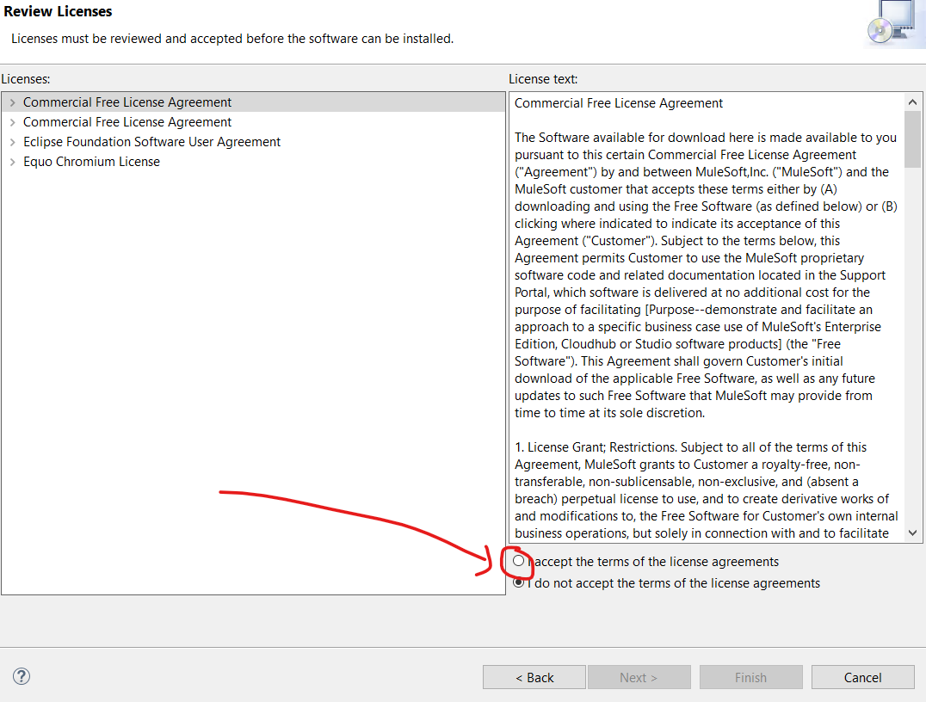
   * Once Installed, Anypoint Studio will prompt to restart, click restart or restart manually.   
     A screenshot of a computer

     Description automatically generated
   * On Restart, anypoint studio would suggest to change the workspace. To be on safe side, create a new workspace and open it.  
     A screenshot of a computer

     Description automatically generated

## Step 2: Update Mule Runtime in Your Project

1. **Open Your Mule Project**: Open or Import the Mule application you built with Mule 4.4 in Anypoint Studio. And make sure to change to mule runtime from 4.4 to 4.6  
   A screenshot of a computer

   Description automatically generated
2. **Change Runtime Version**:
   * Right-click on your project in the Project Explorer.
   * Select Properties.
   * Go to Mule Project -> Runtime.
   * Select Mule Server 4.6.0 from the list of available runtimes.   
     A screenshot of a computer

     Description automatically generated
   * Click Apply and OK.

## Step 3: Update Application Dependencies

1. **pom.xml (if using Maven) Optional**:
   * Open the pom.xml file in your Mule project.
   * Update the Mule Maven plugin version and Mule runtime version to 4.6.0:

xml

Copy code

<plugin>

<groupId>org.mule.tools.maven</groupId>

<artifactId>mule-maven-plugin</artifactId>

<version>3.6.0</version>

<extensions>true</extensions>

</plugin>

<dependency>

<groupId>org.mule.runtime</groupId>

<artifactId>mule-runtime-core</artifactId>

<version>4.6.0</version>

</dependency>

1. **Verify the project   
   A screenshot of a computer

   Description automatically generated**
2. **Update Connectors and Modules**:
   * Ensure all connectors and modules are compatible with Mule 4.6.
   * Check the MuleSoft documentation for any breaking changes or deprecations and update your code accordingly.

## Step 4: Test Your Application

1. **Run the Application**:
   * Start the Mule application in Anypoint Studio.
   * Monitor the logs for any errors or warnings. Make sure its deployed successfully  
     A screen shot of a computer

     Description automatically generated
2. **Functional Testing**:
   * Execute your test cases to verify the application behaves as expected.
   * Ensure all flows and integrations are functioning correctly.
3. **Update Configurations**:
   * Review any custom configurations or scripts that may need adjustments due to changes in the runtime.

## Step 5: Deploy the Updated Application

1. **Export Your Application**:
   * Right-click on the project and select Export.
   * Choose Anypoint Studio Project to Mule Deployable Archive (includes project sources).
   * Save the exported JAR file.
2. **Deploy to Mule Runtime or Anypoint platform**:

## Step 6: Monitor and Validate

1. **Monitor Logs**:
   * Check the Mule runtime logs to ensure the application has started without issues.
2. **Validation**:
   * Validate the application by running end-to-end tests.
   * Ensure all functionalities are working as expected in the new runtime environment.

## Step 7: Documentation and Backup

1. **Document Changes**:
   * Keep a record of all changes made during the update process.
   * Document any issues encountered and their resolutions.
2. **Backup**:
   * Backup the updated project and runtime configuration for future reference.

By following these steps, you should be able to successfully update your Mule runtime from 4.4 to 4.6 and ensure your Mule application runs smoothly in the updated environment.