Chapter III
RESULTS AND DISCUSSION

Practices of Poultry Owners
The interview and on-site observation conducted among small- to medium-scale poultry owners in Ilocos Sur revealed that feeding and water management remain predominantly manual and highly dependent on the poultry owners’ daily routine. Poultry Owners typically perform two major feeding sessions one in the early morning and another in the late afternoon where they manually scatter commercial feeds or a mixture of grains and kitchen leftovers across the pen. Water containers are refilled immediately after each feeding to ensure the birds have constant access to clean water. Although these tasks are simple, poultry owners repeatedly pointed out that the absence of fixed schedules and the varying number of birds often lead to either overfeeding or underfeeding, resulting in feed wastage and uneven growth among the flock.
Figure 2
Flowchart of Poultry Owner Practices
Afternoon Feeding
Water
Refill
Morning Feeding
Start

Water
Refill
End

As illustrated in Figure 2, the daily routine follows a repetitive cycle that begins with morning feeding, followed by water refilling, afternoon feeding, and another water refilling before the farmer ends the day. According to Landge et al. (2024), such manual feeding practices in small-scale operations frequently cause inconsistent nutrient intake because poultry owners rely solely on visual estimation rather than measured portions. The same study noted that without automated dispensing mechanisms, feed spillage and selective eating by dominant birds further reduce overall feed efficiency. Poultry Owners interviewed confirmed that on busy days or when they have off-farm work, these tasks are sometimes delayed or skipped entirely, directly affecting bird weight gain and egg production.
Environmental control is equally manual and reactive. When the temperature rises, poultry owners open additional windows or turn on improvised electric fans; during cold times, they switch on incandescent bulbs for warmth. Water troughs are cleaned only when visibly dirty, and low water levels are noticed only during the next feeding round. From the study of Bist et al. (2024), prolonged exposure to high temperature and poor water quality in manually managed poultry houses significantly increases stress and susceptibility to diseases, yet most small-scale poultry owners lack real-time monitoring tools. These findings show the labor-intensive nature of current practices and the clear opportunities for automation in feeding, watering, and basic climate regulation opportunities that the ChiKulungan system directly addresses through scheduled dispensing, sensor-based alerts, and automated climate actuators.

Architecture and Design for ESP32-Based Poultry Keeper
The ChiKulungan system is built around the ESP32 microcontroller to automate feeding, water refilling, climate regulation, and real-time monitoring while remaining affordable and suitable for small-scale poultry farms in rural areas. All sensors, actuators, and display components are directly interfaced with the ESP32, ensuring reliable offline operation even when internet connectivity is unavailable. The design intentionally combines local control with optional remote access through a custom web application, providing poultry owners with both on-site visibility and the flexibility of smartphone-based monitoring whenever Wi-Fi is present.
Figure 3
System Architecture of ChiKulungan

Power Supply

Environment
User
ESP 32
DHT2200
Scheduling Data
Temperature and Humidity Data
System UI
Request Data
Request Data
HC-SR04
Food Storage Data

Food Storage
Feeding
Live Data Feed
Alert Notifications111
Output data
Output data
Output data
NEMA Motor
Application and SMS
Application

As shown in Figure 3, the ESP32 serves as the central processing unit that continuously collects data from multiple sensors. A DHT22 and MQ135 sensor measures temperature, humidity, and ammonia inside the poultry house, while an HC-SR04 ultrasonic sensor monitors the remaining feed level in the container. Another ultrasonic sensor tracks water level in the drinking trough, and a web application to display all current readings directly to the farmer’s device. This display guarantees that critical information is always accessible anywhere. For network outages the SIM900 module will send an SMS to the user’s mobile devices that has a SIM card to inform the poultry farmer even when there is no network available which are common in rural settings.
For actuation, the ESP32 directly drives a NEMA motor that spins a screw conveyor to dispense a precise amount of feed at scheduled times. The actuator operates independently based on sensor readings and predefined schedules, eliminating the need for constant human intervention. The modular wiring and use of standard GPIO pins allow easy replacement or repair of individual components using locally available parts, keeping maintenance costs low for poultry owners.
Remote monitoring and control are achieved through a custom React-based web application hosted on Firebase, to which the ESP32 connects via its built-in Wi-Fi module whenever an internet connection is available. Real-time sensor values, system status, feeding history, and manual override controls are pushed to Firebase Realtime Database and instantly reflected on the web dashboard accessible from any smartphone or computer browser. When no internet is present, the system continues to function autonomously using locally stored schedules and thresholds, synchronizing data with the cloud the moment connectivity is restored. This approach delivers the reliability of a standalone device combined with the convenience of modern remote access, perfectly matching the actual conditions and budget constraints of poultry owners.

The scale factor formula is important for this study because it makes sure that the physical prototype accurately represents a full-sized chicken coop, based on the real measurements collected from the owner.
$$SF=\frac{Real Size}{Prorotype Size}$$ By finding the ratio between the actual coop dimensions and the prototype dimensions, the researchers can create a smaller but proportional model that still shows real-world spacing and design needs. This helps to check if the automated systems, like sensors, feeding mechanisms, and environmental controls, will work correctly when scaled up to full size. It also aids in planning for material use, component placement, and operational behavior. Overall, using the scale factor keeps the prototype valid and reliable for scaling the ChiKulungan Poultry Keeper into a real, full-scale implementation.
$$Real Size=Prototype Size ×SF$$
Using the formula Real Size = Prototype Size × Scale Factor is important for the study. It makes sure that every part of the hands-on prototype accurately matches the real measurements of an actual chicken coop. This helps the researchers check if the system’s components, such as sensors, motors, pumps, and environmental controls, will work properly and fit well in a full-scale setup. By knowing the exact scale factor, the team can adjust clearances, mounting positions, and structural layout so the automated system runs effectively. This also prevents design mistakes that could happen if the prototype does not reflect real-world sizes. Overall, using this formula boosts the reliability of the ChiKulungan Poultry Keeper by confirming that the prototype is a solid foundation for real-life use.
The scale-down formula Prototype Size = SF × Real Size is crucial in the ChiKulungan study. It helps create a compact and affordable prototype that accurately represents the size and functions of a full-scale poultry house.
$$Prototype Size=\frac{SF}{Real Size}$$Using a consistent scale factor ensures that the placement of sensors, feeding mechanisms, ventilation systems, and overall layout are geometrically accurate. This makes the test results reliable and applicable in real-world situations. The method significantly lowers material costs, reduces fabrication time, and requires less space for development and testing, without compromising the effectiveness of the automated features. It also allows for quick improvements between prototype versions before poultry owners invest in a full-sized system. In the end, the scale-down approach makes the research practical, cost-effective, and highly relevant for small and medium-scale poultry operations with limited resources.

The feed consumption formula Feed per aisle = Total Feed (kg) / Number of chickens per aisle is relevant to the ChiKulungan study. It shows how much feed the automated dispenser needs to release during each feeding cycle.
$$Feed per Chicken Asile=\frac{Total Feed (kg)}{Number of Chickens per Aisle}$$
This calculation makes sure that each chicken gets its daily nutritional needs. It helps prevent underfeeding, which slows growth, and overfeeding, which leads to waste and higher costs. By including this formula in the ESP32 firmware, the system can adjust portion sizes automatically when the farmer changes flock density or aisle setup. This ensures consistent and accurate feed delivery, no matter how many birds there are. The formula also establishes the low-feed alert threshold, enabling the system to notify poultry owners before any aisle runs out of feed. In the end, this straightforward yet essential formula helps reduce feed waste, cut costs, and support healthy, even poultry growth on small and medium-sized farms.

Figure 4
Design A of ChiKulungan (Initial 3D Model)
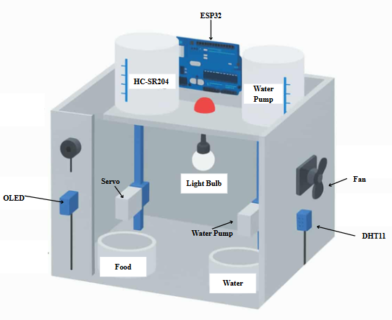
Figure 4 presents the first design iteration, the Design A of the ChiKulungan prototype, developed after the brainstorming phase to translate the system architecture into a tangible, farm-ready enclosure. The structure is built around a rectangular main housing made of weather-resistant acrylic and galvanized steel framing that can be mounted on a wall or placed on a stand inside the poultry house. All electronic components are centrally organized to simplify assembly, wiring, and future maintenance by local poultry owners.
The upper section contains a 2-kg gravity-fed hopper with an HC-SR04 ultrasonic sensor mounted directly underneath to continuously measure remaining feed level. A high-torque servo motor positioned at the base of the hopper opens a sliding gate at scheduled times, releasing a pre-set amount of feed into the troughs below. Directly beside the hopper is a 5-liter water reservoir equipped with another ultrasonic sensor and a 12 V submersible pump that automatically refills the drinking trough whenever the water level drops below 20 %. This layout ensures that both feed and water dispensing mechanisms are visible and easily refillable from the front access panels.
The lower front panel houses the ESP32 development board, a 0.96-inch OLED display for on-site readings, respectively. Temperature and humidity are monitored by a DHT11 sensor placed in a ventilated slot to obtain accurate ambient readings without direct exposure to dust or droppings. Power is supplied through a 12 V sealed lead-acid battery with solar charging capability, allowing the system to operate independently during power outages common in rural areas.
The overall dimensions of Design A measure approximately 45 cm (L) × 30 cm (W) × 60 cm (H), deliberately kept compact so it can be installed in typical backyard or small commercial poultry houses without occupying valuable floor space. Front-facing transparent acrylic doors provide quick visual inspection of feed and water levels while protecting internal electronics from chicken dust and occasional water splashes. Design A, served as the baseline model that later underwent several physical improvements in subsequent iterations for building larger and more practical models, better dust protection, easier cleaning, and more compact component arrangement.
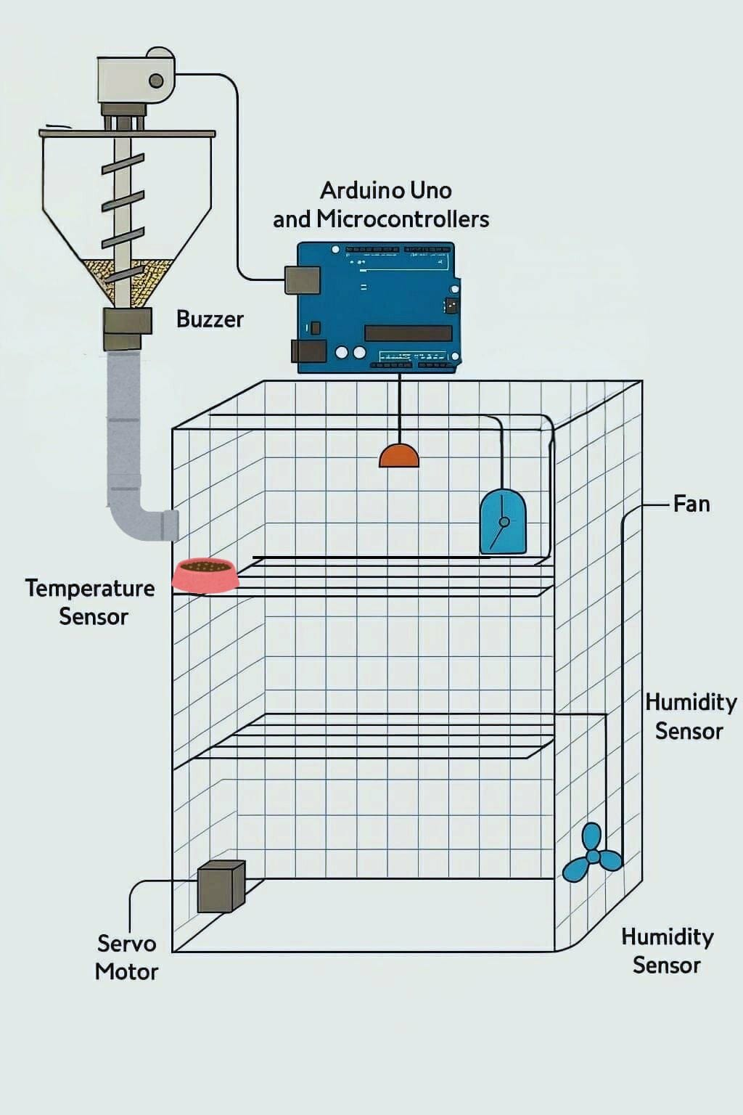
Figure 5
Version 2 Sketch of ChiKulungan
Figure 5 presents Version 2 of the ChiKulungan design, developed after feedback from the first prototype revealed the need for a more robust and scalable structure suitable for medium-scale poultry farms. The enclosure adopts a multi-level, cage-style layout that maximizes vertical space inside typical backyard or semi-commercial poultry houses. The shift from the compact single-unit Design A to this taller, tiered configuration allows simultaneous monitoring and servicing of multiple feeding and watering points, significantly increasing capacity without proportionally raising cost.
Version 2 markedly increases the physical scale and capacity of the ChiKulungan system compared to the compact Design A, with overall dimensions of approximately 80 cm (L) × 60 cm (W) × 180 cm (H) to accommodate three stacked tiers. This vertical expansion was in consideration to medium-scale farms in who required higher bird density without expanding the footprint inside already crowded poultry houses. The shift from a single-level wall-mounted unit to a free-standing multi-tier cage is the most significant structural change, allowing one centralized control unit to serve multiple feeding, watering, and climate zones simultaneously while still using the same low-cost ESP32 microcontroller and standard 12 V power supply.
For more specifics, the feeding system in Version 2 employs a vertical spiral auger mechanism driven by a high-torque servo motor positioned at the top of the main 30-kg hopper. When the scheduled feeding time arrives or the lower trough sensors detect low feed, the auger rotates for a pre-programmed duration, pushing a consistent volume of feed downward through a central PVC pipe and distributing it across the levels via side outlets. This spiral design settles the bridging and clogging problems observed in gravity-only hoppers during Design A, ensuring better feed flow even with mixed grain sizes commonly used by local poultry owners.
Environmental control is handled by three DHT11 sensors. Water management follows a gravity-fed system from a 20-liter overhead tank with float-valve refill, distributed through nipple drinkers on each level to minimize spillage and contamination. The entire structure is built primarily from angle bars, galvanized wire mesh, and recycled PVC piping. –tentative

Implementation of ESP32-Based Poultry Keeper
The developed system was modeled using different diagrams. The use case diagram illustrates how users interact with the poultry management system, highlighting key functions such as setting feeding schedules, monitoring conditions, and automating tasks for efficient poultry care. This is shown in Figure 6.
Figure 6
Use Case Diagram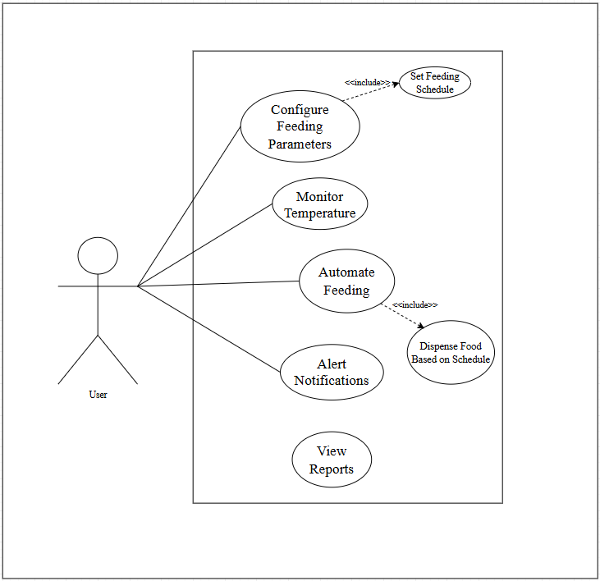
The system offers six important use cases for efficient poultry management. Users can adjust feeding settings and establish schedules to ensure accurate and timely food delivery. Monitoring temperature helps poultry owners maintain suitable environmental conditions and reduces health risks for the poultry. The automated feeding system, linked to the set schedules, ensures that feed dispensed regularly and cuts down on manual labor. Finally, the system sends alert notifications and generates reports that offer insights into feeding trends and environmental conditions, leading to better decision making and improved poultry welfare.
The process starts when the user sets the feeding parameters, such as the schedule. The system checks these inputs to ensure they meet operational standards before saving them. Once confirm, the system uses the set schedule with the automated feeding function for consistent operations. This allows the servo motor to dispense feed automatically at the correct time without needing repeated input from the user. By bringing together monitoring, automation, alerts, and reporting, the system offers a dependable poultry management solution suitable for small-scale farms.
The activity diagram shows how to set a feeding schedule in the poultry management system. It demonstrates how the user enters the desired feeding time and amount. The system then checks and saves this information for automatic execution. This is illustrated in Figure 7.
Figure 7
Activity Diagram for Schedule Configuration

USER | CHIKULUNGAN
Set  Schedule | Save  Schedule

The activity diagram shows the sequences of actions involved in monitoring poultry conditions with the system. It emphasizes how the user and the system work together to ensure ongoing data collection and display, as illustrated in Figure 8.
Figure 8
Activity Diagram for Sensor Monitoring
USER | CHIKULUNGAN
Initialize ESP32  Connect to DHT22 | Display Sensor Data  Collect Sensor Data  Continue Monitor

Figure 8 presents the continuous sensor monitoring loop executed by the ESP32 microcontroller within the ChiKulungan system. The process starts immediately upon system power-up as the ESP32 initializes the DHT22 for temperature and humidity readings and the HC-SR04 ultrasonic sensors for feed and water levels, collecting data every few seconds in an endless cycle. Each new reading is instantly transmitted via MQTT to the custom web dashboard, stored in Firebase for historical tracking, and simultaneously displayed on the local 16×2 LCD for on-site viewing without internet dependency. This real-time, dual-display approach allows poultry owners to observe environmental conditions and resource levels both locally at the poultry house and remotely through any smartphone or computer connected to the web application.
Figure 9
Activity Diagram for Displaying Data to Web App
USER | CHIKULUNGAN
Connect to Web-Application  Initialize ESP32 | Continuously Display  Collect Sensor Data  Display Sensor Data

The activity diagram shown in Figure 9 details the sequence of updating information on the developed web application that is connected to the ESP32 unit. After every sensor reading cycle, the system formats the current temperature, humidity, ammonia feed percentage, and water percentage into concise messages before sending them to the web application. The display has a dashboard to present all critical values clearly despite the limited character space, ensuring that poultry owners visiting website can instantly assess the situation. This wireless visualization serves as a reliable source and provides immediate feedback during routine checks.

Figure 10
Activity Diagram for Showing Recent Data
USER | CHIKULUNGAN
Reports  Show History Reports  s | Gathers Data  Generate Report

Figure 10 depicts the process of retrieving and visualizing historical data through the Dashboard page of the ChiKulungan web application. When the user navigates to the dashboard, the system automatically queries Firebase for the most recent sensor logs and generates dynamic charts using Recharts library, including daily uptime bars, temperature/humidity trends, and feed consumption patterns over selectable time ranges. The interface refreshes periodically or on demand, allowing poultry owners to identify long-term patterns such as gradual feed depletion or recurring high-temperature periods that might not be noticeable during daily manual checks. This historical overview supports informed decision-making regarding maintenance schedules, feed replenishment timing, and overall poultry house management improvements.

Figure 11
Activity Diagram for the Feeding Automation
USER | CHIKULUNGAN
Initialize Feeding Process | Wait for Next  NEMA Activates  Check Time

The activity diagram in Figure 11 demonstrates the automated feeding sequence triggered either by the predefined schedule or by manual command from the web application. Upon receiving the trigger, the ESP32 activates the NEMA motor to dispense a controlled portion of feed from the container using a screw conveyor for a preset duration to refill the feeding container. After completion, the system records the event in both the Firebase logs and the app display, then returns to waiting state until the next scheduled or manual activation. This feed routine eliminates missed feedings on busy days and ensures birds receive both nutrition consistently at every session.

Table 3
Data Structure
Node/Path | Key Example | Data Type | Sample Value / Format
/sensors | (single object) | Object | —
├ temperature | temperature | Number | 32.5
├ humidity | humidity | Number | 68
├ feedLevel | feedLevel | Number | 45
├ waterLevel | waterLevel | Number | 72
├ ammoniaLevel | ammoniaLevel | Number | 37
├ ammoniaRaw | ammoniaRaw | Number | 512
├ ammoniaBaselineRaw | ammoniaBaselineRaw | Number | 490
├ ammoniaDeltaRaw | ammoniaDeltaRaw | Number | 22
├ ammoniaVoltage | ammoniaVoltage | Number | 1.874
└ lastUpdate | lastUpdate | Number | 1738700000000 (Unix ms)
/schedules | -N123abc... | Object | (auto-generated key)
├ days | days | Array<String> | ["Monday", "Tuesday", "Friday"]
├ time | time | String | "06:30 AM"
├ enabled | enabled | Boolean | true
├ createdAt | createdAt | Number | 1738700000000 (Unix ms)
└ group | group | String | "starter" | "grower" | "maintenance" | "custom"
/logs | -N456def... | Object | (auto-generated key)
├ message | message | String | "Feeding activated - Schedule: 06:30 AM"
├ source | source | String | "esp32" | "web" | "system"
└ timestamp | timestamp | Number | 1738791234567 (Unix ms)
/alerts | -N789ghi... | Object | (auto-generated key)
├ type | type | String | "Low Feed"
├ message | message | String | "Feed level is low (12%)"
├ severity | severity | String | "critical" | "warning"
├ timestamp | timestamp | Number | 1738795000000
├ resolved | resolved | Boolean | false
├ dedupeKey | dedupeKey | String | "low-feed"
├ resolvedAt | resolvedAt | Number (optional) | 1738798600000
└ resolvedBy | resolvedBy | String (optional) | "auto"
/history/hourly | 2026-03-30/14 | Object | grouped by YYYY-MM-DD/HH
/history/consumptionEvents | -Nabc123... | Object | (auto-generated key)
/settings/farm | timeZone | String | "Asia/Manila"
/smsSettings | (single object) | Object | —
├ phone | phone | String | "+639123456789"
├ enabled | enabled | Boolean | true
└ lastUpdated | lastUpdated | Number | 1738800000000

Table 3 to ensure efficient storage and instant synchronization of all operational data. Five primary nodes sensors, schedules, logs, alerts, and uptime separate different categories of information while maintaining lightweight, hierarchical access suitable for low-bandwidth rural environments. This design enables the ESP32 microcontroller to push updates in real time and allows the custom web application to reflect changes immediately across all connected devices without complex queries.
Each node serves a distinct purpose that directly supports daily poultry management tasks. The sensors node continuously receives the latest environmental and resource readings, while user-created feeding schedules are stored with unique keys under the schedules node for easy retrieval and modification through the web interface. Event logging, alert management, and uptime tracking occupy dedicated nodes, creating a complete historical record that poultry owners can review on the Dashboard and Logs pages to make informed decisions about feed replenishment, maintenance, and overall system performance. (more discussion)

User Interface of the ChiKulungan Web Application

Figure 12
UI Overview and Navigation
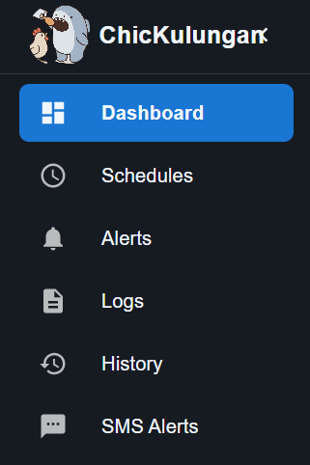 | 

The ChiKulungan web application follows a task-based layout designed around routine poultry monitoring and control. The interface is organized into four primary modules—Dashboard, Schedules, Alerts, and Logs—accessible through a persistent navigation menu. Each module focuses on a single operational goal: real-time status checking (Dashboard), automated feeding routine management (Schedules), incident handling (Alerts), and historical review/troubleshooting (Logs). To support different farm setups and operating preferences, key parameters such as feeding schedules, alert thresholds, and log filtering can be configured within their respective modules, allowing the system to adapt to varying coop sizes, flock age, and local environmental conditions.
Figure 13
Main Dashboard Displaying Real-Time Sensor Readings and System Status
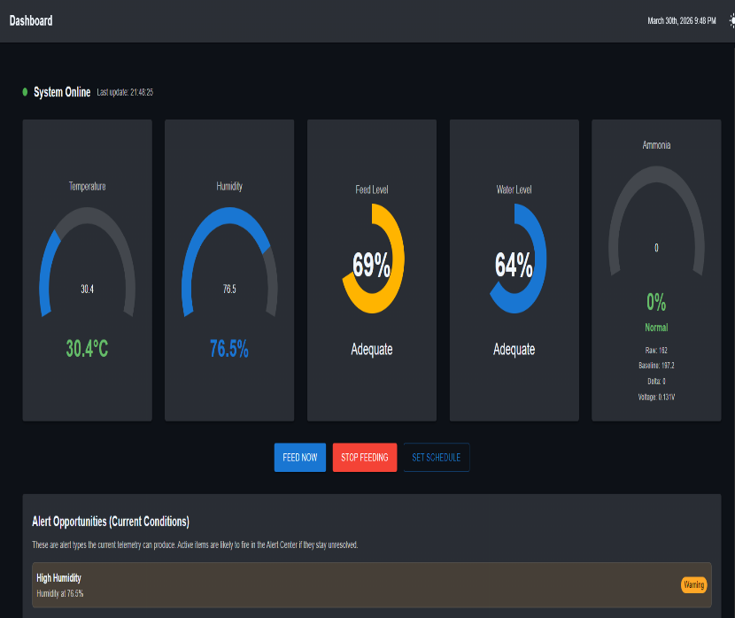
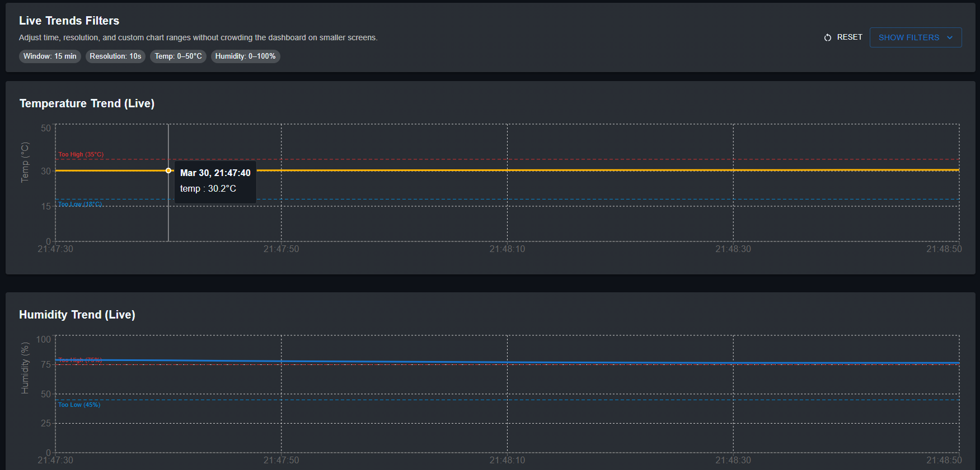
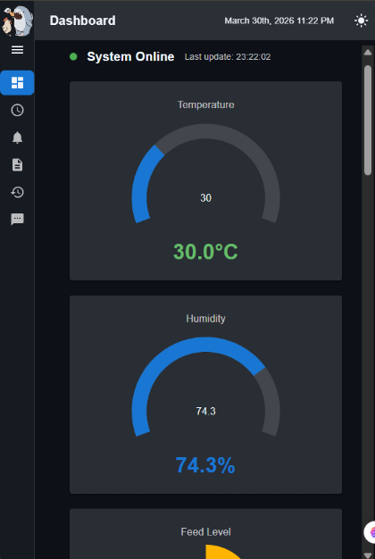 | 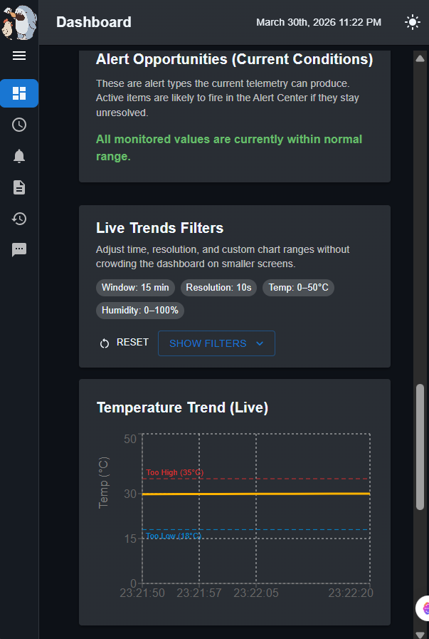

Figure 13, serves as the central monitoring hub of the ChiKulungan system, presenting current temperature, humidity, feed level, and water level through large, easy-to-read circular gauges that update instantly whenever the ESP32 transmits new data. Poultry owners can immediately assess the poultry house condition upon opening the application, with color-coded indicators turning red when values fall outside safe ranges, while the live trend charts below visualize temperature and humidity changes over the past minutes. The terminal log section at the bottom scroll’s recent events in real time, providing an at-a-glance summary that allows even non-technical users to stay informed about automated actions and alerts without navigating multiple pages.

Figure 14
Feeding Schedules Management Interface
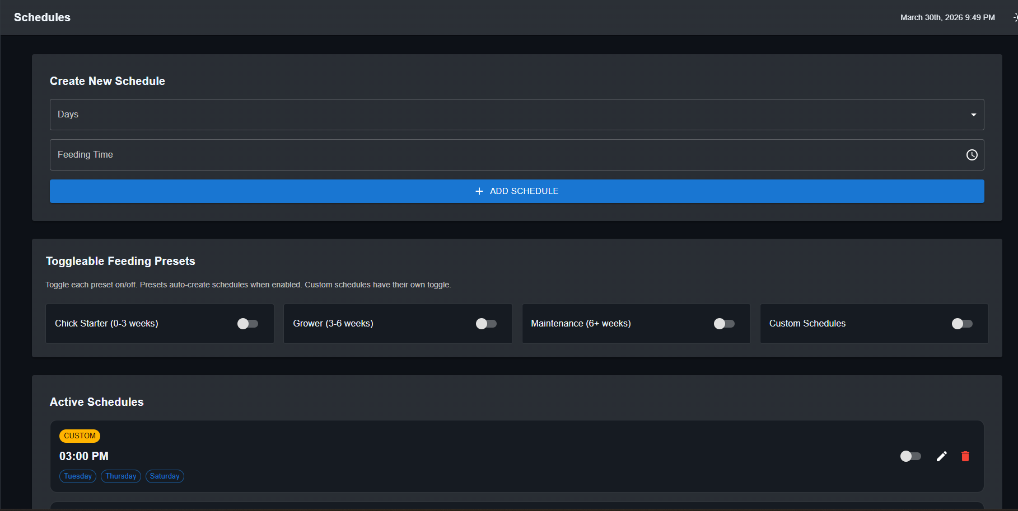
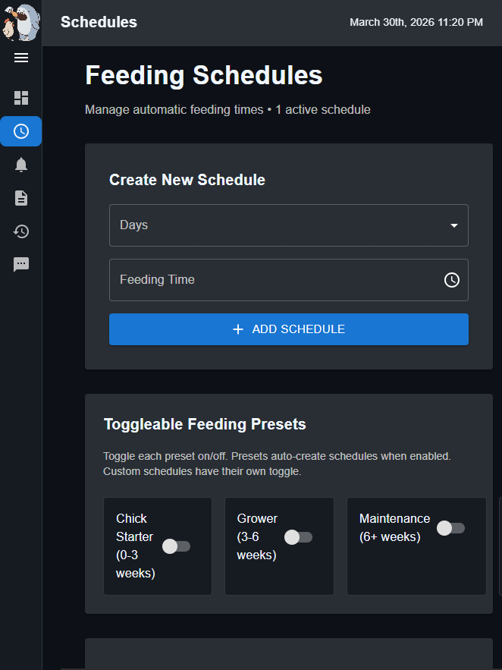 | 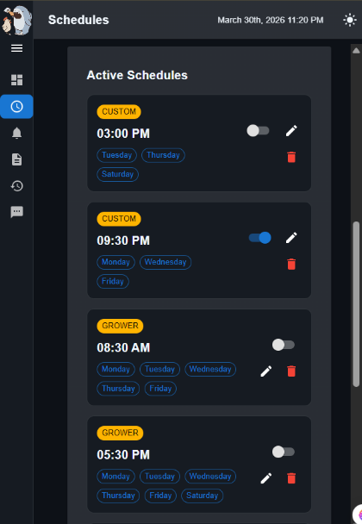

Figure 14 illustrates the Schedules page where poultry owners create, view, enable, edit, or delete automated feeding routines using a clean and intuitive layout designed specifically for daily farm use. The upper section offers a simple form requiring only the selection of days and a single feeding time, followed by a prominent blue “Add Schedule” button that instantly saves the entry to Firebase and reflects it in the active schedules list below. Each schedule appears as a card displaying the time and selected days, accompanied by toggle switches and delete icons that allow quick modifications even during busy farm routines, ensuring consistent nutrition delivery regardless of the farmer’s presence.

Figure 15
Alert Center with Active and Resolved Notifications
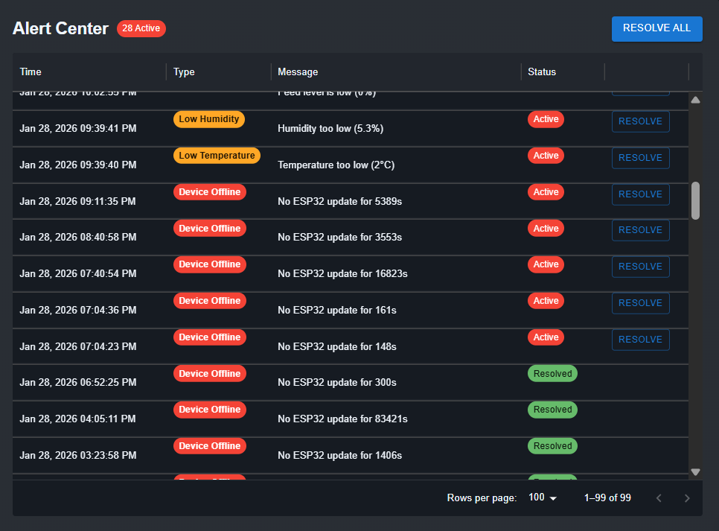 | 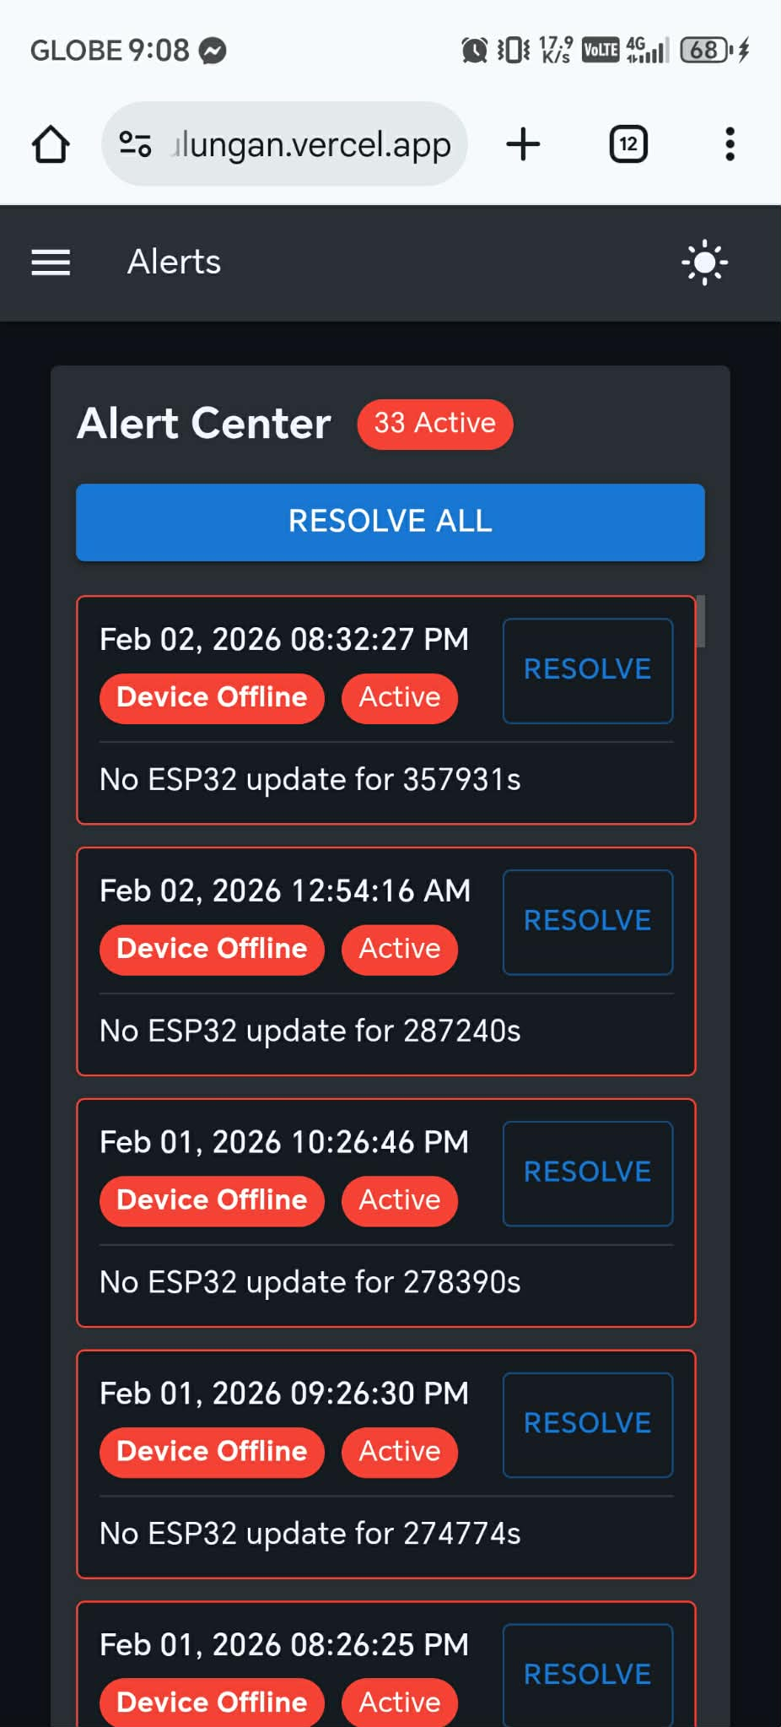
The Alert Center presented in Figure 15 functions as a dedicated notification management area that lists all critical incidents such as low feed, extreme temperature, or high humidity in a clear table format with color-coded severity tags. Active alerts remain prominently displayed with a red “Active” badge and individual “Resolve” buttons, while resolved items shift to green, giving poultry owners immediate visibility of pending issues that require physical intervention. A single “Resolve All” button at the top enables bulk acknowledgment after problems are addressed, maintaining a clean and organized record that prevents important warnings from being overlooked during daily operations.

Figure 16
System Logs and Terminal-Style Event Recording
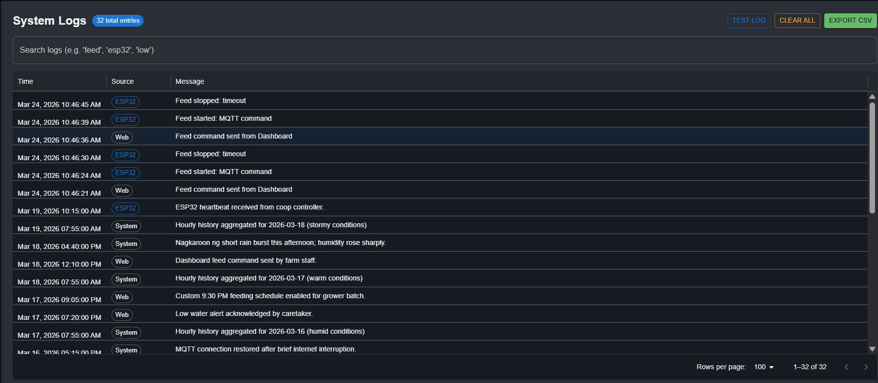 | 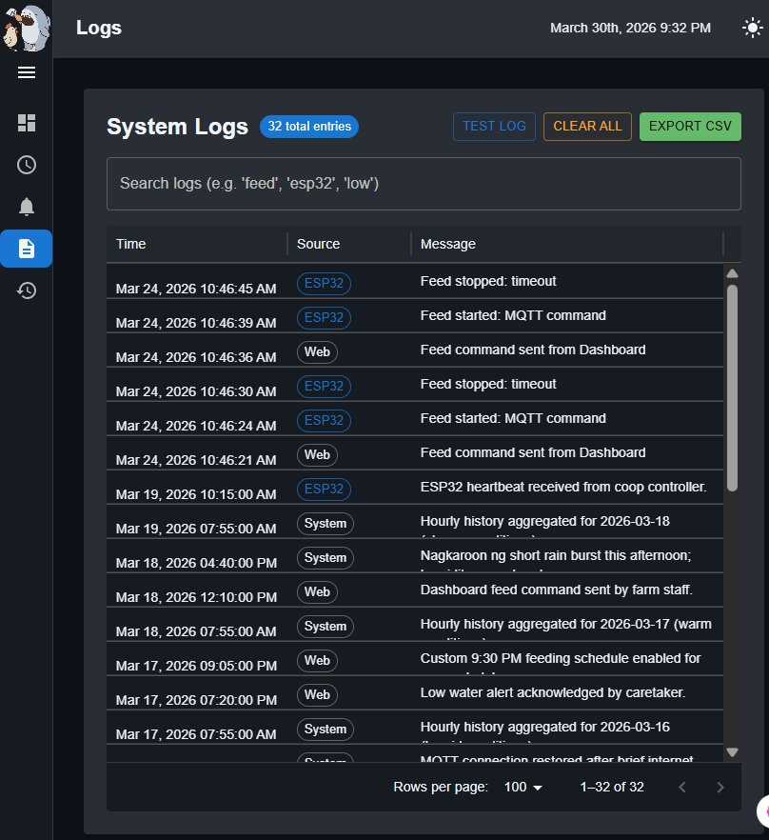
Figure 16 shows the Logs page, which provides a comprehensive, chronological record of every system event in a familiar terminal-style interface with green text on a black background for high readability in various lighting conditions. Entries include timestamps, source identification (web or ESP32), and descriptive messages covering actions such as manual feeding activation, schedule changes, alert triggers, and sensor updates, creating a complete audit trail useful for troubleshooting and performance review. The page supports searchable content and export functionality, allowing poultry owners or technicians to download logs for record-keeping or to analyze patterns in feed consumption and environmental control over extended periods.
Figure 17
History Page Interface for Viewing Sensor Trends and Exporting Records
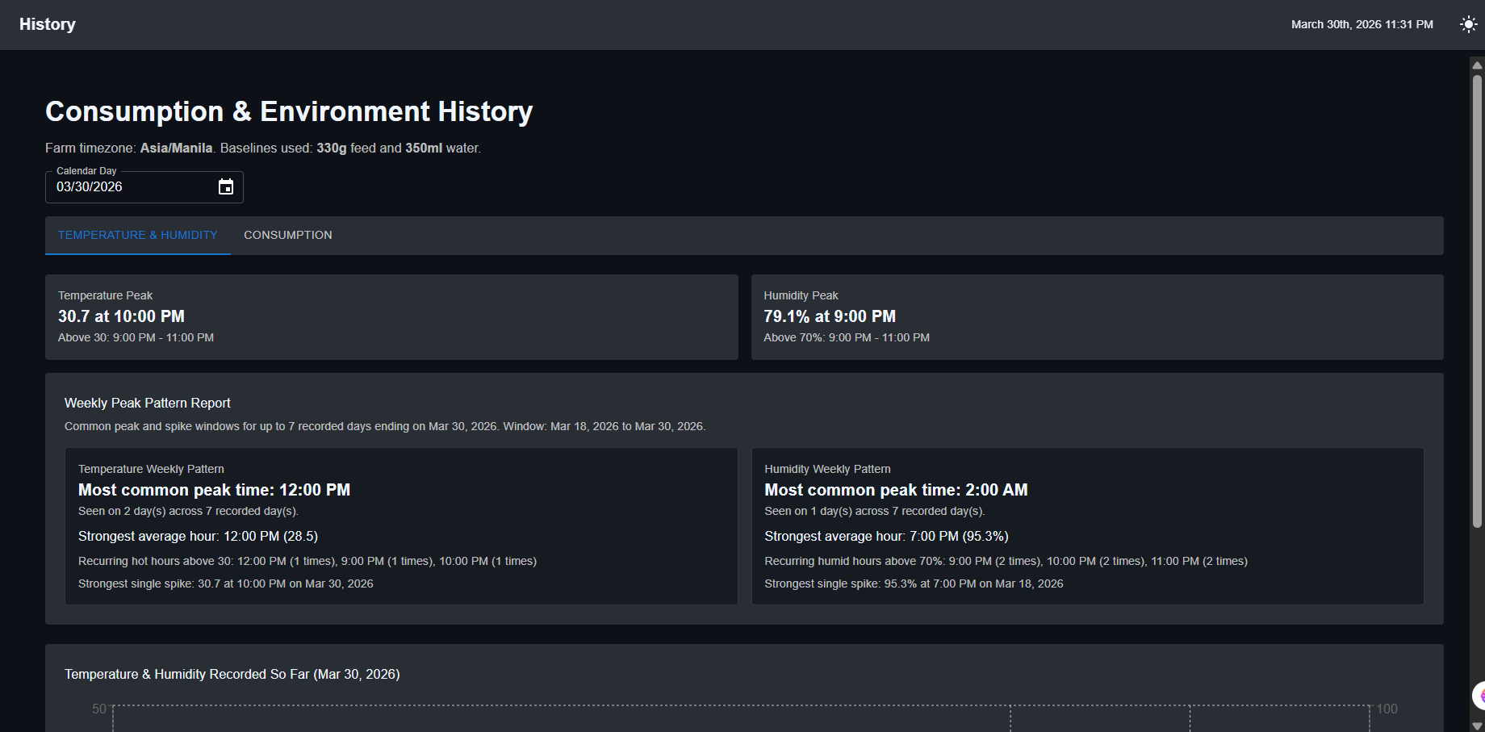
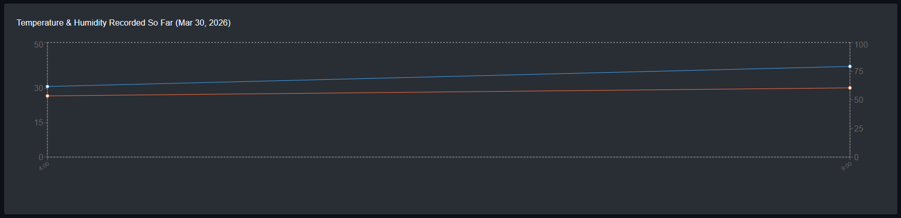
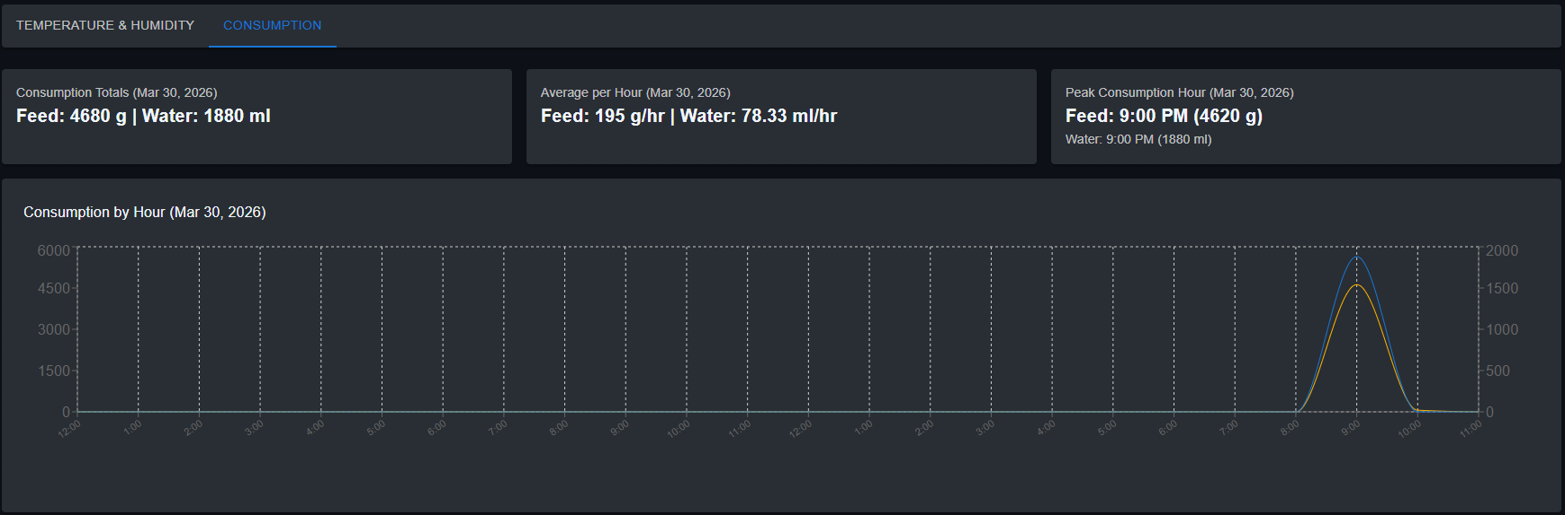
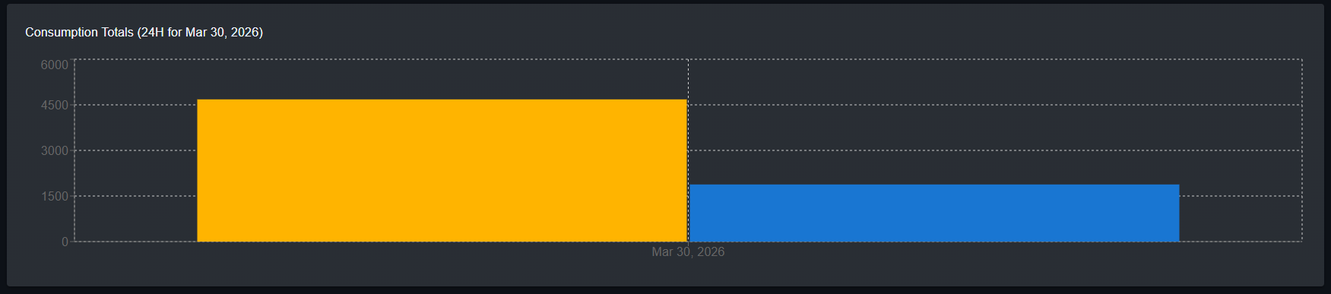
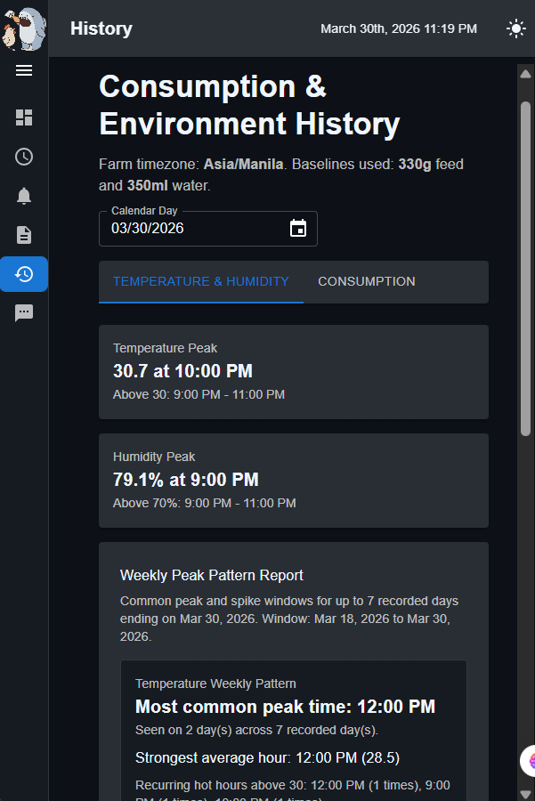 | 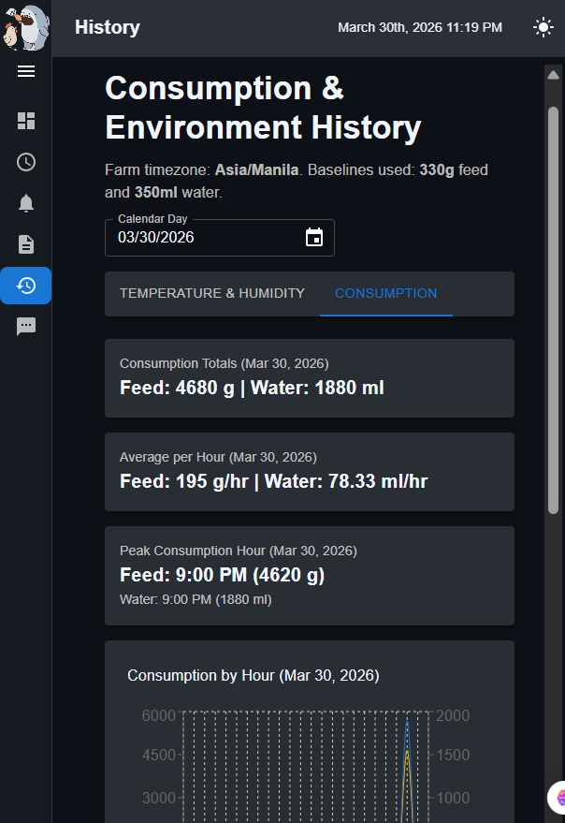

Figure 17 presents the History page, which provides poultry owners with a clear, organized way to review past environmental and container-level readings recorded by the ChiKulungan system. The page highlights sensor trends using a simple timeline view of daily summaries—showing average temperature and humidity alongside end-of-day feed and water levels—to help users quickly identify patterns and possible issues over time. A set of quick range buttons (such as last 7 days, 30 days, 60 days, or all records) and a manual date selection option allow flexible filtering depending on the user’s monitoring needs. For documentation and reporting purposes, an export option is also provided so users can download the filtered records for offline analysis, printing, or inclusion in farm logs.
Figure 18
SmsSetting Page Interface for Setting Up Sms Alerts
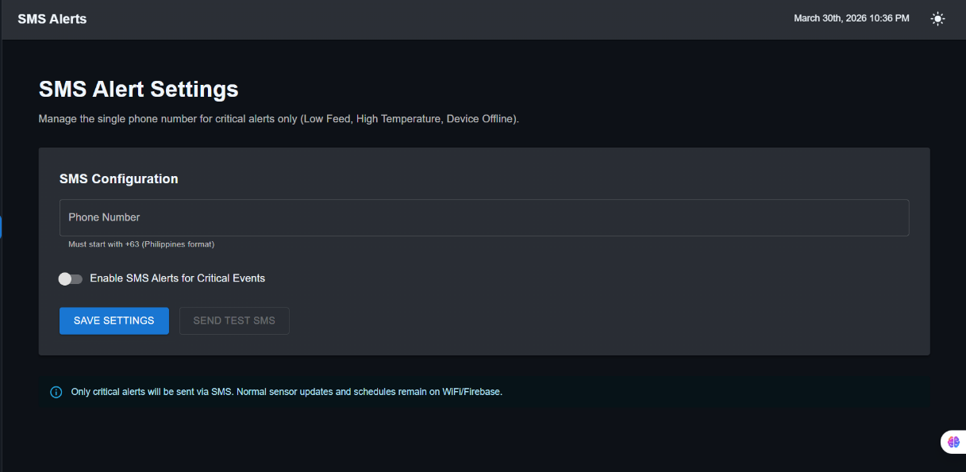

Figure 18 presents the-

Evaluation of the Developed System

