Chapter 4:
Findings and Data Analysis

4.1 Introduction

This chapter deals with the presentation, analysis, and interpretation of data collected for the study. It is a central point in the research process because it provides the empirical data on which the findings and conclusions of the study are based. The purpose of this chapter is to transform raw data collected through both primary and secondary sources into analytical pieces of information that respond to the research questions elucidated in earlier chapters.

The analysis begins with the description of primary data gathered through questionnaires completed by participants in the study population. The feedback represents firsthand knowledge concerning the topic under research, which provides rich information on levels of awareness, perceptions, experiences, and challenges as it relates to sustainable finance in the chosen setting. For purposes of clarity, the feedback is organized in tables, charts, and statistical summaries, making the patterns and relationships clear.

In addition, the chapter employs secondary data gathered from credible institutions such as the World Bank, Central Bank of Nigeria (CBN), United Nations Development Programme (UNDP), and Nigeria's National Bureau of Statistics (NBS). These data sources provide macro-level data such as economic data, trends in the financial sector, and policy directions, which contextualize and provide legitimacy to the findings from the primary data.

By comparing and discussing primary and secondary data, the chapter not only reports the opinions of individual respondents but also contextualizes those findings in terms of national and international trends. Combined, they add to the reliability of the findings and set the stage for a more comprehensive analysis of the implications in the next chapter.
4.2 Presentation and Analysis of Primary Data
The principal data used in this study were obtained through carrying out structured questionnaires administered among respondents with different professional backgrounds. The structured questionnaire was designed to obtain demographic information as well as respondents' level of awareness, perceptions, and experiences towards sustainable finance. The data obtained is displayed in both tabular and graphical presentations for easy understanding.
4.2.1 Demographic Profile of Respondents
The demographic profile of the respondents provides a background of significance in understanding subsequent responses. Gender, age, educational qualification, and occupation have been included in order to capture the diversity of the participants.
Gender Breakdown:
The gender breakdown of the respondents is significant for the relative proportion of male and female participants within the study. Understanding this distribution is significant, as it indicates whether sustainable finance perceptions can differ by gender. Past literature suggests that gender can influence financial decision-making, awareness, and attitudes towards sustainability actions (OECD, 2021).

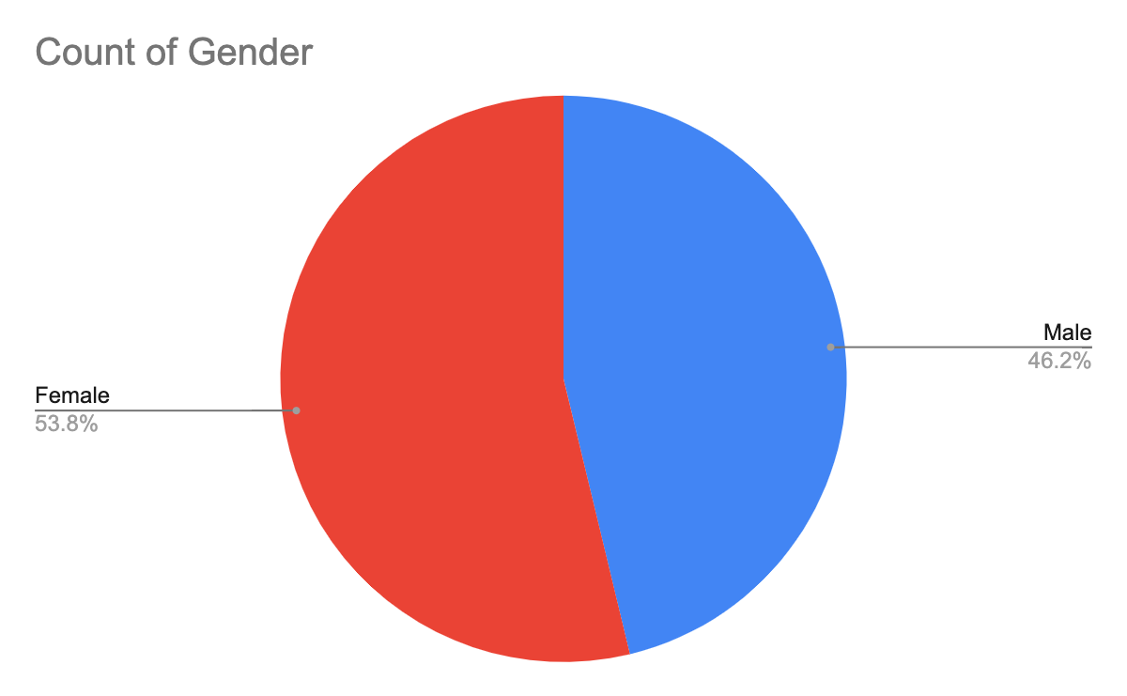
Figure 4.1: Gender Distribution (Pie Chart)
Age Distribution:
The participants were classified by age brackets (18–25, 26–35, 36–45, and 46+), thereby providing a demographic profile that allows for comparative analysis across the generational segments. It is essential to examine age distribution since differing age segments may vary with exposure to financial literacy interventions, propensity to adopt innovation, and perceptions on sustainability practices. For instance, younger respondents are more inclined to be accepting of new financial concepts, while older segments will rely more on tested and proven approaches and institutional wisdom (World Bank, 2022).

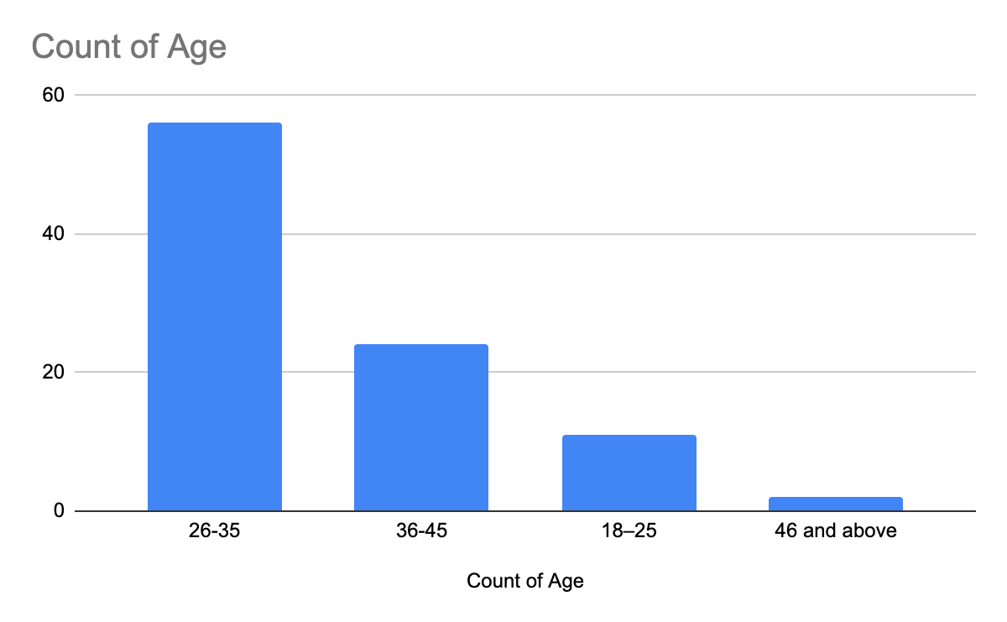
Figure 4.2: Age Distribution (Bar Chart)
Educational Qualification:
The education qualification data reveals the respondents' levels of education ranging from diploma holders to postgraduate degree holders. This is an important variable since the educational level tends to dictate whether an individual can understand and decipher technical finance concepts, such as those relating to sustainability. Higher levels of education are likely to be associated with greater levels of awareness of world finance trends and policy norms, while lower levels might limit exposure to this information (UNDP, 2021). Measuring educational distribution among the respondents thus offers relevant background information for understanding their familiarity with, and attitude toward, sustainable finance.

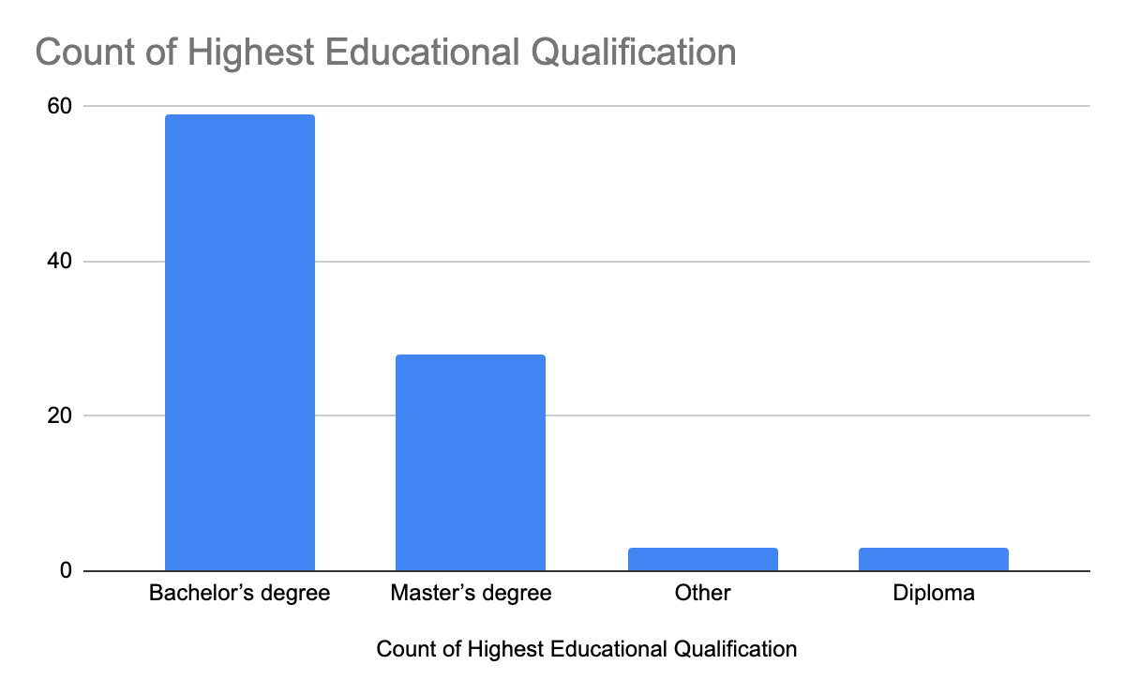
Figure 4.3: Educational Qualification of Respondents
Occupational Background:
The distribution of occupations of respondents provides the representation of a variety of industries, including banking, accounting, ICT, auditing, risk management, and allied professions. As other works confirm, cross-sectoral representation ensures the resilience of findings by incorporating different dimensions of practices and knowledge within the financial system (OECD, 2021). This variation then gives further insight into how sustainable finance is perceived and applied in different areas of work.

Occupation | Frequency | Percentage
Banker | 19 | 20.4%
Accountant | 11 | 11.8%
Banking | 9 | 9.7%
Business | 4 | 4.3%
Entrepreneur | 3 | 3.2%
Student | 3 | 3.2%
Auditor | 3 | 3.2%
Consultant | 2 | 2.2%
Compliance Officer | 2 | 2.2%
Others | 37 | 39.8%
Total | 93 | 100%
Table 4.4: Occupational Background of Respondents
4.2.2 Sensitivity and Knowledge about Sustainable Finance
Sensitivity towards the term "sustainable finance" was requested. The outcome provides an indication of the familiarity of the subject with the respondents. Choices were "Very familiar," "Moderately familiar," "Slightly familiar," and "Not familiar." The reply provides an indication of awareness in the sample.
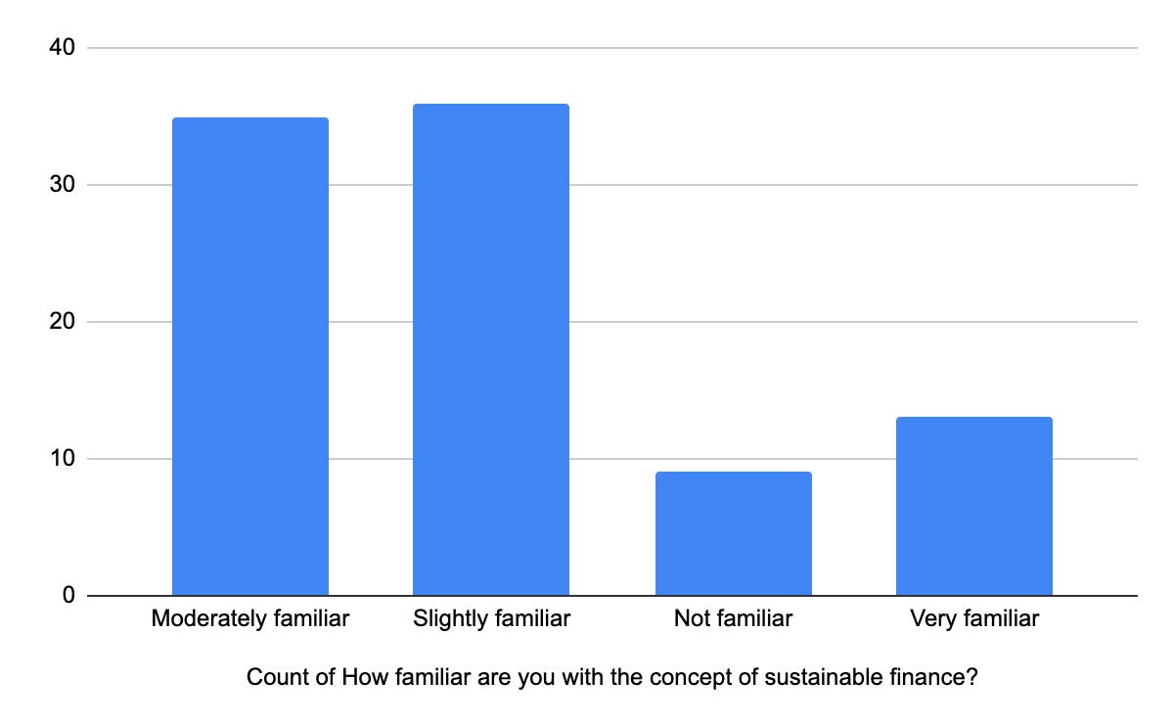
Figure 4.5: Awareness of Sustainable Finance (Bar Chart)

4.2.3 Capacity Building and Training
In addition, respondents were asked whether they had received training or workshops on sustainable finance. The general response provides an indication of the availability and accessibility of such training. This is significant in identifying whether lack of knowledge is a result of fewer training opportunities.

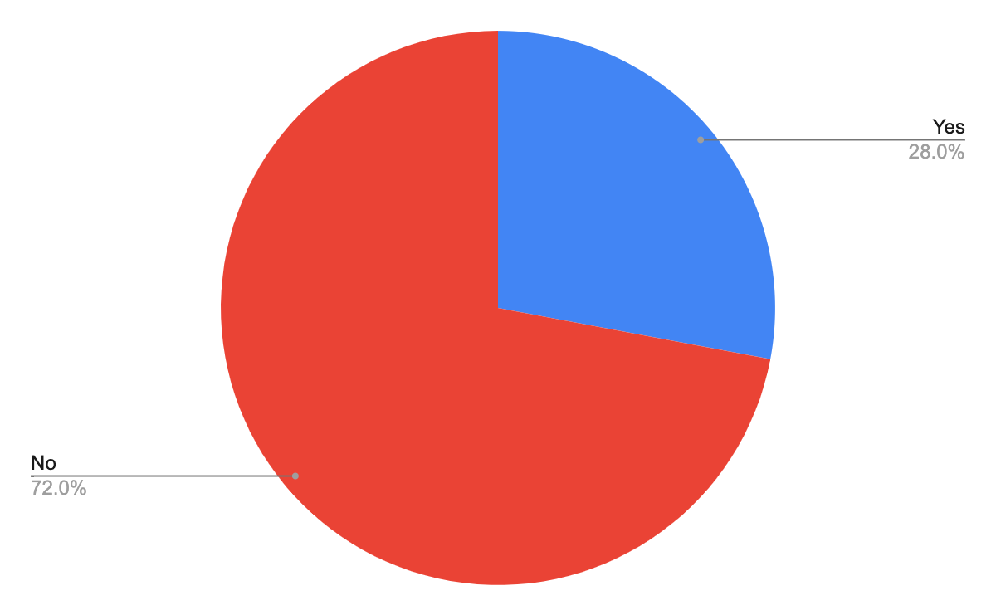
Figure 4.6: Training/Workshops on Sustainable Finance
4.2.4 Perceived Relevance of Sustainable Finance
The study also measured respondents' attitudes towards how sustainable finance can contribute to the achievement of the Sustainable Development Goals (SDGs) for emerging markets. These ranged from "Very important" to "Not important," showing differences in the way it was felt to be pertinent to their development. Understanding such perceptions is important because sustainable finance has been increasingly valued as a force for mobilizing investments for environmentally friendly, socially fair, and economically productive projects (World Bank, 2020). An elevated proportion of the respondents perceiving sustainable finance as significant would suggest rising awareness towards its role in addressing structural challenges such as poverty reduction, climate resilience, and inclusive growth. Lower priority levels, however, may highlight policy communication, financial literacy, or institutional uptake gaps that can render it ineffective to be incorporated into mainstream financial agendas.

4.2.5 Sustainable Finance Outcomes
The respondents were asked to provide some effects they associate with sustainable finance, like environmental preservation, job creation, poverty reduction, and inclusive economic development. These answers conform to the expected development gains and transformative effects of sustainable finance. Aligning finance with sustainability goals ensures that capital is directed towards activities that create not only financial value but also social and environmental value (UNEP, 2022). These findings are in good alignment with SDG pillars and indicate that stakeholders already perceive sustainable finance as a strategic solution to shared problems of the emerging economies. This is in addition to the increasing agreement from academia and policy actions that sustainable finance is at the center of building inclusive and more resilient economies (World Bank, 2020).

4.2.6 Benefits Seen in Practice
Respondents were also invited to ask whether they had seen tangible results of sustainable finance activity either within their organizations or the broader economy.
The "Yes" and "No" tally provides some indication of how far sustainable finance is having an effect on the ground.
Perceived benefits are also of great relevance in that they inform us whether sustainable finance practices are transcending theory and actually creating an impact in the domain of cost reduction, environmental performance, or social outcomes improvement. Based on evidence from available literature, observability of these benefits is a principal determinant of increased familiarity and anchoring of sustainable finance practices (OECD, 2021). Where none or unclear positive impacts exist, this could be a sign of implementation, monitoring, or awareness issues that could be impacting the scalability of such initiatives.

4.2.7 Challenges in Executing Sustainable Finance
The study also sought to discover the nature of challenges respondents felt stood in the way of the effective implementation of sustainable finance in emerging economies. The most common named barriers were unawareness, implementation costs being too high, regulatory support being too poor, and technical skills restrictions.
These findings reflect the structural and institutional barriers that must be overcome for sustainable finance to thrive.
These same barriers have also been listed in the previous studies, assigning that inadequate policy designs, inadequate enforcement, and capacity deficits in the financial sector are likely to hinder the adoption of sustainability-oriented practices (IFC, 2021; UNEP, 2022).
Addressing such barriers will require a collective effort by governments, financial institutions, and development partners to raise regulatory capacity, reduce cost in terms of incentives, and improve technical capacity. Without such interventions, sustainable finance would be a promised theory but not an actual catalyst for inclusive and robust economic growth.
4.2.8 Perception of Government and Policy Support
The respondents also needed to rate whether regulatory systems and government policies offer adequate support for sustainable finance in Nigeria. What they can provide is an indicator of the extent to which existing policy facilitates the construction of sustainability-focused financial practice. Policy support is one of the primary drivers of take-up because governments are the focal institutions in setting standards, establishing incentives, and enforcing rules within finance (World Bank, 2020). Favorable impressions do more strongly suggest rising confidence in the state's determination to deliver embedded sustainability in financial systems. These findings thus highlight the essential role of sufficient and stable policy regimes for nurturing an enabling environment for sustainable finance.
4.2.9 Suggestions for Developing Sustainable Finance
In the final part of the survey, the respondents gave advice on actions that would support the adoption of sustainable finance in the emerging markets. Among the top recommendations were increased public information campaigns, expanding access to training and capacity-building programs, strengthening the regulatory framework, and introducing specific financial incentives.
The above recommendations constitute a recognition that both institutional and individual-level interventions are needed in order to influence actual change.
Current research further points out that it requires a mix of policy reforms, stakeholder consciousness, and incentive structures lowering adoption charges and ensuring long-term participation (OECD, 2021; UNEP, 2022). Such interventions would help go a long way in making the climate more favorable, with sustainable finance evolving from a policy vision to a regular finance practice with the potential for shaping sustainable development agendas.

4.3 Presentation and Analysis of Secondary Data
The chapter draws on credible secondary sources (World Bank, CBN, UNDP, NBS, Climate Bonds Initiative, and FSD Africa) to put the primary survey findings in context and validate them. It provides an overall outlook on sustainable finance trends around the world, in the region, and at home. The analysis is structured around four themes: (1) labelled/sustainable bond issuance, (2) macroeconomic and sectoral indicators, (3) policy and regulatory frameworks, and (4) capacity building and market scale. As a second step, the findings are interpreted with regard to the study's hypotheses (H01–H03).

4.3.1 Labelled/Sustainable Bond Issuance—Global, Continental, and National Trends
Global Picture:
The labelled sustainable debt market, including green, social, sustainability, and sustainability-linked (GSS+) bonds, has grown exponentially. New GSS+ issuance in 2022 alone reached USD 858.5 billion, with green bonds accounting for USD 487.1 billion, according to the Climate Bonds Initiative (2022). Cumulative labelled issuance stood at around USD 3.7 trillion by the close of 2022.
Continental Trends:
Europe: Biggest issuer, driven by the EU Green Bond Standard and country schemes.
North America: Growth of municipal and corporate issuances.
Asia-Pacific: China, Japan, and South Korea dominate.
Latin America: Growing sovereign issuances (Chile, Brazil, Mexico).
Africa: Less than 1% of total issuance (UNDP, 2022). Nigeria, South Africa, Egypt, and Morocco are the leaders but volumes are low.
Middle East: Climbing through green sukuk markets (UAE, Saudi Arabia).

National (Nigeria):
Nigeria was the pioneer African nation to issue a sovereign green bond: ₦10.69 billion in 2017 (Series I) and ₦15.0 billion in 2019 (Series II). These supported climate-resilient afforestation and renewable energy projects.

Indicator | Value | Source
Nigeria—Green Bond (Series I, 2017) | ₦10.69 billion | DMO (2017)
Nigeria—Green Bond (Series II, 2019) | ₦15.0 billion | DMO (2019)
Global GSS+ issuance (2022) | USD 858.5 billion | Climate Bonds (2022
Global green issuance (2022) | USD 487.1 billion | Climate Bonds (2022)
Africa’s share of global issuance | <1% | UNDP (2022)
Table 4.12: Selected Labelled Bond Issuance (Nigeria & Global)

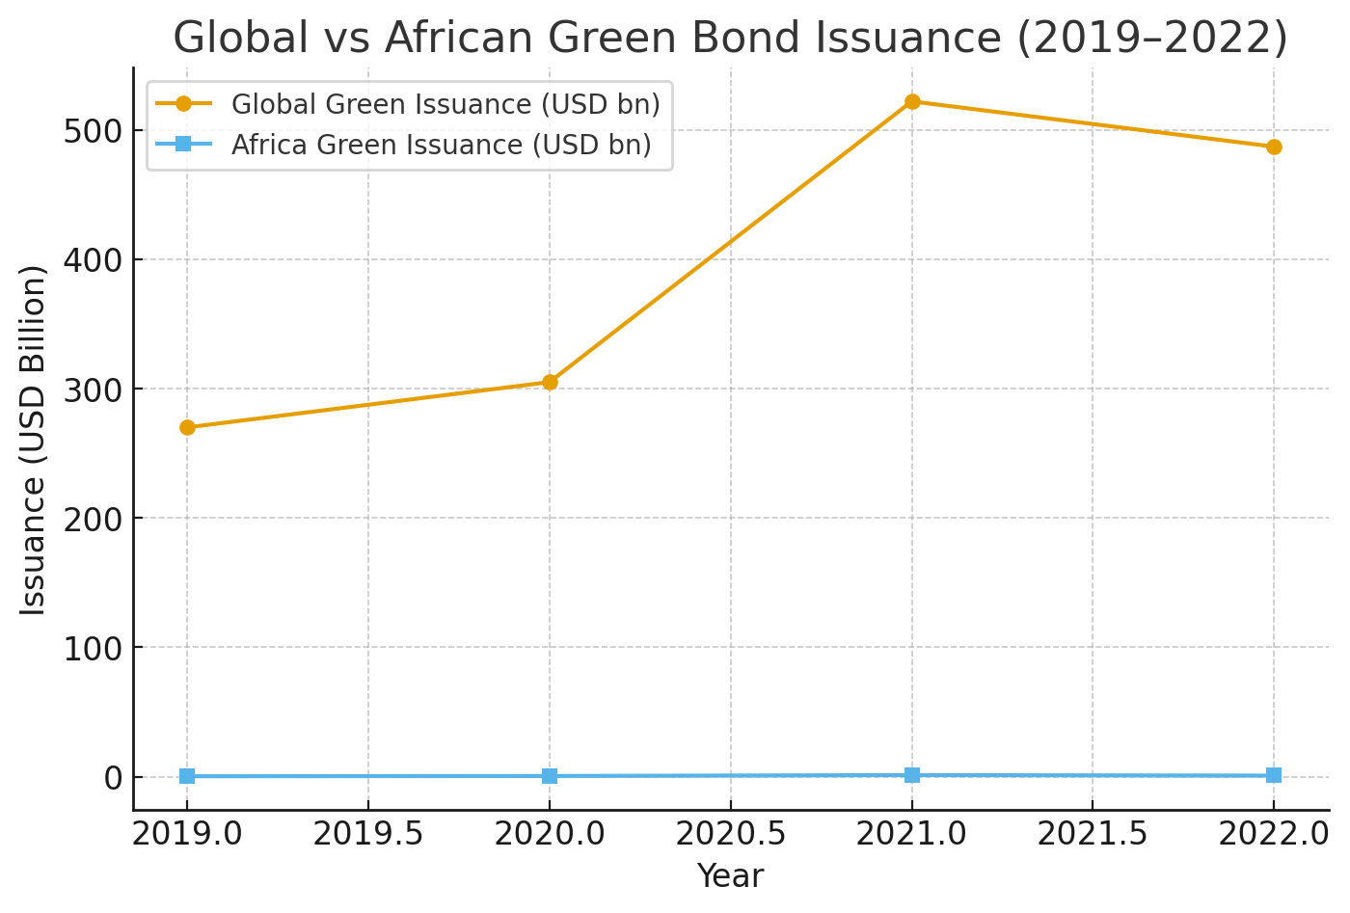Figure 4.1: Global vs African Green Bond Issuance (2019–2022)
Implication: Despite Nigeria's issuances being shown to be feasible, their sizes are insignificant relative to the size of global markets. This supports H03 because it suggests that while green bonds exist, their small size in Africa restricts them from significantly influencing social development relative to global counterparts.

4.3.2 Macroeconomic and Sectoral Indicators

Indicator | 2 | 2 | 2 | 2 | 2 | Source
GDP Growth (%) | 2 | - | 3 | 3 | 2 | World Bank (2024
Inflation (%) | 1 | 1 | 1 | 1 | 2 | NBS (2024)
Unemployment (%) | 2 | 2 | 3 | 3 | 3 | NBS (2024)
Financial Sector GDP | 3 | 3 | 3 | 3 | 3 | CBN/NBS
Table 4.13: Selected Nigerian Macroeconomic Indicators (2019–2023)
Implication: Long-term unemployment and inflation at very high levels emphasize the need for alternative financing systems. Linking to H01, sustainable finance (if ramped up effectively) has the ability to affect economic growth by redirecting funds toward green infrastructure, but it is currently volumes too small to alter macroeconomic trends.
4.3.3 Policy and Regulatory Frameworks
- World: EU Taxonomy, China Green Bond Catalogue, U.S. SEC ESG disclosures.
- Africa: Nigeria's Sustainable Banking Principles (NSBP, 2012), South Africa's JSE Green Bond Segment.
- Nigeria: CBN NSBP and the sovereign green bond framework exist but are poorly enforced (World Bank, 2023).
Implication: Secondary data validate survey respondents' perception that policy support is poor. Policies exist, but their poor enforcement limits their transformative effect. This is connected to H02—because ESG frameworks exist, their environmental sustainability effect is currently restricted by enforcement capability.
4.3.4 Capacity Building and Technical Assistance
World Bank Treasury: Offered technical support to Nigeria, Seychelles, Indonesia, and Fiji to issue green/blue bonds.

UNDP & FSD Africa: Offered ESG readiness training and guidelines.
Reality: Training is directed at institutional/government levels, not practitioners.
Implication: This aligns with survey results where most respondents showed that they did not receive training. In the absence of greater knowledge diffusion, adoption of sustainable finance is superficial, hence limiting the achievement of H01–H03.

4.3.5 Market Scale and Africa’s Share
Implication: Africa's issuance share remains negligible, corroborating respondents' perception of poor prospects. This supports H01 and H03: there is no scale yet, and therefore sustainable finance cannot presently have a significant contribution to economic growth or social development in emerging markets.
4.3.6 Policy-Relevant Synthesis (Hypothesis Integration)
H01: Sustainable finance does not significantly affect economic growth in emerging markets.
Secondary data reveal that while the volume of issuance worldwide is enormous, that of Africa and Nigeria is negligible (<1%). The null hypothesis (H01) is thus corroborated by current evidence—sustainable finance currently has little measurable effect on Nigeria's economic growth.
H02: ESG-compliant investments have no material effect on environmental sustainability in emerging markets.
Legislation like Nigeria's NSBP has been put in place but weak enforcement limits effectiveness. Combined with low awareness/training (from primary data), this means ESG-compliant investments are not currently influencing environmental sustainability in a meaningful way. H02 is provisionally confirmed.

H03: Green bonds and ethical banking have no material influence on social development in emerging markets.
With Nigeria's trillions to billions of bonds globally, and less than 1% for Africa, the impact on social results (employment, poverty, inclusion) is negligible. Secondary data hence confirm the null hypothesis (H03).

4.4 Interpretation and Discussion of Findings
The section integrates results both from the primary survey data and from the secondary sources to provide an intensive analysis of the influence of sustainable finance on sustainable development in emerging markets. The analysis highlights consistencies as well as discrepancies between what was reported by the survey respondents and what authoritative secondary sources (World Bank, UNDP, CBN, NBS, Climate Bonds Initiative, FSD Africa) report. The results are also tested for conformity with the three specific objectives and hypotheses (H01–H03).
4.4.1 Primary and Secondary Data Alignment
In general, the primary data record respondents' optimistic cautiousness about the promise of sustainable finance but with little perceived impact in the real world. This is affirmed by secondary data, which show that while global sustainable finance markets have grown rapidly, Africa, and Nigeria in particular, remain peripheral actors. For example, while global labelled bond issuance in 2022 alone reached USD 858.5 billion, Nigeria's two sovereign green bond offerings for the year totaled only ₦25.69 billion (USD <100 million equivalent). That difference in size is why the respondents said that sustainable finance initiatives are not yet directly adding to growth, environmental effects, or social transformation in Nigeria.

4.4.2 Economic Growth (Objective 1 / H01)
Primary Data: Most of the respondents saw sustainable finance as imperative to developing sustainably but admitted that its economic impact in Nigeria has not been
very noticeable. Some mentioned high costs, low incentives, and limited market opportunities as stifling factors.
Secondary Data: Macroeconomic figures indicate Nigeria's poor growth trajectory (2–3% average GDP growth since 2021, over 20% high inflation, and more than 30% unemployment). At the same time, sustainable finance inflows remain low compared to global levels, with Africa representing less than 1% of issuance.
Interpretation: Sustainable finance has not attained the size required to materially impact Nigeria's economic growth. The null hypothesis (H01) is thus confirmed: currently, sustainable finance does not have a tangible impact on economic growth in emerging markets. This is consistent with literature highlighting the structural limitations of African financial markets (Ziolo et al., 2021; Ariffin & Milala, 2023).
4.4.3 Environmental Sustainability (Objective 2 / H02)
Primary Data: The respondents showed sensitivity towards environmental concerns and ESG principles but registered minimal engagement in training or workshops. Most of them felt that ESG could help enhance environmental performance but observed minimal real-world evidence of such impacts.
Secondary Data: Nigeria's Sustainable Banking Principles of 2012 require banks to include environmental and social risk management, but monitoring and enforcement capacity are low. Other places in the world have more advanced and better enforced ESG structures, such as the EU Taxonomy or China's Green Bond Catalogue.
Interpretation: Frameworks existing without enforcement mean that investments that are compliant with ESG have not yet substantially contributed to environmental sustainability in Nigeria. It temporarily validates the null hypothesis (H02). It also resonates with past findings in the literature that policy frameworks within emerging markets lack the institutional prowess necessary for effective implementation (Okodugha, 2021).
4.4.4 Social Development (Objective 3 / H03)
Primary Data: The respondents linked sustainable finance with potential social effects such as the creation of jobs, poverty reduction, and integration. However, the majority disclosed that they had not observed these effects in practice.
Secondary Data: Sovereign green bonds in Nigeria that financed renewable energy and afforestation programs supported social development, perhaps indirectly, but on an ultra-mini-micro scale relative to world issuance. African issuance of green bonds is under 1%, too small to bring about systemic social change such as poverty alleviation or mass job creation.
Interpretation: Both primary and secondary findings indicate that while green bonds and ethical banking are of symbolic importance, their size restricts their influence upon social development within emerging markets. This is consistent with the null hypothesis (H03).
4.4.5 Consistencies and Divergences
Consistencies: Primary and secondary data all register low awareness, weak policy enforcement, and market structural constraints. Evidence supporting the testimony that respondents perceive a lack of government support is that policies exist but lack vigorous enforcement. Similarly, the absence of provision of general training opportunities that respondents experience is matched by secondary evidence that capacity building is concentrated in institutions of higher level.
Divergences: While global data indicate rapid growth in sustainable finance, Nigerian respondents perceive limited opportunities. The divergence illustrates the difference between global momentum and the marginal participation of Nigeria in sustainable finance markets.
Objective 1 – Economic Growth: The available evidence supports H01. Sustainable finance in emerging economies, such as Nigeria, has not grown big enough to affect economic growth to a significant extent (Ziolo et al., 2021).
Goal 2 – Sustainability of the Environment: Guidelines for ESG exist but are weakly enforced, hence limited gains in environmental sustainability. This provisionally verifies H02 (Okodugha, 2021).
Goal 3 – Social Development: Nigeria's indicative bond issues have potential, but Africa's share of global issuance is too constrained to cause macro-sized social effects. H03 is verified (Ariffin & Milala, 2023).

CHAPTER FIVE
Summary, Conclusions, and Recommendations
5.1 Introduction
This chapter synthesizes the findings of the research into a coherent discussion that connects the study’s objectives, the hypotheses tested, and the data analyzed in Chapter Four. By combining insights from both the primary data (questionnaires) and secondary data (World Bank, UNDP, CBN, NBS, and Climate Bonds Initiative), the chapter provides a comprehensive picture of the current state of sustainable finance in Nigeria and its role in promoting sustainable development in emerging markets.
The chapter begins with a summary of findings, followed by conclusions that directly address the study’s objectives and hypotheses. It then offers practical recommendations for policy and practice, outlines the contribution of the study to knowledge, and finally suggests areas for future research.
The study was guided by the overall aim of examining the contribution of sustainable finance to sustainable development in emerging economies, with Nigeria as the case. Specifically, it sought to (i) examine the relationship between sustainable finance and economic growth, (ii) establish how ESG-compliant investment contributes to environmental sustainability, and (iii) examine green bond and ethical banking contributions to social development. The following were the findings:
5.2.1 Demographic Context
- Respondents came from diverse professional backgrounds, with bankers and accountants constituting a great majority. This reflects the intense involvement of the financial services sector with sustainability discussions.
- The age and gender breakdown revealed that sustainable finance knowledge transcends demographic segments, even though knowledge depth varied.
5.2.2 Awareness and Training
- A number of respondents reported low levels of awareness of sustainable finance and relevant ESG principles.
- None had attended workshops or received formal training. This suggests awareness, but one that is still very superficial in practice.
5.2.3 Attitudes towards Sustainable Finance
- There was agreement among respondents that sustainable finance is required for the achievement of the Sustainable Development Goals (SDGs).
- They associated it with benefits such as environmental protection, job creation, and poverty reduction. When asked about perceived benefits in practice, responses were mixed, with many reporting limited tangible benefits.
5.2.4 Challenges Identified
- Excessive implementation costs and weak regulatory enforcement were consistently mentioned as major challenges.
- Lack of government incentives, weak investor interest, and low technical expertise levels were other constraints mentioned by respondents.
5.2.5 Secondary Data Insights
- Green bond issuance is surging worldwide, with USD 858.5 billion issued in 2022. Africa's share, in comparison, was less than 1%, with Nigeria issuing ₦10.69 billion in 2017 and ₦15 billion in 2019.
- Nigeria has a framework (Nigerian Sustainable Banking Principles (NSBP) and sovereign bond guidelines) but poor enforcement.
- Macroeconomic indicators (chronic inflation, high unemployment, low financial sector contribution to GDP) show Nigeria's economy remains vulnerable, underlining the need to mobilize sustainable finance at scale.
- International technical support (World Bank, UNDP, FSD Africa) has enabled capacity building, but activity is limited mainly to governments and top-tier institutions.

5.2.6 Link to Hypotheses
H₀₁ (Economic Growth): Current sustainable finance initiatives have not significantly influenced Nigeria’s economic growth.
H₀₂ (Environmental Sustainability): ESG frameworks exist but their weak enforcement and low awareness mean investments have not yet significantly advanced environmental sustainability.
H₀₃ (Social Development): Green bonds and ethical banking are symbolically important but too small in scale to significantly influence social outcomes.
From the findings above, the following conclusions are drawn:
5.3.1 Towards Sustainable Finance and Economic Development (Objective 1 / H₀₁)
While sustainable finance is linked to economic growth in theory, its impact in practice in Nigeria and other similar emerging economies is limited. The size of the issuance (₦25.69 billion aggregate for two sovereign bonds) is minuscule compared to the trillions of dollars of global sustainable finance markets. Sustainable finance in its current state has thus not yet contributed meaningfully to the economic growth of Nigeria.
5.3.2 On ESG Investments and Environmental Sustainability (Objective 2 / H₀₂)
ESG principles have been enshrined in Nigeria's policy frameworks, including the CBN's Sustainable Banking Principles, which stand out. However, poor enforcement, weak institutional capacity, and low practitioner awareness restrict their ability to foster environmental sustainability. It then renders ESG-compliant investments more of a wish than a reality in practice.
5.3.3 On Green Bonds, Ethical Banking, and Social Development (Objective 3 / H₀₃)
Although Nigeria has pioneered sovereign green bonds in Africa, their social impacts have been symbolic rather than substantive. The issuances have not been large enough to create substantial jobs, reduce poverty, or boost social inclusion in any quantifiable manner. Without upscaling, green bonds and ethical banking will remain pilot programs rather than transformational tools.

5.3.4 Conclusion
Sustainable finance in Nigeria—and Africa at large—is at an early stage. Despite the clarity of policy signals and symbolic action, the transformative potential of sustainable finance to drive economic, environmental, and social progress is hampered by weak capacity, lack of enforcement, and small market size.
5.4 Recommendations
Based on the findings, the study recommends the following:
5.4.1 Strengthen Policy and Enforcement
The CBN should enforce the Nigerian Sustainable Banking Principles through mandatory ESG disclosures and penalties for non-compliance.
Sovereign and corporate green bond post-issuance monitoring must be enhanced to facilitate transparency and accountability.
5.4.2 Scale Up Capacity Building and Awareness
More comprehensive training programs should be initiated for practitioners, as well as for policymakers. Professional organizations and universities must include modules on sustainable finance in curricula.
Media campaigns and stakeholder workshops will create awareness among investors, businesses, and the general public.
5.4.3 Mobilize Capital for Green Investments
The government should mobilize private investment into sustainable projects through tax incentives, credit guarantees, and public–private partnerships.

Development finance institutions (e.g., AfDB, BOI, IFC) should provide concessional financing to support the reduction of the high cost of issuing green instruments in emerging markets.

5.4.4 Promote Regional and International Collaboration
African countries have to mobilize resources and harmonize bond principles under the AfDB and the African Union.

Lessons from Europe, Asia, and Latin America must be Africanized.

5.4.5 Diversify Sustainable Finance Instruments
Besides green bonds, instruments like sustainability-linked loans, green sukuk, blended finance facilities, and ESG-themed funds have to be launched. This will deepen the market and also attract more investors.

5.5 Contribution to Knowledge
This study contributes to the existing body of knowledge by:
Bringing empirical data from both primary (questionnaires) and secondary (institutional reports) sources on sustainable finance in Nigeria.

Demonstrating the disconnect between policy frameworks and enforcement, especially in emerging markets.

Highlighting the structural impediments (market size, prohibitive costs, low awareness) hindering sustainable finance from realizing its full potential in Africa.

Offering a comparative outlook by situating Nigeria's experience in the global and continental picture.
5.6 Recommendations for Further Research
The following areas of research are suggested for future investigation:
A longitudinal study tracking the actual effects of Nigeria's green bonds on intended projects and sectors (e.g., renewable energy, afforestation).
Comparative studies among emerging markets (e.g., Nigeria in relation to South Africa, Brazil, or India) to extrapolate best practices and policy lessons.
Sectoral studies (e.g., green finance for agriculture, housing, or ICT) to extrapolate tailored interventions.
Exploration of the prospects of fintech and digital finance in advancing ESG adherence and stimulating grassroots participation in sustainable finance.
Assessment of the effects of capacity-building programs by institutions like the World Bank and UNDP to determine their long-term effectiveness in local markets.

