1.1 INTRODUCTION
The modern business environment is typified by constant changes within the regulatory frameworks, most especially in industries of high environmental impacts. The energy sector is put under huge pressure in view of its widely acknowledged role in global emissions and ecological sustainability. The topic chosen for this research is to analyze and evaluate the effect of one recent change forced by the regulatory environment on the financial performance of an organization.
The current research, therefore, focuses on Shell Plc, one of the leading energy companies in the world (Shell Annual Report, 2023), in relation to understanding how a radical shift in regulatory policy—in this case, CBAM by the European Union—shaped financial performance. Consequently, the paper tries to show in greater detail the ramifications that this kind of policy has had on Shell Plc by comparing financial results before and after such regulation.
The Carbon Border Adjustment Mechanism (CBAM) is a regulatory framework introduced by the European Union (EU) to address carbon leakage and ensure fair competition in industries with high greenhouse gas emissions, according to the European Commission (2023). It is designed to complement the EU’s Emissions Trading System (ETS) by imposing a carbon price on imported goods based on their embedded carbon emissions. CBAM primarily applies to industries such as cement, electricity, aluminum, fertilizers, iron, and steel, which are highly carbon-intensive (European Commission, 2023).

What Was in Use Before CBAM?
Before CBAM, the EU Emissions Trading System (EU ETS) was the primary regulatory mechanism to control carbon emissions. According to the European Commission (2023), the ETS required EU-based companies to purchase allowances for their emissions, but imported goods were not subject to the same carbon costs. This led to carbon leakage, a situation where companies relocated production to countries with weaker climate policies to avoid emission costs. CBAM seeks to close this gap by extending similar carbon pricing to imports, ensuring a fairer and more sustainable trade system (European Commission, 2023).

What Exactly is CBAM Addressing?
CBAM specifically addresses the following:

Carbon Leakage Prevention: Ensuring that EU industries are not disadvantaged by cheaper, high-emission imports from non-EU countries.

Climate Change Mitigation: encouraging global industries to adopt cleaner production processes by aligning them with EU environmental standards.

Fair Market Competition: Creating a level playing field for EU businesses by ensuring that imports face the same carbon costs as domestic production.

Jurisdiction and Implementation
CBAM applies to imports into the European Union, affecting trade partners worldwide, particularly those with less stringent climate regulations. It was introduced as part of the European Green Deal and entered its transitional phase in October 2023, with full implementation expected by 2026 (European Commission, 2023).

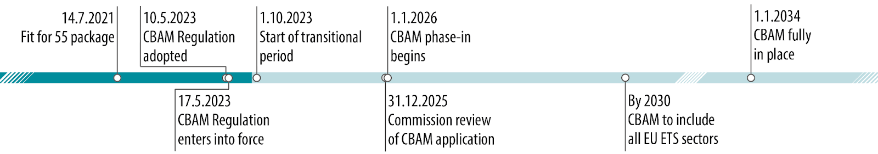
Figure 1.1.1: Timeline for the Implementation of CBAM
Source: European Union, 2023

1.2 REASONS FOR CHOOSING THE TOPIC
1.2.1 Relevance of Changes in Regulations to Business Today
Regulatory changes are one of the building blocks of contemporary governance in which the contours of industries are shaped if not global economic trends influenced. The Center for Climate and Energy Solutions said changes in this respect, particularly in the energy resource sector, become necessary in the light of environmental concerns, compliance with international agreements, and attainment of sustainable development. CBAM mechanisms aim to reduce carbon emissions and greener practices that are supposed to hit companies that involve high-emission industries below the belt.
1.2.2 Financial Performance
This often requires changes not only in the operational and financial areas but, in some cases, even strategic adjustments. In this context, Argus Media (2023) argues that compliance with these policies can significantly increase costs or necessitate changes in investment strategies, which may ultimately affect profit margins. The financial implications of such regulations on energy companies are illustrated in the case study of Shell Plc. Shell has acknowledged that the costs of complying with carbon pricing schemes are expected to triple over the next decade, reaching an estimated $1.5 billion by 2032 (Argus Media, 2023).

1.3 REASONS FOR CHOOSING SHELL PLC
1.3.1 Industry Leadership
Shell Plc is a global leader in the energy industry, headquartered in The Hague, Netherlands, and incorporated in the United Kingdom. The company operates across the full energy value chain, including exploration, production, refining, and distribution of oil and natural gas, as well as the development of renewable energy sources. With a presence in over 70 countries, Shell plays a crucial role in global energy markets, supplying energy to millions of customers and businesses worldwide, according to Shell (2023).
Founded in 1907, Shell has since become one of the world's largest energy companies. It has consistently ranked among the top companies in the world by revenue, often listed in the Fortune Global 500, according to Fortune (2023). Shell’s operations span multiple sectors, from upstream and downstream activities to innovations in clean energy, with significant investments in wind, solar, and bioenergy, according to Shell (2023).
In addition to its significant economic presence, Shell has received numerous accolades for its contributions to both the energy sector and corporate sustainability. Notably, Shell has been recognized for its environmental initiatives, including being ranked among the top companies for sustainability in the Dow Jones Sustainability Index (DJSI), according to S&P Global (2023). Furthermore, Shell has consistently earned high marks for its commitment to innovation and corporate governance. In 2022, Shell received the 'Best Sustainability Strategy' award from the Energy Intelligence Group, according to Energy Intelligence Group (2022).
However, Shell’s journey has not been without controversy. Over the years, the company has faced criticism and sanctions related to environmental concerns, particularly regarding its oil exploration activities in the Arctic and its historic environmental violations. Notably, according to Reuters (2021), Shell was ordered by a Dutch court to cut its carbon emissions by 45% by 2030, a landmark ruling that pressured the company to accelerate its shift toward cleaner energy. Such legal and regulatory actions highlight the increasing scrutiny that Shell faces, especially in the context of global sustainability goals.
As a publicly traded company, Shell has a wealth of information available to the public, which has made researching its policies, financials, and strategies more accessible. According to Shell (2023), the company’s transparency and detailed annual reports allow stakeholders and researchers to gain insight into its operations, regulatory compliance, and long-term strategic objectives.

1.3.2 Exposure to Change in Regulations
Operating in very strict environmental legislation areas such as the European Union places Shell directly at the forefront regarding such policies as CBAM. The extensive reporting and access to publicly available financial data allow for detailed reporting on the company. Shell provided active input in various consultations that have taken place on carbon border adjustment mechanisms from experiences within the EU (Shell, 2023).

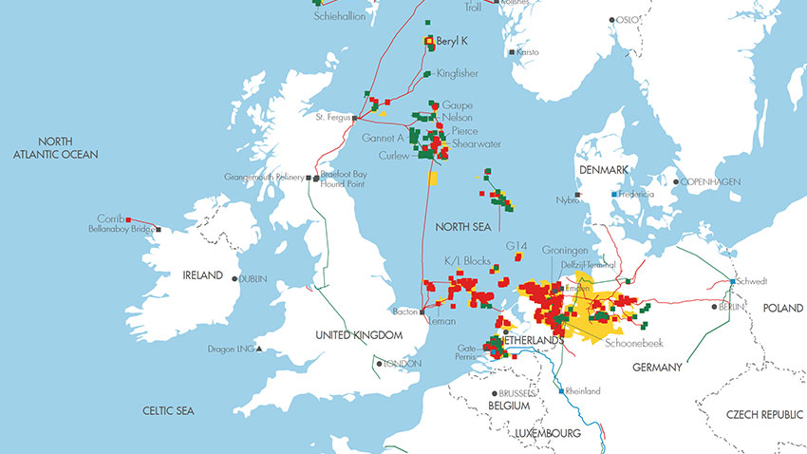
Figure 1.3.2.1: Shell's Operations in CBAM-Affected Regions
Source: Adapted from Shell Plc (2023)
The map above displays the onshore and offshore sites, pipelines, and extraction locations in Europe where Shell operates, according to Shell’s annual report (2023). Some of the key sites include the Bacton gas terminal in the UK, the Groningen gas field in the Netherlands, and Shell’s oil and gas production platforms in the North Sea, which are integral to the company’s operations in the region. This map highlights areas of the European Union that are currently implementing the Carbon Border Adjustment Mechanism (CBAM) regulations, as outlined by the European Commission (2023).
Key annotations:
Red squares: The highly-emitting facilities, such as refineries and treatment plants, which fall directly under the regulation of CBAM.
Green squares represent low emission facilities or renewable energy plants and represent part of the transition for Shell.
Yellow Highlighting: The focal areas of operation, such as the Netherlands and the North Sea, are indispensable to Shell's business in Europe. Pipelines: interconnected facilities of Shell within regions to show how their operations interlink. The above visualization gives full insight into the way that CBAM would affect the economic and operational strategies of Shell given the concentration of its high-emission facilities in CBAM-regulated territories.

1.4 PROJECT OBJECTIVES
The objectives of the project are:

To analyze the impact of the CBAM regulation on Shell Plc’s financial performance before and after its implementation.

To evaluate Shell’s adaptation strategies to this new regulatory requirement, CBAM.

1.5 RESEARCH QUESTIONS
This research seeks to address the following questions:

How does the introduction of the Carbon Border Adjustment Mechanism by the European Union affect the financial performance of Shell Plc?

What are the strategies adopted by Shell Plc regarding the above regulatory changes, and how effective are they?

What can other energy companies learn from Shell's experience in terms of regulatory compliance?

