## Output 1. Home page

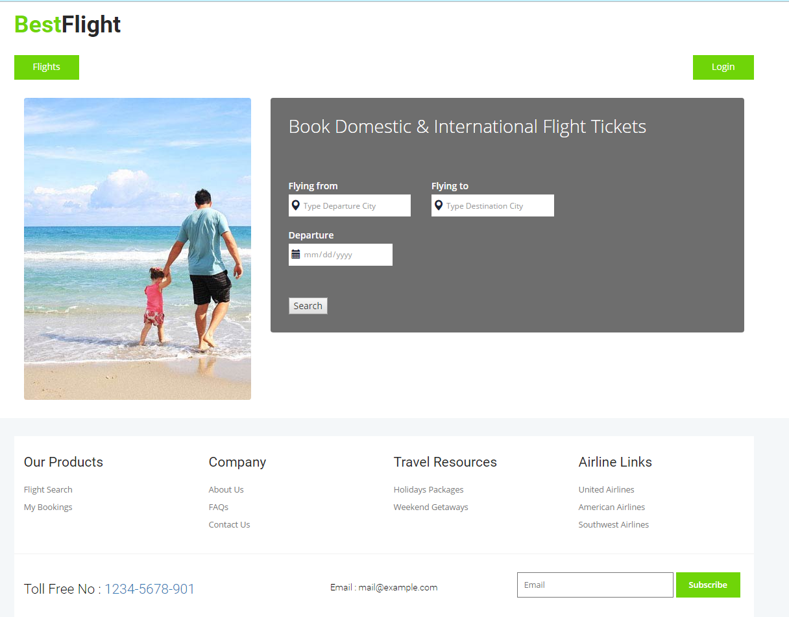

## Output 2. Flight ticket stored in MySQL

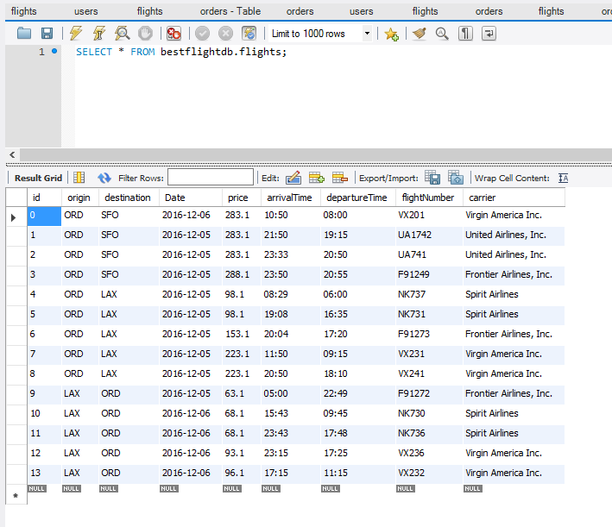

## Output 3. Search ticket from ORD to SFO, 2016/12/05

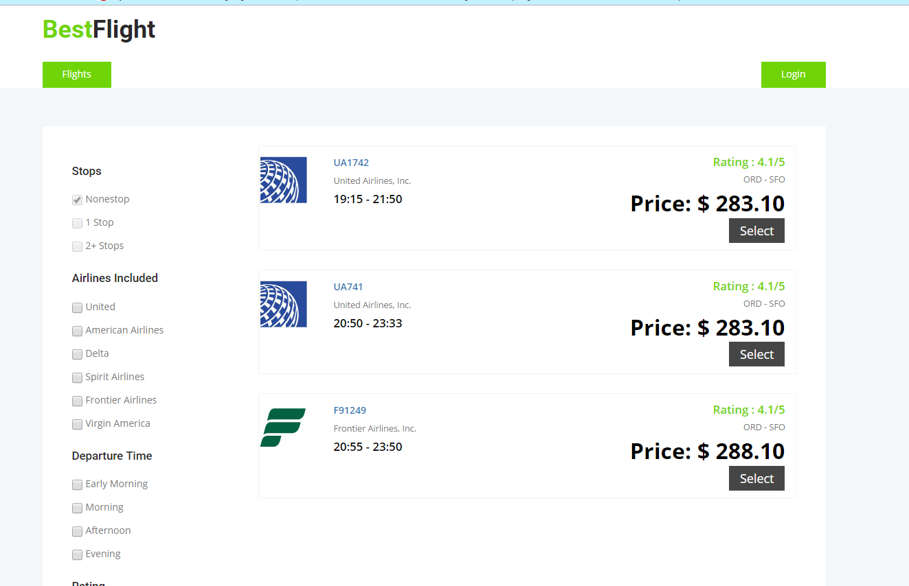

## Output 4. Using left navigation bar to choose flight run by different company.

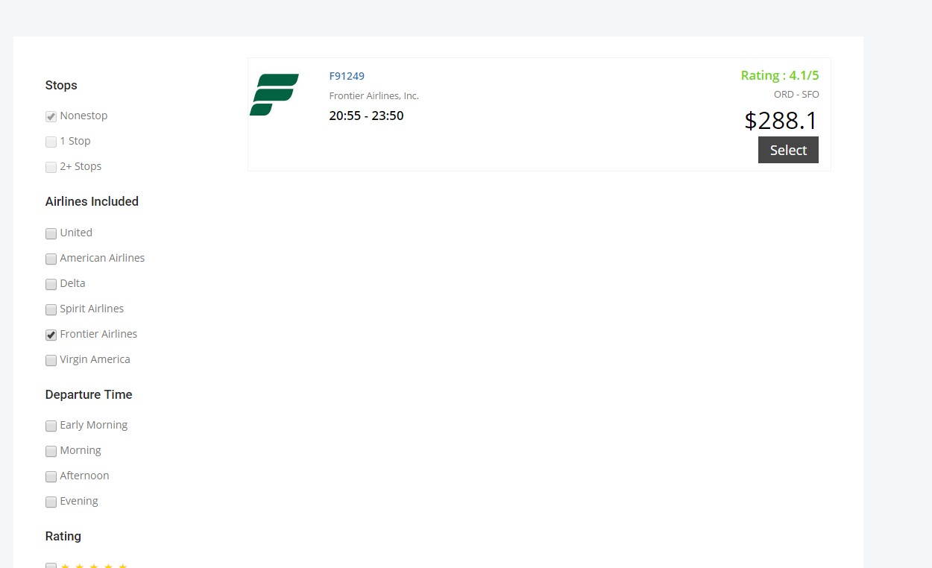

## Output 5. Visitors cannot add ticket into cart.

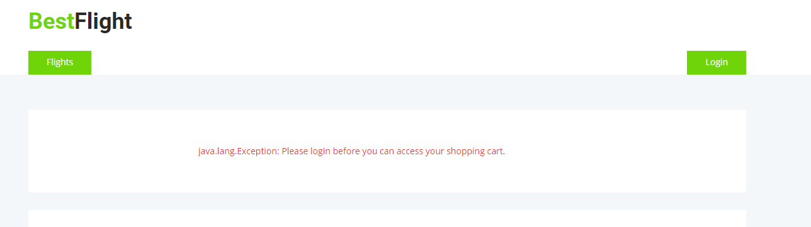

## Output 6. Login button. Username = user1, password = user1

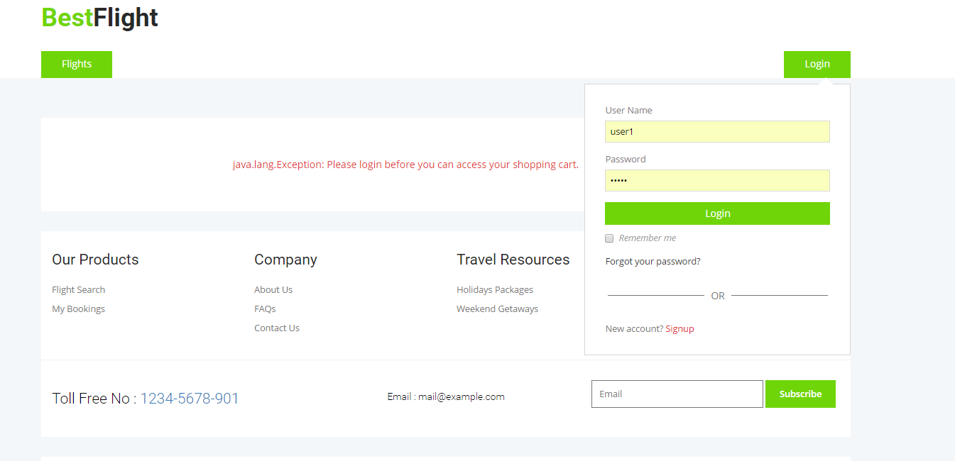

## Output 7. After login, shows order history and shopping cart button

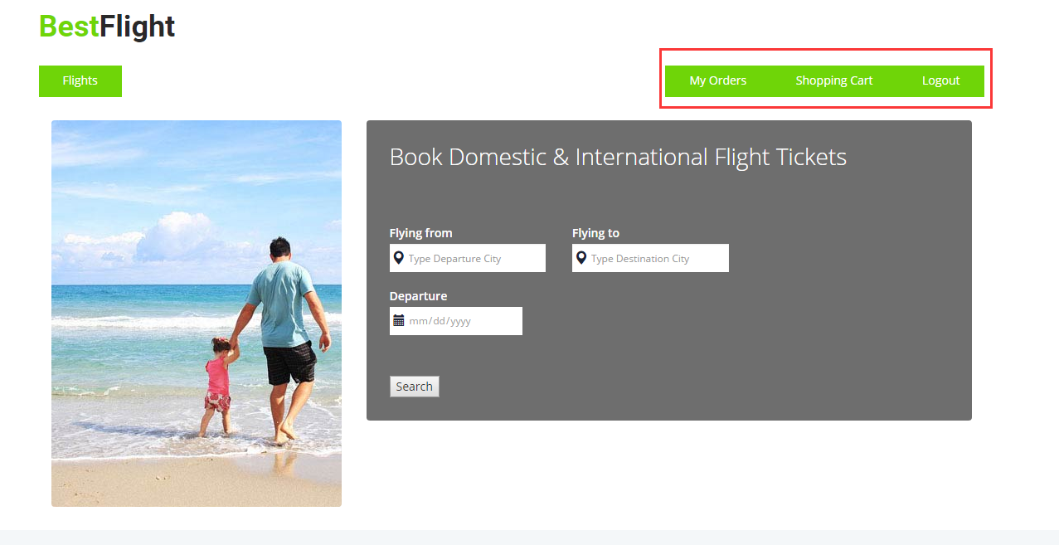

## Output 8. User can view and cancel his/her own order, however, the order can only be cancelled in one day.

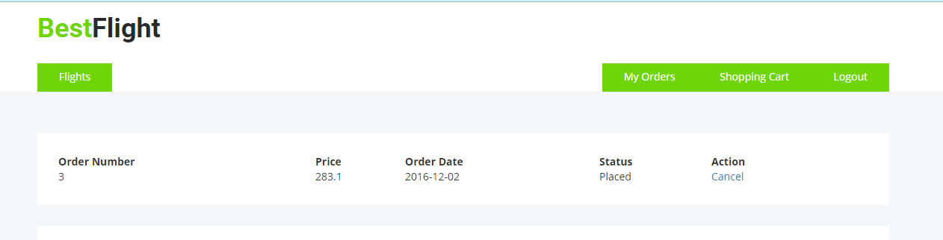

## Output 9. User can add/delete tickets in shopping cart before check out

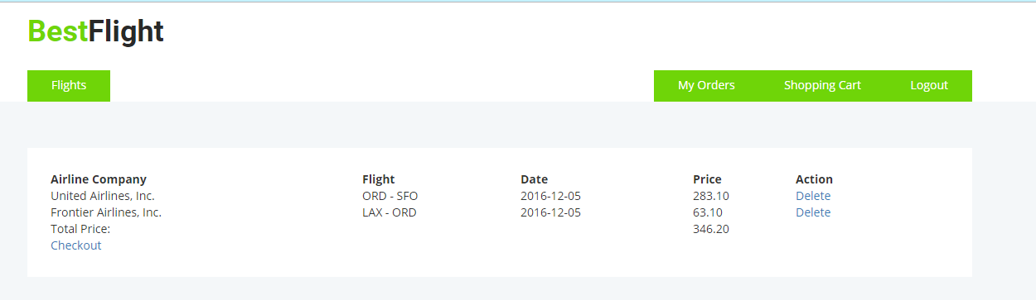

## Output 10. If user doesn’t login, he/she cannot visit shopping cart, check out, my orders using url like list below.

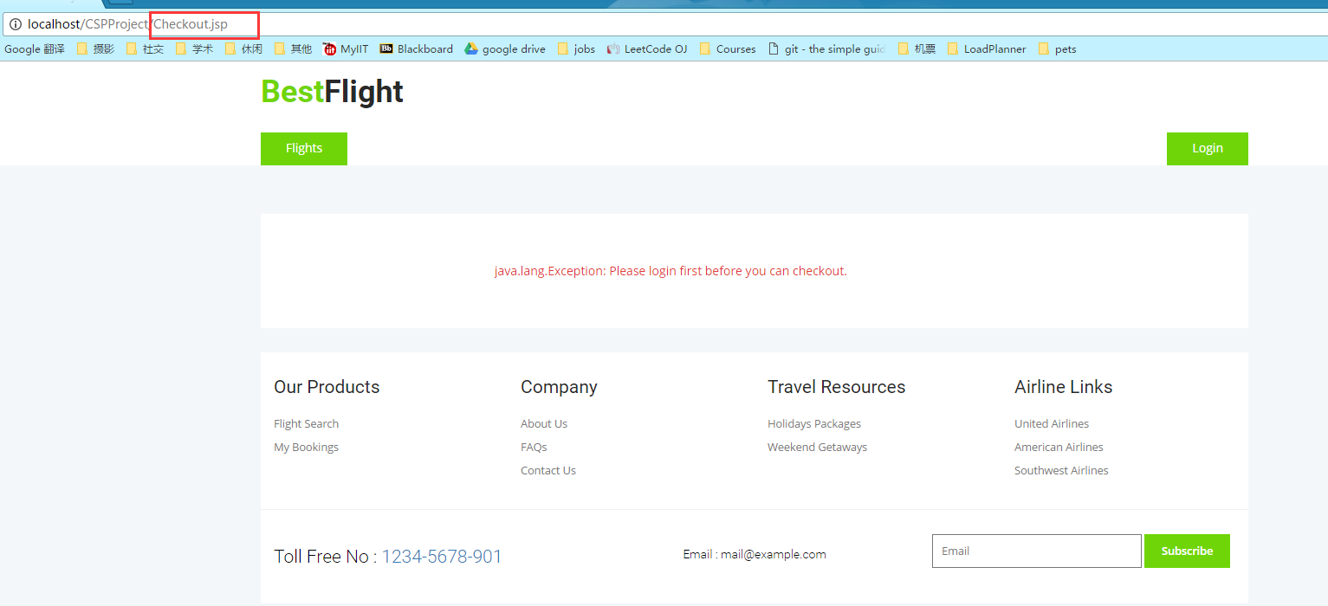

## Output 11. Check out page:

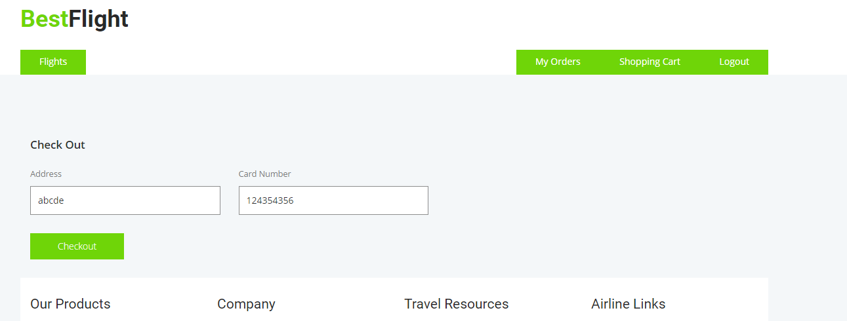

## Output 12. Tracking number and status are shown after check out.

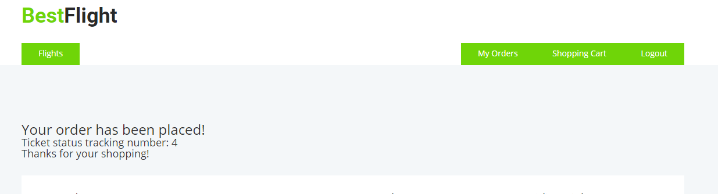

## Output 13. User orders are stored in MySQL “orders” table.

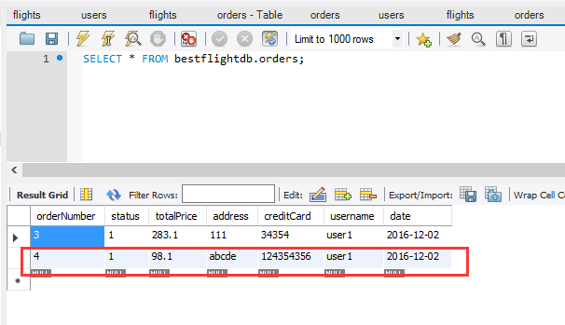

## Output 14. Signup page. If user name is used before or passwords are not the same, the page would give an exception hit and asked user to try again.

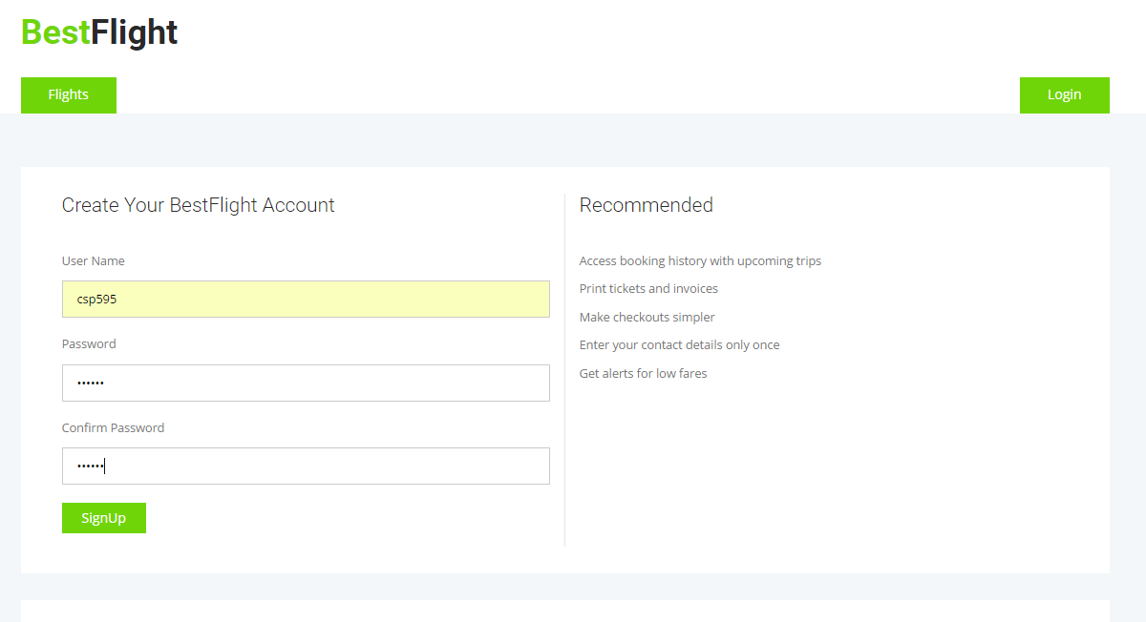

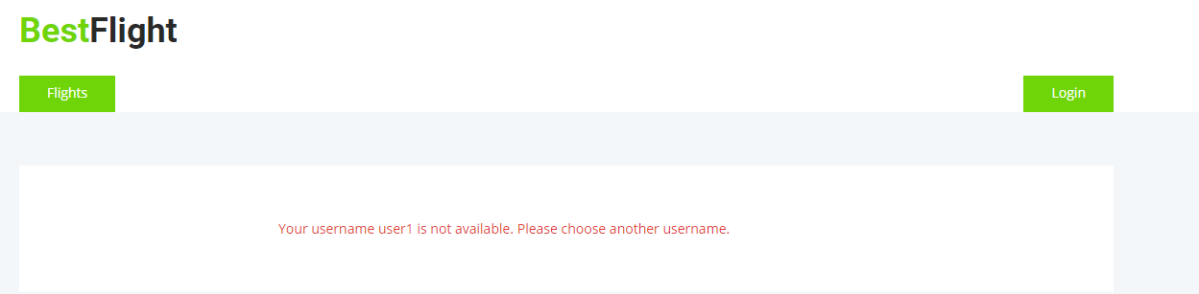



## Output 15. User csp595 has been saved in MySQL “users” table

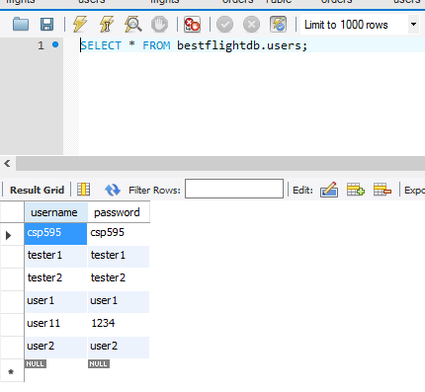

## Output 16. Tickets information are got from Google Flight API, using python to modify flights information and store modified flights in the file “formatedflight.json”. If MySQL ‘flights’ table is empty when user is visiting homepage, this project will read this json file and store flights into MySQL.

