|  |  |  |
| --- | --- | --- |
| **Supervisor** | PHAM THI LANH |  |
| **Semester** | 1 |  |
| **Batch No** | T1.2006.M1 |  |
| **Group No** |  |  |
| **Order** | **Full name** | **Roll No.** |
| 1. | Phùng Công Dũng | Student1269 823 |
| 2. | Trần Đức Tân | Student1269 825 |
| 3. | Nguyễn Hùng Vương | Student1269 822 |

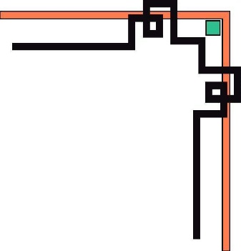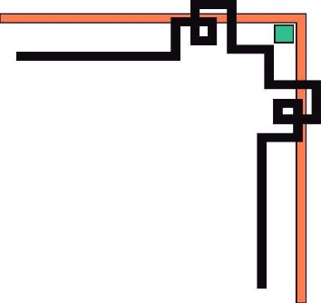

**This is to certify that**

**Mr:** Phung Cong Dung

**Mr:** Tran Duc Tan

**Mr:** Nguyen Hung Vuong

Has successfully Designed & Developed

BAGBAG STORE

Submitted by:

Pham Thi Lanh

Date of issue:

September, 2020

Authori Zed Sign ature

Month 09 Year 2020

# CONTENTS

Contents

CONTENTS 3

ACKNOWLEDGEMENT 4

EDGEMENT 5

SYNOPSIS 6

REQUIREMENT SPECIFICATION 7

PROBLEM DEFINITION 7

CUSTOMERS REQUIREMENT SPECIFICATIONS (CRS) 8

1.Client: BagBag WebSite Online: 8

2.Business/Project Objectives: 8

3.Inputs provided by clients: 8

4.Hardware Requirement: 9

5.Software Requirements: 9

ARCHITECTURE & DESIGN OF THE SYSTEM SI 10

WEBSITE LAYOUTS 13

REVIEW 2 15

I. WEBSITE INTERFACE 16

Homepage: 16

CONTENT OF HOMEPAGE AND FOOTER 18

B. Contact us 20

C. Categories: 21

D. About us: 22

E .Login: 24

F. Feedback: 25

TIME MANAGEMENT 25

# ACKNOWLEDGEMENT

I would like to acknowledge all those who have given moral support and helped in making the project a success.

I wish to express my gratitude to the e-Projects Team at the Head Office, who guided and helped me. I would also like to express my gratitude to all the staff members of my center for not only providing me with the opportunity to work with them on this project, but also for their support and encouragement throughout the process.

I also express my sincere gratitude to the e-Projects Team at the Aptech Head Office and my project guide at the organization, for her valuable guidance and support for the completion of this project.

And finally, I would like to offer many thanks to all my colleagues for their valuable suggestions and constructive feedback.

# EDGEMENT

I would like to acknowledge all those who have given moral support and helped in making the project a success.

I wish to express my gratitude to the e-Projects Team at the Head Office, who guided and helped me. I would also like to express my gratitude to all the staff members of my center for not only providing me with the opportunity to work with them on this project, but also for their support and encouragement throughout the process.

I also express my sincere gratitude to the e-Projects Team at the Aptech Head Office and my project guide at the organization, for her valuable guidance and support for the completion of this project.

And finally, I would like to offer many thanks to all my colleagues for their valuable suggestions and constructive feedback.

# SYNOPSIS

BagBag is the abbreviation of BagBag Production and Trading Joint Stock Company,. BagBag is the leading brand in Vietnam with fashion products and bags. After many years on the market, as well as the desire to blow up the passion and beauty needs of Vietnamese women, set the motto as a companion, encouraging and satisfying the beauty needs of all women. . . Especially, customers who order online will receive the goods within 1-2 days. Delivery quickly to home. BagBag regularly applies promotions and discounts on beautiful and fashionable handbags. Help you satisfy your passion for bags

Hand bags are not just for storing essentials when going out. A handbag is a woman's closest and dearest friend. By the 20th century, handbags were no longer as simple as they originally meant. It becomes an icon page. It's hard to believe but for a man, when looking at a woman, it's a handbag

Website Bagbag will provide all kinds of handbags from famous brands in the world such as LV, Louis Vuitton, Hermes ... The price is suitable for your financial ability with the quality and color equal to more than 98%. . To realize the dream of a luxury and elegant handbag for special occasions such as parties, gatherings

**REVIEW 1**

# REQUIREMENT SPECIFICATION

**The Web site is to be created based on the following requirements.**

1) The Home Page should be created making use of Sections with a suitable

logo, the header section can be added which will show images of various

Bags.

2) The site must contain the links to navigate through various types of Bags,

BackPacks etc.

3) Site should have different section for Men and Women and bags should be

placed accordingly.

4) Links of bags must be categorized like (Bags, Sling Bags, BackPacks etc.)

5) Specification and Pricing of Bags should be added along with the images.

6) Website should provide section for various brands offered in the store.

7) Gallery section should be added for viewing different images.

8) Feedback must be allowed to enter by the viewer

9) Site map, Gallery, about us, Queries link, Contact us link must be added.

Show the location using maps or GeoLocation API.

10) The complete description must be allowed to get download as pdf or doc file.

11) The advertise section with various facilities provided should be mentioned.

# 

# PROBLEM DEFINITION

After reading the project specifications, the developer states the scope of the project very briefly. This is referred to as the problem definition. Queries of various staff members can be one or all of the following:

* Our website can display 8 products at the same time, each with a price of ice cream below, a total of 119 products in the store: Gucci and LouisVuitton have both men and women.
* On our home page, the store's best-selling products are displayed, along with the world's fashion trends of the year.
* When buying each product, there will be information tools and specific images about that product for customers to learn
* In each product there are feedback about service quality, product and product quality, and attach pictures
* In the contact section we will show you the store branch address, customer service time.
* There is a section for customers to contact to ask questions for the store

# 

# CUSTOMERS REQUIREMENT SPECIFICATIONS (CRS)

## 1.Client: BagBag WebSite Online:

## 2.Business/Project Objectives:

* Provide a website to displays the programs and services about BagBag store such as: “Categories” “About us”, “Contect us”, “Log in”, “Contact Us”, “Feedback”…

## 3.Inputs provided by clients:

Inputs to the existing system.

Outputs from the existing system.

Process involved in the application.

Expected delivery dates.

List of deliverables.

## 4.Hardware Requirement:

* A minimum computer system that will help you access all the tools in the courses is a Pentium 166 or better
* 64 Megabytes of RAM or better

## 5.Software Requirements:

* Notepad/HTML editor
* Dreamweaver
* IE 5.0/ Netscape 6.0

# 

# ARCHITECTURE & DESIGN OF THE SYSTEM SI

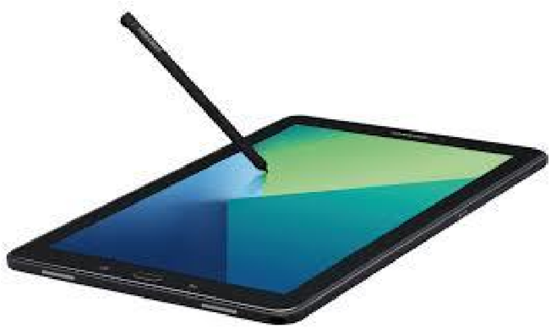

**CLIENT**

**SERVER**



Font End technologies

(

HTML5, CSS3, Bootstrap, jQuery

)

**1. Homepage:**

**2. Informative pages:**

|  |  |  |  |  |  |
| --- | --- | --- | --- | --- | --- |
| Search  Log In  Logo BagBag | | | | | |
| Home  page | | Categories | About us | Contact us | Feedback |
| **LV**  **Gucci**    Tote  Shoulder  Clutch  Travel  Business  Backpack  Women  Men | | | | | |
|  | BAGBAG  IMAGE 1  IMAGE 1  IMAGE 1 | | | | |
|  | Introduced some information BagBag | | | | |
| FOOTER | | | | | |

This layout we will apply to most other pages (Contact Us, Feedback, Queries ...) give people different information about the bagbag store. It also has the same Page Title, Navigation Bar and Footer as the Homepage, but the main content is changed. What's interesting is that we will further design a sidebar with an "active" layer to make it easier for people to visit another related site.

**SITEMAP**

# 

# WEBSITE LAYOUTS

**Here are our layouts which will show you how we brainstormed ideas for the hospital’s web pages. Because of being academic website, we tried to build them SIMPLE but USEFUL and INFORMATIVE as much as possible.**

**The website is going to have several pages which include different information in the same main layout.**

|  |  |  |  |  |  |  |
| --- | --- | --- | --- | --- | --- | --- |
| **Project Ref. No.** | **Project Title** | **Activity**  **Plan**  **Prepared by** | **Date of Preparation of Activity Plan** | | | |
| **Task** | **Actual Start**  **Date** | **Actual**  **Days** | **Teammate**  **Names** | **Status** |
| Create layouts for website base on group discussion ideas | BAGBAG STORE |  | 07/09/2020 | 2 |  | Completed |
| Draw layouts using  Paint | BAGBAG STORE |  | 09/09/2020 | 2 |  | Completed |
| Write project  report 1 | BAGBAG STORE |  | 12/09/2020 | 3 |  | Completed |
| Homepage design and coding  (include navigation bar and footer) | BAGBAG STORE |  | 14/09/2020 | 7 |  | Completed |

|  |  |
| --- | --- |
| Signature of Faculty | Signature of Leader Team |
|  |  |

# 

# REVIEW 2

# WEBSITE INTERFACE

## Homepage:

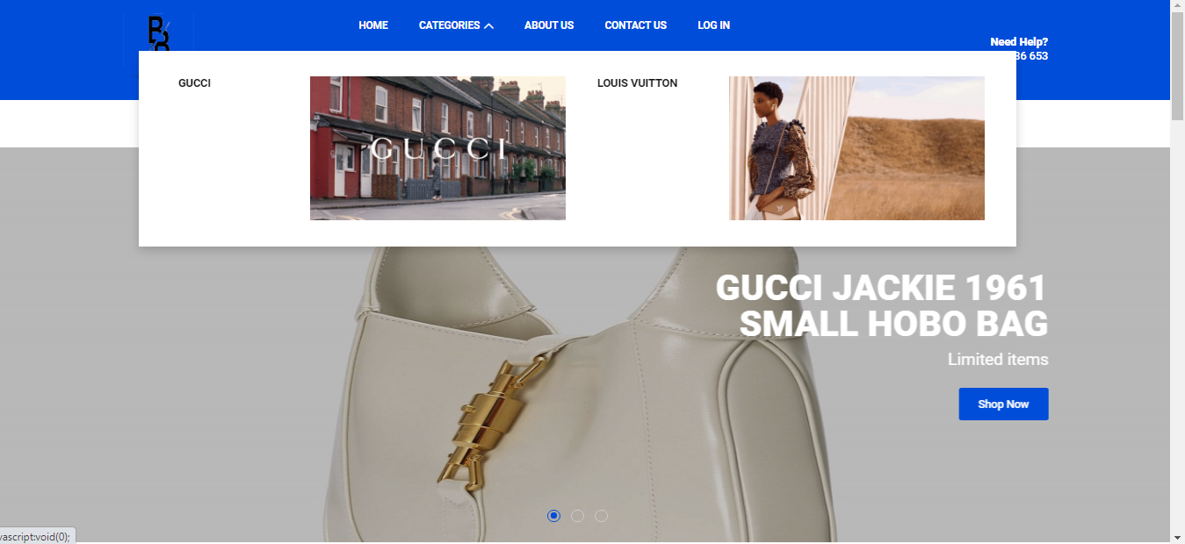

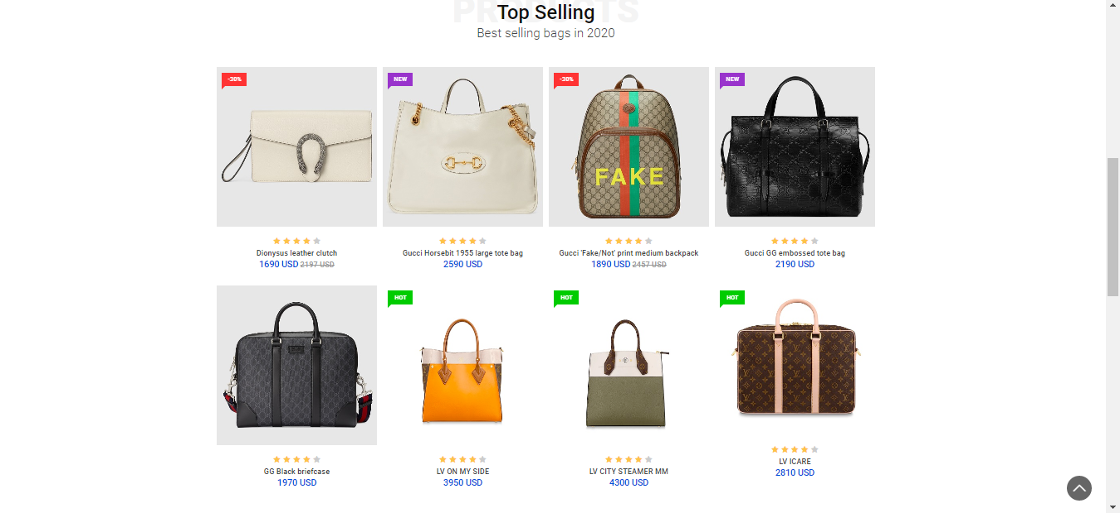

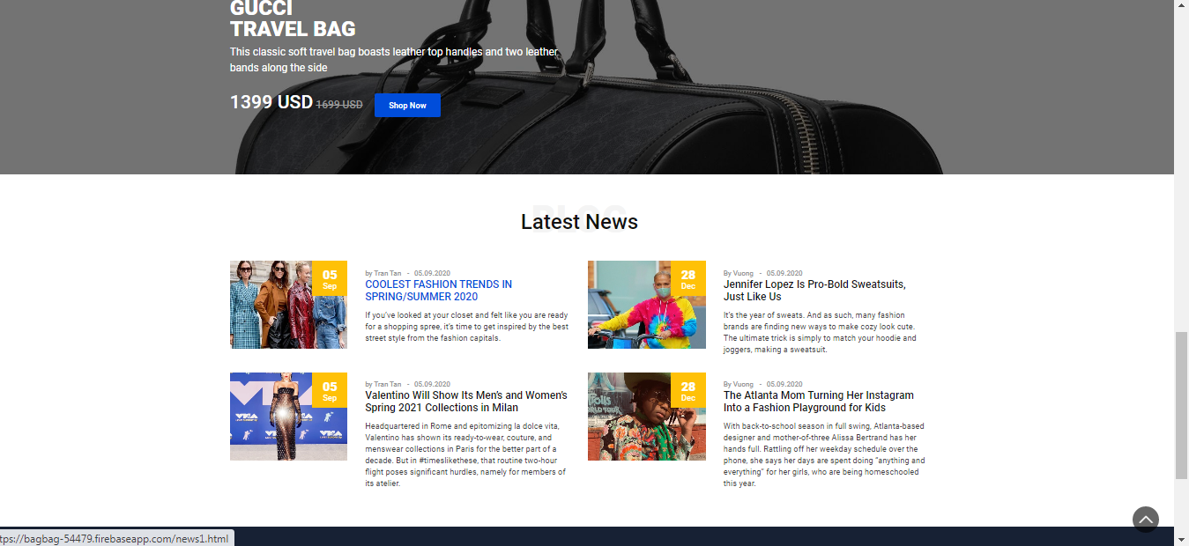

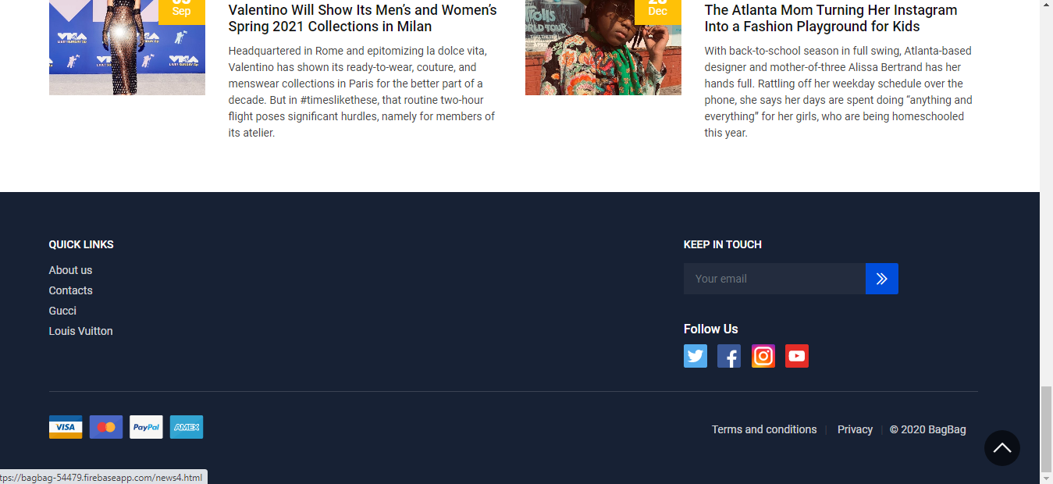

|  |
| --- |
| HEADER AND CAROUSEL |
|  |
| C:\Users\PC\Desktop\New folder (4)\Untitled.png |
|  |
| CONTENT OF HOMEPAGE AND FOOTER |

|  |  |
| --- | --- |
| **Title** | **Description** |
| Contact us | Phone: +84937486653,  BagBag’s address with map, main contacts.  Date, time of opening daily sales and our branch shop.  There is an item to resend a message to us  Addresses and branches on a window map |
| Home page | The carousel displays a number of highlights and notices about bags  - Introduce popular bags at the store  Introducing best-selling bags of 2020  Introducing trending fashion styles of the year  The footer has payment options and where to fill your mail for us to contact |
| Categories | Category: There are 2 main types of bags: Gucci And Louis Vuitton including women and men for customers to choose from.  Women  + Shoulder bag  +Tote bag  +Clutch  Men  +Backpack  +Business  +Travel |
| About us | About the founder store  + **Main Products**  + **Service and Quality**  + **A Luxury Shopping Experience**  + **Why Choose BagBag**  + Meet BagBag Staff |
| Login | Login with facebook or google |
| Feedback | The response has an overall rating, your review title and a product photo with your review attached |
| Responsive | Can watch the web on many mobile devices, laptops, tablets, mobile phones (except for very small phones) |

## B. Contact us

When you click the Contact us link in the Home page, this page below will show you our affiliate map and shop contact form and daily opening hours with the geolocation API.

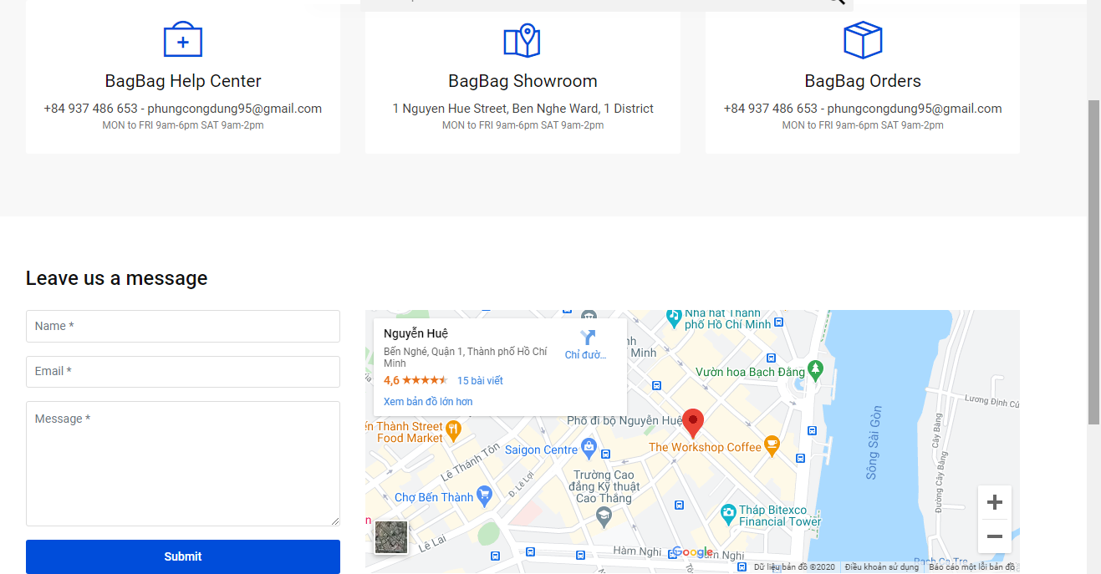

**C. Categories:**

Category: There are 2 main types of bags: Gucci And Louis Vuitton including women and men for customers to choose from.

Women

Shoulder bag

Tote bag

Clutch

Men

Backpack

Business

Travel

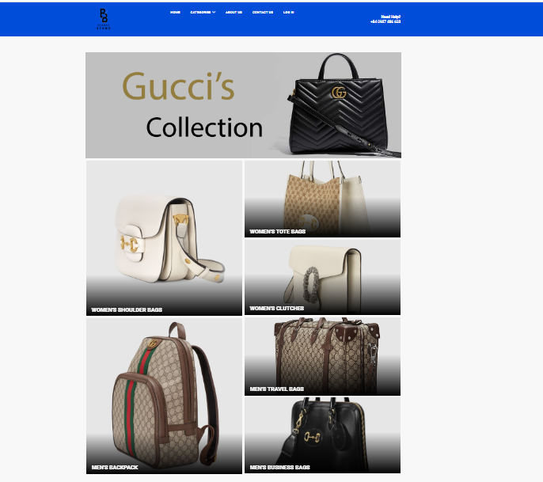

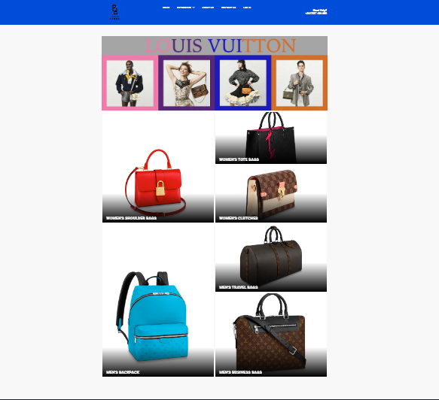

**D. About us:**

About the founder store

Main Products

Service and Quality

A Luxury Shopping Experience

Why Choose BagB**ag**

Meet BagBag Staff

* By clicking on our listing, the customer will know information about the historical founder, about the quality of service.
* The store's main products.

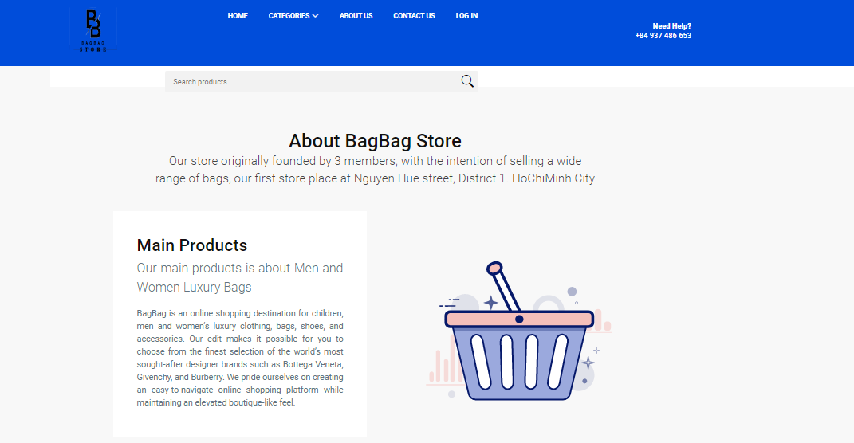

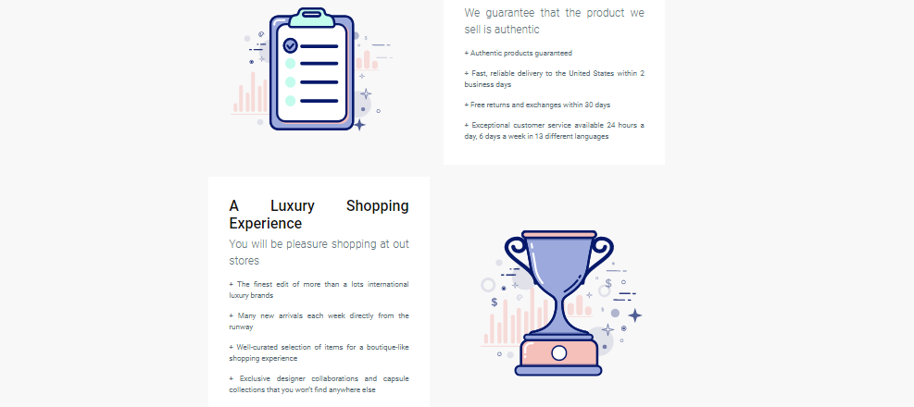

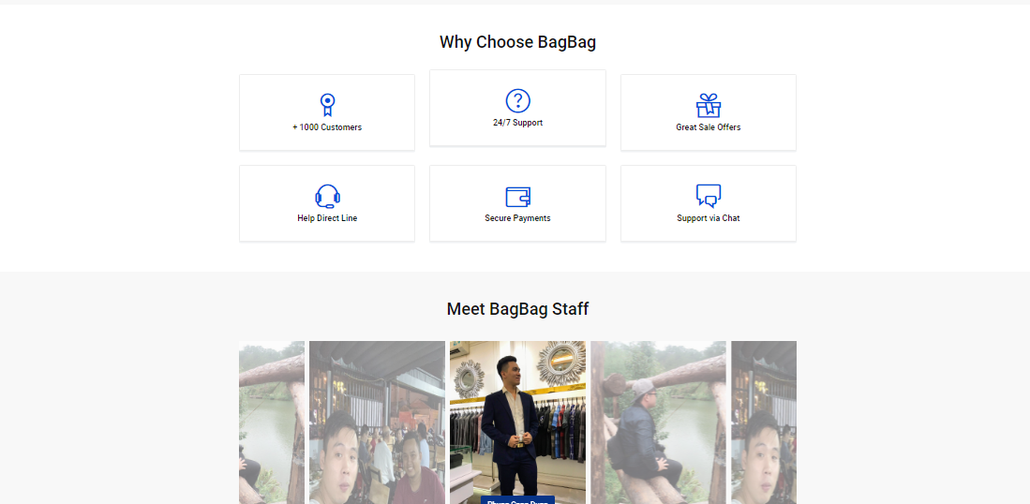

## E .Login:

* When you click on the log in entry, a web page will appear for you to login.
* You can create a store account using facebook, google or you can register an account on BagBag website

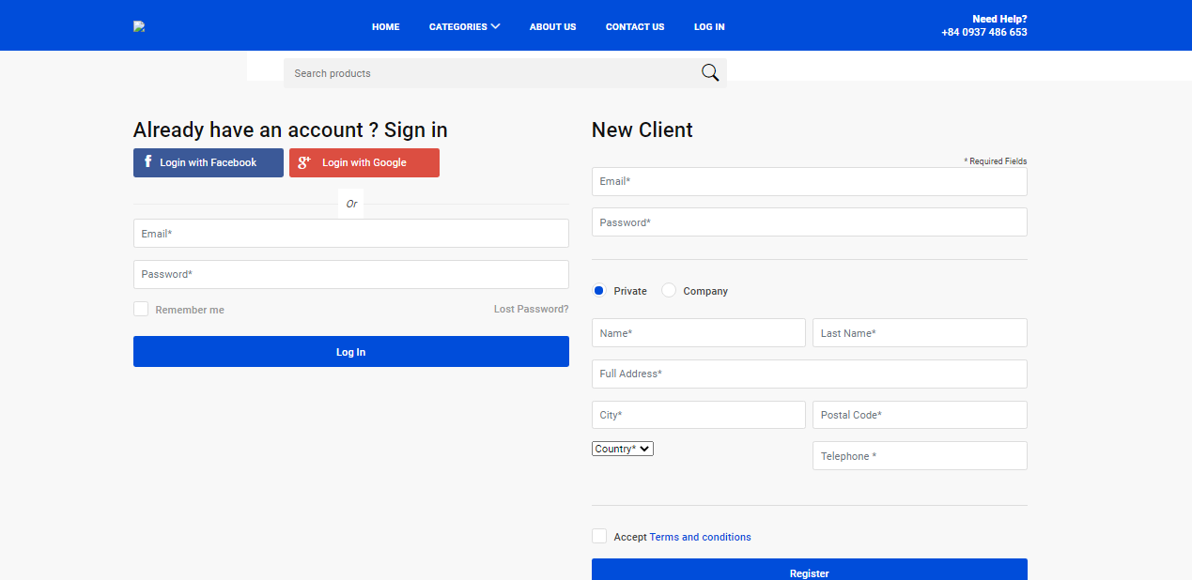

## F. Feedback:

When you enter the item to buy each product will have the item

Leave a review so that customers leave a review on that product, the item will pop up with that product feedback for us..

You can submit a photo of the rated product to the store.

Any feedback from you is the honor of the store

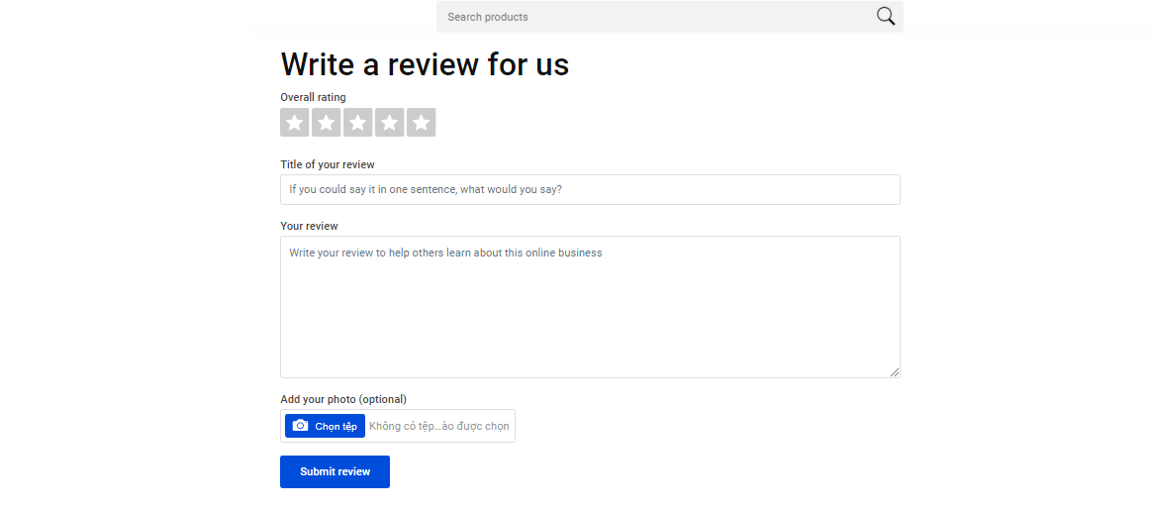

# 

# TIME MANAGEMENT

|  |  |  |  |  |  |  |  |
| --- | --- | --- | --- | --- | --- | --- | --- |
| **Project Ref. No.** | | **Project Title** | **Activity**  **Plan**  **Prepared by** | **Date of Preparation of Activity Plan** | | | |
| **Sr.**  **No** | **Task** | **Actual Start Date** | **Actual**  **Days** | **Team mate**  **Names** | **Status** |
| 1 | Design Contact Us page and coding  (include Geolocation  API) | BAGBAG STORE | Dũng  Tân  Vương | 07/09/2020 | 2 | Dũng  Tân  Vương | Completed |
| 2 | Design Feedback page, Query page and coding | BAGBAG STORE | Dũng  Tân  Vương | 09/09/2020 | 2 | Dũng  Tân | Complete |
| 3 | Design Account page and coding | BAGBAG STORE | Dũng  Tân  Vương | 11/09/2020 | 1 | Dũng  Tân | Completed |
| 4 | Design About us pages and coding (include Board Members, Staff  Directory, Careers  page) | BAGBAG STORE | Dũng  Tân | 12/09/2020 | 5 | Vương | Completed |
| 5 | Design Services pages and coding (include General Services,  Health checkup,  Specialities pages) | BAGBAG STORE | Dũng  Tân | 17/09/2020 | 3 | Dũng  Tân | Completed |
| 6 | Design Department pages and coding (include Help Desk, Doctor Schedule and Registration, Billing and Accounts page) | BAGBAG STORE | Dũng  Tân | 20/09/2020 | 5 | Dũng  Tân  Vương | Completed |
| 7 | Design Academics pages and coding (include Training programs, Research, Continuing Education page) | BAGBAG STORE | Dũng  Tân | 25/09/2020 | 2 | Dũng  Tân  Vương | Completed |
| 8 | Design Make an appointment area (Health Records page), Upcoming Event area (Event calendar and Online  Registration page) | BAGBAG STORE | Dũng  Tân  Vương | 27/09/2020 | 3 | Dũng  Tân | Completed |
| 9 | Design Facility area (Facility page, Demo  Facility page) | BAGBAG STORE | Dũng  Tân | 30/09/2020 | 2 | Dũng  Tân | Completed |
| 10 | Design For  Emergency area (About Emergency page, Emergency  Services page) | BAGBAG STORE | Dũng  Tân | 02/10/2020 | 1 | Dũng  Tân | Completed |
| 11 | Group pages together with links and update information | BAGBAG STORE | Dũng  Tân | 03/10/2020 | 1 | Vương | Completed |
| 12 | Test website in  different browsers | BAGBAG STORE | Dũng  Tân | 04/10/2020 | 1 | Vương | Completed |