**A Guide to Public-Use Research Data Sources Containing Race and Health Outcomes**

**Proposed list of authors in alpha order: Marcela Alsan, Cong Gian and Kosali Simon** [1]

**Table of Contents**

**Introduction** 3

**A. Description** 4

1. Behavioral Risk Factor Surveillance System (BRFSS) 4

2. Rand Health Retirement Study Longitudinal (HRS) 5

3. National Health and Nutrition Examination Survey (NHANES) 6

4. National Health Interview Survey (NHIS) 8

5. Medical Expenditure Panel Survey (MEPS) 9

**B. Comparison and harmonization of health variables across data sets** 12

**C. Stata Code** 17

**D. GitHub Storage and Sharing of Codes and Documents** 18

# **Introduction**

In this document, we provide a detailed guidance on obtaining and analyzing data from five nationally representative, public-use data sources collected by U.S. federal agencies, that contain information about race and health outcomes. This file accompanies the Excel document that provides a comparison of various features of the data sources. This is a “live” document to which we will continue adding more data sources in the following dimensions 1) ones that contain health insurance and health care access data (these five all do as well, but there are other data sets that, say, contain only health insurance and race); 2) ones that are non-public use but are not prohibitively expensive or prohibitively administratively difficult to obtain, and we will describe the data protection protocols in place; 3) ones that contain socioeconomic determinants of health (this will be a large potential set, including education, housing, correctional systems, etc). Please send us any suggestions you have for making this auseful resource.

# **A. Description**

## **1. Behavioral Risk Factor Surveillance System (BRFSS)**

* 1. Dataset Description:

(*From BRFSS website at* [*https://www.cdc.gov/brfss/index.html*](https://www.cdc.gov/brfss/index.html) *)*

“The Behavioral Risk Factor Surveillance System (BRFSS) is the nation's premier system of health-related telephone surveys that collect state data about U.S. residents regarding their health-related risk behaviors, chronic health conditions, and use of preventive services. Established in 1984 with 15 states, BRFSS now collects data in all 50 states as well as the District of Columbia and three U.S. territories. BRFSS completes more than 400,000 adult interviews each year, making it the largest continuously conducted health survey system in the world”

* 1. Years Available: 2007-2018
  2. Download instructions

1. Go to <https://www.cdc.gov/brfss/annual_data/annual_data.htm>
2. Click “*Year* Annual Survey Data.” You will then see a page like this. 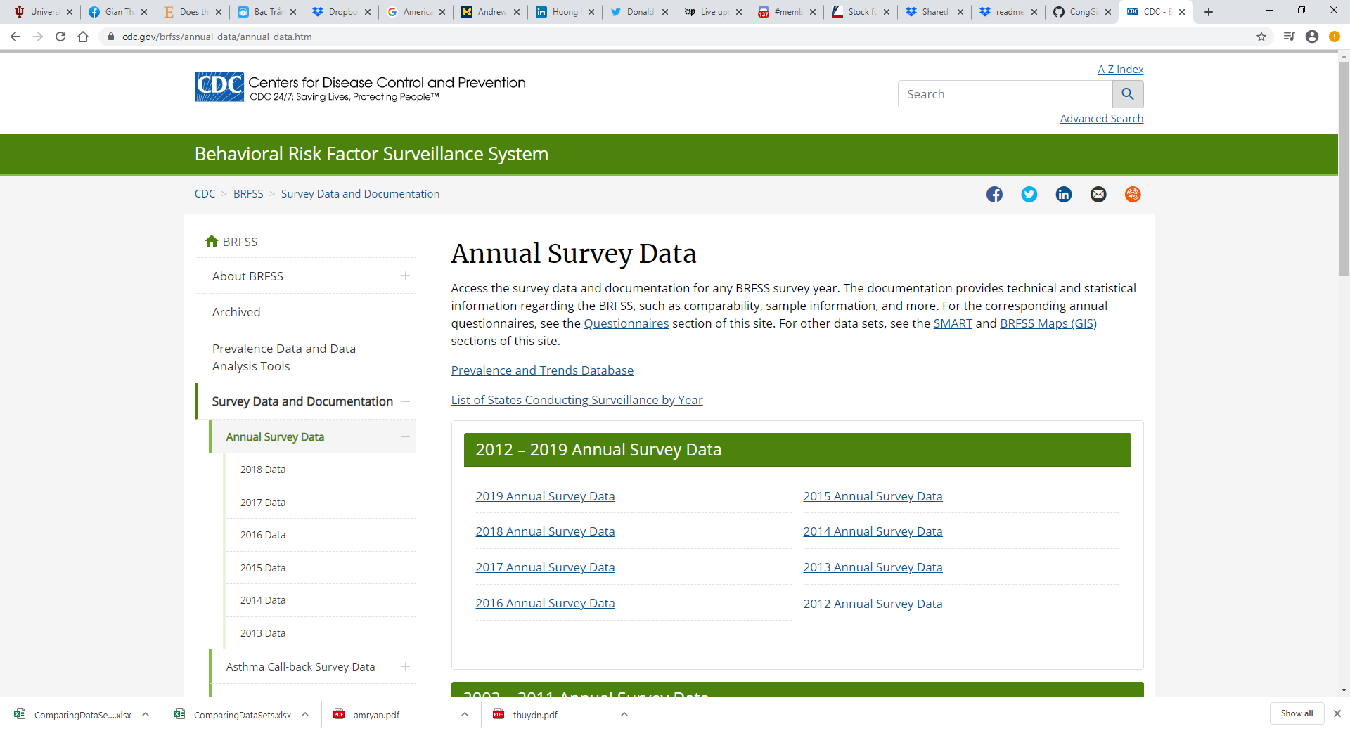
3. For each year, under the “Data Files” section, select the appropriate “*Year* BRFSS Data (SAS Transport Format)” Zip File. The correct download will look like below (for the year 20007)

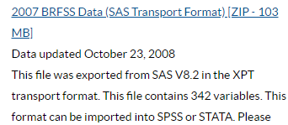

1. The Zip file should download automatically. Once it is finished, extract the .XTP data file and add it to the folder that contains raw data. Rename the raw files as needed to be consistent and to clearly denote the file year. An XPT file looks something like this

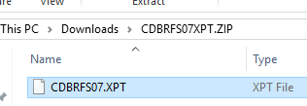

1. Repeat steps c) and d) for other years
2. Refer to the code in the Appendix to convert .xpt file to .dta file
3. Save .dta files to a raw data folder
   1. Notes for users of this dataset

“The [BRFSS Data User Guide](https://www.cdc.gov/brfss/data_documentation/pdf/UserguideJune2013.pdf) is intended to provide a brief overview of BRFSS to data users. Specific information regarding data quality, response and/or cooperation rates, or calling outcome can be found in the Summary Data Quality Report produced each year in conjunction with the annual data release. Data users needing more information about comparability across years should refer to the annual Comparability of Data document, particularly before using the data to conduct trend analyses”

* 1. References and papers

Disability, gender, and intimate partner violence: Relationships from the behavioral risk factor surveillance system ([Smith 2008](https://doi.org/10.1007/s11195-007-9064-6))

Demographic characteristics and health status of transgender adults in select US regions: Behavioral Risk Factor Surveillance System, 2014 ([Meyer et al. 2017](https://dx.doi.org/10.2105/AJPH.2016.303648))

Time trends in racial and ethnic disparities in asthma prevalence in the United States from the Behavioral Risk Factor Surveillance System (BRFSS) Study (1999-2011) ([Bhan et al. 2015](https://dx.doi.org/10.2105%2FAJPH.2014.302172))

## **2. Rand Health Retirement Study Longitudinal (HRS)**

* 1. Dataset Description

*(From HRS documentation)*

“The RAND HRS Longitudinal File is a cleaned, easy-to-use, and streamlined version of the Health and Retirement Study (HRS) core interviews, with derived variables covering a very large range of measures (demographics, health, health insurance, out-of-pocket medical expenditures, income, Social Security, pensions, wealth, family structure, retirement plans, expectations, employment history, etc.). Variables are named and derived consistently across waves, and any cross-wave differences are documented”

“The file includes imputations for income, assets, and medical expenditures developed at RAND. Every individual interviewed by HRS has a record in this file. As such, the RAND HRS Longitudinal File meets essential needs of most if not all research projects. However, we note that only a large subset of the core interview information is included. The file can easily be merged with other RAND HRS data products, as well as those released separately by HRS”

“The RAND HRS Longitudinal File 2016 (V1) includes 13 waves (1992-2016; and 1993 and 1995 of AHEAD) and all five entry cohorts: the initial 1992 Health and Retirement Study (HRS) cohort; the 1993 Study of Assets and Health Dynamics (AHEAD) cohort; the Children of Depression and War Baby cohorts entering in 1998; the Early Baby Boomer cohort entering in 2004; and the Mid Baby Boomer cohort entering in 2010)”.

* 1. Years available: 1992-2016
  2. Download Instruction

1. Go to <https://hrs.isr.umich.edu/data-products> and scroll down to the bottom left, then click the link to Register and Access Public Data; either log in if an existing user or register if a new user
2. Once logged in, go to the data downloads page which is linked to on the log in page
3. Click “RAND HRS Longitudinal File 2016 (v.1)” under the heading “Rand Contributed Files” on the right side of the page
4. Download randhrs1992_2016v1_STATA.zip
5. Unzip the .zip file and store the resulting .dta file in the “input_data” directory
6. Run panelrandhrs1992_2016.do. This results in a dataset called panelrandhrs1992_2016.dta. Variables are labeled almost identically to in the raw data, except changes due to data being in long rather than wide form. Variables are, with the exception of the wave variable and the year variable, in the order in which the documentation lists them. A note is attached to each variable describing from which section of the documentation they come, e.g., “Section A Demographics, identifiers, and weights”.
   1. References and papers

## **3. National Health and Nutrition Examination Survey (NHANES)**

* 1. Datasets Description

*(From NHANES website* <https://wwwn.cdc.gov/nchs/nhanes/default.aspx>)

“The National Health and Nutrition Examination Survey (NHANES) is a program of studies designed to assess the health and nutritional status of adults and children in the United States. The survey is unique in that it combines interviews and physical examinations. NHANES is a major program of the National Center for Health Statistics (NCHS). NCHS is part of the Centers for Disease Control and Prevention (CDC) and is responsible for producing vital and health statistics for the nation. In 1999, the survey became a continuous program that has a changing focus on a variety of health and nutrition measurements to meet emerging needs. The survey examines a nationally representative sample of about 5,000 people each year. These people are located in counties across the country, 15 of which are visited each year. The NHANES interview includes demographic, socioeconomic, dietary, and health-related questions. The examination component consists of medical, dental, and physiological measurements, as well as laboratory tests administered by highly trained medical personnel.”

* 1. Years available: 1999-2018
  2. Download instructions   
     *Health Condition Measures*

1. For health condition measures, the data are from the main questionnaire. Go to the link below for 1999-2000 data <https://wwwn.cdc.gov/nchs/nhanes/search/datapage.aspx?Component=Questionnaire&CycleBeginYear=1999>
2. Download the .xpt file (as indicated by the arrow) for each of the section of data that you are interested in. you can also download the .doc with variables descriptions for each of section
3. Repeat a) and b) for data in other years

Details are as follows:

|  |  |  |
| --- | --- | --- |
| Acculturation | [ACQ Doc](https://wwwn.cdc.gov/Nchs/Nhanes/1999-2000/ACQ.htm) | [ACQ Data [XPT - 629.2 KB]](https://wwwn.cdc.gov/Nchs/Nhanes/1999-2000/ACQ.XPT) |
| Alcohol Use | [ALQ Doc](https://wwwn.cdc.gov/Nchs/Nhanes/1999-2000/ALQ.htm) | [ALQ Data [XPT - 314.5 KB]](https://wwwn.cdc.gov/Nchs/Nhanes/1999-2000/ALQ.XPT) |
| Analgesic Pain Relievers | [RXQ_ANA Doc](https://wwwn.cdc.gov/Nchs/Nhanes/1999-2000/RXQ_ANA.htm) | [RXQ_ANA Data [XPT - 279.2 KB]](https://wwwn.cdc.gov/Nchs/Nhanes/1999-2000/RXQ_ANA.XPT) |
| Audiometry | [AUQ Doc](https://wwwn.cdc.gov/Nchs/Nhanes/1999-2000/AUQ.htm) | [AUQ Data [XPT - 966.6 KB]](https://wwwn.cdc.gov/Nchs/Nhanes/1999-2000/AUQ.XPT) |
| Balance | [BAQ Doc](https://wwwn.cdc.gov/Nchs/Nhanes/1999-2000/BAQ.htm) | [BAQ Data [XPT - 601.2 KB]](https://wwwn.cdc.gov/Nchs/Nhanes/1999-2000/BAQ.XPT) |
| Blood Pressure & Cholesterol | [BPQ Doc](https://wwwn.cdc.gov/Nchs/Nhanes/1999-2000/BPQ.htm) | [BPQ Data [XPT - 1.7 MB]](https://wwwn.cdc.gov/Nchs/Nhanes/1999-2000/BPQ.XPT) |
| Cardiovascular Health | [CDQ Doc](https://wwwn.cdc.gov/Nchs/Nhanes/1999-2000/CDQ.htm) | [CDQ Data [XPT - 250.9 KB]](https://wwwn.cdc.gov/Nchs/Nhanes/1999-2000/CDQ.XPT) |
| Cognitive Functioning | [CFQ Doc](https://wwwn.cdc.gov/Nchs/Nhanes/1999-2000/CFQ.htm) | [CFQ Data [XPT - 116.5 KB]](https://wwwn.cdc.gov/Nchs/Nhanes/1999-2000/CFQ.XPT) |
| Current Health Status | [HSQ Doc](https://wwwn.cdc.gov/Nchs/Nhanes/1999-2000/HSQ.htm) | [HSQ Data [XPT - 553.8 KB]](https://wwwn.cdc.gov/Nchs/Nhanes/1999-2000/HSQ.XPT) |
| Dermatology | [DEQ Doc](https://wwwn.cdc.gov/Nchs/Nhanes/1999-2000/DEQ.htm) | [DEQ Data [XPT - 3.5 MB]](https://wwwn.cdc.gov/Nchs/Nhanes/1999-2000/DEQ.XPT) |
| Diabetes | [DIQ Doc](https://wwwn.cdc.gov/Nchs/Nhanes/1999-2000/DIQ.htm) | [DIQ Data [XPT - 1.2 MB]](https://wwwn.cdc.gov/Nchs/Nhanes/1999-2000/DIQ.XPT) |
| Diet Behavior & Nutrition | [DBQ Doc](https://wwwn.cdc.gov/Nchs/Nhanes/1999-2000/DBQ.htm) | [DBQ Data [XPT - 3.5 MB]](https://wwwn.cdc.gov/Nchs/Nhanes/1999-2000/DBQ.XPT) |
| Drug Use | [DUQ Doc](https://wwwn.cdc.gov/Nchs/Nhanes/1999-2000/DUQ.htm) | [DUQ Data [XPT - 112.3 KB]](https://wwwn.cdc.gov/Nchs/Nhanes/1999-2000/DUQ.XPT) |
| Early Childhood | [ECQ Doc](https://wwwn.cdc.gov/Nchs/Nhanes/1999-2000/ECQ.htm) | [ECQ Data [XPT - 462.3 KB]](https://wwwn.cdc.gov/Nchs/Nhanes/1999-2000/ECQ.XPT) |
| Food Security | [FSQ Doc](https://wwwn.cdc.gov/Nchs/Nhanes/1999-2000/FSQ.htm) | [FSQ Data [XPT - 1.2 MB]](https://wwwn.cdc.gov/Nchs/Nhanes/1999-2000/FSQ.XPT) |
| Health Insurance | [HIQ Doc](https://wwwn.cdc.gov/Nchs/Nhanes/1999-2000/HIQ.htm) | [HIQ Data [XPT - 780.6 KB]](https://wwwn.cdc.gov/Nchs/Nhanes/1999-2000/HIQ.XPT) |
| Hospital Utilization & Access to Care | [HUQ Doc](https://wwwn.cdc.gov/Nchs/Nhanes/1999-2000/HUQ.htm) | [HUQ Data [XPT - 780.6 KB]](https://wwwn.cdc.gov/Nchs/Nhanes/1999-2000/HUQ.XPT) |
| Housing Characteristics | [HOQ Doc](https://wwwn.cdc.gov/Nchs/Nhanes/1999-2000/HOQ.htm) | [HOQ Data [XPT - 1.3 MB]](https://wwwn.cdc.gov/Nchs/Nhanes/1999-2000/HOQ.XPT) |
| Immunization | [IMQ Doc](https://wwwn.cdc.gov/Nchs/Nhanes/1999-2000/IMQ.htm) | [IMQ Data [XPT - 312.7 KB]](https://wwwn.cdc.gov/Nchs/Nhanes/1999-2000/IMQ.XPT) |
| Kidney Conditions | [KIQ Doc](https://wwwn.cdc.gov/Nchs/Nhanes/1999-2000/KIQ.htm) | [KIQ Data [XPT - 804.2 KB]](https://wwwn.cdc.gov/Nchs/Nhanes/1999-2000/KIQ.XPT) |
| Medical Conditions | [MCQ Doc](https://wwwn.cdc.gov/Nchs/Nhanes/1999-2000/MCQ.htm) | [MCQ Data [XPT - 12.1 MB]](https://wwwn.cdc.gov/Nchs/Nhanes/1999-2000/MCQ.XPT) |
| Mental Health - Depression | [CIQMDEP Doc](https://wwwn.cdc.gov/Nchs/Nhanes/1999-2000/CIQMDEP.htm) | [CIQMDEP Data [XPT - 1.1 MB]](https://wwwn.cdc.gov/Nchs/Nhanes/1999-2000/CIQMDEP.XPT) |
| Mental Health - Generalized Anxiety Disorder | [CIQGAD Doc](https://wwwn.cdc.gov/Nchs/Nhanes/1999-2000/CIQGAD.htm) | [CIQGAD Data [XPT - 765.2 KB]](https://wwwn.cdc.gov/Nchs/Nhanes/1999-2000/CIQGAD.XPT) |
| Mental Health - Panic Disorder | [CIQPANIC Doc](https://wwwn.cdc.gov/Nchs/Nhanes/1999-2000/CIQPANIC.htm) | [CIQPANIC Data [XPT - 1.2 MB]](https://wwwn.cdc.gov/Nchs/Nhanes/1999-2000/CIQPANIC.XPT) |
| Miscellaneous Pain | [MPQ Doc](https://wwwn.cdc.gov/Nchs/Nhanes/1999-2000/MPQ.htm) | [MPQ Data [XPT - 2.2 MB]](https://wwwn.cdc.gov/Nchs/Nhanes/1999-2000/MPQ.XPT) |
| Occupation | [OCQ Doc](https://wwwn.cdc.gov/Nchs/Nhanes/1999-2000/OCQ.htm) | [OCQ Data [XPT - 2 MB]](https://wwwn.cdc.gov/Nchs/Nhanes/1999-2000/OCQ.XPT) |
| Oral Health | [OHQ Doc](https://wwwn.cdc.gov/Nchs/Nhanes/1999-2000/OHQ.htm) | [OHQ Data [XPT - 1012.2 KB]](https://wwwn.cdc.gov/Nchs/Nhanes/1999-2000/OHQ.XPT) |
| Osteoporosis | [OSQ Doc](https://wwwn.cdc.gov/Nchs/Nhanes/1999-2000/OSQ.htm) | [OSQ Data [XPT - 2 MB]](https://wwwn.cdc.gov/Nchs/Nhanes/1999-2000/OSQ.XPT) |
| Pesticide Use | [PUQ Doc](https://wwwn.cdc.gov/Nchs/Nhanes/1999-2000/PUQ.htm) | [PUQ Data [XPT - 1.1 MB]](https://wwwn.cdc.gov/Nchs/Nhanes/1999-2000/PUQ.XPT) |
| Physical Activity | [PAQ Doc](https://wwwn.cdc.gov/Nchs/Nhanes/1999-2000/PAQ.htm) | [PAQ Data [XPT - 1.5 MB]](https://wwwn.cdc.gov/Nchs/Nhanes/1999-2000/PAQ.XPT) |
| Physical Activity - Individual Activities | [PAQIAF Doc](https://wwwn.cdc.gov/Nchs/Nhanes/1999-2000/PAQIAF.htm) | [PAQIAF Data [XPT - 508.5 KB]](https://wwwn.cdc.gov/Nchs/Nhanes/1999-2000/PAQIAF.XPT) |
| Physical Functioning | [PFQ Doc](https://wwwn.cdc.gov/Nchs/Nhanes/1999-2000/PFQ.htm) | [PFQ Data [XPT - 6.7 MB]](https://wwwn.cdc.gov/Nchs/Nhanes/1999-2000/PFQ.XPT) |
| Prescription Medications | [RXQ_RX Doc](https://wwwn.cdc.gov/Nchs/Nhanes/1999-2000/RXQ_RX.htm) | [RXQ_RX Data [XPT - 3 MB]](https://wwwn.cdc.gov/Nchs/Nhanes/1999-2000/RXQ_RX.XPT) |
| Prescription Medications - Drug Information | [RXQ_DRUG Doc](https://wwwn.cdc.gov/Nchs/Nhanes/1999-2000/RXQ_DRUG.htm) | [RXQ_DRUG Data [XPT - 2.6 KB]](https://wwwn.cdc.gov/Nchs/Nhanes/1999-2000/RXQ_DRUG.xpt) |
| Reproductive Health | [RHQ Doc](https://wwwn.cdc.gov/Nchs/Nhanes/1999-2000/RHQ.htm) | [RHQ Data [XPT - 2.5 MB]](https://wwwn.cdc.gov/Nchs/Nhanes/1999-2000/RHQ.XPT) |
| Respiratory Health | [RDQ Doc](https://wwwn.cdc.gov/Nchs/Nhanes/1999-2000/RDQ.htm) | [RDQ Data [XPT - 1.4 MB]](https://wwwn.cdc.gov/Nchs/Nhanes/1999-2000/RDQ.XPT) |
| Sexual Behavior | [SXQ Doc](https://wwwn.cdc.gov/Nchs/Nhanes/1999-2000/SXQ.htm) | [SXQ Data [XPT - 402.3 KB]](https://wwwn.cdc.gov/Nchs/Nhanes/1999-2000/SXQ.XPT) |
| Smoking - Adult Recent Tobacco Use & Youth Cigarette/Tobacco Use | [SMQMEC Doc](https://wwwn.cdc.gov/Nchs/Nhanes/1999-2000/SMQMEC.htm) | [SMQMEC Data [XPT - 2.2 MB]](https://wwwn.cdc.gov/Nchs/Nhanes/1999-2000/SMQMEC.XPT) |
| Smoking - Cigarette/Tobacco Use - Adult | [SMQ Doc](https://wwwn.cdc.gov/Nchs/Nhanes/1999-2000/SMQ.htm) | [SMQ Data [XPT - 1.7 MB]](https://wwwn.cdc.gov/Nchs/Nhanes/1999-2000/SMQ.XPT) |
| Smoking - Household Smokers | [SMQFAM Doc](https://wwwn.cdc.gov/Nchs/Nhanes/1999-2000/SMQFAM.htm) | [SMQFAM Data [XPT - 702.7 KB]](https://wwwn.cdc.gov/Nchs/Nhanes/1999-2000/SMQFAM.XPT) |
| Social Support | [SSQ Doc](https://wwwn.cdc.gov/Nchs/Nhanes/1999-2000/SSQ.htm) | [SSQ Data [XPT - 290 KB]](https://wwwn.cdc.gov/Nchs/Nhanes/1999-2000/SSQ.XPT) |
| Tuberculosis | [TBQ Doc](https://wwwn.cdc.gov/Nchs/Nhanes/1999-2000/TBQ.htm) | [TBQ Data [XPT - 520.9 KB]](https://wwwn.cdc.gov/Nchs/Nhanes/1999-2000/TBQ.XPT) |
| Vision | [VIQ Doc](https://wwwn.cdc.gov/Nchs/Nhanes/1999-2000/VIQ.htm) | [VIQ Data [XPT - 229.2 KB]](https://wwwn.cdc.gov/Nchs/Nhanes/1999-2000/VIQ.XPT) |
| Weight History | [WHQ Doc](https://wwwn.cdc.gov/Nchs/Nhanes/1999-2000/WHQ.htm) | [WHQ Data [XPT - 2 MB]](https://wwwn.cdc.gov/Nchs/Nhanes/1999-2000/WHQ.XPT) |

*Demographic information*

1. Demographic information is from a different questionnaire. In order to retrieve information of age, gender, race, ect.,go to the link below <https://wwwn.cdc.gov/nchs/nhanes/Search/DataPage.aspx?Component=Demographics&CycleBeginYear=1999>
2. Download the XPT file (as indicated by the arrow)
3. Repeat a) and (b) for data in other years

| **Data File Name** | **Doc File** | **Data File** | **Date Published** |
| --- | --- | --- | --- |
| Demographic Variables & Sample Weights | [DEMO Doc](https://wwwn.cdc.gov/Nchs/Nhanes/1999-2000/DEMO.htm) | [DEMO Data [XPT - 11 MB]](https://wwwn.cdc.gov/Nchs/Nhanes/1999-2000/DEMO.XPT) | Updated September 2009 |

*Other health related information*

NHANES also provide data from other modules including Dietary, Examination, Laboratory, and Other Limited Access data. Each module has a corresponding data sets for all the years NHANES was conducted

* 1. References and Papers

## **4. National Health Interview Survey (NHIS)**

* 1. Dataset Description

“The National Health Interview Survey (NHIS) has monitored the health of the nation since 1957. NHIS data on a broad range of health topics are collected through personal household interviews. For over 50 years, the U.S. Census Bureau has been the data collection agent for the National Health Interview Survey. Survey results have been instrumental in providing data to track health status, health care access, and progress toward achieving national health objectives”

* 1. Years available: 1994-2018
  2. Download instructions

*Health conditions*

1. Go to <https://nhis.ipums.org/nhis-action/data_requests/download>.
2. Select “all samples” to get a long series of years
3. Select the tab “person” for person-level variables (not “household”)
4. Select all health conditions that seemed to be asked all years from 1994 onwards. Please see the picture below

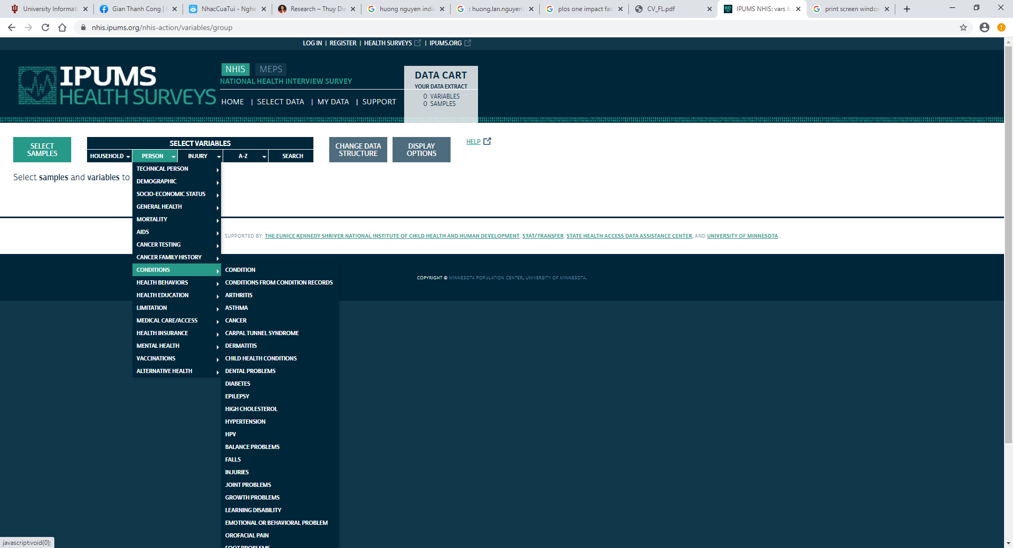

*Demographic information*

1. Select demographic tab that contains age, race and gender variables
2. Submit a request and wait until IPUMS notifies of the availability of download
3. Download .dat and the Stata code from the download page
4. Open the Stata code to read the .dta file.
5. Save the .dta file into a raw data folder
   1. References and Papers

**Lynn A. Blewett, Julia A. Rivera Drew, Miriam L. King and Kari C.W. Williams. IPUMS Health Surveys: National Health Interview Survey, Version 6.4 [dataset]. Minneapolis, MN: IPUMS, 2019.**<https://doi.org/10.18128/D070.V6.4>

## **5. Medical Expenditure Panel Survey (MEPS)**

* 1. Dataset Description

From MEPS website: “The Medical Expenditure Panel Survey, which began in 1996, is a set of large-scale surveys of families and individuals, their medical providers (doctors, hospitals, pharmacies, etc.), and employers across the United States. MEPS collects data on the specific health services that Americans use, how frequently they use them, the cost of these services, and how they are paid for, as well as data on the cost, scope, and breadth of health insurance held by and available to U.S. workers”

* 1. Years Available: 1996-2017
  2. Download Instructions

1. Go to <https://healthsurveys.ipums.org/>
2. Select “all samples” to get a long series of years
3. Select the tab “person” for person-level variables (not “household”)
4. Select all health conditions. Selected variables from annual, not round option. That should make this like a repeated cross section of sorts. Of course person id is available to link peoples answers from one year to the next but if doing longitudinal work, it would be much better to do round level

Please see the picture below

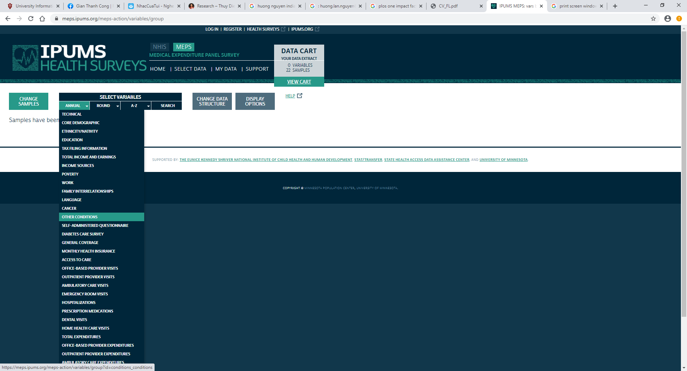

*Demographic information*

1. Select demographic tab that contains age, race and gender variables
2. Submit a request and wait until IPUMS notifies of the availability of download
3. Download .dat and the Stata code from the download page
4. Open the Stata code to read the .dta file.
5. Save the .dta file into a raw data folder
   1. References and Papers

**Lynn A. Blewett, Julia A. Rivera Drew, Risa Griffin and Kari C.W. Williams. IPUMS Health Surveys: Medical Expenditure Panel Survey, Version 1.1 [dataset]. Minneapolis, MN: IPUMS, 2019.**<https://doi.org/10.18128/D071.V1.1>

# **B. Comparison and harmonization of health variables across data sets**

|  |  |  |  |  |  |
| --- | --- | --- | --- | --- | --- |
|  | **Behavioral Risk Factor Surveillance System** | **National Health Interview Survey** | **National Health and Nutrition Examination Survey** | **Medical Expenditure Panel Survey** | **Health Retirement Survey** |
| **Health Measures** | | | | | | |
| **Asthma** | **Variable/Question** *(asthma2)*: *Have you ever been told by a doctor, nurse, or other health professional that you had asthma?* | **Variable/Question** (*Asthmaev)*: *Ever told to have asthma before?* | **Variable/Question** (*MCQ010): Ever been told you have asthma?* | **Variable/Question** (*Asthmaev): Ever told to have asthma before*? | **Variable/Question** (*rheart)* |
| *if new interview "Ever told to have diabetes before?"* |
| *If reinterviewed and no condition**"Since we last talked to you, that is since [last interview date], has a doctor told you that you have"* |
| *if**reinterviewed and had condition " "Our records from your last interview show that you have had"* |
| *Categories: 1- Yes; 2- No; 7-Don't Know/Not Sure; 9- Refused to answer* | *Categories 0-niu; 1- no or not mentioned; 2-- Yes; 7-Unknown- Refused; 8-Unknown- Not certain; 9- Unknown- Don’t know* | *Categories: 1-Yes; 2-No; 7-Refused; 9-Don't know* | *Categories: 0- niu; 1- no or not mentioned; 2- Yes; 7-Unknown- Refused; 8-Unknown- Not certain; 9- Unknown- Don’t know* | *Categories 1-no; 2-- Yes;3- Disp prev record and has cond; 4- Disp prev record and no cond; 5- Disp prev record (DK if cond)* |
| **Cancer** | **Variable/Question**: (*cncrhave* for 2009-2010 and *chcocncr* for 2011-2018): *Ever told you had cancer before ?* | **Variable/Question (***cancerev***):** *Ever told you had cancer before  ?* | **Variable/Question (***mcq220***)**  *Ever told you had cancer or malignancy?* | **Variable/Question (***cancerev***):** *Ever told you had cancer before ?* | **Variable/Question** (*rheart)* |
| *if new interview "Ever told to have diabetes before?"* |
| *If reinterviewed and no condition**"Since we last talked to you, that is since [last interview date], has a doctor told you that you have"* |
| *if**reinterviewed and had condition " "Our records from your last interview show that you have had"* |
| ***Categories****: 1- Yes;2- No; 7-Don’t know/Not Sure—Go to next module; 9- Refused—Go to next module; Blank- Not asked or Missing* | ***Categories****: 0- niu;1- Yes;2- No; 7- Unknown - Refused; 8- Unknown- Not ascertained; 9- Unknown - Don't know* | ***Categories****: 1 Yes;2 No;7 Refused;9 Don't know; . Missing* | ***Categories****: 0- niu; 1- Yes; 2- No; 7- Unknown - Refused; 8- Unknown - Not ascertained; 9- Unknown- Don't know* | ***Categories:*** *1-no; 2-- Yes; 3- Disp prev record and has cond; 4- Disp prev record and no cond; 5- Disp prev record (DK if cond)* |
| ***Skin cancer exclusion****: reliance on type of cancer (cncrtype for 2009-2010) and ever being told to have skin cancer (chcscncr for 2011-2018)* | ***Skin cancer exclusion****: reliance on having skin cancer questions (cnskdk cnsknm cnsoft): ever being told to have skin cancer, or non-melanoma, or soft tissue cancer)* | ***Skin cancer exclusion****: Reliance on cancer type questions( mcq230a, mcq230b, mcq230c, mcq230d). Skin cancer categories-non-melanoma, soft tissue excluded* | ***Skin cancer exclusion****: reliance on having skin cancer questions (cnskdk cnsknmag cnstom): ever being told to have skin cancer, or non-melanoma, or soft tissue cancer))* | ***Skin cancer exclusion*** *is not feasible* |
| **Obesity** | **Variable/Question** *(diabete2)*: *Have you ever been told by a doctor that you have diabetes?* | **Variable/Question** (*diabeticev) : Ever told to have diabetes before* | **Variable/Question**(*DIQ010*): *Doctor told you have diabetes?* | **Variable/Question** (*diabeticev) :* Ever told to have diabetes before | **Variable/Question** (*rdiab)* |
| *if new interview "Ever told to have diabetes before?"* |
| *If reinterviewed and no condition**"Since we last talked to you, that is since [last interview date], has a doctor told you that you have"* |
| *if**reinterviewed and had condition " "Our records from your last interview show that you have had"* |
| ***Categories****: 1- Yes; 2- Yes, but female told only during pregnancy; 3- No; 4- No, pre-diabetes or borderline diabetes; 7-Don’t know; 9- Not Sure* | ***Categories:*** *0-niu; 1- no or not mentioned; 2-- Yes; 3- Borderline; 7-Unknown- Refused; 8-Unknown- Not certained; 9- Unknown- Don’t know* | ***Categories****:1-Yes; 2-No; 3-Borderline; 7-Refused; 9-Don't know; . Missing* | ***Categories*** *0-niu; 1- no or not mentioned; 2-- Yes; 3- Borderline; 7-Unknown- Refused; 8-Unknown- Not certained; 9- Unknown- Don’t know* | ***Categories:*** *1-no; 2-- Yes; 3- Disp prev record and has cond; 4- Disp prev record and no cond; 5- Disp prev record (DK if cond)* |
| **Heart Disease** | **Variable/Question** (*CVDCRHD4):* *Has a doctor, nurse, or other health professional ever told you had angina or coronary heart disease?* | **Variable/Question** (*cheartdiev) : Ever told to have corona heart disease before?* | **Variable/Question (***MCQ160c)* - *Ever told you had coronary heart disease* | **Variable/Question** (*cheartdiev): Ever told to have corona heart disease before* | **Variable/Question** (*rheart)* |
| *if new interview "Ever told to have diabetes before?"* |
| *If reinterviewed and no condition**"Since we last talked to you, that is since [last interview date], has a doctor told you that you have"* |
| *if**reinterviewed and had condition " "Our records from your last interview show that you have had"* |
| ***Categories****: 1-Yes; 2- No; 7- Don't know/Not Sure; 9- Refused* | ***Categories*** *0-niu; 1- no or not mentioned; 2-- Yes; 3- Borderline; 7-Unknown- Refused; 8-Unknown- Not certain; 9- Unknown- Don’t know* | ***Categories****:1 Yes; 2 No; 7 Refused; 9 Don't know; . Missing* | ***Categories:*** *0-niu; 1- no or not mentioned; 2-- Yes; 3- Borderline; 7-Unknown- Refused; 8-Unknown- Not certain; 9- Unknown- Don’t know* | ***Categories:*** *1-no; 2-- Yes; 3- Disp prev record and has cond; 4- Disp prev record and no cond; 5- Disp prev record (DK if cond)* |
| **Hyper-tension** | **Variable/Question:** (*BPHIGH4*) *Have you EVER been told by a doctor, nurse or other health professional that you have high blood pressure?* | **Variable/Question** (*hypertenev) :* *Ever told to hyper tension before* | **Variable/Question**: *BPQ020* : *Ever told you had high blood pressure* | **Variable/Question** (*hypertenev) - Ever told to hyper tension before* | **Variable/Question** (*rhibp)* |
| *if new interview "Ever told to have diabetes before?"* |
| *If reinterviewed and no condition**"Since we last talked to you, that is since [last interview date], has a doctor told you that you have"* |
| *if**reinterviewed and had condition " "Our records from your last interview show that you have had"* |
| ***Categories****: 1-Yes; 2- Yes, but female told only during pregnancy; 3- No; 4- Told borderline high or pre-hypertensive; 7- Don´t know/Not Sure; 9- Refused* | ***Categories:*** *0-niu; 1- no or not mentioned; 2-- Yes; 3- Borderline;7-Unknown- Refused; 8-Unknown- Not certain; 9- Unknown- Don’t know* | ***Categories:*** *1 Yes; 2 No; 7 Refused; 9 Don't know; . Missing* | ***Categories:*** *0-niu; 1- no or not mentioned; 2-- Yes; 3- Borderline; 7-Unknown- Refused; 8-Unknown- Not certain; 9- Unknown- Don’t know* | ***Categories:*** *1-no; 2-- Yes; 3- Disp prev record and has cond; 4- Disp prev record and no cond; 5- Disp prev record (DK if cond)* |
| **Demographic Variable** | | | | | | |
| Age | 1--85 & above | 0-99 | 1--85 & above | 0-99 | 50 and above |
| Race/ Ethnicity | race/ethnicity variable | From questions of race back ground and Hispanic origin | race/ethnicity variable | From questions of race back ground and Hispanic origin | From questions of race back ground and Hispanic origin |
| Sex | Male/Female | Male/Female | Male/Female | Male/Female | Male/Female |
| **Other Notes** | | | | | | |
| **Years Health Conditions Measure Available** | 2009-2018 | 1997-2018 | 1999-2018 (2-year period) | 2007-2017 | 1992-2018 |
| **Geographic variable availability** | State ID available in public use version | State or county ID can be obtained by applying to https://www.cdc.gov/rdc/B2AccessMod/ACs220.htm (to use at a RDC site) | State or county ID can be obtained by applying to https://www.cdc.gov/rdc/b1datatype/Dt1222.htm | State or county ID can be obtained by applying to https://www.cdc.gov/rdc/B2AccessMod/ACs220.htm (to use at a RDC site) | State or county ID can be obtained by applying to https://meps.ahrq.gov/mepsweb/data_stats/onsite_datacenter.jsp?# (to use at a RDC site) |
| **Sample Size** | Approximately 450,000 individuals/year | Approximately 100,000 individuals / year | Approximately 10,000 individuals / year | Approximately 35,000 individuals / year | Approximately 42,000 individuals / year |

# **C. Stata Code**

Most of the files downloaded are in SAS format. This section introduces the Stata codes to convert them in to Stata file

In Stata, use *fdause* command to convert a SAS file to a DTA file.

The code below gives an example of how to use the command to convert .xpt files from NHANES data in to .dta files

**Details as follows**

* Author: Cong GIan (6/15/20)

** Converting SAS file to Stata file

** Change local macro to include other periods after 1999-2000

local yr "1999_2000"

foreach yr in `yr' {

dis "`yr'"

*Change the current directory to the folder in which the .xpt files are located

cd "I:\NHANES\Raw Data\\`yr'"

local filelist: dir . files "*.xpt"

dis `filelist'

}

local yr "1999_2000"

foreach yr in `yr' {

foreach file in `filelist' {

clear

fdause `file'

local filename = substr("`file'", 1, strpos("`file'", ".") -1)

save "I:\NHANES\Gen Data\\`yr'\\`filename'.dta", replace

}

}

# **D. GitHub Storage and Sharing of Codes and Documents**

Link <https://github.com/CongGian/racehealthdatasets>

(Snap shot is below)

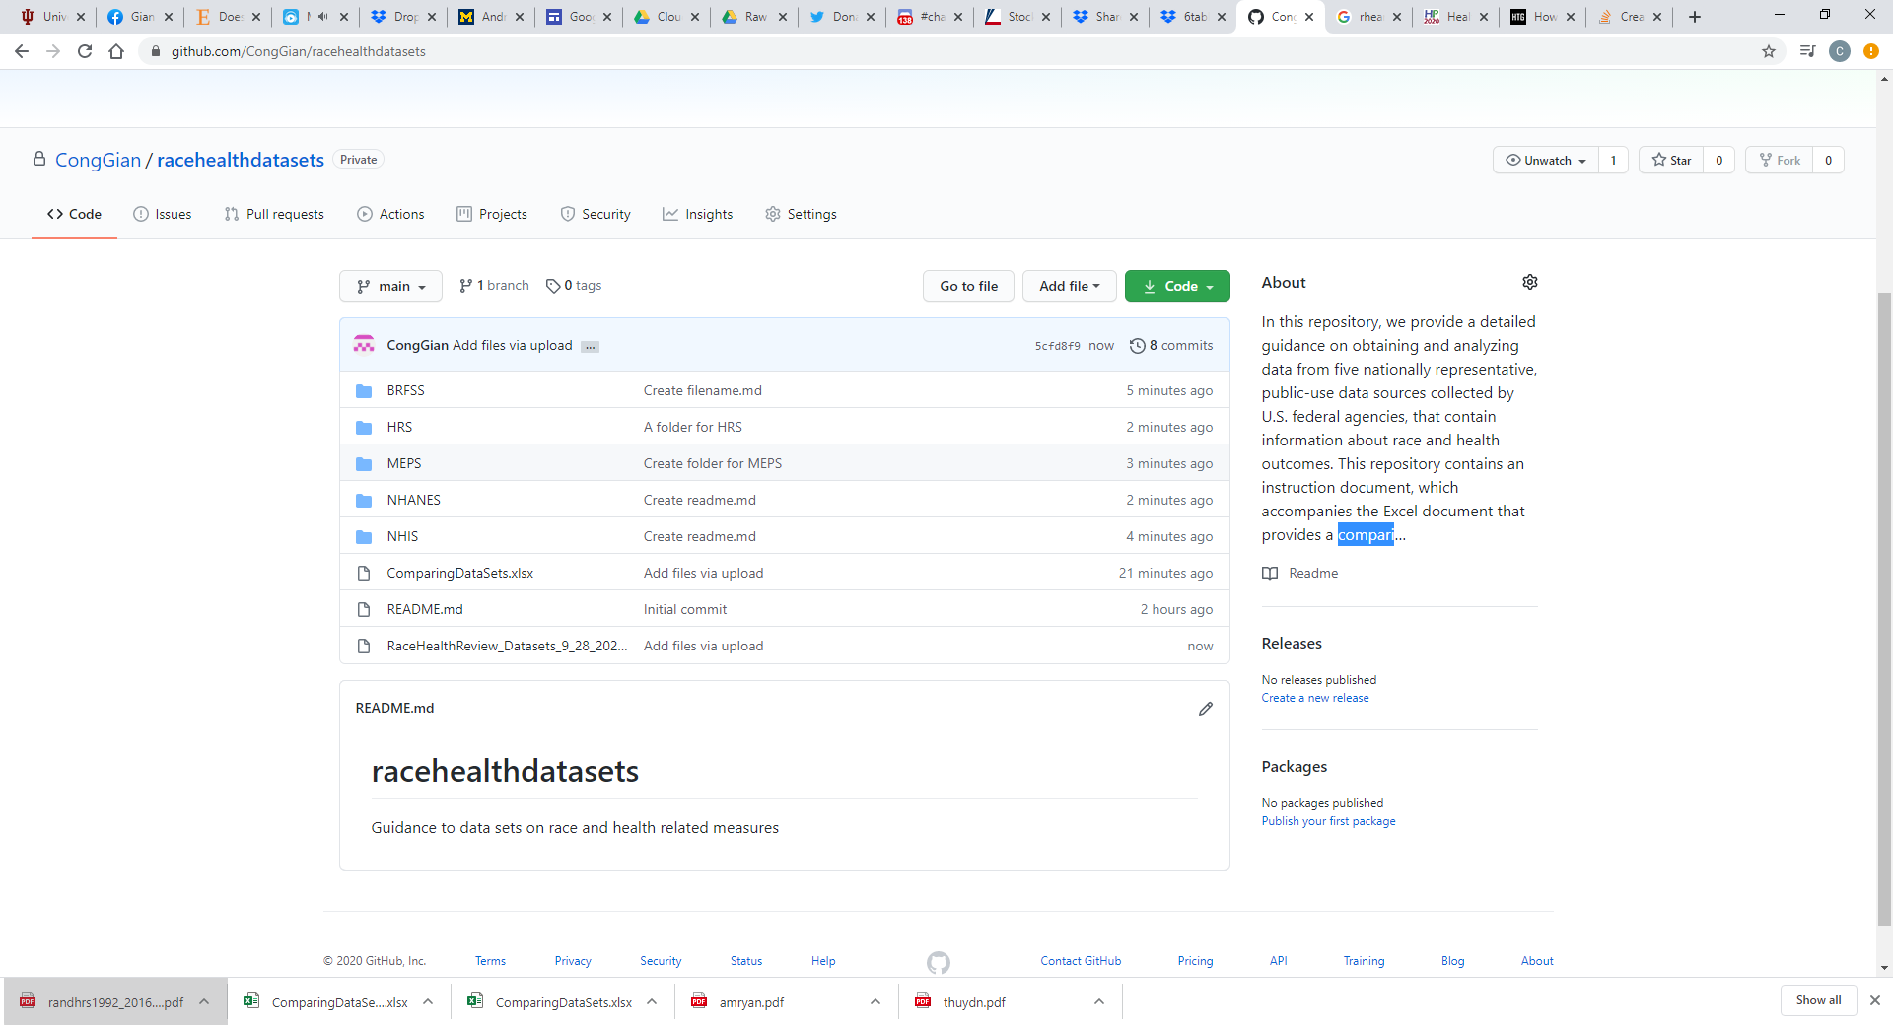

1. Emails: [marcella_alsan@hks.harvard.edu](mailto:marcella_alsan@hks.harvard.edu); [tgian@indiana.edu](mailto:tgian@indiana.edu); [simonkos@indiana.edu](mailto:simonkos@indiana.edu). We thank Livia Crim, Ruth Winecoff, and especially Nikhil Shankar for their help with the data sets included in this compilation.