1. Shrimp and Cucumber Canapes

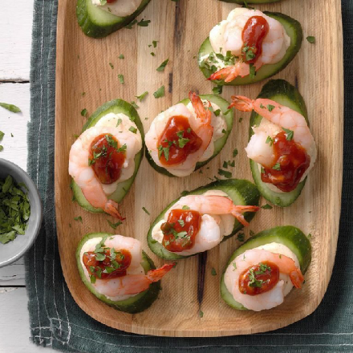

Des: These cute stacks really stand out in a holiday appetizer buffet. Tasty, cool and crunchy, they come together in a snap

2. Fish Taco Bites

I think these appetizers are better than full-size fish tacos I’ve had as an entree. Enjoy the creamy salsa drizzle not only on these bites, but also on other Mexican dishes.

## 3. [Salmon Mousse Cups](https://www.tasteofhome.com/recipes/salmon-mousse-cups/)

I make these tempting little tarts frequently for parties. They disappear at an astonishing speed, so I usually double or triple the recipe. The salmon-cream cheese filling and flaky crust will melt in your mouth.