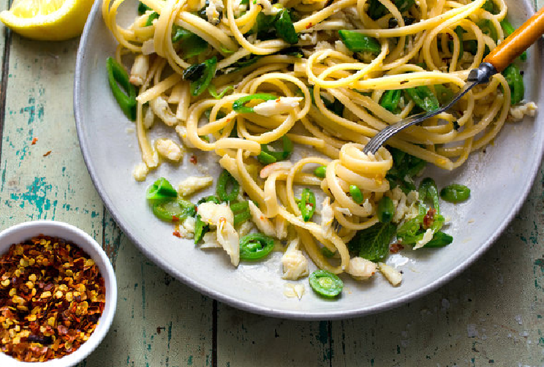

**Crab Pasta With Snap Peas and Mint**

**Description:** Sweet crab meat and even sweeter sugar snap peas are a lovely match in this green-flecked springtime pasta. Don’t overlook the final garnish of olive oil, lemon juice, black pepper and flaky sea salt – it really brings out the saline flavor of the crab. Try replacing the mint with basil or chives, or even with tender pea shoots, which will increase the pea quotient in a delightful way.

**2.** **Crab Toast**

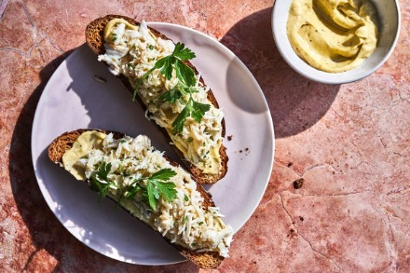

**Des:** Like the very best crab cakes on earth, which have as little dulling, distracting or deadening filler as possible, these crab toasts take that ethos to the extreme. There is no call for bell pepper or bread crumbs or diced celery; just the best fresh, sweet, saline crab meat you can buy, gently seasoned with a little lemon juice, bound with a tiny amount of tangy crème fraîche, then piled onto a slab of good toast, still warm. The toast is made ever so luxurious with a slathering of nutty brown butter mayonnaise. These two simple components — crab and brown butter toast — act in concert, and a glass of cold rosé to wash them down makes for the most exhilarating, satisfying spring supper imaginable.

**3. Crab and Shrimp Boil Pasta**

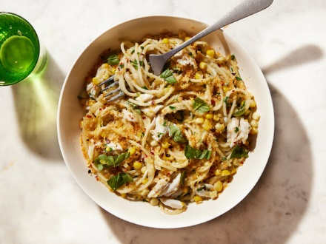

Des: Sweet corn, salty sausage, zesty shrimp, creamy potatoes and butter for dipping – a crab boil has everything you want in a meal. But unless you’re a pro at cracking crab legs, it can be a challenge. Instead, capture those same flavors with this seafood pasta, which uses lump crab meat and this speedy sheet-pan shrimp boil. Get the shrimp boil into the oven, then immediately start preparing this recipe. ( If the shrimp foil until ready to add). In the end, it all comes together in a big, shareable dish.

**4. Soft-Shell Crab Crostini With Arugula Butter**

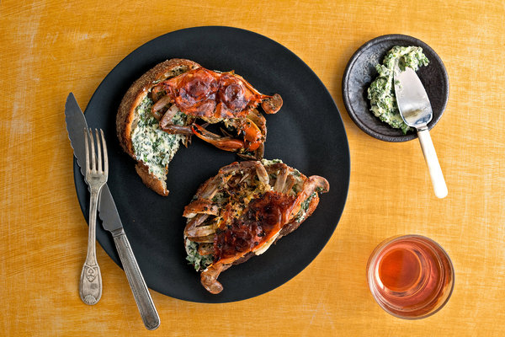

Des: For easy weeknight meals, I dry my cleaned crabs thoroughly so they don't steam, then sauté them in plenty of butter or oil. You could use a breading like flour or cornmeal to augment the crunch factor, but it also impedes the sweetness of the meat. And good crabs don't really need it.

The trick is to know when to take them off the heat. As soon as they turn from gray-brown to rust and white, the texture goes from soft to taut and they are ready.

Soft-shell crabs don't need much adornment; a squirt of citrus and some freshly ground black pepper offset the funky sea flavor beautifully. But a little garlic and something green and sprightly (here, a combination of arugula and chives) can make them even better.

5. Spacy Crab Dip

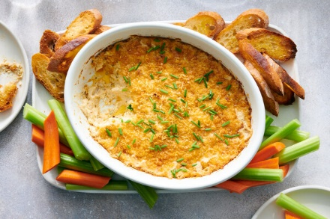

Des : This style of crab dip, often referred to as Maryland crab dip because of its Chesapeake Bay origins, makes for a festive appetizer. Here, it's served hot out of the oven and is extra creamy thanks to the combination of cream cheese and a little mayonnaise. Though crabs are plentiful this time of year – and you can certainly make this with freshly steamed and picked meat if you'd like - canned lump crabmeat makes this dish simple to assemble. Just be careful to leave the clumps of meat as intact as possible when mixing. A sprinkle of cayenne pepper and a generous douse of hot sauce add heat to this flavorful dish.

6. Baked Crab Dip With Old Bay and Ritz Crackers

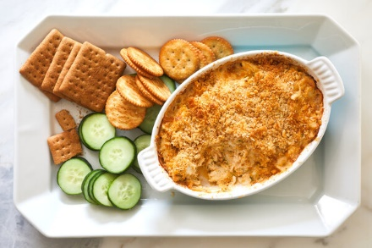

This crab dip is inspired by a recipe called “ritzy dip” from the “Three Rivers Cookbook,” a Pittsburgh community cookbook published in 1973, in which canned crab is mixed with cream cheese, topped with Ritz crackers and baked. Fresh lump crab meat is the star in this updated version, with lemon juice, scallions and plenty of Old Bay seasoning to spice things up. This recipe doubles easily for larger groups, and the whole thing can be assembled and refrigerated up to a day in advance before being baked.