JSP-Servlet Test 01

1. Create a web page, named Test1.jsp.
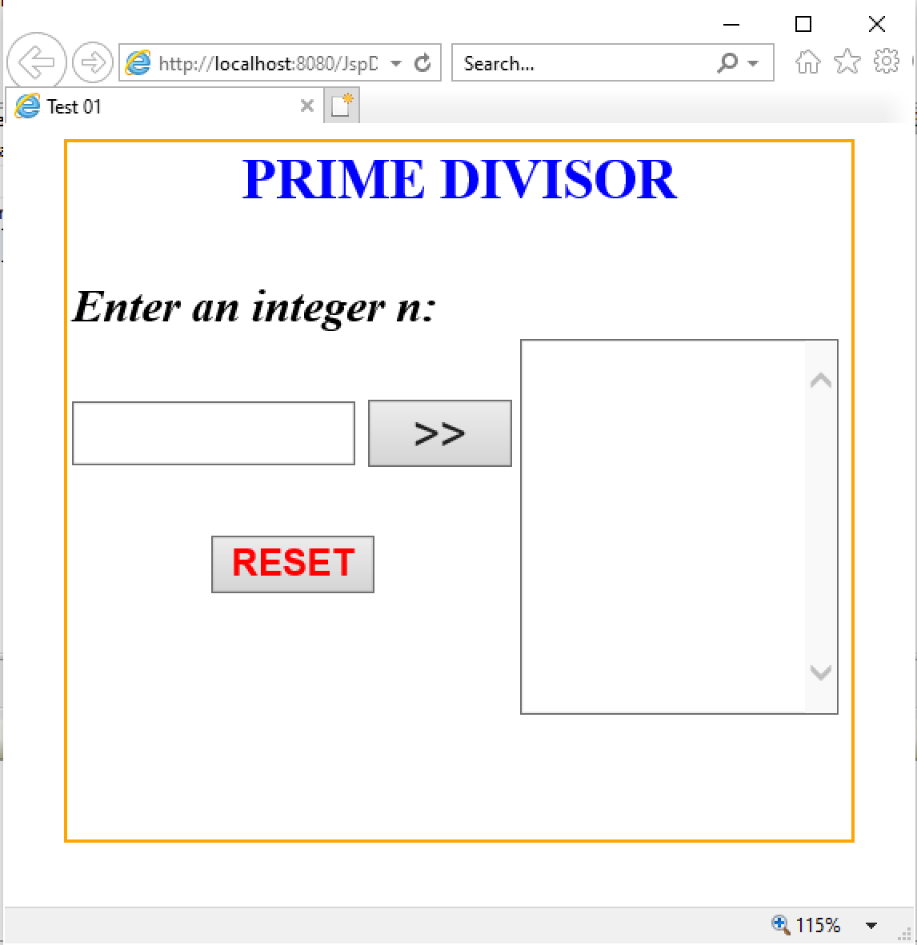

2. Requirement:
a. Click RESET button, set value of TextField and TextArea is empty.
b. Check input n is integer (n>0). If input fail, TextBox “Enter an integer n” is set empty and show error message.
c. Click “>>” button, The prime divisor numbers of n will be added to the TextArea.

