JSP-Servlet Test 03

1. Create a web page, named Test3.jsp.
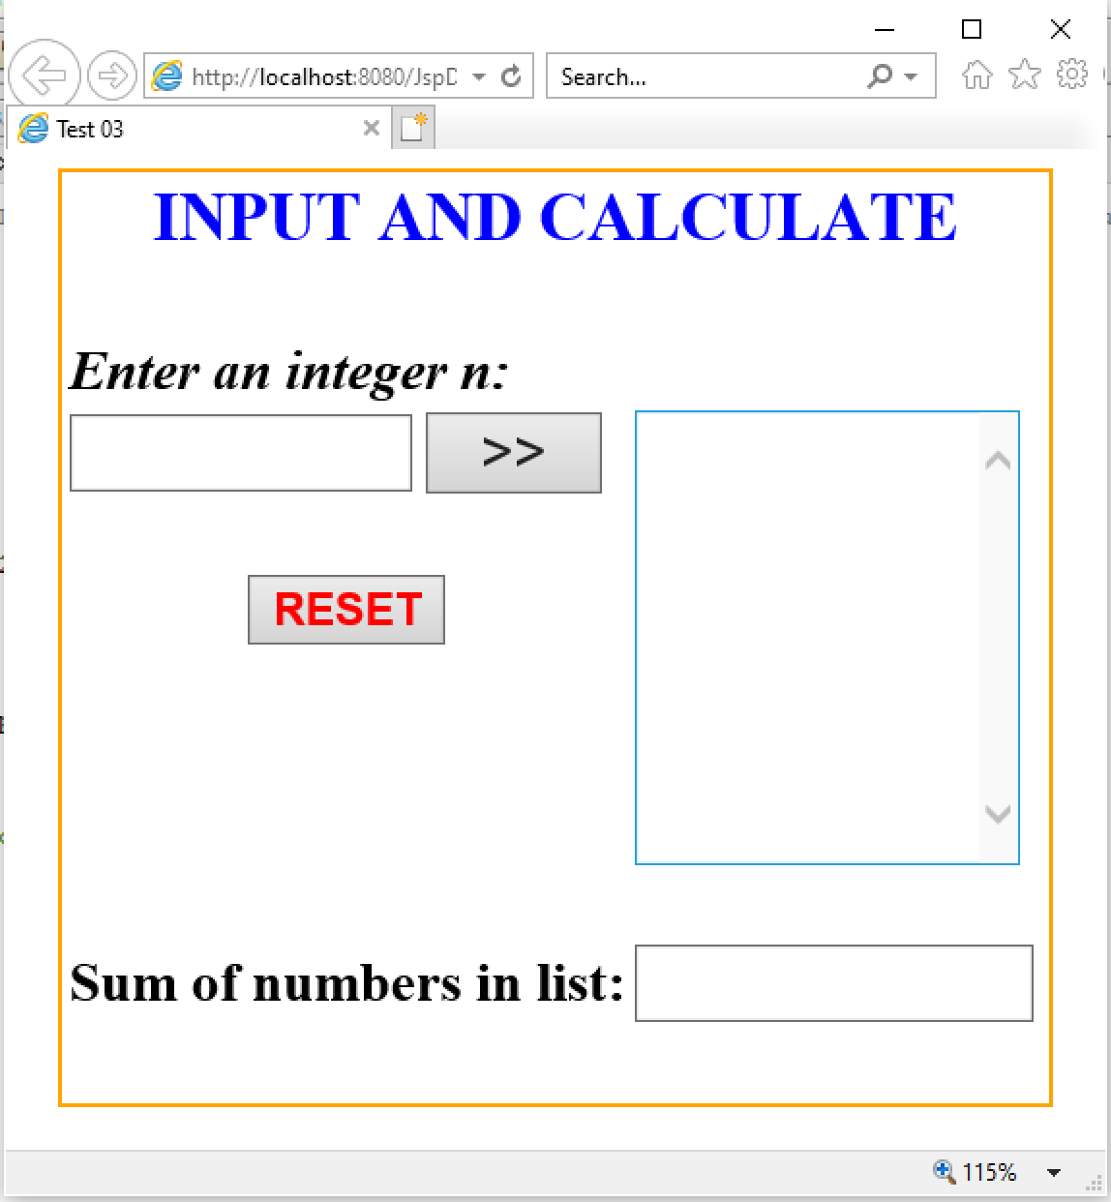

2. Requirement:
a. Click RESET button, set value of TextField and TextArea is empty.
b. Check input n is integer (n>4). If input fail, TextBox “Enter an integer n” is set empty and show error message.
c. Click button >>:
d1. The odd number < n will be added to the TextArea.
d2. The sum of number in the TextArea will be added to the TextField.

