TEST1
(Time: 40minute)

Question 1: (5 points)
You are given a web project. It already contains MyPoint class (inside package model). It describes a 2D point (x-horizontal axis,y-vertical axis). You are also given the display.jsp file that contains the code to plot the these 2D points.
You are asked to design a Servlet that enables user to:
- Access via url: /plot?num=[X]. With /plot is the URL to access the servlet and X is an integer param passed by the query string (1 point).
- The system will automatically generate X points corresponding to the passed value. Those points stored in REQUEST SCOPE with name of “data” then passed to display by display.jsp (2 point).
- All points must have the value of x is a multiple of 10 (2 point)
The following picture shows an example of /plot?num=5
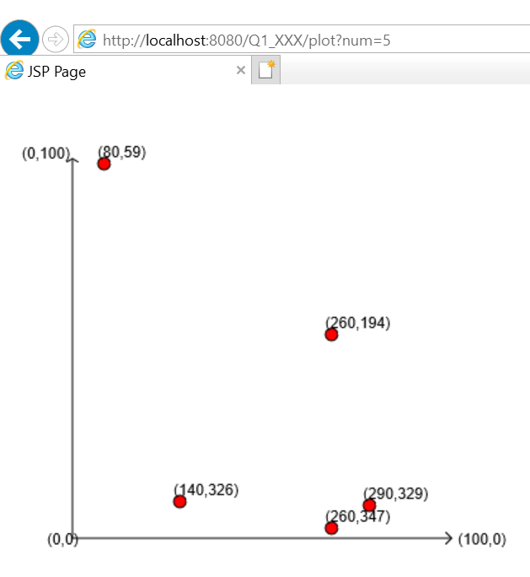

Question 2: (4 points)
You are given a project template that contains Servlet (QuestionController.java). It plays a role in generating Question and Answer (these entity objects are declared in the model package), then stored in REQUEST SCOPE and passed to display.jsp. However, the web developer does not yet study JSP, so he would like to ask your help to complete it.
Users can access /question to make a request to the Servlet.
Your tasks:
- Complete code in display.jsp to display all of forwarded data from the Controller as follows:
