**Abstract**

The experiment is about signal attenuation and this is the fourth experiment to measure the signal attenuation between 10.25GHz and 2.45GHz in a section of distance.

Each of experiment between 2014, 2015, 2016 and 2017 has different condition such as different ground condition, different antenna and different distance between antennas and ground.

We will solute the following question in this assignment.

1. To provide an introduction to practical radio wave propagation and polarization by conducting a small scale field trial.

2. To provide insight into the utility and limitations of radio wave propagation theory in a practical situation.

**Introduction**

The electromagnetic (EM) force consists of an electrical component & a magnetic component. EM fields travel (propagate) through free space & non-conductive materials as waves, & induce currents on conductive objects. For communications systems the receiving conductive objects are specially designed & are called antennas. When the properties are constant throughout the sample of the material, the material can be named a homogeneous medium. A pair of linearly polarized microstrip patch antennas was used to transmit and receive a continuous wave 2.45GHz radio signal down the 4th floor corridor of the EE Building in 2014. This assignment is the fourth experiment for signal attenuation, there are three experiments about this content is held in the 2014, 2015 and 2016. A pair of linearly polarized microstrip patch antennas was used to transmit and receive a continuous wave 2.45GHz radio signal down the 4th floor corridor of the EE Building in 2014. The antennas were held at 96.5cm above the floor, as the receiving antenna was moved along the corridor on a trolley in a line above the seam in the flooring material 72.5cm from the nearest wall. However the each of experiment between 2014, 2015, 2016 and 2017 has different condition such as different ground condition, different antenna and different distance between antennas and ground.

**Method (Material/Procedure)**

**Materials**

1. Open rectangular mouth (coaxial to waveguide) (the black frame of figure 2)

2. Power meter (figure 1)

3. Signal generator (figure 2)

4. FAXE beer (can antennas)

5. Perpendicular (it can keep the receiving terminal move in a straight line)

**Procedure**

1. Measuring distance (From one end of the classroom to the other, it is about 35 meters), and then, make the parameters return to zero for all of instrument, connected the each of instrument correctly.

2. Use two open rectangular mouth transitions as the transmitting and receiving antennas (10.25 GHz), the distance between antennas and ground is 109.5cm. And use two FAXE beers as the transmitting and receiving antennas (2.45GHz), the distance between antennas and ground is 103cm.

3. Make the receiving antennas move along the straight line on the trolley and recorded data between each of 50cm.

4.After the above steps, both 2.45GHz and 10.25GHz will replicated in the antenna simulator FEKO using infinite ground planes of PEC and εr=4.5 (dielectric constant) and repeat the following steps.

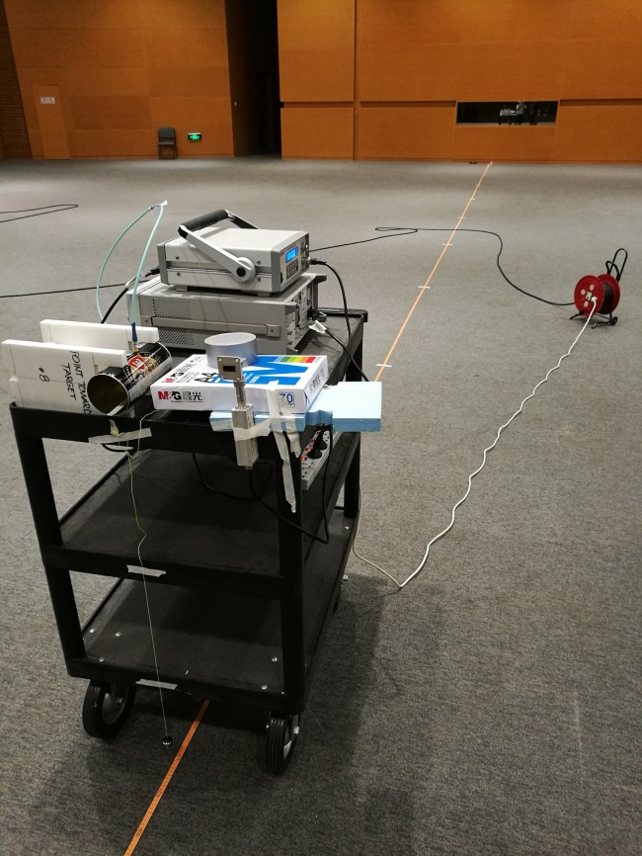

**Figure 1** Power meter (the part of black frame)

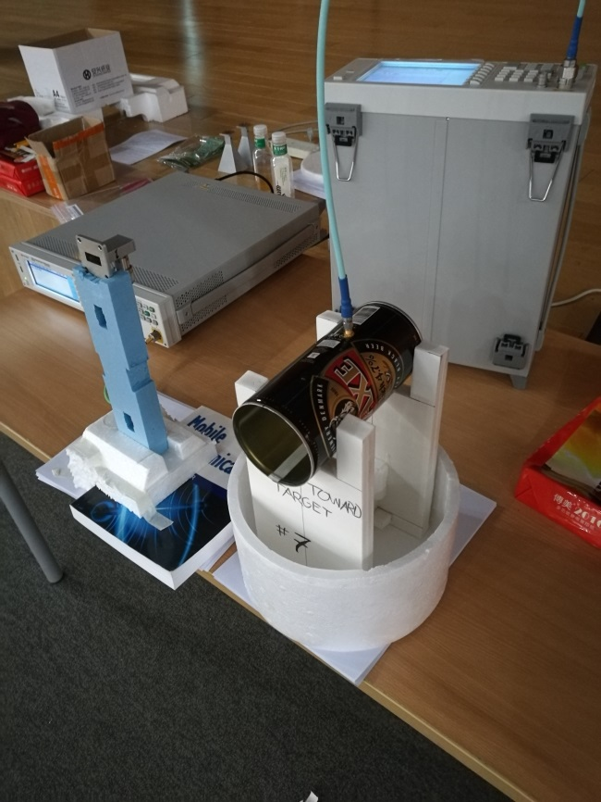

**Figure 2** The transmitting terminal

**Results**

**Plot all the measured V-V data measured in CG13W on a 2D graph using the provided Matlab M-file, or equivalent. How do the data sets compare? Are there any significant differences between the 2017 and 2016 2.45 GHz data?**

Run the giving code from file, we can get the flowing picture.



**Figure 3** 2.45 GHz measure data



**Figure 4** 10.25 GHz measure data

The Figure 3 shows the different data value between 2016 and 2017, they are all presented a tendency of decrease all the time. It's worth noting that the position in the point of 5m is a clear cut-off point, before this point, two data sets has no obvious difference, after this point, the two data sets has obvious and different fluctuation. The figure 4 shows the trend is same as figure 3, the different from figure 3 is smaller value, and it proved that the power of 2.45GHz is larger than 10.25GHz. The cause of this error maybe is the manual record, the value shows in power meter is fluctuant value, and we just use a random value.

**Compare the measured data sets to the Friis Equation / free space LOS propagation model and the 2-ray interference model that accounts for any reflection off the floor. How do the measured data sets compare to this analytic theory and the FEKO numerical simulations? What are the possible sources of difference between experiment, theory and simulation? What assumptions are made in the theory? What is not accounted for in the theory?**

Run the giving code from file, we can get the flowing picture.



**Figure 5** The different from los theory and experiment (10.25 GHz)



**Figure 6** The different from los theory and experiment (2.45 GHz)

The figure 5 and figure 6 shows the difference between LOS theory and experiment. Two ways presented a tendency of decrease all the time, however the LOS theory is a smooth curve because the LOS theory is an ideal environment.



**Figure 7** The different from experiment, FEKO PEC and FEKO

εr=4.5 (10.25 GHz)



**Figure 8** The different from experiment, FEKO PEC and FEKO

εr=4.5 (2.45 GHz)

FEKOεr=4.5 is a theoretical value, although the experiment value has a lot of fluctuation caused by many errors, however the tendency of experiment value is same as theoretical value. Compare to the FEKO PEC and FEKOεr=4.5 that shows the influence caused by materials, the fluctuation of FEKO PEC is more and more heavy than FEKOεr=4.5.



**Figure 9** The different from experiment, 2-ray interference floor only and 2-ray interference PEC floor only (10.25 GHz)



**Figure 10** The different from experiment, 2-ray interference floor only and 2-ray interference PEC floor only (2.45 GHz)

2-ray interference floor only and 2-ray interference PEC floor only are closer to the experiment, because that think about two directions of reflection (include ground reflection and line-of-sight propagation). However the experiment value is very closer to two sets of data.

Compare to the three ideal model, the LOS theory use the following function, it just a kind of line-of-sight propagation

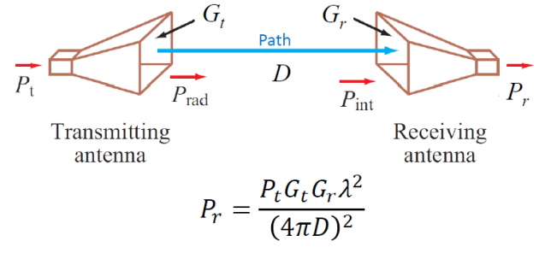

**Figure 11** Friis Transmission Formula

Compare the first the ideal model, the 2-ray interference floor only and 2-ray interference PEC floor only add a kind of ground reflection that include two propagation path，it just like the following picture.

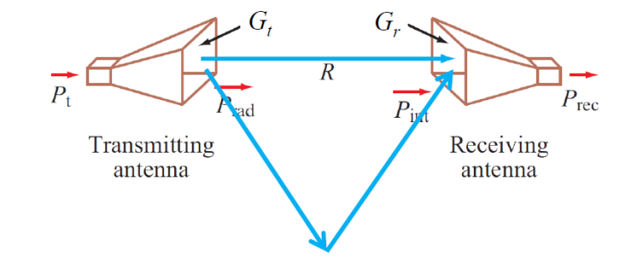

**Figure 12** Twopaths for signal transmission

FEKO PEC and FEKOεr=4.5 is based on the software simulation(EM equation simulation) that is different from the first and second ways, the following ways is be deduced by mathematical formula. The experiment includes a large quantity of uncertain factors and errors that include environmental noise, recording error and minute environment reflections from different walls.

**What are the implications of any severe fading on signal reception by a mobile receiver?**

The mobile receiver is a flexible installation, it is necessary for us to move it in a straight line. If not, with the moving of flexible installation, the signal paths are always changed that will lose part of signal power. Obviously, there are lots of experimental errors in this time, because keep the line moving is very difficult. It is the reason why the receiving power will change drastically and produce the short-term fading in the short term

**How will the fading effect the bit error rate (BER)?**

The bit error rate is an index for evaluate the accuracy of data, during the data transmission within the prescribed time. The bit error rate is the number of bit errors divide by the total number of transferred bits during a studied time interval. Firstly, the generation of error code was caused by fading, the fading change the voltage of signal that will destroy the signal during transmission. Secondly, the distance, which from transmitter to receiver will lead to the serious fading, the longer distance will leads to the severe long term fading.

**Given the choice between 2.45GHz and 10.25GHz, which do you think is best for a short range mobile application?**

Compare with 2.45GHz, the 10.25GHz is more suitable for a short range mobile application, because the higher frequency will lead to the higher penetrating power and weaker diffraction force. Although higher frequency will lose more and more power during the long-distance transmission, however, for a short range mobile application, the higher penetrating power will through buildings easier than lower penetrating power. Moreover, the lower frequency needs more diffraction that will affect the signal transmission and interference.

**How do the 2016 and 2017 data compare to the 2014 and 2015 data? What are the significant differences? Can you suggest causes?**



**Figure 11** The difference between 2014, 2015, 2016 and 2017

Compare with 2014, on the one hand, the path of 2015 is same as 2014, the difference of the two experimental was led by the material of antennas. Because they are all located in the EE building, so we can eliminate the environment factors, the pictures shows, there are some upward trends before 15m. On the other, beer is falling slowly in the speed of fading. For the two sets of data, the experiment of 2016 and 2017 was located in the CG13W, compare with 2014 and 2015, the later experiments were closer to theoretical values, because the EE building is a more complex environment. There are many walls in the EE building, which can reflect the signal. Moreover, in the CG13W, the ceiling and the walls were more than 8metres away, and the reflections off the ceiling and walls were expected to have little or no effect.

**As background information to help with your assignment, Chapter 3 of [1] introduces mobile radio propagation. Sections 3.6 and 3.11 may prove helpful in the analysis of the measured data. Note that Figures 3.28 and 3.29 were measurements made at 914MHz. Some 1.8GHz and 2GHz outdoor propagation results were presented in [2] and [3]. As our measurements were made at 2.45GHz, was there any interference from WiFi?**

The signal of WiFi is based on 2.4G UHF or 5G SHF ISM radio bands, the frequency of WiFi is same as transmitting frequency, which transmitted by transmitting antennas. There are lots of network access points in the CG13W, it will be mistaken for the transmitting signal, which transmitted by transmitting antennas. It is the one of reasons caused measurement error.

**To conclude your assignment, do you have observations or comments from the exercise with regard to conducting field trials?**

I think the first key point of this assessment is decrease the environmental error, the easier environment make the more accurately result. Secondly, make the receiving antennas moves in a straight line is very necessary.

**References [4] and [5] present an ideal outdoor measurement field trial. Could we perform such an experiment on campus? Where on campus would you recommend? Justify your recommendation.**

The path loss, shadow effect and multipath effect are the three key points for affect the fading. The long-distance transmission has a lot of restrictive factors, such as distance from transmitting and receiving antennas, many obstructions and lots of network access points, which from different sources. Received power variation due to path loss occurs over long distance (100-1000m), whereas variation due to shadowing occurs over distances that are proportional to the length of the obstructing object (10-100m in outdoor environments and less in indoor environments). So, if we choose the outdoors to complete this experiment, the underground passage is a better environment. The first reason is this environment is a simple environment, there are not many obstructions, which reflected signal repeatedly. And the second reason is the same materials of walls can reduce the reflection in the materials.