**Multimedia Communications**

EEE415

Lab 1 - report

Name: Cong Yin

ID Number: 1715471

**Introduction**

In information theory, in information theory, the binary symmetric channel is a kind of classic noise channel model. In this memoryless channel model, the average packet loss rate is commonly used to describe the packet loss characteristics of a network. However, in actual networks, the channels usually have “memory”. There is often a kind of short-term correlation between the packet loss. It is generally, the communication process was recommended to use a Markov model to capture temporary correlations of packet loss. They all use a two-state Markov model, which is known as the Gilbert model. The Gilbert model is often used to describe the sudden packet loss in the network, which was proposed by Gilbert in 1960.

This lab should use the matlab function to generate sample binary sequences. And then, draw a histogram for run length distributions. All of that will help students to understand the basic application of packet loss on the Gilbert model.

**Method**

Gilbert model can be described completely with two probability of independent event probability

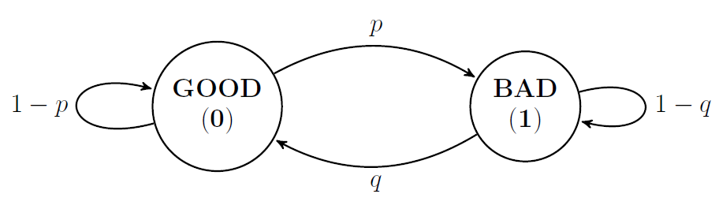

**Figure 1-1 Simple Gilbert model**

The probability of “p” represents the probability of state, which translate from a "0" to a "1". And represents of “q” represents the probability of a state, which translate from a "1" to a "0". The "number of packet loss events" records a number of consecutive packet losses as a packet loss event. In other words, the "number of packet loss events" means that the number of state, which translate from a "0" to a "1". At the same time, that is also the number of state, which translate from a "1" to a "0". That can get the following function, and the “ $P_{01}$” means the number of state, which translate from a "0" to a "1".

$$P_{GSM}\left[\begin{matrix}(1-p) & q \\ p & (1-q)\end{matrix}\right]=\left[\begin{matrix}P_{00} & P_{10} \\ P_{01} & P_{11}\end{matrix}\right]$$

This assessment we use a simple method proposed by Yajnik et al. It is a simple method to calculate the probabilities of transition. where p and q are estimated as follows:

$$p=\frac{n_{01}}{n_{0}}$$

$$q=\frac{n_{10}}{n_{1}}$$

**Result**

Run the following code, we can get the value of “p” and “q” as shown in figure 1-2, which create new packet loss. According to the figure 1-4 and figure 1-5 shows that there is a verity of similarity and difference. Firstly, no matter the histograms of run lengths for zeros or ones, the tendency of sequence generated by SGM is similar to original sequences. Secondly, compare the two figures, we can clearly see the different tendency of run lengths for zeros and run lengths for ones.

clc,clear

load('loss_seq.mat');

[n_0,n_1] = binaryRunLengths(seq);%[zerorl, onerl] = binaryrunlengths(SEQ) generates a sequence of run

n_0=sum(n_0);%This n_0 means n0 that is the number of 0 at intervals. Add up all the n_0, we can caculate the n0

n_1=sum(n_1);%This n_1 means n0 that is the number of 1 at intervals. Add up all the n_1, we can caculate the n1

n_01= find(diff(seq)==1);

n_10= find(diff(seq)==-1);

n_0_1=length(n_01);%n01 is the number of times in the observed time series that 1 follows 0

n_1_0=length(n_10);%n10 is the number of times in the observed time series that 0 follows 1

p=n_0_1/n_0;%According to the simple method proposed by Yajnik, we can cacultae the p=n01/n0

q=n_1_0/n_1;%According to the simple method proposed by Yajnik, we can cacultae the q=n10/n1

tr=[(1-p),q;p,(1-q)];%The transition matrix for the SGM is given by P_SGM=[(1-p),q;p,(1-q)]

len=length(seq);

SGM_seq=sgmGenerate(len,tr);%Generate a Loss Pattern based on SGM

[zerorl_seq, onerl_seq] = binaryRunLengths(seq);%[zerorl, onerl] = binaryrunlengths(SEQ) generates a sequence of run

[zerorl_SGM_seq, onerl_SGM_seq] = binaryRunLengths(SGM_seq);%[zerorl, onerl] = binaryrunlengths(SEQ) generates a sequence of run

figure;

histogram(zerorl_seq);%Drawing a histogram

title('zero');

hold on

histogram(zerorl_SGM_seq);%Drawing a histogram

legend('original seq','SGM_seq');

figure;

histogram(onerl_seq);%Drawing a histogram

title('one');

hold on

histogram(onerl_SGM_seq);%Drawing a histogram

legend('original seq','SGM_seq');



**Figure 1-2 The value of p and q**



**Figure 1-3 The value of tr**

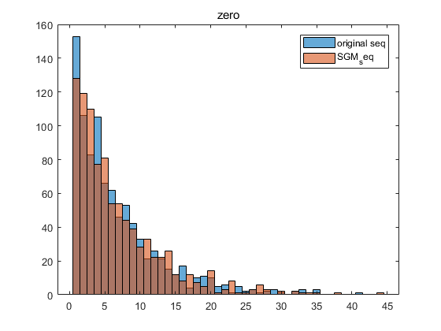

**Figure 1-4 The histograms of run lengths for zeros**

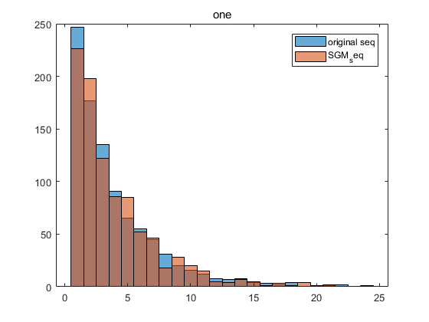

**Figure 1-5 The histograms of run lengths for ones**