**Multimedia Communications**

EEE415

Lab 1 - report

Name: Cong Yin

ID Number: 1715471

**Introduction**

MPEG (Moving Picture Experts Group) is an origination was established by ISO (International Standardization Organization) and IEC (International Electrotechnical Commission) in 1988. The responsibilities of that is to prepare International Standards. The standard of MPEG can be divided into five main kinds, MPEG-1, MPEG-2, MPEG-4, MPEG-7 and MPEG-21. Among of that, the MPEG-4 use the very narrow bandwidth, for the best quality of image can be obtained with the least data, which according to the frame reconstruction technology and data compression.

This lab is based on the lab 1 and aim to establish simulations for a video server, which include a video client, and an unreliable channel. And compare with decodable frame rate between Simple Gilbert model and Bernoulli Model.

**Relevant Theories**

**GOP**

GOP (Group of Pictures) specifies the order in which intra- and inter-frames are arranged. The GOP is a collection of successive pictures within a coded video stream. Each coded video stream consists of successive GOPs, from which the visible frames are generated. The GOP can make all frame to divide into three groups, I-frame, P-frame and B-frame. I-frame (intra coded picture) is a frame that is coded independently of all other frames. Each GOP begins with this type of frame. P-frame (predictive coded picture) contains motion-compensated difference information relative to previously decoded frames. B-frame (bidirectional coded frame) contains motion-compensated difference information relative to previously decoded frames. The relationship of these three frames as shown in the figure.1.

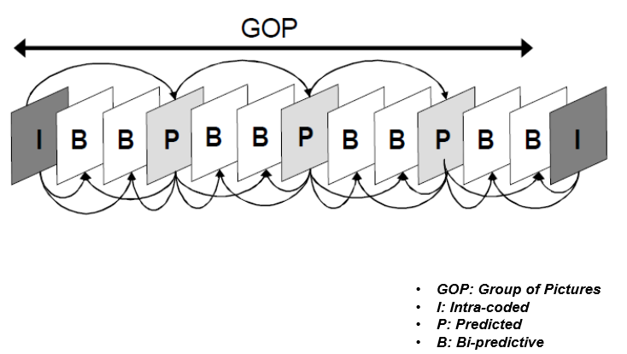

**Figure.1 GOP with M=3 and N=12**

**Decodable Frame Rate (Q)**

For evaluation of the packet loss impact on the video quality, we need an objective measure.

Decodable frame rate (Q) is one of objective measure and defined as

$$Q=\frac{N_{dec}}{N_{I}+N_{P}+N_{B}}$$

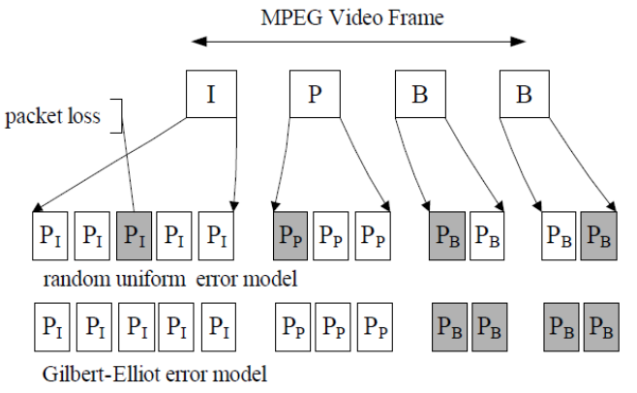

**Figure.2 Decodable Frame Rate (Q)**

**Simple Gilbert model**

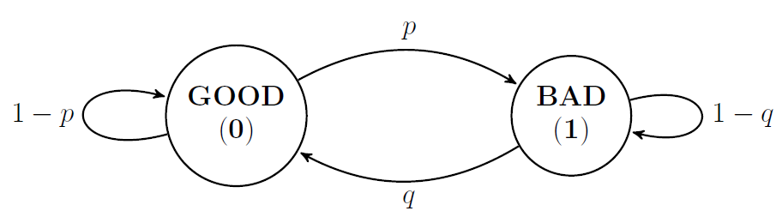

**Figure.3 Simple Gilbert model**

The “p” represents the probability of state, which translate from a "0" to a "1". And the “q” also represents the probability of a state, which translate from a "1" to a "0". The "number of packet loss events" records a number of consecutive packet losses as a packet loss event. In other words, the "number of packet loss events" means that the number of state, which translate from a "0" to a "1". At the same time, that is also the number of state, which translate from a "1" to a "0".

**Bernoulli Model**

q=1-p

p

GOOD

（0）

BAD

（1）

**Figure.4 Bernoulli Model**

Unconditional loss probability is an average packet loss probability of the network, conditional loss probability reflects a kind of correlation between the packet loss, which located in the network. If unconditional loss probability (p) plus conditional loss probability (q) equals to 1, the Gilbert model will become to a kind of Bernoulli model, which have only one state.

**Experimental Process**

The first step of experimental process is run the following matlab script can get the value of “p”, “q” and packet loss rate of two models as shown in the figure.5

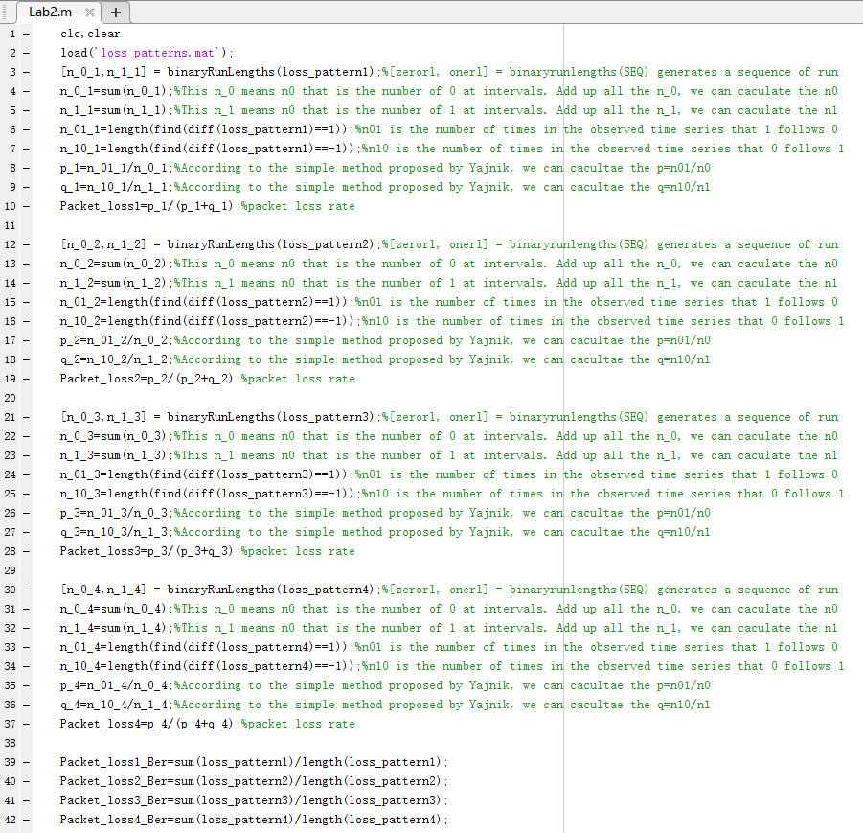

**Figure.5 The matlab script for calculate p, q and packet loss rate**

The calculative process of “p” and “q” in the SGM model is same as lab 1 that use a simple method proposed by Yajnik et al. It is a simple method to calculate the probabilities of transition. where p and q are estimated as follows:

$$p=\frac{n_{01}}{n_{0}}$$

$$q=\frac{n_{10}}{n_{1}}$$

The packet loss rate of SGM model equals to divide “p” by the sum of “p” and” q”.

The calculative process of “p” in the Bernoulli model equals to divide the number of zeros by the length of loss pattern, which as same as the value of packet loss rate. And the result of “p”, “q” and packet loss rate was shown in the figure.6, table.1 and table.2.

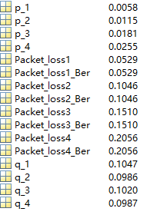

**Figure.6 The results of matlab script**

**Table.1 The value of p, q and packet loss of SGM**

|  |  |  |  |  |
| --- | --- | --- | --- | --- |
|  | Loss_pattern1 | Loss_pattern2 | Loss_pattern3 | Loss_pattern4 |
| p | 0.0058 | 0.0115 | 0.0181 | 0.0255 |
| q | 0.1047 | 0.0986 | 0.1020 | 0.0987 |
| Loss pattern rate | 0.0529 | 0.1046 | 0.1510 | 0.2056 |

**Table.2 The value of packet loss of Bernoulli model**

|  |  |  |  |  |
| --- | --- | --- | --- | --- |
|  | Loss_pattern1 | Loss_pattern2 | Loss_pattern3 | Loss_pattern4 |
| Loss pattern rate(p) | 0.0529 | 0.1046 | 0.1510 | 0.2056 |

The second part of experimental process is change the value of “p” and “q” in the script, which software was named Omnetpp. And then, record the value of decodable frame rate. The value should be changed, which was marked by box in the figure.7

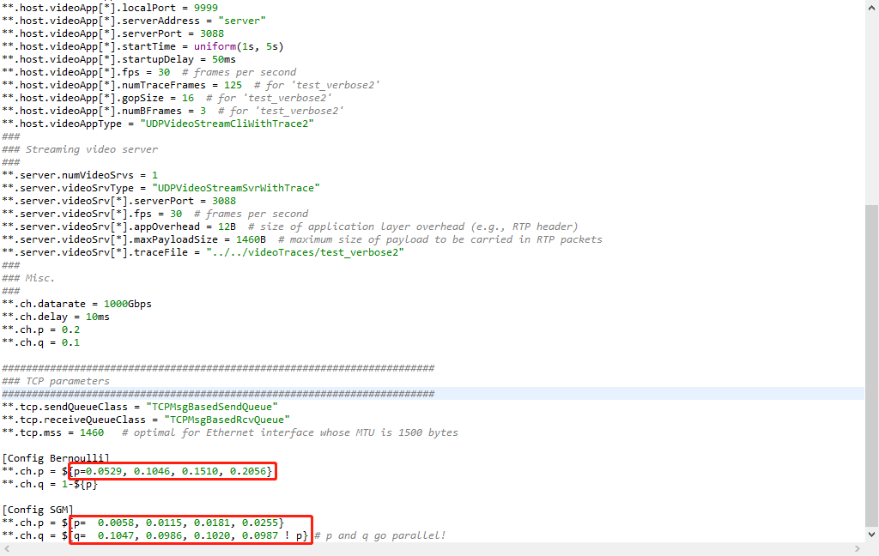

**Figure.7 Set the value of p and q for each model**

And then, run a series of simulations using four SGMs. In addition, repeat the process of simulation, which using a uniform loss model (Bernoulli model), we can get the values of decodable frame rate as shown in the figure.8 and figure.9.

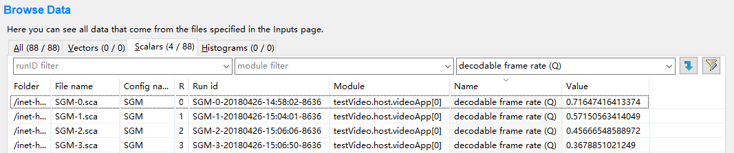

**Figur.8 The result of SGM model**

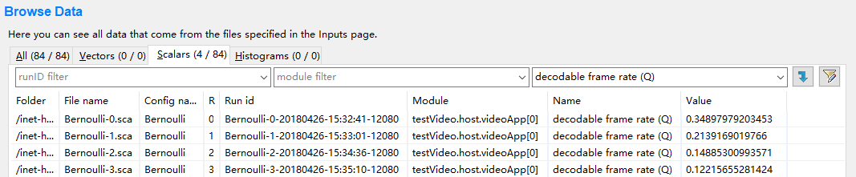

**Figure.9 The result of Bernoulli model**

Finally, use the line chart for comparison, which was built by matlab. The mat lab script as shown in the figure.10 and the result is shown in the figure.11. Decodable frame rate (DFR) as an objective measure of video quality, is used to evaluate the packet loss impact.

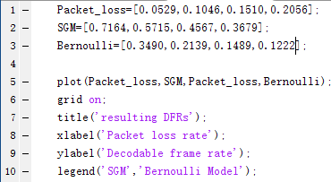

**Figure.10 The matlab script for compare two models**

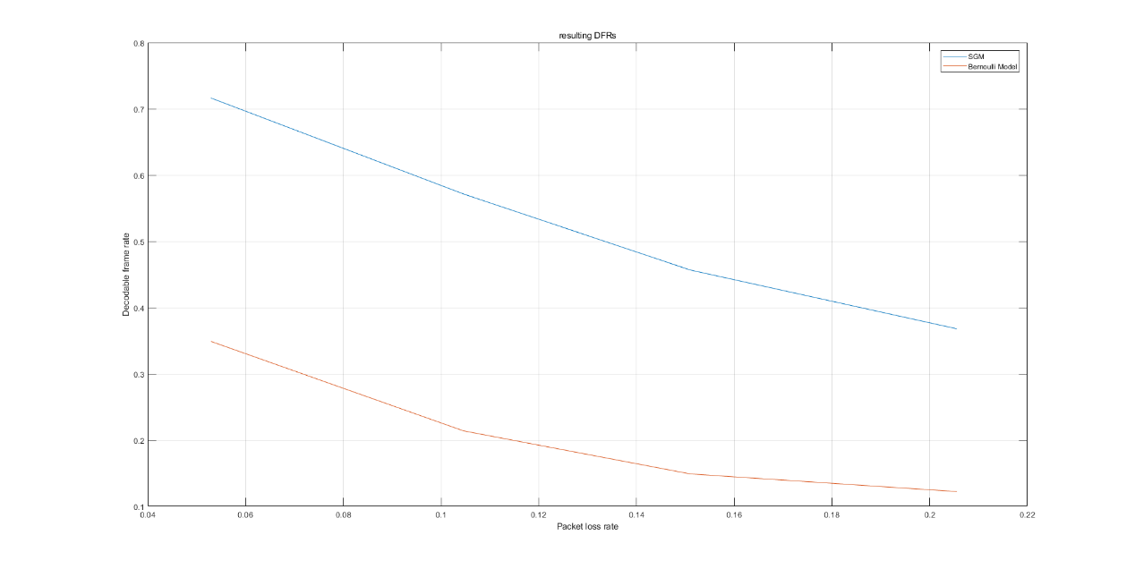

**Figure.11 The result for compare two models**

**Discussion**

According to the figure.11, It is clear that the decodable frame rate of SGM is higher than uniform loss model (Bernoulli model) in same condition of channel packet loss rate, which result is about two times as large as possible. It is means that the video quality with SGM model is better than uniform loss model (Bernoulli model) in the same channel conditions.

For SGM model, the “p” represents the probability of state, which translate from a "0" to a "1". And the “q” also represents the probability of a state, which translate from a "1" to a "0". The “1-p” represents the probability of state, which translate from a "0" to a "0" and the ”1-q” represents the probability of state, which translate from a "1" to a "1". It is means that in the SGM model, the relative probability of “p” and” q” is lower than “1-p” and ”1-q”. When packets are successfully transmitted, subsequent packets will be successfully transmitted, if the packets have been lost, and subsequent packets will be lost. However, in this model, if the first packets have been transmitted successful. And then, the probability of packets is successfully transmitted, which include a several of packets is high.

For Bernoulli model, the switching probability of state, which from a "0" to a "1" and from a "1" to a "0" is higher than SGM model. So, a frame cannot successful transmitted easily caused by loss packet.

**Suggestions**

If the frame cannot decode in the receiving terminal, which include I-frame, B-frame and D-frame. The receiving terminal should try to decode next I-frame and discard all of frames which between next I-frame and this frame.

For the SGM model, the Multiple Description Coding (MDC) is a kind of effective measure to improvement. The MDC assumes that there are multiple channels between the information source and information, the probability of simultaneous error for each channel is very low at the same time. According to the generate a number of equally important and independent description of the encoding. It can ensure that when some of the descriptions are lost, the acceptable quality of image can still be obtained. With the increase of description, the quality of image will also be improved.

For the SGM model, the Packet-level forward error correction (FEC) is a kind of effective measure to improvement. It is the way to increase the credibility of data communication. In a one-way communication channel, once the error is detected, the receiver will not have the right to request transmission again. FEC is a method of transmitting redundant information by data. When errors occur in transmission, it will allow the receiver to rebuild data.

**Conclusion**

This lab compared with decodable frame rate between Simple Gilbert model and Bernoulli Model according to a series of simulation, which have been ran to calculate the packet loss and its impact on video quality. According to this lab, we analyzed the effect of decodable frame rate and help us to enhance our comprehension for two models.