

EEE415 mULTIMEDIA COMMUNICATIONS

LAB2 Report



May 7, 2016

XJTLU

Muyuan Tong

10114703

Contents

1. Introduction 2

2. Relevant Theories 2

2.1 MPEG (H.264/AVC) GOP 2

2.2 Decodable Frame Rate 3

2.3 Simple Gilbert Model and uniform loss model 4

2.4 Packet loss rate 4

3. Experimental results and analysis 5

3.1 Transition probabilities and Packet loss rate estimation 5

3.2 Decodable frame rate evaluation 7

3.3 Discussion 8

3.3.1 Plot analysis (difference analysis) 8

3.3.2 Improvement suggestions (video streaming case) 9

4. Conclusion 10

5. References 11

# **Introduction**

The Moving Picture Experts Group (MPEG) is formed by IEC and ISO in 1988, and includes of a working group of experts to establish standards for audio and video compression and transmission. MPEG-4 (H.264/AVC) is a standard for lossy compression, and it defined the video signal is a sequence of frames (images), which are related along the temporal dimension. There are three important frame types, which are I-frames, P-frames and B-frames, and also in detail, these special frames are transmitted in form of packets. Decodable frame rate (DFR) as an objective measure of video quality.

This Lab aims to establish simulations for a video server, a video client and an unreliable channel to estimate the decodable frame rate after obtain the packet loss information from given loss patterns. In addition, the analysis about packet loss impact on video quality (decodable frame rate) is given in this report. Two loss models are involved in this Lab, one of them is simple Gilbert model (SGM), and another is uniform loss model (Bernoulli model).

# **Relevant Theories**

* 1. **MPEG (H.264/AVC) GOP**

GOP is abbreviation of Group of Pictures. Before compression, all frames of a video will be separated into different group, and then some frames are chosen to be I-frames, some frames are chosen to be P-frames, rest are B-frames. The relationship among these three type of frames are demonstrated in Fig.1.

* I-frames:

Intra-frame (key-frame) is decoded independently of any other type of frames. This type of frames result in very large file sizes after compression.

* P-frames:

Predicted-frame (forward-predicted/inter frame). The existence of P-frames can improve compression, because the transmitted packets of P-frames only include the information of difference in image from previous I-frame or previous P-frame.

* B-frames:

Bidirectional-frame (backwards-predicted frame) can further improve the compression, and it has the lowest compressed size by comparing to I-frame and P-frame. B frames are encoded based on motion compensated differences information in reference to immediate past and future I or P frames.

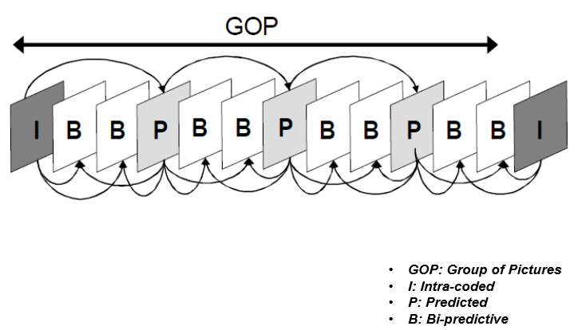

**Figure 1 A sample of MPEG GOP**

* 1. **Decodable Frame Rate**

Decodable frame rate (DFR) as an objective measure of video quality, is used to evaluate the packet loss impact. The Decodable frame rate can be calculated by following formula:

$$Q=\frac{N_{dec}}{N_{I}+N_{P}+N_{B}} (1)$$

Two simple cases of packet loss with same packet loss rate but different decodable frame rate are given in Fig.2 as below.

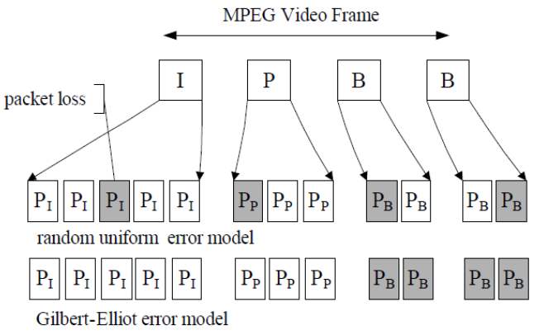

**Figure 2 packet losses with same packet loss rate**

In Fig.2 the decodable frame rate Q1 of first case is zero, but Q2 for second case is 0.5, which is higher than first case.

* 1. **Simple Gilbert Model and uniform loss model**
* **Simple Gilbert Model (SGM)**

**Figure 3 Simple Gilbert Model**

In simple Gilbert model, state ‘Good’ means no packet loss, and state ‘Bad’ means one packet loss. The probability $p=Prob(G→B)$ and probability $q=Prob(B→G)$ is small and the probabilities $1-p$ and $1-q$ are large, which are remaining in ‘Good’ state and ‘Bad’ state.

* **Uniform loss model (Bernoulli Model)**

**Figure 4 Uniform loss model**

In this case, the situation is much sample. Once the probability $p=Prob(G→B)$ is settle down, another probability satisfied.

* 1. **Packet loss rate**

Once the transition probabilities is obtained, the packet loss rate can be evaluated as follow formula:

$$π_{1}=\frac{p}{p+q} (2)$$

# **Experimental results and analysis**

* 1. **Transition probabilities and Packet loss rate estimation**
* **SGM Model**

The transition probabilities of given four loss patterns are estimated using MATLAB with Yajnik method, which has been discussed in previous Lab (Lab1 report). The MATLAB script is given as Fig.5.

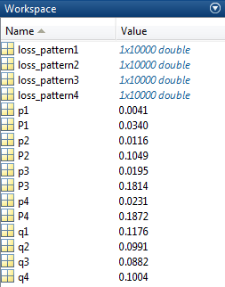

clc;clear;close all;

% load the given loss pattern

load ('loss_patterns.mat');

% Yajnik method to estimate p and q

[p1,q1]= trace(loss_pattern1);

[p2,q2]= trace(loss_pattern2);

[p3,q3]= trace(loss_pattern3);

[p4,q4]= trace(loss_pattern4);

% calculate the packet loss rate

P1=p1/(p1+q1);

P2=p2/(p2+q2);

P3=p3/(p3+q3);

P4=p4/(p4+q4);

**Figure 5 MATLAB estimation of transition probabilities and packet loss rate for SGM**

The results are:

|  |  |  |  |  |
| --- | --- | --- | --- | --- |
| Simple Gilbert Model | | | | |
|  | Loss_pattern1 | Loss_pattern2 | Loss_pattern3 | Loss_pattern4 |
| p | 0.0041 | 0.0116 | 0.0195 | 0.0231 |
| q | 0.1176 | 0.0991 | 0.0882 | 0.1004 |
| Packet loss rate | 0.0340 | 0.1049 | 0.1814 | 0.1872 |

**Table 1 Transition probabilities and packet loss rates for SGM model**

* **Bernoulli Model**

The Packet loss rate for Bernoulli model can be calculated by:

$$PLR=\frac{N_{0}}{N}=p (3)$$

where N0 is the number of zeros, N is the length of loss pattern.

The MATLAB script to estimate packet loss rate for Bernoulli model is given as Fig.6.

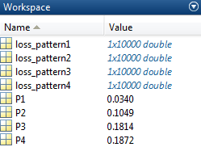

clc;clear;close all;

% load the given loss pattern

load ('loss_patterns.mat');

% estimate packet loss rate

P1=sum(loss_pattern1)/length(loss_pattern1);

P2=sum(loss_pattern2)/length(loss_pattern2);

P3=sum(loss_pattern3)/length(loss_pattern3);

P4=sum(loss_pattern4)/length(loss_pattern4);

**Figure 6 MATLAB estimation of packet loss rate for Bernoulli model**

The results are:

|  |  |  |  |  |
| --- | --- | --- | --- | --- |
| Bernoulli model | | | | |
|  | Loss_pattern1 | Loss_pattern2 | Loss_pattern3 | Loss_pattern4 |
| Packet loss rate | 0.0340 | 0.1049 | 0.1814 | 0.1872 |

**Table 1 Transition probabilities and packet loss rates for SGM model**

* 1. **Decodable frame rate evaluation**

Setting the transition probabilities for SGM and Bernoulli model, as well as corresponding results are showing in Fig.6-Fig.9, and Table.2.

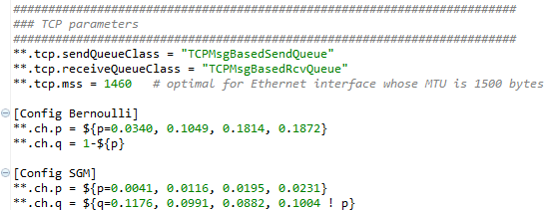

**Bernoulli transition probabilities**

**SGM transition probabilities**

**Figure 6 Simulation parameters setting for both model**

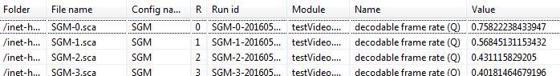

**Figure 7 DFR evaluations for SGM model**

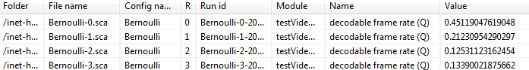

**Figure 8 DFR evaluations for Bernoulli model**

|  |  |  |  |  |
| --- | --- | --- | --- | --- |
|  | Loss_pattern1 | Loss_pattern2 | Loss_pattern3 | Loss_pattern4 |
| Packet loss rate | **0.0340** | **0.1049** | **0.1814** | **0.1872** |
| SGM DFR | 0.758 | 0.568 | 0.431 | 0.402 |
| Bernoulli DFR | 0.4512 | 0.2123 | 0.1253 | 0.1339 |

**Table 2 DFR evaluations for both model respect to Packet loss rate**

Using MATLAB to plot the decodable frame rate versus packet loss rate for these two models. The MATLAB script and the plot of DFR versus packet loss rate are showing in Fig.8 and Fig.10.

clc;clear;close all;

% parameter setting

Packet_loss_rate=[0.0340,0.1049,0.1814,0.1872];

SGM_DFR=[0.758,0.568,0.431,0.402];

Bernoulli_DFR=[0.4512,0.2123,0.1253,0.1339];

% plot the Decodable Frame Rate versus Packet loss rate

plot(Packet_loss_rate,SGM_DFR,'-+',Packet_loss_rate,Bernoulli_DFR,'-o');grid on;

title('DFRs versus Packet loss rate');

xlabel('Packet loss rate');

ylabel('Decodable Frame Rate');

legend('Simple Gilbert Model','Random Uniform Error Model (Bernoulli)');

**Figure 9 MATLAB script for plotting**

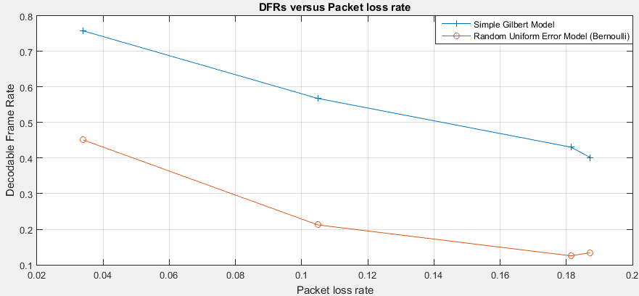

**Figure 10 DFRs versus packet loss rates of two channel model**

* 1. **Discussion** 
     1. **Plot analysis (difference analysis)**

From Fig.10, it is easy to find that the decodable frame rate for SGM is approximately double the decodable frame rate of uniform loss model in same condition of channel packet loss rate. The result can be derived that in same condition of channel, simple Gilbert model performs better than uniform loss model on video quality. This difference can be explained by introduce the transition probabilities of two unreliable channel models.

For SGM channel, the probabilities $p=Prob\left(G→B\right)$ and $q=Prob\left(B→G\right)$ are relatively lower than probabilities $1-p=Prob\left(G→G\right)$ and $1-q=Prob\left(B→B\right)$. This means in SGM channel, probabilities of stay in ‘Good’ state and stay in ‘Bad’ state are relatively higher, and the probabilities of switching states are much lower. While a packet is succeed transmitted, following packets always will be succeed transmitted; while a packet is loss, following packets always will loss in channel. Hence, in SGM model, the probability to send a frame (several packets) successfully is high if the first packet is sent successfully.

For uniform loss model, the transition probabilities satisfied Bernoulli process where $p=1-q$. The probability $p=Prob\left(G→B\right)$ is calculated as formula (3) in this report. In this case, the state switching probabilities of uniform loss model is much higher than SGM. A frame in consist of several packets, and this frame much difficult to send successfully by uniform loss model channel, because some packets are likely lost in the middle.

* + 1. **Improvement suggestions (video streaming case)**

Once a frame is un-decodable in receiver side (no matter current frame is I, P or B), receiver should try to decode next I-frame and discards all frames between current un-decodable frame and next I-frame. In contrast, a normal playback (retransmission) can be experienced by in receiver side once a frame is un-decoded, and it aims recover this frame.

Some approaches are design to handle transmission errors, and they are separated into two types: through data communications (i.e. error control FEC and retransmission ARQ) and through coding (i.e. Error-resilient source, channel coding, error concealment, and interaction between source encoder and destination decoder) [1].

**SGM model: (loss with whole frames in burst)**

* **Multiple Description Coding (MDC)**

Using two or more independent channels to transmit video frames simultaneously, so the probability of simultaneous packet losses over all channels is minimal [1]. These video frames for different channels could be sampled differently. Once the receiver receives frames from more channels successfully, it can decode and recover full quality of video; if it receives frames from less channel, it can recover the video with coarse quality, but has no impact on video streaming.

**Uniform loss model: (loss with random packets)**

* **Packet-level forward error correction (FEC)**

Similar to channel coding, FEC inducting proper amount of redundant packet [2]. In this case, it improving the end-to-end video quality of video streaming. Assume one group of pictures (GOP) of length *n* contains *k* video packets and followed by *m-k* redundant packets to form an *m-*packet FEC block. Performance of FEC is given in Fig.11, with comparing no FEC, where ABL is average burst length.

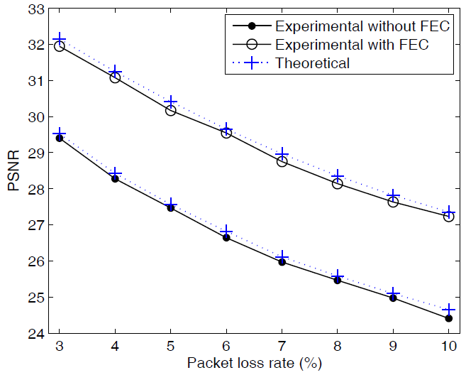

**Figure 11 comparisons of PSNR for video streaming with and without FEC [2]**

FEC always results in increasing the computing complexity. This technique can also been used in SGM modeled channel.

# **Conclusion**

In this experiment, a series of simulation have been ran to discover the packet loss and its impact on video quality. Two unreliable channels involved, one is simple Gilbert model (SGM), and another is uniform loss model. Four loss patterns were provided for participants to estimated corresponding transition probabilities and packet loss rate for SGM, and estimated packet loss rate for uniform loss model.

The simulation results given by plotting the decodable frame rate versus packet loss rate for different channel models. Corresponding analysis are given in this report by comparing these two models. In addition, what can be done in video streaming for each type of loss pattern is discussed in this report.

# **References**

1. K.S. Kim, “Introduction to Multimedia Transmission over Unreliable Networks”, Xian Jiaotong-Liverpool University, March 2016.
2. Z. Li, J. Chakareski, and L. Wang, “Video Quality in Transmission over Burst-Loss Channels: A Forward Error Correction Perspective”, IEEE Communications Letters, Vol.15, February 2011.