**Multimedia Communications**

EEE415

Lab 3 - report

Name: Cong Yin

ID Number: 1715471

**Introduction**

Spatial interpolation is one of the effective method for shape from texture, which used in damaged macroblocks. It can interpolate spatial pixels through the correct macroblocks of adjacent macroblocks, and it does not require the motion information of macroblocks. Of course, there are many kinds of interpolation methods, such as weighted interpolation, directional interpolation, and so on. The most important thing for spatial interpolation is to guarantee the effect of interpolation, and then, do not destroy the smoothness of edges, and do not make the images become blurred.

**Relevant Theories**

**Task1**

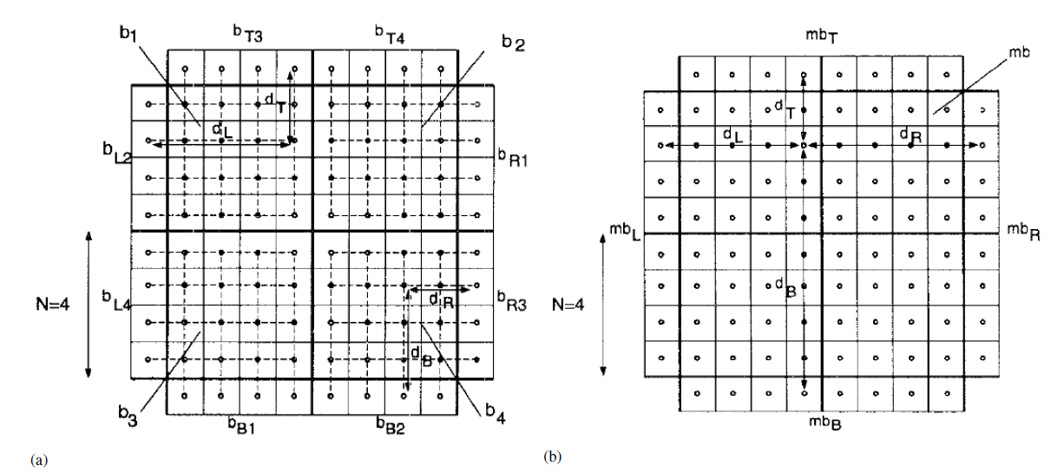

**Figure.1 Spatial interpolation techniques for error concealment: (a) Block based. (b) Macroblock based (from [1]).**

The first method as shown in figure.1 (a) that interpolates each single $N×N$ block in one macroblock. This interpolation can be described as follows: For $i, k = 1,⋯,N$

$$b_{1}\left(i,k\right)=\frac{d_{T}b_{R1}\left(i,N\right)+d_{T}b_{T3}(N,k)}{d_{L}+d_{T}}$$

$$b_{2}\left(i,k\right)=\frac{d_{T}b_{L2}\left(i,N\right)+d_{R}b_{T4}\left(N,k\right)}{d_{R}+d_{T}}$$

$$b_{3}\left(i,k\right)=\frac{d_{B}b_{L4}\left(i,N\right)+d_{L}b_{B1}\left(N,k\right)}{d_{L}+d_{B}}$$

$$b_{4}\left(i,k\right)=\frac{d_{B}b_{R3}\left(i,N\right)+d_{R}b_{B2}(N,k)}{d_{R}+d_{B}}$$

where $b_{l}, l= 1,⋯, 4$ is the $l^{th}$ block of the current macroblock, $b_{xl},l=1,⋯,4$ with $X = L, R, T, B$ is the $l^{th}$ block of the neighbored macroblock (Left, Right, Top, Bottom) and $d_{x}$ with $X = L, R, T, B$ is the distance from the respective pixel of the block $b_{xl}$ to the current pixel $b_{l}(i,k)$.

The second method as shown in figure.1 (b) that interpolates each pixel of the whole macroblock with the adjacent pixels of the four neighboring macroblocks. Each pixel of the current macroblock with the size $2N×2N$ will be concealed by simple interpolation of the four pixels of the surrounding macroblocks, i.e., for $i, k = 1,⋯,2N$

$$mb\left(i,k\right)=\frac{1}{{d_{L}+d_{R}+d}_{T}+d_{B}}{(d}_{R}mb_{L}\left(i,2N\right)+d_{L}mb_{R}\left(i,1\right)+d_{B}mb_{T}\left(2N,k\right)+d_{T}mb_{B}\left(1,k\right))$$

With only two available macroblocks $mb_{T}$ and $mb_{B}$ the equation reduces to: for $i, k = 1,⋯,2N$

$$mb\left(i,k\right)=\frac{d_{B}mb_{T}\left(2N,k\right)+d_{T}mb_{B}\left(1,k\right)}{d_{T}+d_{B}}$$

that as shown in figure.2

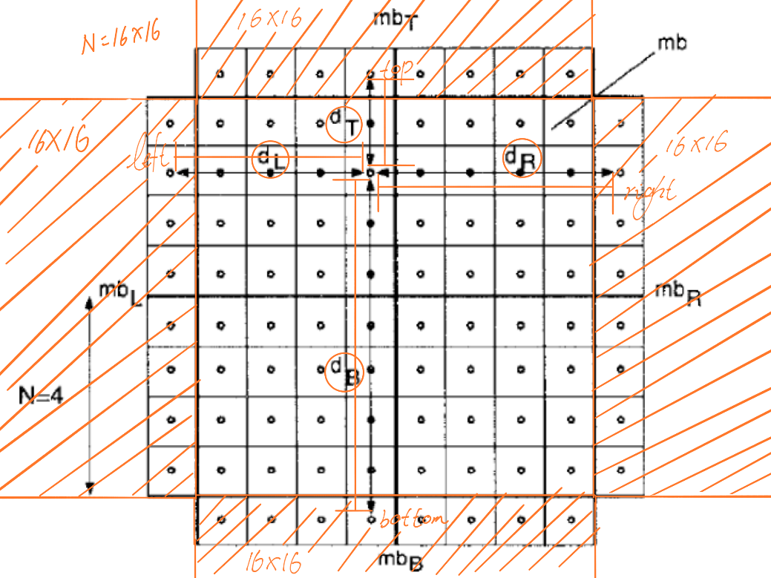

**Figure.2 Macroblock based**

**Task2**

**Edge detection**

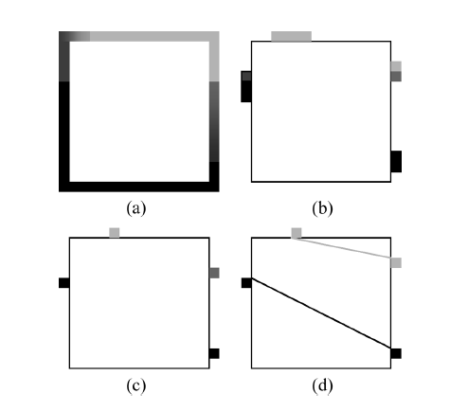

**Figure.3 Edge recovery process. (a) Edge detection on boundary pixels. (b) Detected edge points. (c) Obtaining representative edge points. (d) Edge matching and linking.**

Edge is a discontinuity of local quality, which located in the image. In other words, it is the mutation of grayscale, color or structure, which have two characteristics was named direction and amplitude. Because of the spatial correlation for two neighboring macroblocks, one object edge maybe cannot pass through only one macroblock. At the same time, it will pass through several neighboring macroblocks. Therefore, we can judge the edge position and direction of the damaged area according to the location of other eight macroblocks, which around the damage macroblock.

This model uses Sobel operator for calculate the gradient magnitude and gradient direction. The following Sobel operator is adopted in this work:

$H_{r}=\frac{1}{4}\left[\begin{matrix}1 & 0 & -1 \\ 2 & 0 & -2 \\ 1 & 0 & -1\end{matrix}\right]$, $H_{r}=\frac{1}{4}\left[\begin{matrix}1 & 0 & -1 \\ 2 & 0 & -2 \\ 1 & 0 & -1\end{matrix}\right]$

Assume the pixel $(x,y)$, the gradient of pixel $(x,y)$ can indicate to $G_{r}(x,y)$ and $G_{c}(x,y)$. ( $G_{r}(x,y)$ is the horizontal component, $G_{c}(x,y)$ is the vertical component) $G_{r}(x,y)$ and $G_{c}(x,y)$ can computed by the convolution of the image $F\left(x,y\right)$ with row and column impulse arrays as

$$G_{r}\left(x,y\right)=F\left(x,y\right)×H_{r}(x,y)$$

$$G_{c}\left(x,y\right)=F\left(x,y\right)×H_{c}(x,y)$$

The module value and direction of gradient can be calculated by the following function

$$A\left(x,y\right)=\sqrt{G_{r}^{2}\left(x,y\right)+G_{c}^{2}(x,y)}$$

$$θ\left(x,y\right)=arctan\frac{G_{r}\left(x,y\right)}{G_{c}\left(x,y\right)}$$

If the amplitude $A\left(x,y\right)$ is larger than a pre-specified threshold, pixel $\left(x,y\right)$ is said to lie on an edge. The threshold is set to the variance of pixel values here. Several consecutive pixels are often detected as edge points as shown in Figure. 1(b). Among them, only one pixel with the largest gradient amplitude is selected as the true edge point as shown in Figure. 1(c).

A simple attribute distance between two edge points can be calculated as the following function

$$d\left(α\left(x_{1},y_{1}\right),α\left(x_{2},y_{2}\right)\right)=\left|G_{r}\left(x_{1},y_{1}\right)-G_{r}\left(x_{2},y_{2}\right)\right|+\left|G_{c}\left(x_{1},y_{1}\right)-G_{c}\left(x_{2},y_{2}\right)\right|+\left|θ\left(x_{1},y_{1}\right)-θ_{1,2}\right|+\left|θ\left(x_{2},y_{2}\right)-θ_{1,2}\right|+\left|P\left(x_{1},y_{1}\right)-P\left(x_{2},y_{2}\right)\right|$$

where $θ_{1,2}$ is the slant angle of the line connecting $\left(x_{1},y_{1}\right)$ and $\left(x_{2},y_{2}\right)$. A pair of edge points is deemed to be a match if their attribute distance is the smallest among all. Thus, we will label them as a pair and treat the remaining edge points as a new group. The same matching process is performed iteratively until all points are matched or the attribute distance between two edge points is still above a certain threshold. Finally, each matched pair is linked together to recover a broken edge.

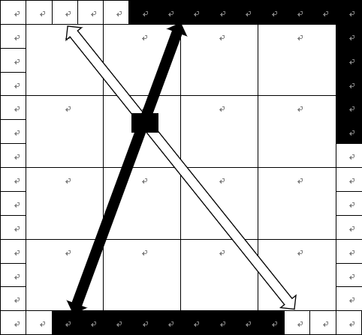

**Figure.3 The interpolation of macroblock, which located in the edge**

I apologize for this lab, because I cannot complete this method on matlab.

**Experimental Process**

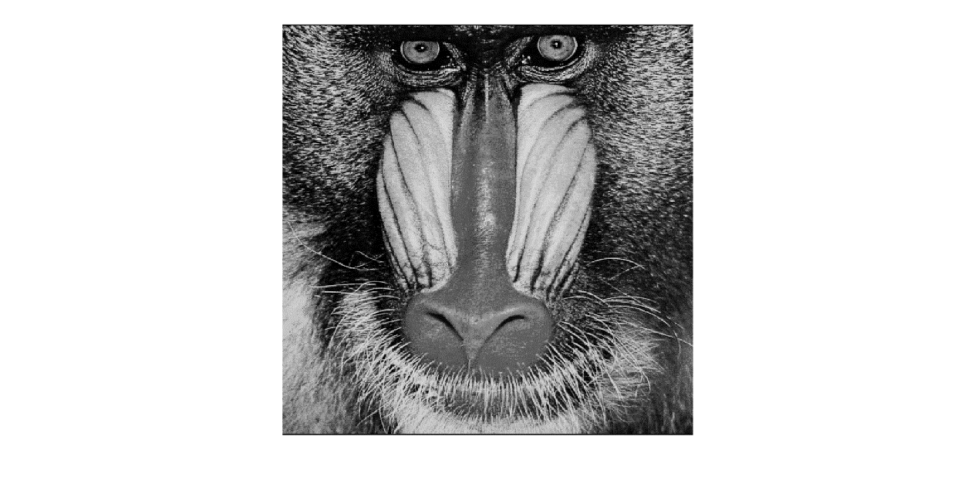

**Figure.4 original image**

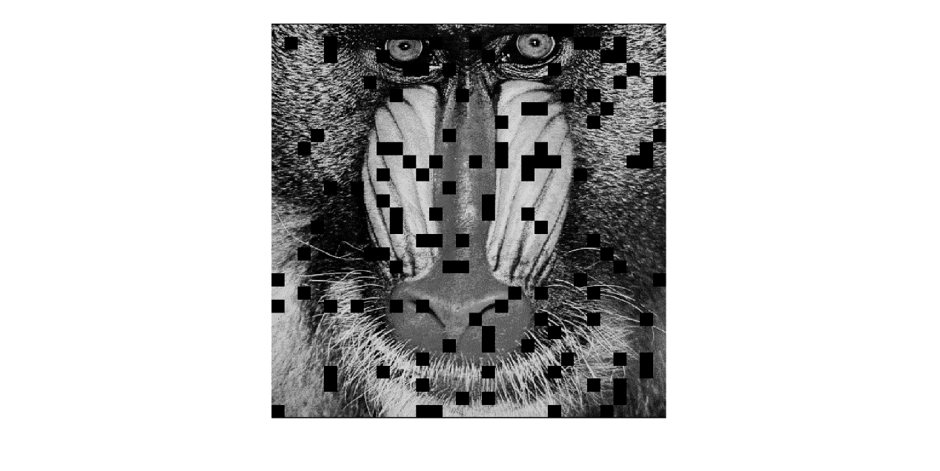

**Figure.5 damage image**

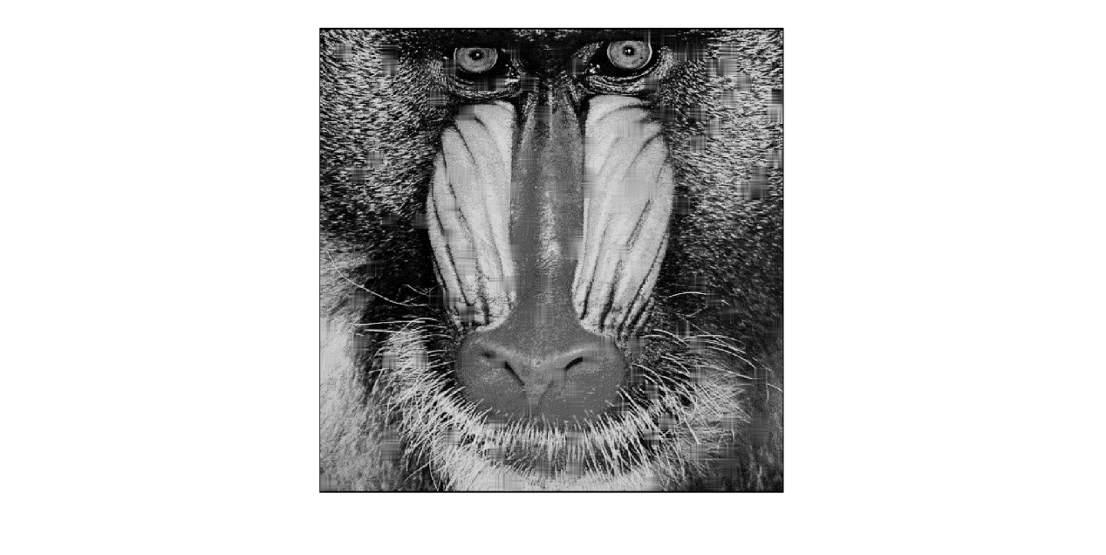

**Figure.6 recovery image**

Finally, the psnr equals to 24.2232, compare with the damage image that have previously improvement.

**Discussion**

For the first task, this method is used to interpolate the pixel value of the neighborhood block of the non-recoverable block, which requires the interpolated data to be smooth and natural. Compare with the damaged pictures, this method can improve the PSNR of the image. The advantage of the algorithm is very simple and easy to implement. It has a better effect of interpolation for images, which have smooth changes. However, it has a very serious limitation, the algorithm is always treating damaged macroblocks as smooth images. If the damaged macroblock has rich high frequency information, or when the image boundary passes through the macroblock, this method will lead to the texture of the image is lost, the image will become to blurred and the quality of the image will be significantly reduced. This model uses weighted interpolation, which just include horizontal direction and vertical direction for recover image. Because of that without considering the texture characteristics. So, the image texture complexity and motion details cannot be recovered satisfactorily. At the same time, there are only linear interpolation is made in the horizontal and vertical direction. It is considered that the edge of the texture is just in the vertical direction and horizontal direction. So that will loss the boundary information of the damaged area and blurred the block of image.

For the second task, this method based on the edge detection. It can effectively restore the edge information of the image, and more accurately restore the macroblocks which are currently wrong, thus greatly improving the quality of the macroblock.

**Conclusion**

At present, all kinds of error concealment algorithms have different characteristics and range of adaptation. According to different situations, choosing different methods will get the different results, which can improve the quality of the image.