Eyamba D. Bokamba

HW2: Stock Analysis (EASY) Screenshots

U of M Data Viz Boot Camp

11/29/18

Screenshots for Final Report

**2016**

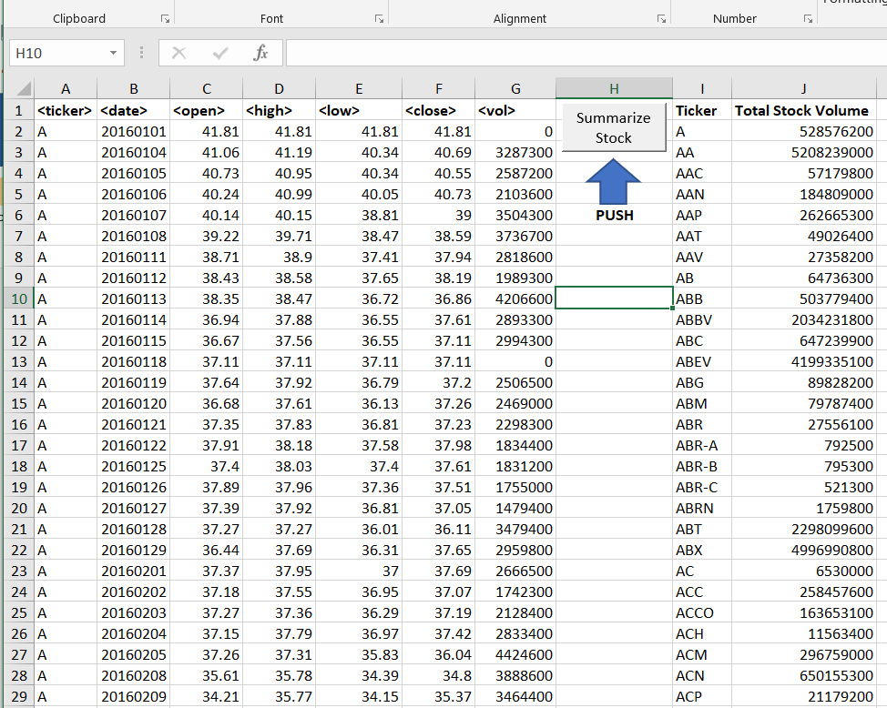

**2015**

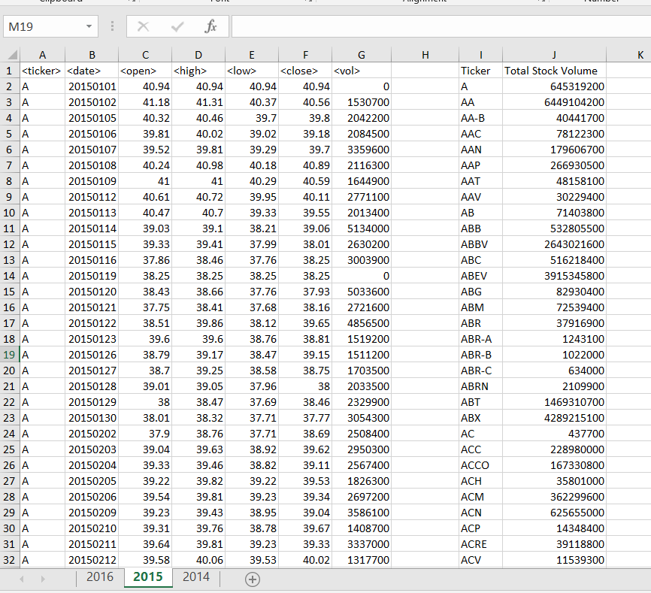

**2014**

