Overview:

I will be creating an application to store and manage useful resources (urls) that the user finds across the internet. They’ll be able to easily create and manage entries that will be presented to them on their homepage after they log in. If time allows for more complexity on top of that, additional functionalities can be added such as making the resources saved with tags and then creating filters for the resources, or adding a search functionality. I’m not completely sure how difficult each step of the process will be so it would be nice to have more flexibility in the functions. As a result some of the following wireframes / routes might need to be adjusted in the future to fit the application accordingly.

Storyboard:

- Basic Wireframes

- Mobile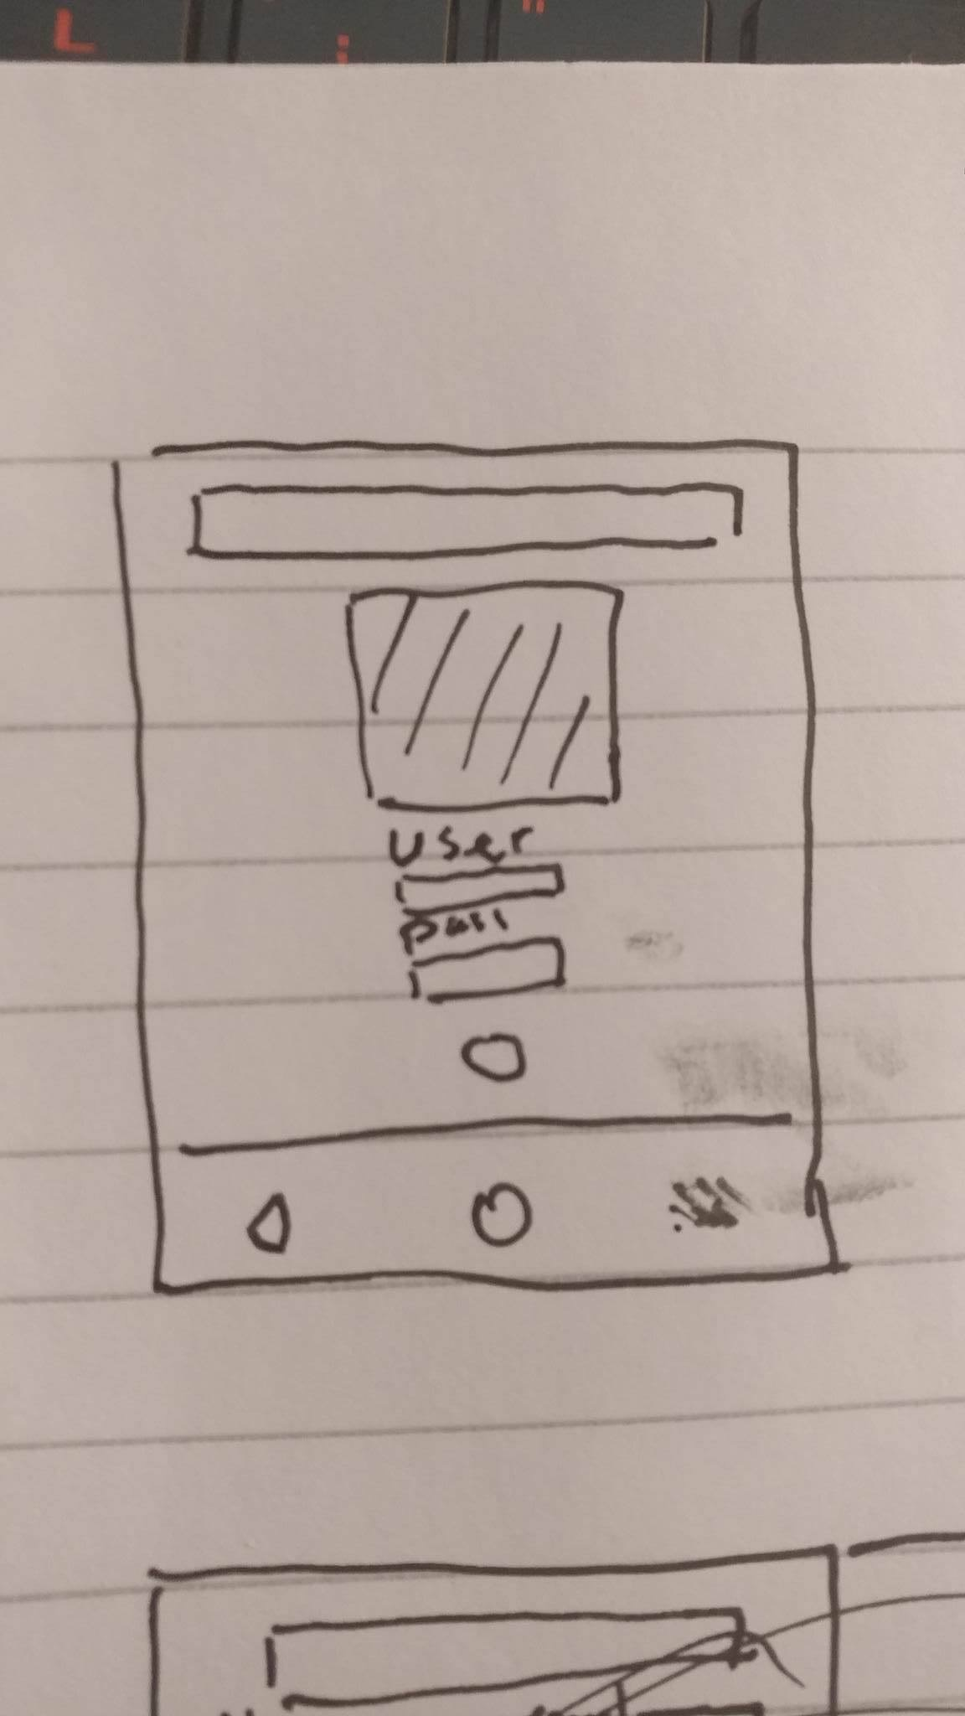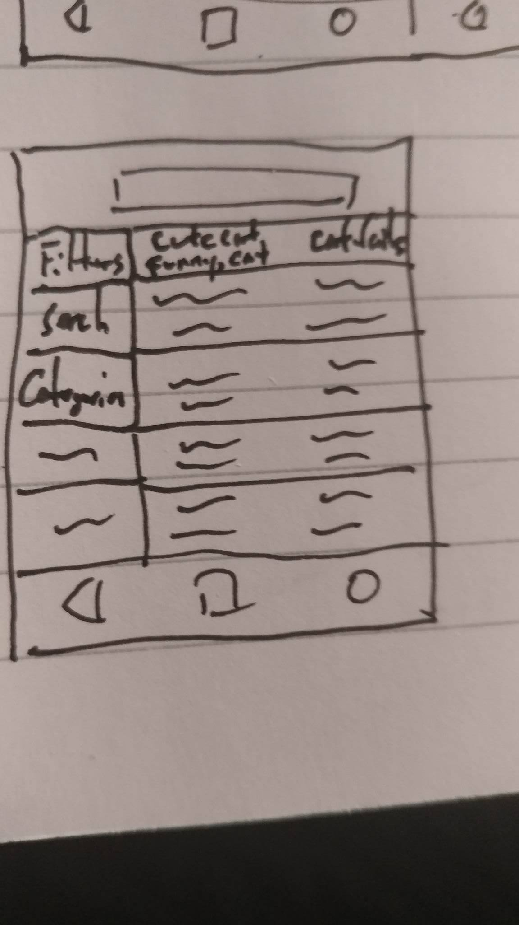

- Desktop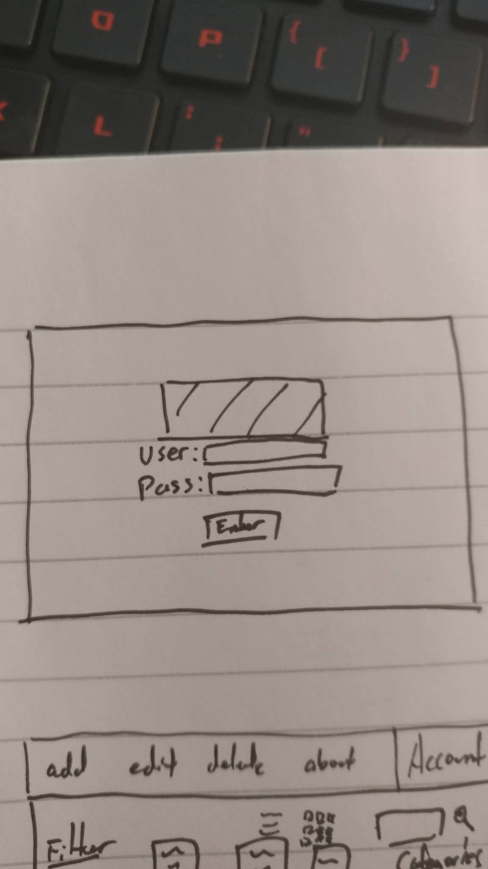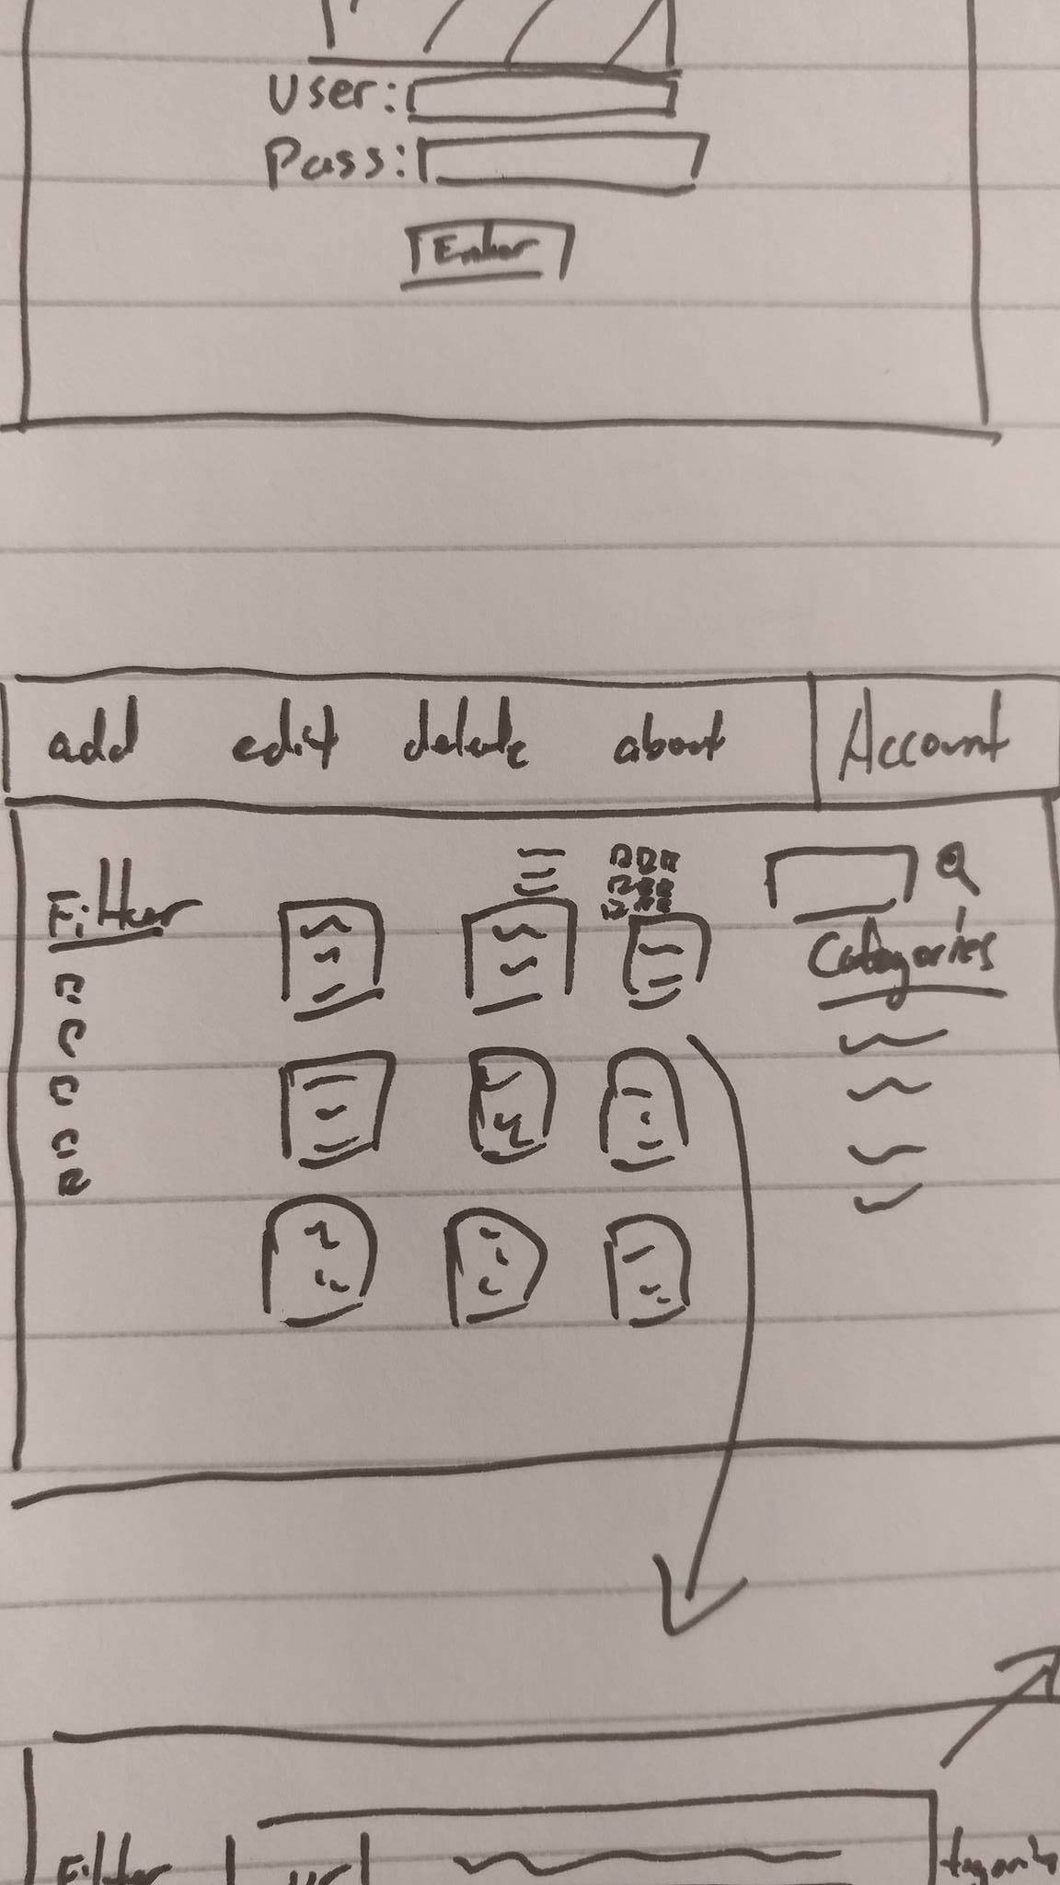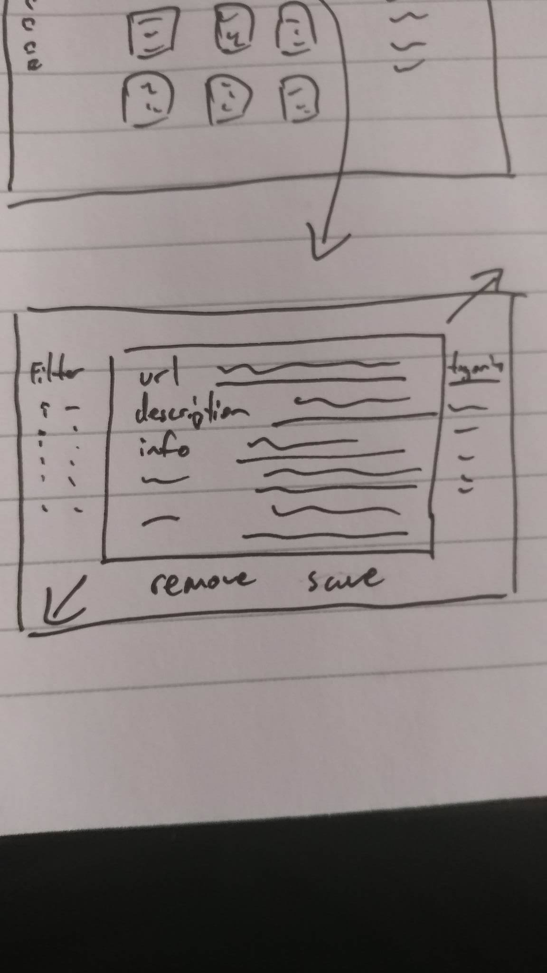

WebServices:

I don’t think it’s necessary to use any web services outside of a database manager for this project. It’s possible that I might end up using URL.parse later on when adding functionalities such as information autofill, but for the basic application, the only thing I’ll be using is mlab as a way to manage the mongoDB that i’ll need to store the user’s information in. The methods I’ll most likely use are the editing and retrieving features in db.collection(‘example’) database tables.

MVC Models/Routes:

Models that will need to be called are most likely be a createURL model and a createCategory model. On top of that I was also going to use a authentication middleware like Passport for NodeJS as a way to manage user log ons. For routes the main one would be a starting /login route that would get the login page which would end up being used for authentication, after that it would have the user id retrieve the user lists and display it to them with the category route being displayed after the user id. For the search and filter features, each term would end up being added to the route and the information entered would be used to narrow down the list.

MVC Methods:

There’s not too many direct methods I would need to use for this outside of the createURL model where I would need an editing and retrieving methods and the methods for storing and retrieving url objects in the category class. Other than that I would need to use a lot of mlab calls in order to manage the mongoDB information which is stored on [mlab.com](http://mlab.com).

Stored Data:

I’ll be storing each user’s saved url as well as the information they’ve entered about it as JSON objects for each user. For example the app might ask the user for the url of the site they want to save, a description, any tags they might want to use to help with filtering, a name, any other details they want to include about the resource, and also add on the date and time the resource was created. Depending on how feasible it is, it might also be cool to add in a type of autofill for whatever information you can get from the url.