TandemX reveals family-specific tandem-repeat under-representation in high-quality plant genome assemblies
Running title: Read-based assessment of plant tandem-repeat representation

Abstract
Long tandem-repeat arrays remain among the least reliably represented components of plant genomes, even as chromosome continuity approaches telomere-to-telomere resolution. We asked whether abundant repeat families can remain under-represented in high-quality assemblies and developed TandemX to compare family abundance in raw long reads with representation of the same families in an assembly. In Arabidopsis thaliana Ey15-2, all eight repeat families that gained substantial representation from a historical CLR-Canu assembly to a HiFi assembly were independently prioritized from HiFi reads; the other 11 eligible families were not. In Macadamia jansenii, the same analysis identified both families preferentially recovered in the newer assembly and did not label the other 41. Independent Illumina data supported residual deficits for two Ey15-2 families, and Illumina plus direction-level Nanopore evidence supported one Macadamia family. Three additional preselected candidates remained unresolved, revealing how k-mer length and sequence composition can change family-abundance estimates. Controlled simulations defined the analytical scope of the workflow: TandemX recovered all 54 planted family conditions in a unified comparison, whereas SRF recovered 45 at k=151 and 53 at k=101. Ordinary competitive mapping with the TandemX catalogue produced lower abundance error, and shared-fragment backgrounds exposed lower catalogue specificity for TandemX. Together, these results show that raw-read abundance can reveal family-specific repeat deficits that contiguity statistics do not capture, while explicit cross-k and cross-platform tests distinguish supported candidates from unstable estimates.

Introduction
Tandemly repeated DNA is a prominent and rapidly evolving component of plant genomes. Large arrays occur at centromeres, pericentromeric regions, nucleolar organizers and other chromosome domains, where their abundance and sequence organization contribute to genome structure and chromosome variation [1–4]. Their monomer lengths, sequence divergence and copy numbers can differ sharply among families, chromosomes, accessions and species. Describing a plant genome therefore requires more than locating a repeat family: it also requires asking whether the assembly represents its genomic abundance.
Long-read sequencing and telomere-to-telomere assembly have resolved many regions that were absent from earlier references [3,4,6–8]. Tandem arrays nevertheless remain difficult because highly similar copies provide few unique anchors and the arrays can exceed individual sequencing molecules. A chromosome-scale or gapless assembly can contain a repeat family while still representing fewer copies than occur in the sequenced material. N50, gap count and genome-wide k-mer completeness summarize important properties, but none directly answers this family-level abundance question.
Available methods address complementary parts of the problem. TRF and AniAnn's annotate tandem arrays in sequence [9,19]; TideHunter detects repeat intervals and consensus units in long reads [10]; TRASH and TideCluster annotate and cluster assembly-derived repeats [11,12]; and SRF reconstructs abundant satellite units from reads or assemblies and estimates mapped-base abundance [13]. Merqury and KAT compare read and assembly k-mer spectra to assess genome-wide quality and completeness [16,17], whereas TandemTools uses long reads to assess assembled extra-long tandem repeats [18]. What remains difficult is to follow a de novo repeat family from raw-read discovery through abundance estimation and assembly localization, then report the family-specific discrepancy together with the evidence needed to interpret it.
We developed TandemX for this purpose. It constructs sequence-supported operational families from HiFi reads, estimates their abundance with diagnostic k-mers, localizes the same family catalogue in an assembly and reports the read--assembly abundance deficit. The linked output distinguishes TandemX from tools that reconstruct repeat units, annotate arrays or score whole-assembly completeness as separate tasks (Table 1). Cross-k and orthogonal-platform evidence is used to separate stable family-specific deficits from estimates that depend on sequence composition or measurement mode.
We first define the workflow and its analytical performance with controlled, endpoint-matched comparisons. We then establish its range across ten public HiFi libraries from eight plant species. The biological tests focus on historical and newer assemblies of Arabidopsis thaliana Ey15-2 and Macadamia jansenii, asking whether read-prioritized families were preferentially recovered by improved assemblies and whether any deficits persisted in the newer assemblies. Independent Illumina data, supplemented by Nanopore evidence in Macadamia, support three residual family-specific deficits. These results establish repeat-family representation as a dimension of plant assembly quality that remains partly independent of chromosome continuity.

Results

TandemX connects raw-read repeat families to assembly representation
TandemX addresses a distinction that is invisible to contiguity statistics: an assembly can contain a tandem-repeat family while representing fewer copies than are supported by the sequenced material (Fig. 1A). The workflow begins with HiFi reads, detects periodic intervals, derives candidate monomers and groups them by cyclic, strand-aware sequence similarity (Fig. 1B). Each operational family is represented by a consensus sequence and its supporting read intervals. Related representatives and possible period multiples are retained as candidate relationships, without assigning ancestry or higher-order-repeat structure.
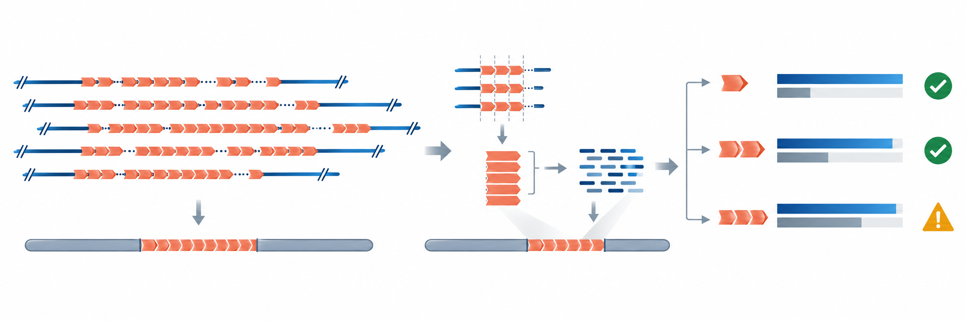
Figure 1. TandemX links raw-read tandem-repeat families to assembly representation.
Diagnostic canonical k-mers that distinguish a family from other catalogue representatives provide a read-derived abundance estimate. The same family representative is then localized in an assembly, and overlapping intervals are unioned to measure assembled repeat bases. For read-derived abundance R and assembly representation A, TandemX reports D = max[R - A, 0) and the ratio A/R (Fig. 1B,C). Candidate deficits can then be tested across k-mer lengths or with independent sequencing platforms. A family with discordant measurements remains unresolved rather than contributing to a genome-wide score.
This linked family-level output is the main distinction from existing tools (Table 1). Repeat detection, repeat-unit reconstruction, assembly annotation, long-read mapping and genome-wide k-mer completeness are all established tasks. TandemX connects them around one operational family catalogue so that a reader can move directly from a read-supported family to its estimated abundance, assembly coordinates, representation ratio and evidence state (Fig. 1C).
Table 1. Native analytical scope of tools relevant to tandem-repeat assembly assessment. The table describes standard inputs and outputs rather than every possible downstream combination.
Tool or class | Native input | Principal relevant output | Family-resolved read abundance | Linked family-level read--assembly audit
TideHunter | Long reads | Per-read tandem intervals and consensus units | No catalogue-level estimate | No
SRF | Reads or assemblies | Reconstructed satellite units/HORs and mapped-base abundance | Yes, for reconstructed units | No linked assembly audit
TRASH/TRASH2, TideCluster, AniAnn's | Assembly sequence | Tandem-array annotation, clustering or repeat structure | No read-derived estimate | No
TandemTools | Assembly and long reads | Mapping, polishing and quality assessment of assembled extra-long tandem repeats | Not a primary output | Assembly assessment without a de novo abundance catalogue
Merqury/KAT | High-accuracy reads and assembly | K-mer spectra and whole-assembly quality summaries | No repeat-family catalogue | Genome-wide rather than family-resolved
TandemX | HiFi reads; assembly optional | Operational family catalogue, abundance, localization, deficit and evidence state | Yes | Yes

Controlled benchmarks establish analytical performance and method complementarity
We evaluated repeat discovery, abundance estimation and assembly localization against separate planted truth definitions before comparing tools at matched endpoints. The complete simulation design and TandemX-only validation panels are reported in the Supplementary material; the main figure is restricted to final production TandemX and external comparators. In a factorial 10-Mb simulation containing 55 planted families, TandemX recovered all founders from clean and high-error 5x long-read datasets. A broader validation spanning period, divergence, indels, array number and negative controls retained high array and family recovery and made no calls in the three purely negative classes. Sequence-based clustering also recovered all three related planted families in a dedicated validation.
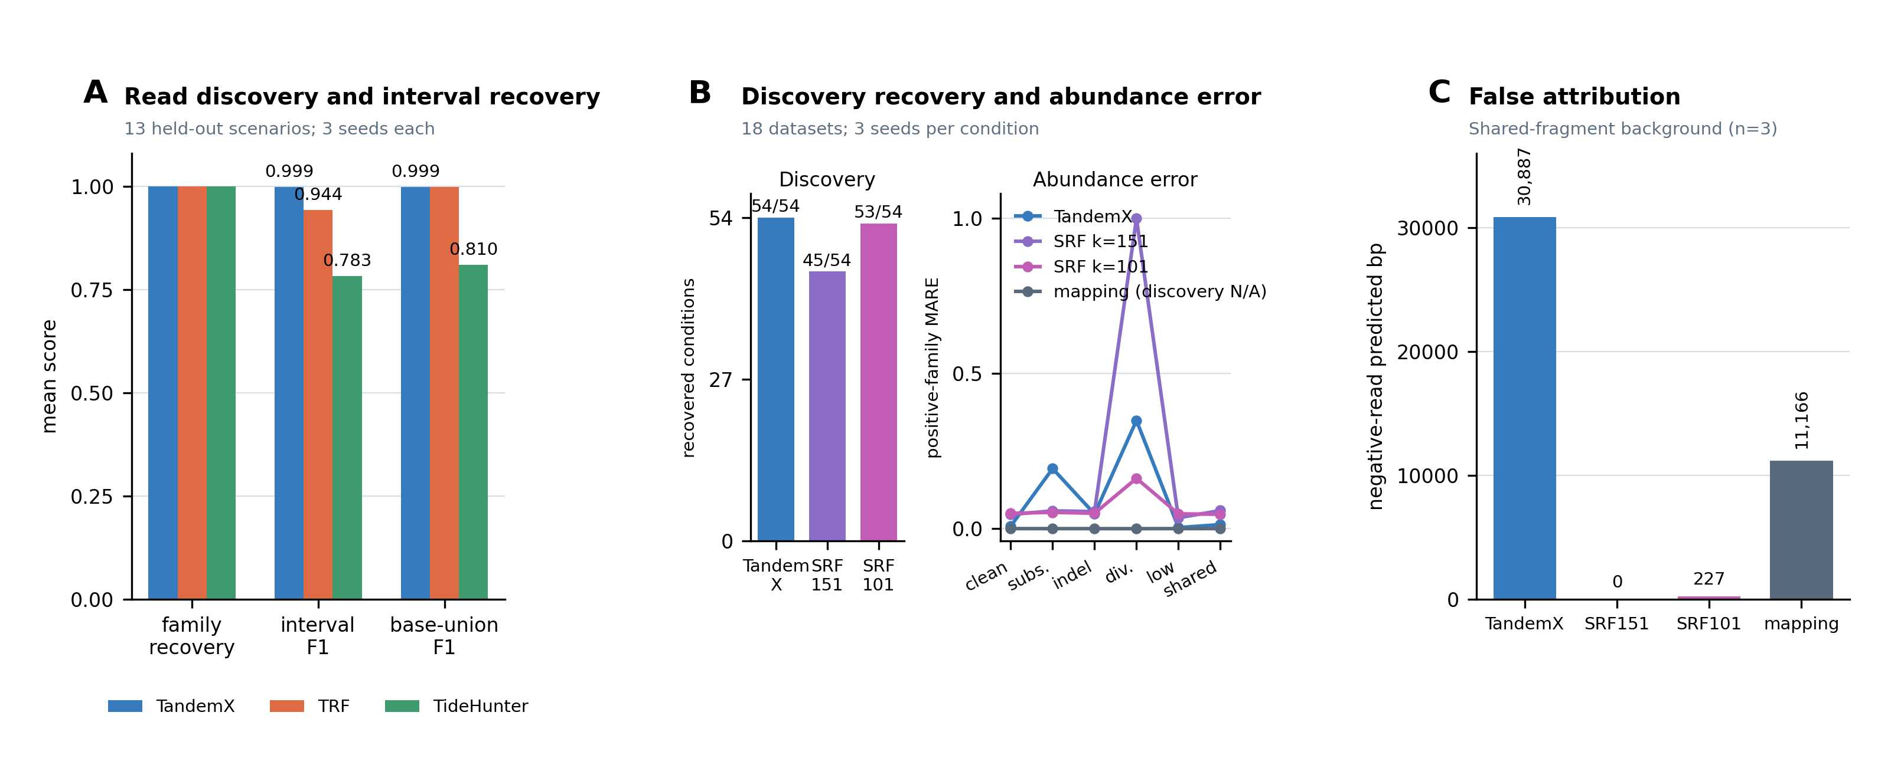
Figure 2. Endpoint-matched comparisons define the analytical scope of TandemX.
We next measured how discovery changed from 0.5x to 30x in nested read sets from three independently generated 10-Mb validation genomes (Supplementary Fig. S1; Supplementary Tables S3 and S4). Median operational-family count increased from 34 at 0.5x to 55 at 5x and 58 at 30x, whereas the median number of unique candidate monomers continued to increase from 36 to 119. All 55 planted families, including the 20-copy low-abundance tier, were recovered in every genome at 5x, and no additional planted family was recovered at higher depth. Under the pre-specified catalogue criterion, 5x--10x and 10x--20x both had a new-family fraction below 0.05 and a family-level Jaccard above 0.95 in all three genomes; 20x was therefore the first operational saturation depth. The 20x--30x transition also passed in all genomes. This result separates early recovery of the planted families from the more conservative stabilization of the complete operational catalogue.
Supplementary Figure S1 is placed in the Supplementary Figures file; its complete legend appears below.
Quantification was scored with the planted catalogue supplied so that abundance error remained separate from discovery error (Supplementary Fig. S3). Across three independent 10-Mb validation genomes and 1,485 family conditions, the frozen production estimator had a mean absolute relative error of 0.363. Error remained highest in the deliberately difficult 20x, 2%-divergence, high-error condition. Diagnostic support was insufficient in some low-coverage conditions, so the workflow reports availability and dispersion with each estimate. Comparisons among earlier normalization variants are retained only in the Supplementary material.
Assembly localization remained accurate when nearby anchors were bridged across no more than one monomer length (Supplementary Fig. S4). On new simulated genomes, mean recall was 0.981 and mean precision was 0.9996; recall in the weakest 5%-divergent, three-segment stratum was 0.949. The downstream binary comparison was more sensitive to abundance error: in the held-out test, sensitivity was 0.654, false- positive rate was 0.016 and precision was 0.983.
Task-matched comparisons showed substantial overlap with existing tools rather than one universal winner (Fig. 2A). TandemX, TRF and TideHunter recovered all 55 founders in the read simulation, although one-to-one high-error array precision was 1.000, 0.699 and 0.920, respectively. Base-union precision exceeded 0.996 for all three, showing that overlapping and harmonic calls affected interval counts more than covered bases. On assemblies, TRASH2 recovered all planted families, and TideCluster achieved high base-union accuracy in completed runs. Runtime and memory measurements are reported in the Supplementary material rather than used to structure the main comparison.
A unified experiment compared TandemX, SRF and ordinary competitive mapping on 18 newly generated read datasets spanning six conditions (Fig. 2B,C; Supplementary Table S2). TandemX recovered all 54 planted family conditions, whereas SRF recovered 45 at k=151 and 53 at k=101. Positive-family abundance accuracy followed a different ranking: competitive mapping with the TandemX catalogue had the lowest error in every condition, and SRF was more accurate than TandemX under substitutions and 2% unit divergence. In shared-fragment backgrounds, TandemX annotated a mean 30,887 negative-read bases per dataset, compared with 0 for SRF k=151, 227 for SRF k=101 and 11,166 for competitive mapping. The combined benchmarks therefore define TandemX as a connected family-level audit with strong recovery, while abundance estimation and catalogue specificity remain endpoint-dependent.

TandemX operates across diverse plant repeat landscapes
We next asked whether the workflow could be applied across the range of genome sizes and repeat contents encountered in plant genomics. Ten complete HiFi libraries from eight reported species passed checksum, FASTQ traversal and record/base reconciliation, together comprising 14,937,608 reads and 262.7 Gb of sequence (Fig. 3A; Supplementary Table S1). The cohort included Arabidopsis, rice, maize, barley, rye, wheat, oat and wild soybean, with individual libraries ranging from 5.62 to 77.09 Gb and median read lengths from 13.46 to 21.51 kb.
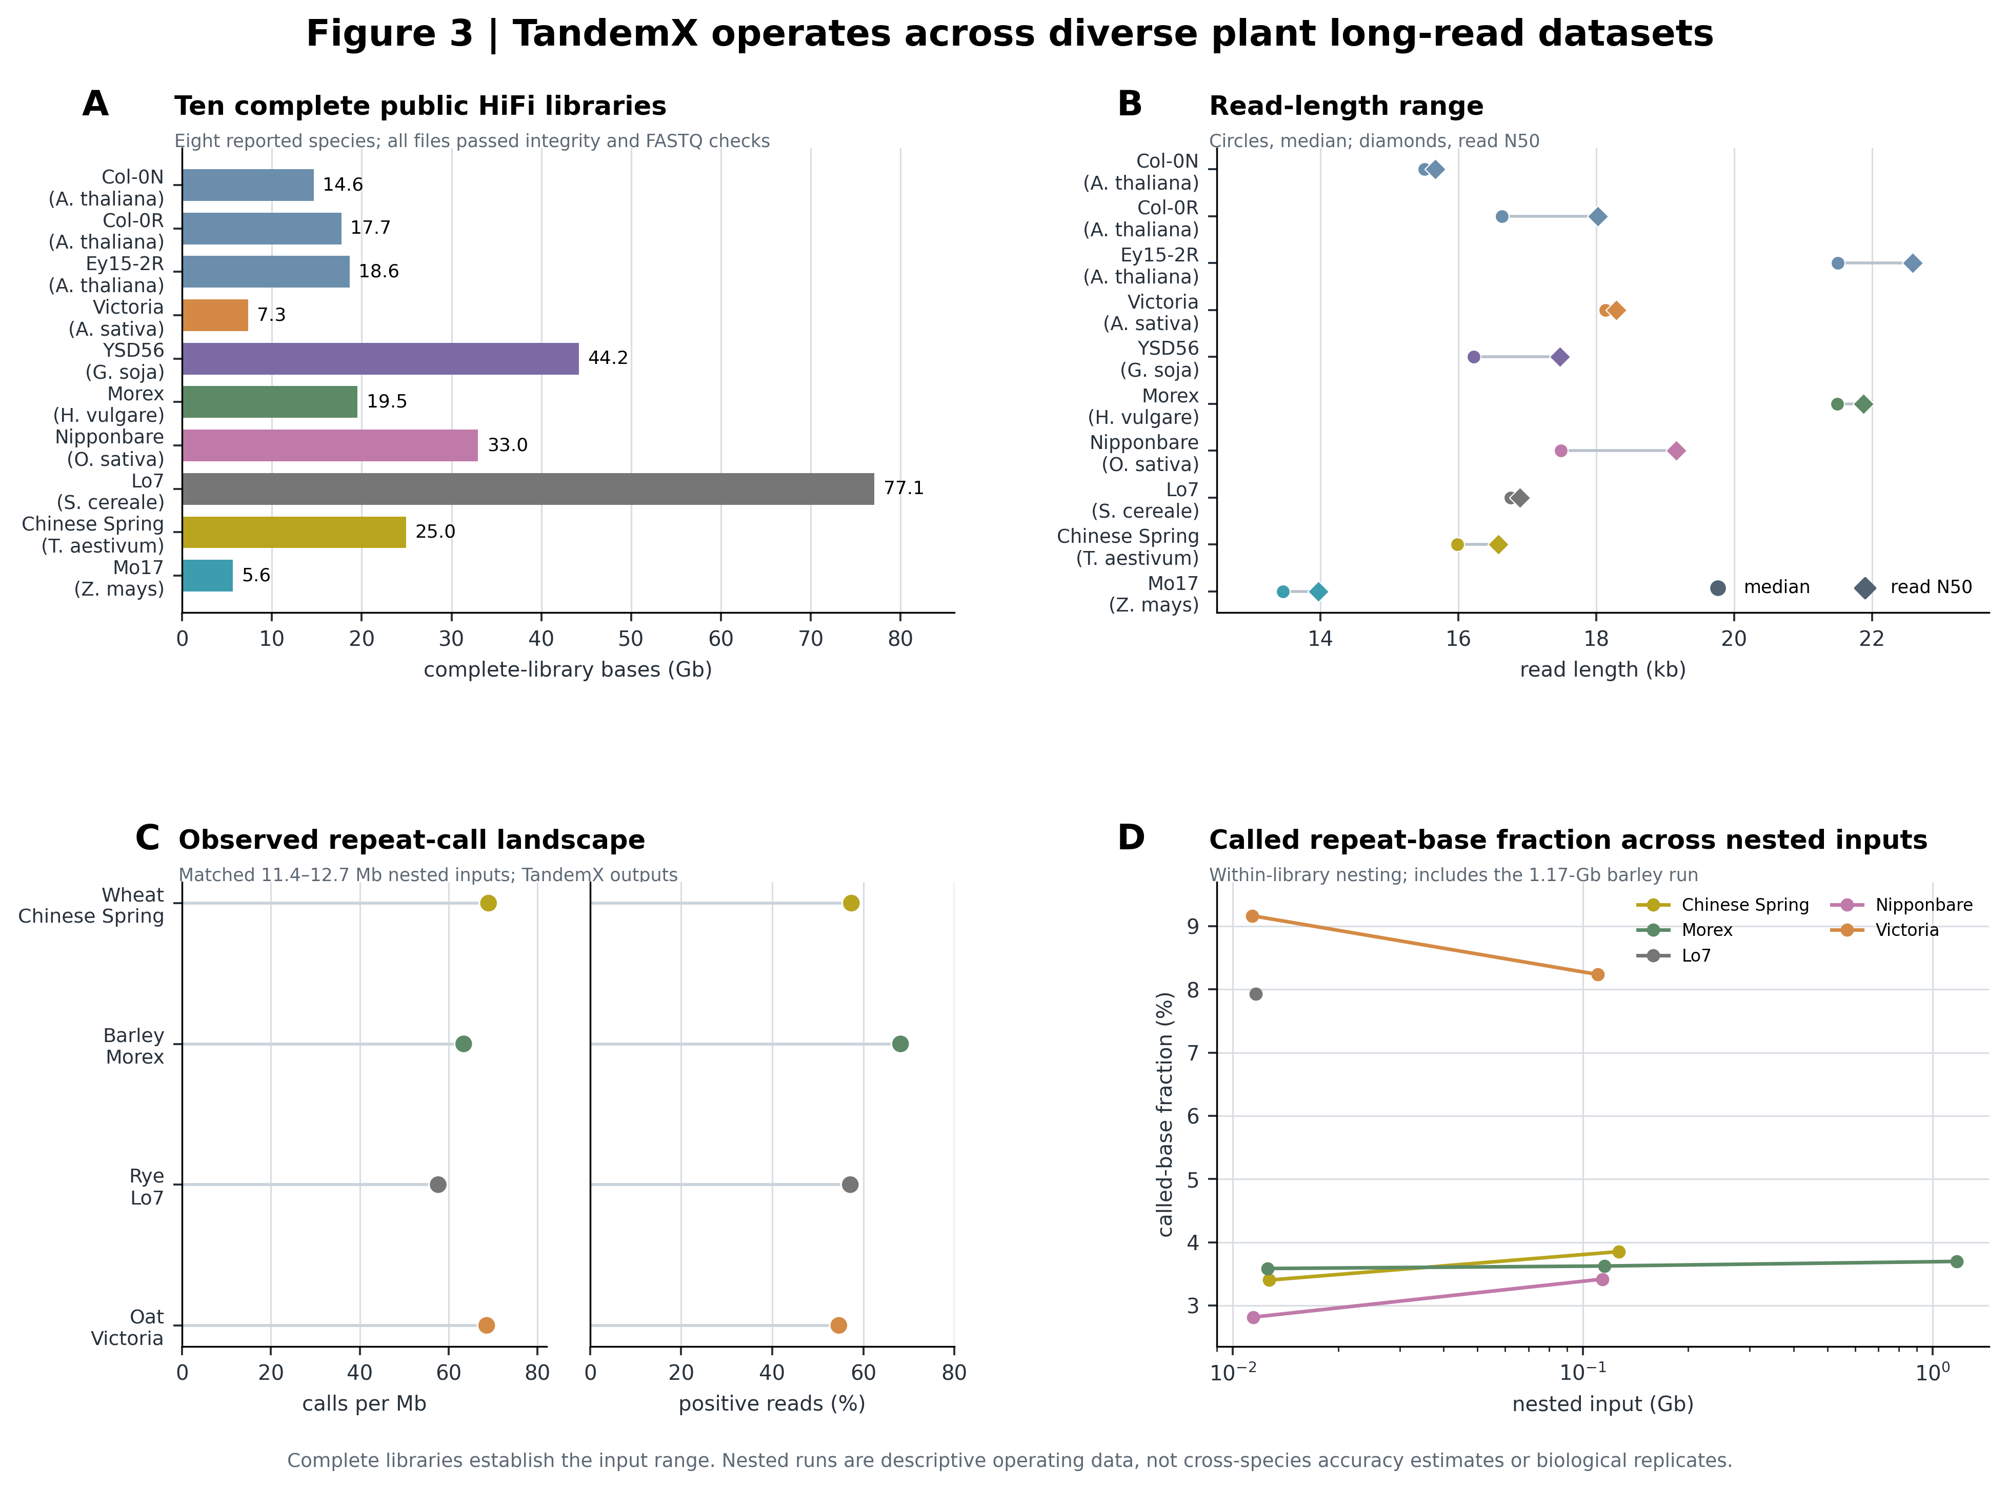
Figure 3. TandemX operates across diverse plant long-read datasets.
TandemX produced repeat calls in each tested plant dataset, including wheat, barley, rye and oat libraries from large, repeat-rich genomes (Fig. 3B-D). Catalogue size, monomer length, supporting-read fraction and repeat-base fraction varied among libraries and input scales. Nested subsamples retained the major input-specific patterns while increasing the number of lower-support calls at larger scale. These profiles demonstrate that the same workflow can generate family catalogues across contrasting plant datasets without loading complete libraries into memory.
The cross-species profiles are used here to establish operating range and to display the diversity of candidate repeat families. Several libraries represent pooled plants or technical batches, and no matched family-level truth exists across the cohort. The biological assembly tests therefore use the two systems with the strongest available historical/newer assembly relationship rather than treating the ten libraries as replicate estimates of species differences.

Improved assemblies preferentially recover repeat families prioritized from raw reads
The first biological test asked whether raw-read abundance could identify repeat families later recovered by improved assemblies (Fig. 4A). In A. thaliana Ey15-2, we compared the paper-supplied Bionano-scaffolded CLR-Canu assembly with the newer HiFi-Hifiasm assembly from the same accession and sample designation [4]. Nineteen read-derived families had at least 15 kb in the newer assembly and entered the primary analysis. Eight showed an old/new assembly ratio below 0.6. The HiFi-read comparison independently prioritized all eight against the historical assembly and did not label the other 11 (Fig. 4B).
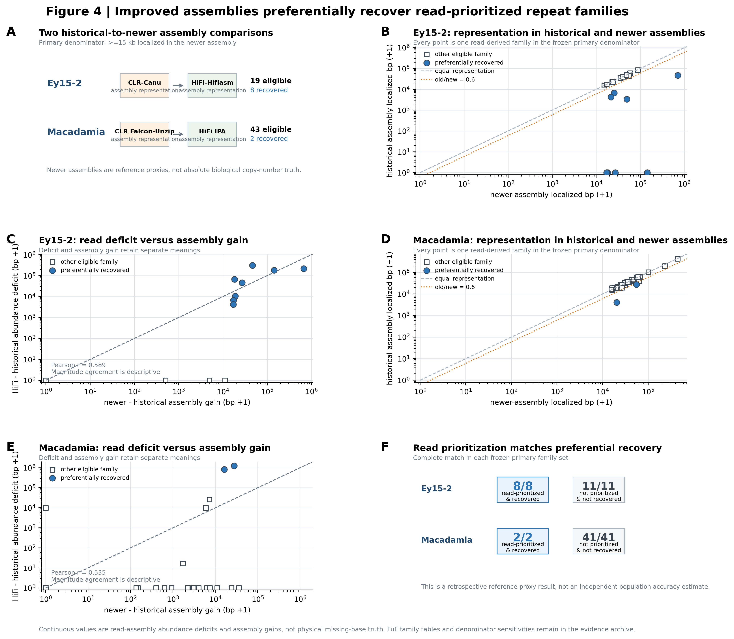
Figure 4. Repeat families prioritized from raw reads are preferentially recovered by improved assemblies.
Representation changed most clearly at the family level. Across the eligible Ey15-2 families, the total HiFi-versus-old abundance deficit was 840,658 bp and the new-versus-old assembly gain was 973,959 bp. The family-level Pearson correlation was 0.589, and the mean absolute difference was 45,551 bp, indicating agreement in which families gained rather than exact agreement in gain magnitude (Fig. 4C). At a permissive 5-kb eligibility threshold the larger family set contained one missed and two additional calls; six families remained at 50 kb.
We repeated the analysis in the phylogenetically distant M. jansenii, using an earlier CLR Falcon-Unzip primary assembly and a newer HiFi IPA primary assembly (Fig. 4D). The newer assembly was more contiguous, with 284 rather than 762 primary contigs, although it was slightly shorter overall. Of 1,227 read-derived families, 43 had at least 15 kb represented in the newer assembly. Two families showed strong historical under-representation; TandemX prioritized both and did not label the other 41. The result was unchanged when read depth was normalized by the paper-reported 28-Gb yield instead of the public FASTQ total.
The Macadamia HiFi-versus-old abundance deficit was 2.12 Mb, whereas the new-versus-old gain among eligible families was 0.159 Mb. Family-level correlation was 0.535 and the mean absolute difference was 50.3 kb (Fig. 4E). Thus both plant systems supported the same qualitative result: families with a large raw-read signal relative to a historical assembly were the families that preferentially gained representation in an improved assembly. The discordant magnitudes led us to test remaining deficits with independent reads.

Independent reads support residual deficits in three high-quality assembly families
We selected six newer-assembly candidates before examining orthogonal data: TXF000002, TXF000154 and TXF001517 in Ey15-2, and TXF000496, TXF000563 and TXF000695 in Macadamia (Fig. 5A; Table 2). Family definitions, the 15-kb eligibility criterion and the 0.6 assembly/read ratio were held constant. Illumina abundance was evaluated at k=21 and k=31; Macadamia also had direction-level PromethION evidence.
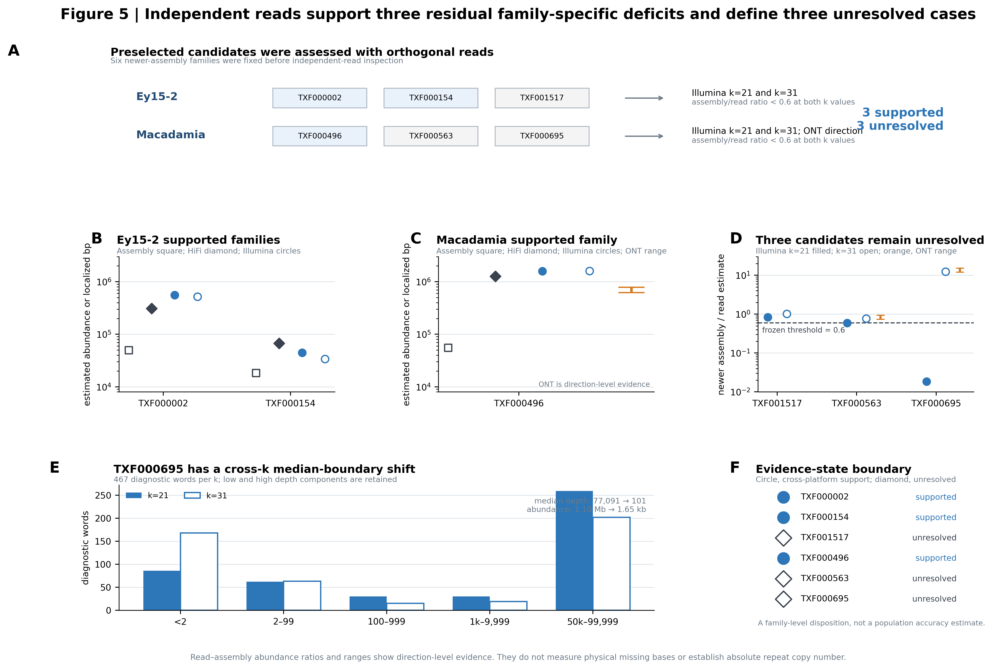
Figure 5. Independent reads support three residual family-specific deficits and resolve the confidence boundary of three others.
Ey15-2 TXF000002 had an Illumina abundance estimate of 519,994-555,544 bp, compared with 49,758 bp localized in the newer assembly. TXF000154 had an Illumina estimate of 33,895-44,496 bp, compared with 18,297 bp in the assembly. Both remained below the assembly/read threshold at both k values (Fig. 5B). None of the other 16 eligible Ey15-2 context families crossed the orthogonal deficit rule at either k.
Macadamia TXF000496 provided the strongest cross-platform example (Fig. 5C). Its Illumina estimate was 1.586-1.604 Mb, whereas 55,562 bp was localized in the newer assembly. Calibrated ONT occupancy corresponded to 0.620-0.785 Mb across the genome-size sensitivity and supported the same direction. None of the other 40 eligible Macadamia context families crossed the Illumina rule at both k values. The two Ey15-2 families and TXF000496 therefore form three independently supported cases in which a newer HiFi assembly retains substantially less family sequence than is indicated by a second sequencing library or platform.
The remaining candidates show why sequence-level diagnostics must accompany the headline result (Fig. 5D-F). Ey15-2 TXF001517 changed interpretation between k=21 and k=31. Macadamia TXF000563 crossed the 0.6 boundary at k=21 but not k=31, and ONT did not support a deficit. TXF000695 showed the strongest instability: its 467 diagnostic words produced median Illumina depths of 77,091 at k=21 and 101 at k=31, yielding abundance estimates of 1,104,859 and 1,649 bp. HiFi and ONT mapping instead supported the low-abundance direction.
The TXF000695 distribution was bimodal rather than driven by one extreme word. At k=21, 259 of 467 words occupied the high-depth component; at k=31, only 202 did so and the median shifted to the low-depth component. Shorter words may be sampling a conserved segment shared with other genomic sequence, although the current data cannot distinguish that explanation from mosaic family structure or other sources of homology. TXF001517, TXF000563 and TXF000695 therefore remain unresolved. Together with the three supported families, they show that independent platforms can identify reproducible residual deficits while cross-k disagreement exposes repeat families that require sequence or cytological follow-up.
Table 2. Family-level evidence from historical/newer assemblies and orthogonal reads. Counts use the primary 15-kb newer-assembly eligibility criterion.
System | Eligible families | Historical families preferentially recovered in newer assembly | Correctly prioritized from raw reads | Orthogonal candidates | Supported residual deficits | Unresolved candidates
A. thaliana Ey15-2 | 19 | 8 | 8 | 3 | 2 | 1
M. jansenii | 43 | 2 | 2 | 3 | 1 | 2

Discussion
The central biological result is that repeat-family representation can remain incomplete after large gains in assembly continuity. In Ey15-2 and Macadamia, raw-read abundance identified exactly the primary families that were preferentially recovered when CLR-era assemblies were replaced by HiFi assemblies. Independent reads then supported residual deficits for two Ey15-2 families and one Macadamia family. Assembly continuity and family-level repeat representation are therefore related but distinct dimensions of genome quality.
The historical/newer comparisons provide a useful retrospective test because they ask whether a prediction made from reads points to sequence recovered by a subsequent assembly. The agreement was exact at the primary family threshold in both species: eight of eight Ey15-2 families and two of two Macadamia families were prioritized, with no calls among the remaining 52 eligible families. The continuous estimates were less concordant with assembly gains. TandemX is thus most strongly supported as a method for identifying which families merit review, rather than for reconstructing the precise number of bases absent from an older assembly.
Orthogonal data extend the result beyond a comparison between assemblies. The Ey15-2 Illumina library changed extraction, library construction and sequencing technology while retaining the source tissue pool. Macadamia Illumina reads provided a separate diagnostic-k-mer measurement, and PromethION reads changed the measurement mode to long-read occupancy. Concordant evidence at two k-mer lengths supported TXF000002 and TXF000154; concordant Illumina and ONT direction supported TXF000496. These three cases show that substantial family-specific deficits can persist in newer HiFi assemblies.
TandemX makes this question accessible by preserving the identity of a repeat family across discovery, abundance estimation and assembly localization. SRF reconstructs repeat units and estimates their abundance, TRASH and related tools annotate assembled arrays, TandemTools examines read support for assembled extra-long repeats, and Merqury/KAT assess genome-wide k-mer completeness. The distinct output of TandemX is a linked family record that combines the raw-read signal, assembly representation and evidence state. This organization turns a general observation that repeats challenge assembly into a list of specific families that can be inspected, reassembled or tested experimentally.
The controlled comparisons also define where this output is most useful. TandemX showed strong family recovery and accurate assembly localization, but it was not uniformly best at every endpoint. TideHunter was faster in the tested read comparisons; TRASH2 and TideCluster performed strongly on assembly annotation; SRF produced more specific catalogues in the shared-fragment background; and competitive mapping gave the lowest abundance error when the TandemX catalogue was supplied. These results support a task-specific view of repeat analysis. TandemX contributes the connected audit and family prioritization, while established tools remain preferable for several component tasks.
The unresolved candidates define a family-specific confidence boundary. TXF000695 contained two diagnostic-word depth components, and the median changed components between the separately evaluated k=21 and k=31 diagnostics. This pattern is consistent with a repeat containing locally conserved sequence shared with a larger genomic background, although mosaic family structure and other forms of homology remain possible. The observed-word fraction, depth dispersion and disagreement between the two fixed diagnostics are reported as QC context; they do not promote a new estimator or classifier.
The present evidence has clear boundaries. The old/new analysis covers two species, the orthogonal analysis was restricted to six preselected candidates, and no physical copy-number measurement is available. Macadamia public metadata support a close sample relationship but not identical DNA extraction for every library. Simulations simplify ploidy, population heterogeneity and long-range array organization, while ONT occupancy supplies direction rather than exact copy number. The supported cases should therefore be interpreted as family-specific under-representation rather than a prevalence estimate for all plant assemblies.
These results nominate a direct next biological test. Candidate families can be mapped to chromosome domains, examined with targeted long-read or assembly analysis and validated cytologically with FISH. A repeat discovered from reads, poorly represented in an assembly and independently localized on chromosomes would connect the abundance deficit to a visible genomic structure. The current study establishes the analytical and cross-platform basis for that experiment; the discovery and validation of additional repeat families remain future work.

Methods

Study design and terminology
The study was organized around three levels of evidence. Controlled simulations tested discovery, abundance estimation, localization and binary comparison against planted truth. Historical/newer assembly pairs tested whether read-predicted families preferentially gained representation as assembly data and methods improved. Orthogonal Illumina and ONT data then tested candidate deficits in the newer assemblies without assuming that either assembly was absolute copy-number truth.
An operational repeat family is a group of candidate monomers connected to a fixed representative by the documented cyclic, strand-aware sequence criterion. It is an analytical unit, not an evolutionary clade. Read-derived abundance denotes the repeat bases implied by diagnostic-k-mer depth after the stated normalization. Assembly representation denotes unioned bases localized for the same family. Read--assembly abundance deficit is the positive difference between these quantities. Estimated under-representation is the same continuous quantity interpreted within the evidence limits. A binary candidate state was defined by an assembly/read ratio below 0.6 in the pre-specified experiments. Residual under-representation required concordant orthogonal support; discordant k values, platforms or sensitivities were unresolved.

TandemX discovery and family construction
TandemX scans long reads for local periodicity over the stated period range, refines candidate array intervals by alignment and derives a consensus monomer for each supported interval. Candidate monomers are canonicalized across rotation and reverse complement before sequence-based clustering. Families use fixed representatives rather than transitive merging, and supporting read intervals, member assignments and ambiguous relationships are retained. Candidate relationships among representatives are reported separately: a shorter-to-longer edge can be labelled as a possible period multiple when its length ratio is close to an integer, but no unit order, biological root or higher-order-repeat status is inferred.
Discovery validation used independently generated genomes spanning monomer periods, array copy numbers, GC composition, unit divergence, substitutions, indels, multiple arrays per read and negative controls. Array recovery required one-to-one interval matching with intersection-over-union of at least 0.5 and period error no greater than 2 bp or 2% of the true period, whichever was larger. Sequence-family recovery used cyclic edit identity with reverse- complement equivalence. Exact simulation configurations, split identities and all adverse development results are provided in Supplementary Methods and Supplementary Results.

Coverage-saturation validation
Three independently generated 10-Mb genomes used validation seeds 6501, 6502 and 6503. Each contained 54 factorial families spanning periods of 61, 171 and 421 bp, copy counts of 20, 80 and 200, GC fractions of 0.3, 0.5 and 0.7, and unit divergence of 0 or 0.02, together with one 171-bp, 6,000-copy family. Reads followed the complete Mo17 HiFi length distribution and one fixed IID error model with substitution, insertion and deletion probabilities of 0.001 each. For each genome, the 0.5x, 1x, 2x, 5x, 10x, 20x and 30x datasets were nested prefixes of one simulated read stream. Depths were paired within a seed; the three genome seeds were the independent simulation units.
Discovery used periods of 30--1,000 bp, a minimum repeat span of 100 bp, minimum support of one read, elastic interval refinement, sequence clustering at 0.95 identity and the related-family audit. Candidates and operational families were counted after cyclic and reverse-complement canonicalization. Planted-family recall and adjacent-depth catalogue matching used independent one-to-one cyclic global edit matching at identity at least 0.90. The abundance tiers were fixed by planted copy count: low, 20 copies; medium, 80 copies; and high, at least 200 copies. For adjacent depths with M matched families and L and H lower- and higher-depth families, catalogue Jaccard was M/(L + H - M) and new-family fraction was (H - M)/H. A transition passed when new-family fraction was below 0.05 and Jaccard was above 0.95. Operational saturation required two consecutive transitions to pass in all three seeds; the earliest upper depth was reported. This rule, all seeds, all depths and the matching thresholds were committed before validation outputs were examined.

Diagnostic-k-mer abundance estimation
For each family and k, TandemX constructs canonical circular k-mers from the representative, removes low-complexity words and retains words not assigned to another catalogue family. Counts are divided by their multiplicity in the representative. The primary single-k estimator summarizes diagnostic-word depth and converts it to family copy number using either explicit haploid depth, empirical single-copy controls or total read bases divided by haploid genome size, in that order of precedence. Estimated copy number is multiplied by monomer length to obtain read-derived family abundance. Median depth, median absolute deviation, zero or unobserved fractions and warnings are retained.
The frozen abundance estimator uses one specified diagnostic-k setting per analysis. In the orthogonal-read assessment, k=21 and k=31 were evaluated as separate fixed diagnostics and reported separately; they were not combined into one abundance estimate or used to refit the estimator. The fixed zero-or-one midpoint rule was retained for unobserved diagnostic words. Reported estimates condition on the supplied genome size and catalogue and do not include family error, normalization error or systematic extrapolation bias. No model was refitted in the old/new or orthogonal plant analyses.

Assembly localization and comparison
Catalogue representatives were localized to assemblies by exact diagnostic anchors followed by bounded extension and bridging. Overlapping intervals were unioned within family before their bases were summed. The final simulated localizer allowed anchor gaps of no more than one monomer length and applied the fixed identity criterion. Localization truth was scored as base-union recall and precision, separately from family recovery and binary comparison.
For a family with read-derived abundance R and assembly representation A, TandemX reports max[R − A, 0] and the ratio A/R when R is positive. The fixed binary candidate threshold was A/R < 0.6. This threshold is an analytical rule evaluated in the reported benchmark, not a universal biological boundary. Insufficient read evidence, localization warnings and denominator exclusions remain explicit family fates.

Comparator evaluation
Read-level comparisons used identical FASTA inputs and matched period and minimum-array scopes for TandemX, TRF and TideHunter. Raw interval precision, one-to-one array recovery, base-union recovery and cyclic family recovery were scored separately. Assembly-side evaluations used TRASH/TRASH2 and TideCluster with their native output relationships retained. Approximate region summaries, unit-level intervals, primary and secondary consensuses, and merged intervals were not treated as interchangeable. A failed, timed-out, malformed or unstarted process yielded unavailable evidence rather than zero accuracy. Complete settings, resource measurements and failure histories are in Supplementary Methods.
The unified SRF comparison was specified before generating seeds 2026091001–2026091003. Each of six conditions contained 100 approximately 5-kb reads, three unrelated families and 12 units per planted array, with 70% positive reads except the 10% low-abundance condition. Conditions were clean 171-bp units, 1% substitutions, 0.1% insertions plus 0.1% deletions, 2% unit substitutions, low abundance, and a 120-bp-unit shared-fragment background. Negative reads in the last condition contained a 100-bp fragment from one family separated by independent 30–80-bp random gaps. Observed post-mutation coordinates defined positive truth; neutral input read IDs contained no labels.
TandemX used the existing cascade detector, sequence clustering, periods 30–1000 bp, minimum span 100 bp and support of one read. Its Rust diagnostic counter used k=21 and depth=1; no simulated error rate was supplied to the FASTA quantifier. SRF used its native KMC–SRF–mapping–filtering–abundance workflow, with count cutoff 20 and both k=151 and k=101 reported. A clean KMC rebuild passed independent canonical-count checks at k=17,101,151. Competitive mapping used 10-kb tandemized native TandemX representatives and minimap2 map-hifi, retaining primary and secondary alignments with block length >=100 bp and identity >=90%. Cross-native-family overlaps were withheld from abundance before truth correspondence but retained in global interval precision.
Independent global edit correspondence allowed circular rotations, reverse complements and pure integer-repeat units up to 64 times at >=90% identity. Multiple matching families remained ambiguous. Native SRF retained mapped bp was verified against positive-keep BED intervals. Abundance errors included all positive-truth families; unmatched native amounts and negative-read interval attribution were reported separately. All 72 method/configuration cells completed, including three valid empty SRF catalogues. Native stages ran serially; wall time, CPU and maximum child RSS were recorded per dataset. These three simulation seeds were not technical timing repeats or a large-input scaling study.

Plant long-read cohort
Complete public long-read files were accepted only after source byte count and checksum verification, gzip and FASTQ traversal through end of file, record and base reconciliation, and an exact duplicate-identifier audit. Ten HiFi libraries from eight reported species were retained. Deterministic whole-file sampling produced nested input sizes for descriptive catalogue and comparator analyses. Library, BioSample and source-paper provenance were kept separate; technical batches and pooled plants were not counted as independent biological replicates. Reference and organellar content were recorded where available, because total-library bases do not necessarily equal nuclear sequencing depth.

Ey15-2 and Macadamia historical/newer assembly analyses
The Ey15-2 analysis used complete public HiFi reads and the paper-supplied Bionano-scaffolded CLR-Canu and HiFi-Hifiasm assemblies. One HiFi-derived catalogue was quantified and independently localized to each assembly. The primary denominator required at least 15,000 localized bases in the newer assembly; 5,000- and 50,000-bp denominators were retained as sensitivities. The old/new assembly reference-proxy label used the same 0.6 ratio as the read/old comparison. A combined final assembly and explicit 107× normalization were sensitivity analyses only.
The Macadamia analysis used two complete HiFi runs, the purged CLR Falcon-Unzip primary assembly and the HiFi IPA primary assembly. The update study's paper-level same-sample statement supported enrollment, while differing archival BioSamples precluded a same-extraction claim. Discovery used a deterministic whole-library sample and abundance used both complete read files. The primary normalization used public read bases and the reported 780-Mb genome size; a separate sensitivity used the paper-reported 28-Gb yield. Eligibility, localization and binary rules matched Ey15-2.
For explanatory context only, newer assemblies were aligned to their historical counterparts and family intervals were summarized by primary aligned-query coverage. Ey15-2 allowed same-chromosome scopes; Macadamia did not because old and new contig identifiers were not shared. These alignments did not define family eligibility or truth.

Orthogonal Illumina and ONT validation
The orthogonal analysis retained the unchanged HiFi catalogues, newer-assembly localization and 15-kb denominators. Ey15-2 used PCR-free Illumina run ERR8666067. Macadamia used Illumina run SRR11191912 and PromethION run SRR11191910. Input objects were accepted only after official checksum, vdb-validate and converted record/base reconciliation. The Ey15-2 library contained 157,774,340 reads and 23,666,151,000 bases; Macadamia Illumina and ONT contained 225,016,144 reads/33,669,394,677 bases and 2,841,932 reads/23,186,565,438 bases, respectively.
Illumina abundance was estimated independently at k=21 and k=31 from family-exclusive diagnostic k-mers. The denominator was the mean depth of 20,000 deterministic controls present exactly once in both enrolled assemblies and absent from all catalogue monomers. Counts below the minimum reported by the counter were conservatively treated as the midpoint of zero and one. Control median, dispersion and zero fraction were retained as diagnostics. Original base qualities were not used in the sequence-only count.
For Macadamia ONT validation, the 43 eligible representatives were tandemized and reads were mapped competitively. Primary family assignments required at least 500 aligned bases and 0.75 identity; reads assigned to multiple families were excluded. Occupancy was corrected by a single mapping-efficiency factor fixed from the corresponding HiFi mapping before candidate ONT results were examined. ONT direction was evaluated at haploid genome sizes of 616, 653, 738 and 780 Mb. The mapping estimate was used only to determine whether read occupancy supported more or less family sequence than the assembly.
Residual under-representation required an assembly/orthogonal-read ratio below 0.6, agreement with the HiFi direction and agreement between the separately evaluated k settings and applicable genome-size sensitivities. The strongest Macadamia interpretation additionally required concordant ONT direction. A quantification-bias interpretation required the orthogonal estimate to be compatible with the newer assembly while the fixed HiFi analysis indicated a deficit and exceeded orthogonal abundance by at least 1.5-fold. All other outcomes were unresolved. Binary interpretation was reported separately from deficit magnitude.

Cross-k diagnostic assessment of TXF000695
The complete diagnostic-k-mer count distributions were retained for the preselected Macadamia families. For TXF000695, the 467 family k-mers at each k were joined to the exact sequence counts; words absent from the counter output were assigned the same fixed 0/1 midpoint used by the abundance analysis. We reported diagnostic-set size, fraction observed at least twice, median, median absolute deviation, MAD/median and the cross-k fold differences in median depth and estimated abundance. Counts were also summarized by fixed depth ranges to determine whether the cross-k reversal reflected one outlier or a redistribution of the diagnostic set. The labels unstable_across_k, depth_median_boundary_sensitive and reliability=low are descriptive QC annotations for this manuscript. They were not used to change family selection, the estimator, the 0.6 threshold or the pre-specified interpretation rules.

Statistical analysis and reproducibility
The family was the unit of the old/new and orthogonal comparisons. Binary sensitivity, false-positive rate and precision were kept separate from continuous abundance error. Correlations between read-versus-old deficits and new-versus-old assembly gains were descriptive and did not treat the latter as truth. Simulation summaries distinguished independent source genomes from dependent coverage/error conditions and technical timing repetitions.
Analyses were specified before the relevant validation data were examined where stated. Independent implementations recomputed the Ey15-2 and Macadamia family tables and the successful TideCluster accuracy endpoints. Commands, software versions, validation splits, input identities and resource profiles accompany the source data.

Data and code availability
The TandemX source code and committed source data are available at github.com/CongyangY/TandemX. Public read and assembly accessions are given in Methods and the source-data manifests. Large FASTQ/FASTA files and intermediate mapping or k-mer databases can be regenerated from the recorded public sources and are not versioned in Git.

Figure legends
Figure 1. TandemX links raw-read tandem-repeat families to assembly representation. (A) Raw HiFi molecules support a long array of one satellite family, whereas an otherwise continuous assembly represents fewer units of the same family. (B) Periodic read intervals define an operational family catalogue; diagnostic k-mers estimate read-derived abundance, and the same representative is localized in the assembly. (C) Paired read and assembly estimates identify family-specific deficits, which are classified as supported or unresolved using cross-k and orthogonal evidence.
Figure 2. Endpoint-matched comparisons define the analytical scope of TandemX. (A) Family recovery and interval/base-union performance of production TandemX, TRF and TideHunter in held-out read simulations. (B) Native family recovery and positive-family abundance error for production TandemX, SRF at the two pre-specified k-mer lengths and ordinary competitive mapping; mapping uses the TandemX catalogue and therefore has no independent discovery endpoint. (C) Negative-read attribution in the shared-fragment background condition. Internal TandemX variants, binary-classification validation, runtime and peak memory are reported only in the Supplementary material.
Figure 3. TandemX operates across diverse plant long-read datasets. (A) Species, accessions and total HiFi bases for ten complete libraries from eight plant species. (B) Median and N50 read lengths. (C) Tandem-repeat interval call density and positive-read fraction in matched-size subsamples from wheat, barley, rye and oat. (D) Repeat-base fraction across nested input sizes, including the 1.17-Gb barley workload. These comparisons describe the observed data and operating range; they are not cross-species accuracy estimates.
Figure 4. Repeat families prioritized from raw reads are preferentially recovered by improved assemblies. (A) Historical/newer assembly comparison for Ey15-2 and Macadamia. (B) Ey15-2 family representation in the historical and newer assemblies, with the eight primary proxy-positive families highlighted. (C) Ey15-2 read--historical deficits versus newer--historical gains and eligibility-threshold sensitivities. (D) Corresponding Macadamia family representation, highlighting the two primary proxy-positive families. (E) Macadamia deficit-versus-gain comparison and genome-size normalization sensitivity. (F) Summary of primary family-level prioritization in the two species.
Figure 5. Independent reads support three residual family-specific deficits and resolve the confidence boundary of three others. (A) Evidence design for the six candidates selected from the newer assemblies. (B) HiFi, Illumina k=21/k=31 and assembly estimates for Ey15-2 TXF000002 and TXF000154. (C) Illumina and direction-level ONT evidence for Macadamia TXF000496. (D) Cross-k and ONT results for the unresolved TXF001517 and TXF000563 candidates. (E) Complete k-mer depth distributions for TXF000695 at k=21 and k=31, showing the median transition between low- and high-depth components. (F) Family-level classification of the six candidates as orthogonally supported or unresolved.

Supplementary figure legends
Supplementary Figure S1. TandemX discovery saturation across three simulated validation genomes. (A) Unique candidate monomers and operational families from 0.5x to 30x. (B) New operational families per added 1x and the fraction new relative to the higher-depth catalogue. (C) One-to-one family-level Jaccard between adjacent nested depths. (D) Planted-family recall for low (20-copy), medium (80-copy) and high (at least 200-copy) families. Lines show medians and ribbons show ranges across three independently generated genomes. Dashed lines mark the pre-specified new-family fraction of 0.05 and Jaccard of 0.95; the vertical dotted line marks the first depth satisfying the two-consecutive- transition, all-seed saturation rule.
Supplementary Figure S2. Specified production validation endpoints. (A) Array F1 for TandemX and TideHunter on the planted positive scenarios of the frozen validation record. (B) Negative-read call rate on three specified controls. One frozen validation seed was used for each condition; points are scenario outputs rather than biological replicates.
Supplementary Figure S3. Production quantification endpoints on the formal simulation record. (A) TandemX mean absolute relative error across specified simulation conditions. (B) Base-union recall and precision for the same production endpoint. Values summarize three simulation seeds per condition and do not constitute population-level plant validation.
Supplementary Figure S4. TideCluster evaluable endpoint cells and completion record. (A) Array recall and precision for the completed TideCluster cells of the frozen factorial assembly test. (B) Completion status across technical seed and setting cells. Unavailable external-tool accuracy is retained as unavailable rather than plotted as zero.
Supplementary Figure S5. Held-out simulated endpoint record. (A) Mean array F1 for TandemX, TideHunter and TRF across positive held-out scenarios. (B) Mean negative-read call rate across held-out controls. Values are means of three frozen held-out simulation seeds; missing values remain unavailable.
Supplementary Figure S6. Formal SRF endpoint record. (A) Mean abundance error, (B) base-union recall and (C) family recovery across the formal simulation conditions for TandemX, SRF k=151, SRF k=101 and competitive mapping. Competitive mapping reuses the TandemX catalogue and therefore is not an independent discovery endpoint; its family-recovery value is unavailable.
Supplementary Figure S7. Input-library and descriptive output context across plant long-read datasets. (A) Complete-library bases, (B) median and N50 read lengths, and (C) observed TandemX called-base fraction on matched random subsets. These panels describe input and output context, not cross-species biological replication or accuracy.
Supplementary Figure S8. Ey15-2 donor-matched reference context. (A) New-assembly/read abundance ratio for source-eligible families, (B) the ratio under the specified depth sensitivity input, and (C) old-to-new alignment fractions. The newer assembly is a donor-matched reference proxy, not absolute copy-number truth.
Supplementary Figure S9. Macadamia donor-matched reference context. (A) New-assembly/read abundance ratio for source-eligible families, (B) the ratio under the reported-depth sensitivity input, and (C) any and primary old-to-new alignment fractions. These comparisons provide reference context and do not establish absolute biological copy number.
Supplementary Figure S10. Orthogonal abundance evidence for six selected families. (A) Newer-assembly, frozen HiFi and Illumina abundance estimates; ONT directional ranges remain in the source record. (B) Final evidence state: three candidates have direction support for residual collapse and three remain unresolved. The estimates are not physical copy-number truth.
Supplementary Figure S11. TXF000695 diagnostic-k-mer QC and unresolved context. (A) Fraction of diagnostic k-mers observed at the frozen threshold, (B) median depth and depth MAD for k=21 and k=31 shown separately, and (C) assembly, HiFi and Illumina abundance estimates. The cross-k discrepancy leaves TXF000695 unresolved.

Supplementary table legends
Supplementary Table S1. Public plant HiFi libraries used to establish the operating range of TandemX. The table reports species and material labels, run accessions, complete-file read and base counts, read-length summaries, GC and N fractions and input-validation results for ten libraries from eight reported plant species. Source: paper/tables/input_cohort.tsv.
Supplementary Table S2. Unified abundance comparison on newly generated planted-read data. Values are mean MARE across three independent simulated datasets per condition. All positive-truth families, including undetected families, enter each mean; unmatched native abundance and negative-read attribution are reported separately.
Supplementary Table S3. Discovery yield and abundance-stratified recovery across nested read depths. Values are medians and ranges across three independently generated validation genomes. Candidate and family counts were canonicalized across rotation and strand; recall used one-to-one cyclic sequence matching to the 55 planted families.
Supplementary Table S4. Marginal family discovery and catalogue stability between adjacent read depths. Values are medians and ranges across three validation genomes. The table reports both new operational families and newly recovered planted families. Passing-seed counts apply the pre-specified new-family-fraction and Jaccard criteria.

References
1. Garrido-Ramos MA. Satellite DNA: an evolving topic. Genes 8, 230 (2017). doi:10.3390/genes8090230.
2. Melters DP et al. Comparative analysis of tandem repeats from hundreds of species reveals unique insights into centromere evolution. Genome Biology 14, R10 (2013). doi:10.1186/gb-2013-14-1-r10.
3. Naish M et al. The genetic and epigenetic landscape of the Arabidopsis centromeres. Science 374, eabi7489 (2021). doi:10.1126/science.abi7489.
4. Rabanal FA et al. Pushing the limits of HiFi assemblies reveals centromere diversity between two Arabidopsis thaliana genomes. Nucleic Acids Research 50, 12309–12327 (2022). doi:10.1093/nar/gkac1115.
5. The Arabidopsis Genome Initiative. Analysis of the genome sequence of the flowering plant Arabidopsis thaliana. Nature 408, 796–815 (2000). doi:10.1038/35048692.
6. Wang B et al. High-quality Arabidopsis thaliana genome assembly with Nanopore and HiFi long reads. Genomics, Proteomics & Bioinformatics 20, 4–13 (2022). doi:10.1016/j.gpb.2021.08.003.
7. Navrátilová P et al. Prospects of telomere-to-telomere assembly in barley: analysis of sequence gaps in the MorexV3 reference genome. Plant Biotechnology Journal 20, 1373–1386 (2022). doi:10.1111/pbi.13816.
8. Shang L et al. A complete assembly of the rice Nipponbare reference genome. Molecular Plant 16, 1232–1236 (2023). doi:10.1016/j.molp.2023.08.003.
9. Benson G. Tandem repeats finder: a program to analyze DNA sequences. Nucleic Acids Research 27, 573–580 (1999). doi:10.1093/nar/27.2.573.
10. Gao Y, Liu B, Wang Y, Xing Y. TideHunter: efficient and sensitive tandem repeat detection from noisy long reads using seed-and-chain. Bioinformatics 35, i200–i207 (2019). doi:10.1093/bioinformatics/btz376.
11. Wlodzimierz P, Hong M, Henderson IR. TRASH: Tandem Repeat Annotation and Structural Hierarchy. Bioinformatics 39, btad308 (2023). doi:10.1093/bioinformatics/btad308.
12. Novák P et al. TideCluster: tandem-repeat annotation and clustering software. Source and versioned software record available from GitHub (accessed 10 September 2026).
13. Zhang Y, Chu J, Cheng H, Li H. De novo reconstruction of satellite repeat units from sequence data. Genome Research 33, 1994–2001 (2023). doi:10.1101/gr.278005.123.
14. Murigneux V et al. Comparison of long-read methods for sequencing and assembly of a plant genome. GigaScience 9, giaa146 (2020). doi:10.1093/gigascience/giaa146.
15. Murigneux V et al. Improvements in the sequencing and assembly of plant genomes. GigaByte (2021). doi:10.46471/gigabyte.24.
16. Rhie A, Walenz BP, Koren S, Phillippy AM. Merqury: reference-free quality, completeness, and phasing assessment for genome assemblies. Genome Biology 21, 245 (2020). doi:10.1186/s13059-020-02134-9.
17. Mapleson D et al. KAT: a K-mer analysis toolkit to quality control NGS datasets and genome assemblies. Bioinformatics 33, 574–576 (2017). doi:10.1093/bioinformatics/btw663.
18. Mikheenko A et al. TandemTools: mapping long reads and assessing/improving assembly quality in extra-long tandem repeats. Bioinformatics 36, i75–i83 (2020). doi:10.1093/bioinformatics/btaa440.
19. Sweeten A, Schatz MC, Phillippy AM. AniAnn’s: alignment-free annotation of tandem repeat arrays using fast average nucleotide identity estimates. Bioinformatics 42, btag581 (2026). doi:10.1093/bioinformatics/btag581.

