Connor Raiford

url: <http://ck.csit.selu.edu/~raiford/TryAndGuessThisFolderName/294/JS_assignment/HTMLwithJS.html>

Code:

<!DOCTYPE html>  
<html lang="en">  
<center>  
<head>  
  
 <meta charset="UTF-8">  
 <title>Title</title>  
 <h1>Fill in the form below</h1>  
  
</head>  
<form name="myForm" action=" http://csit.selu.edu/cgi-bin/echo.cgi">  
<body>  
<br>  
Address  
<input name="Address" type="text">  
<br><br><br>  
<table>  
 <tr>  
 <input type="radio" name="who" value="Bus" onclick="youabus()"> Business  
 <input type="radio" name="who" value="Res" onclick="youares()"> Resident<br>  
  
 </tr>  
 <br><br>  
</table>  
<div id="whoyouis"></div>  
<script>  
 **function** youabus(){  
 document.getElementById("whoyouis").innerHTML =  
 "<table>" +  
 "<tr align='Right'><td>Business name:</td><td><input name='BusinessName' type=\"text\"></td></tr>" +  
 "<tr align='Right'><td>Business Website URL:</td><td><input name='BusinessURL' type=\"text\"></td></tr>" +  
 "<tr align='Right'><td>Business Tax ID:</td><td><input name='BusinessTaxId' type=\"text\"></td></tr>" +  
 "</table><br><br>" +  
 "<button type='button' onclick='validateBus()' >Submit</button>";  
 }  
 **function** youares() {  
 document.getElementById("whoyouis").innerHTML =  
 "<table>" +  
 "<tr align='Right'><td>Name:</td><td><input name='Name' type=\"text\"></td></tr>" +  
 "<tr align='Right'><td>Email:</td><td><input name='Email' type=\"text\"></td></tr>" +  
 "</table><br><br>" +  
 "<button name='Submit' onclick='validateRes()' type='button'>Submit</button>";  
  
 }  
 **function** validateRes() {  
  
  
  
 **var** ResPatt=/[a-z0-9._%+-]+@[a-z0-9.-]+\.[a-z]{2,3}$/;  
  
 **if** (document.forms["myForm"]["Address"].value == "") {  
 alert("Address is a required field");  
 **return false**;  
  
 }  
  
 **else if** (document.forms["myForm"]["Name"].value == "") {  
 alert("Name is a required field");  
 **return false**;  
 }  
  
 **else if** (document.forms["myForm"]["Email"].value == "") {  
 alert("Email is a required field");  
 **return false**;  
 }  
  
 **else if** (ResPatt.test(document.forms["myForm"]["Email"].value) == **false**) {  
 alert("This field must be in email format");  
 **return false**;  
  
 }  
 document.myForm.target = "myActionWin";  
 window.open("http://csit.selu.edu/cgi-bin/echo.cgi","myActionWin","width=400,height=400,toolbar=0");  
  
  
 document.myForm.submit();  
 }  
  
 **function** validateBus() {  
  
  
 **var** BusPatt = /https?:.+/;  
  
 **if** (document.forms["myForm"]["Address"].value == "") {  
 alert("Address is a required field");  
 **return false**;  
 }  
  
 **else if** (document.forms["myForm"]["BusinessName"].value == "") {  
 alert("Name is a required field");  
 **return false**;  
 }  
  
 **else if** (document.forms["myForm"]["BusinessURL"].value == "") {  
 alert("URL is a required field");  
 **return false**;  
 }  
  
 **else if** (BusPatt.test(document.forms["myForm"]["BusinessURL"].value) == **false**) {  
 alert("This field must be in URL format");  
 **return false**;  
  
 }  
  
 **else if** (document.forms["myForm"]["BusinessTaxId"].value == "") {  
 alert("Tax Id is a required field");  
 **return false**;  
 }  
 document.myForm.target = "myActionWin";  
 window.open("http://csit.selu.edu/cgi-bin/echo.cgi","myActionWin","width=400,height=400,toolbar=0");  
 document.myForm.submit();  
 }  
  
</script>  
</body>  
</form>  
</center>  
</html>

Home page

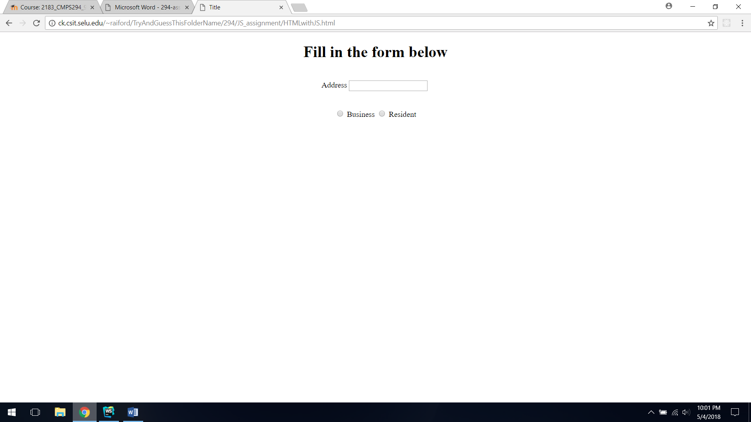

Business

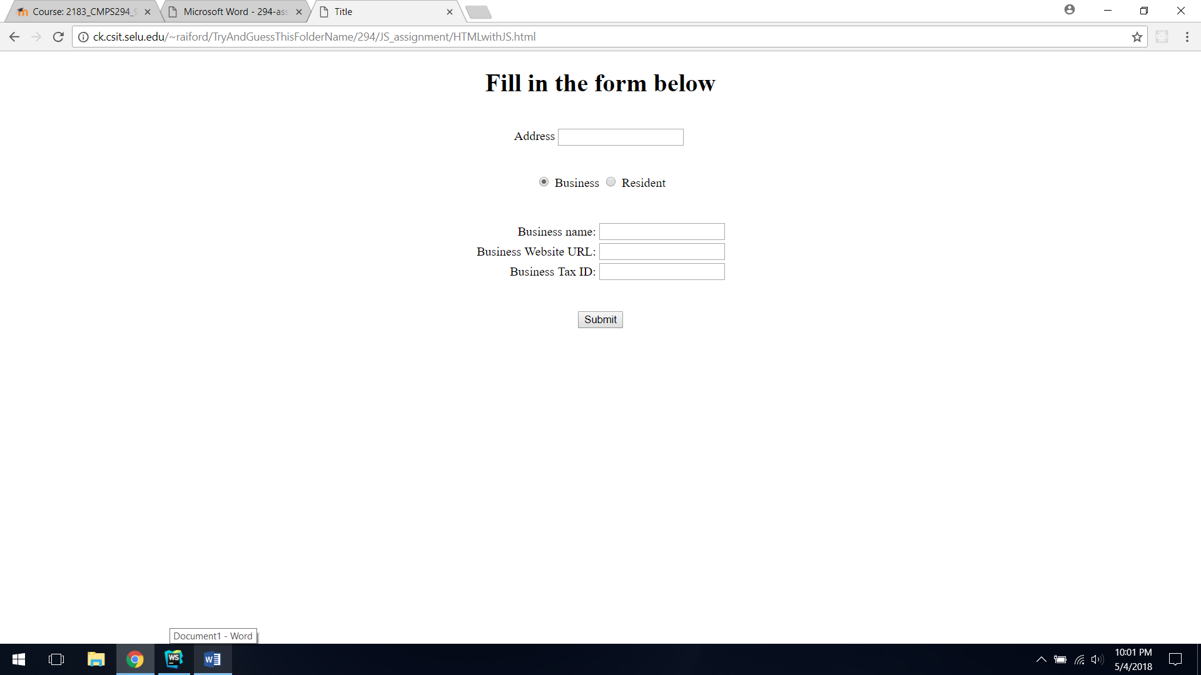

Resident

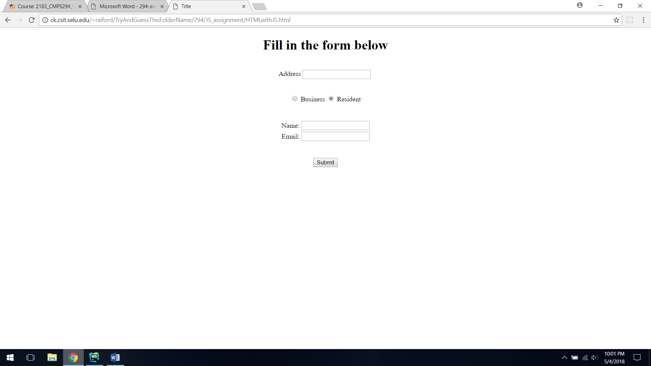

Wrong email format

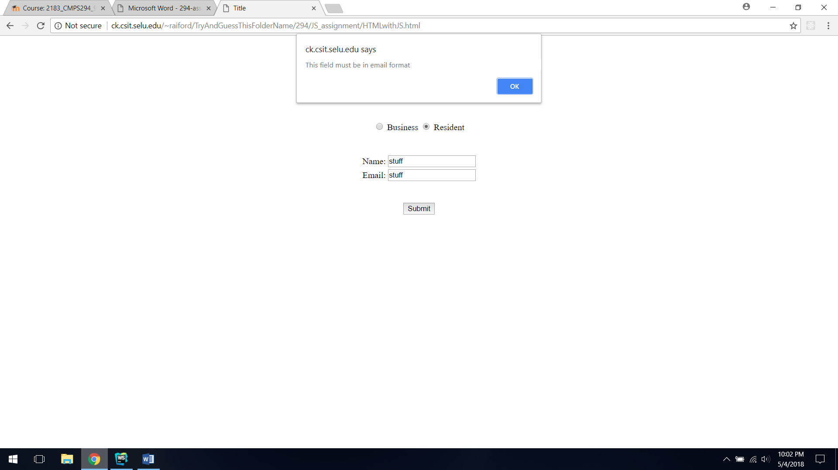

Wrong URL format

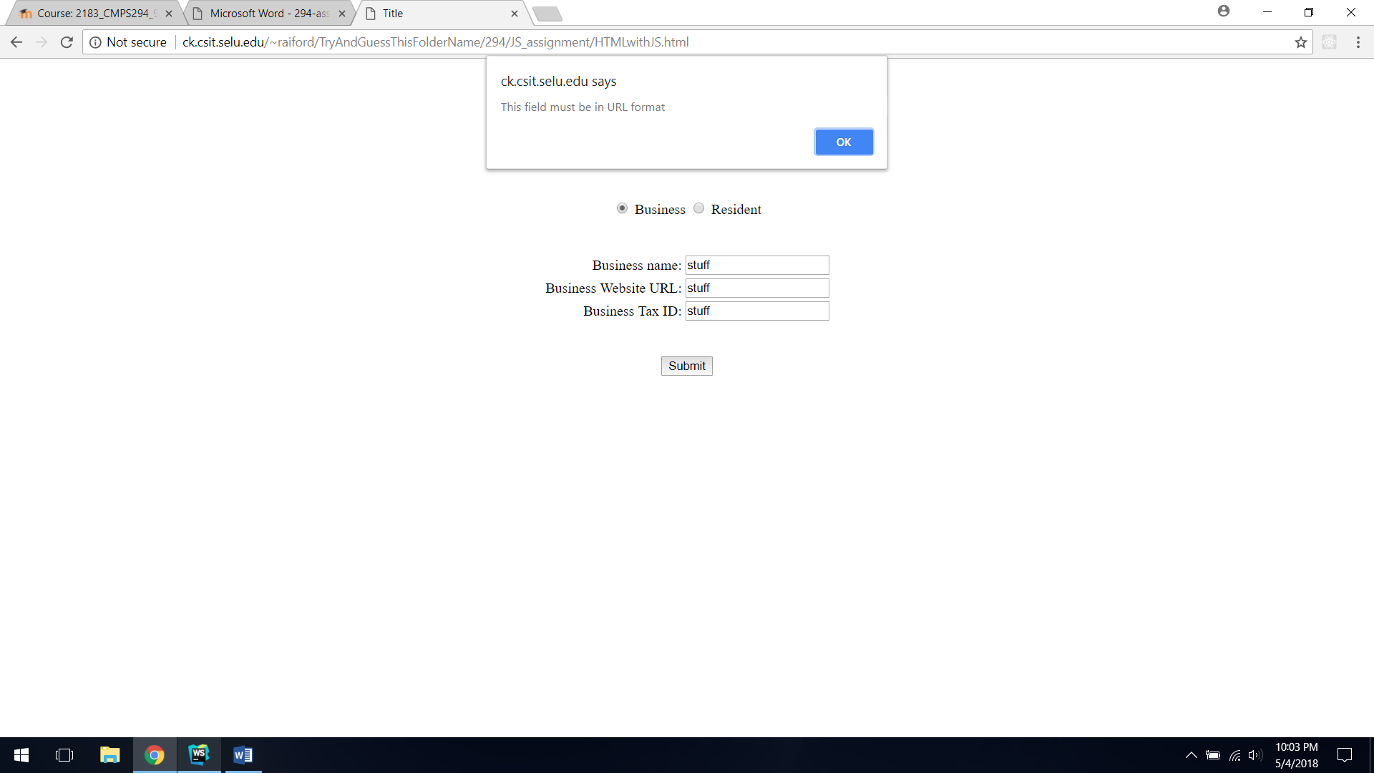

On successful submit

