Follow these steps to set up your button project.

1. Setup a new Python script with the following code:

**import** RPi.GPIO **as** GPIO # Import Raspberry Pi GPIO library

GPIO.setwarnings(**False**) # Ignore warning for now

GPIO.setmode(GPIO.BOARD) # Use physical pin numbering

GPIO.setup(10, GPIO.IN, pull_up_down=GPIO.PUD_UP)

# Set pin 10 to be an input pin and set initial value to be

# pulled low (off)

1. Set up four buttons and one LED on your breadboard BUT DO NOT PLUG THE POWER OR GROUND INTO YOUR RASPBERRY PI!

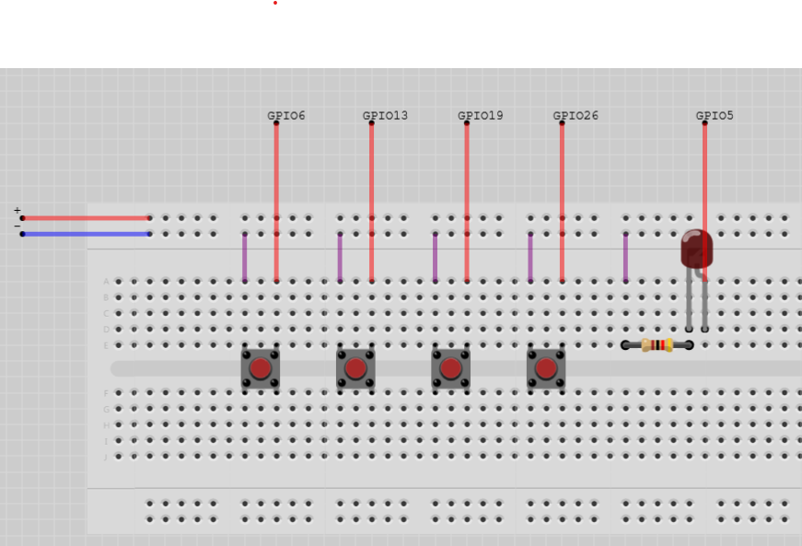

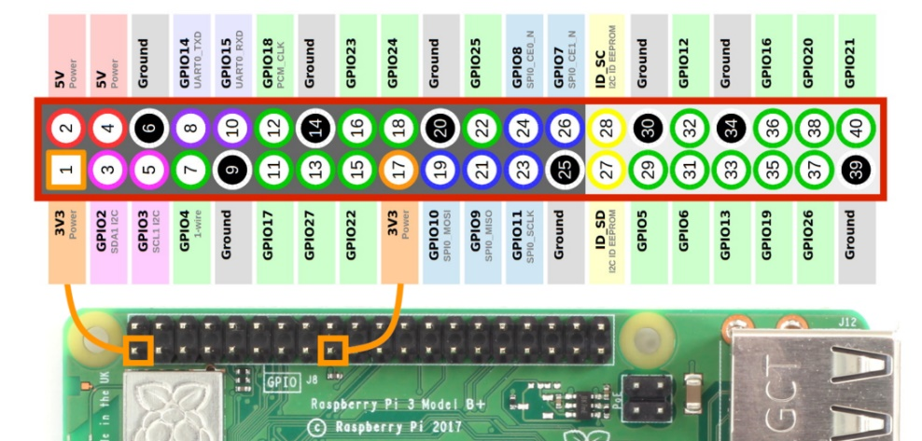

1. Hit the help button to call Mr. Smith over and have him check your circuit
2. Write code to print which button was pressed
3. If the first button was pressed, toggle the LED on or off.

Convert this English to Python to achieve this (after following the other code in the guides).

* Put ‘False’ in ‘LEDlit”
* While the program is running, then…
  + If the first button is pressed, then…
    - Print “First button pressed”
    - If LEDlit is True, then…
      * Make LEDlit False
      * Turn off the LED
    - Otherwise, then…
      * Make LEDlit True
      * Turn on the LED
  + If the second button is pressed, then…
    - Print “Second button pressed”
  + If the third button is pressed, then…
    - Print “Third button pressed”
  + If the fourth button is pressed, then…
    - Print “Fourth button pressed”

1. Here is an example of the code you will use:

**while** **True**: # Run forever

**if** GPIO.input(10) == GPIO.HIGH:

print("Button was pushed!")

You can also use the guide in Schoology if you need more information:

<https://schoology.ytech.edu/course/5174416460/materials/link/view/5310975087>