Contractor App User Guide
  - Step-by-step project, budget and subcontracting workflows
en.connect4systems.com | 2026-10-29
This guide combines application source review with authorized inspection of the live site. Screenshots are from the actual system and may show existing test data. Review covered sign-in, forms, tabs and selected dialogs/browser calculations. No invoices or financial certificates were created or submitted for this guide. A temporary CR draft was used to test fetching and deleted afterwards; its naming sequence may advance. Buttons and values can differ with your permissions and site settings. Login credentials are excluded.
ERPNext 15 · Frappe 15 · Contractor App

Contents
01. Sign in and find your documents
02. Prepare master data and Project Abbreviation
03. Create a Tender Analysis and its clauses
04. Create the Costing Note
05. Price BOQ resources for the full Project Quantity
06. Add equipment and reuse a Template BOQ
07. Apply selling margins and complete tender pricing
08. Create the Project Offer and Project Contract
09. Set taxes, discounts and contracting deductions
10. Create and approve the Project Budget
11. Monitor Project quantities and progress
12. Create a CR and enter contract clauses
13. Fetch Project clauses repeatedly without losing rows
14. Create the Subcontractor Contract
15. Issue a customer Project Clearnce
16. Issue a Subcontract Clearnce from Project
17. Review invoices, deductions and payments
18. Use Purchase Comparison
19. Use Item Coding Request and Subcontractor Custody
20. Use standard purchasing and project-based names
21. Correct, cancel and amend documents
22. Troubleshooting and daily checks

01. Sign in and find your documents
1.1 Open https://en.connect4systems.com and select Login. Enter the account assigned to you, then click Login.
1.2 Open the Tender workspace. Alternatively, use the search box at the top and enter the exact document name shown in this guide.
1.3 Open a list to review existing records. Select a record to open it, or use Add/New when creating a new document.
1.4 Use the tabs to move between Details, Clauses, Taxes and Totals, Contracting and Connections where available.
1.5 Save stores a draft. Submit approves a submittable document and may trigger downstream actions. If a Workflow is configured, use its permitted approval actions.
Check: Screenshots show the English interface. Button visibility depends on permissions, document status and the installed site version. Use the English labels to locate the corresponding Arabic interface controls.

Sign in and find your documents
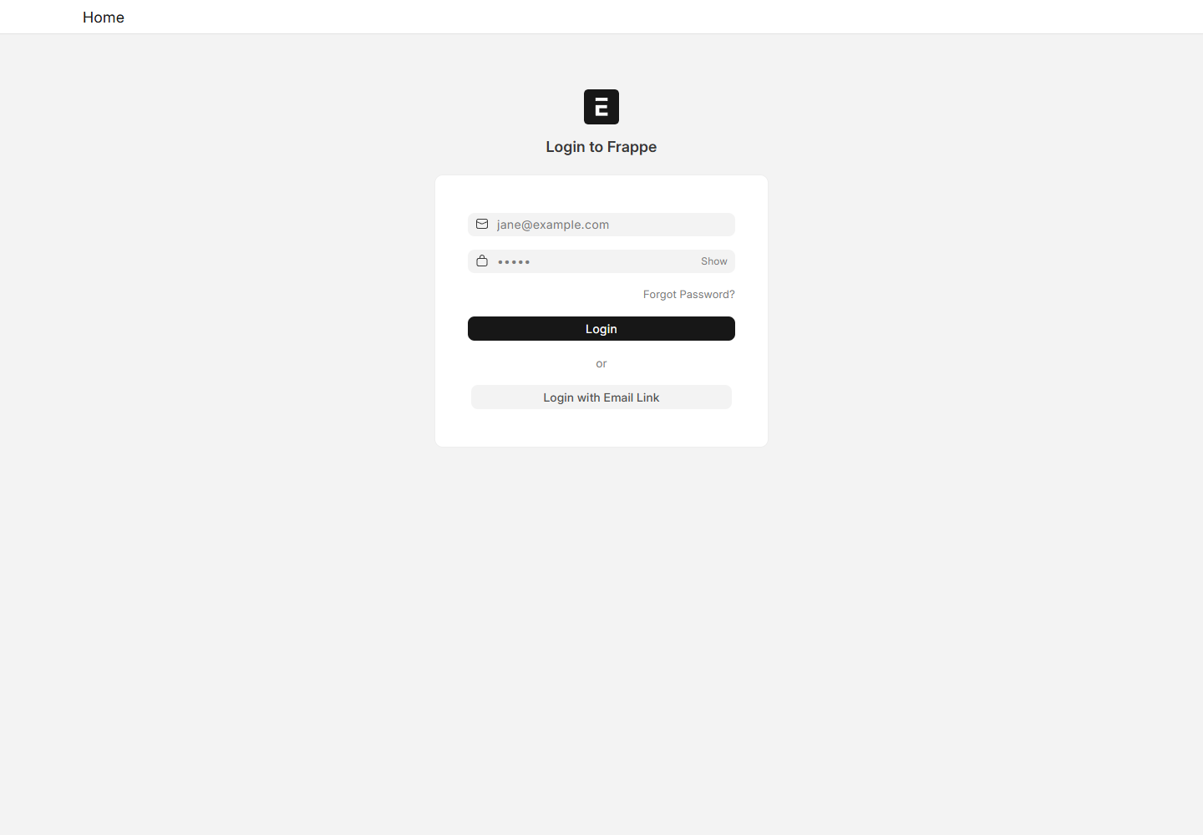
System screenshot: Site Access

Sign in and find your documents
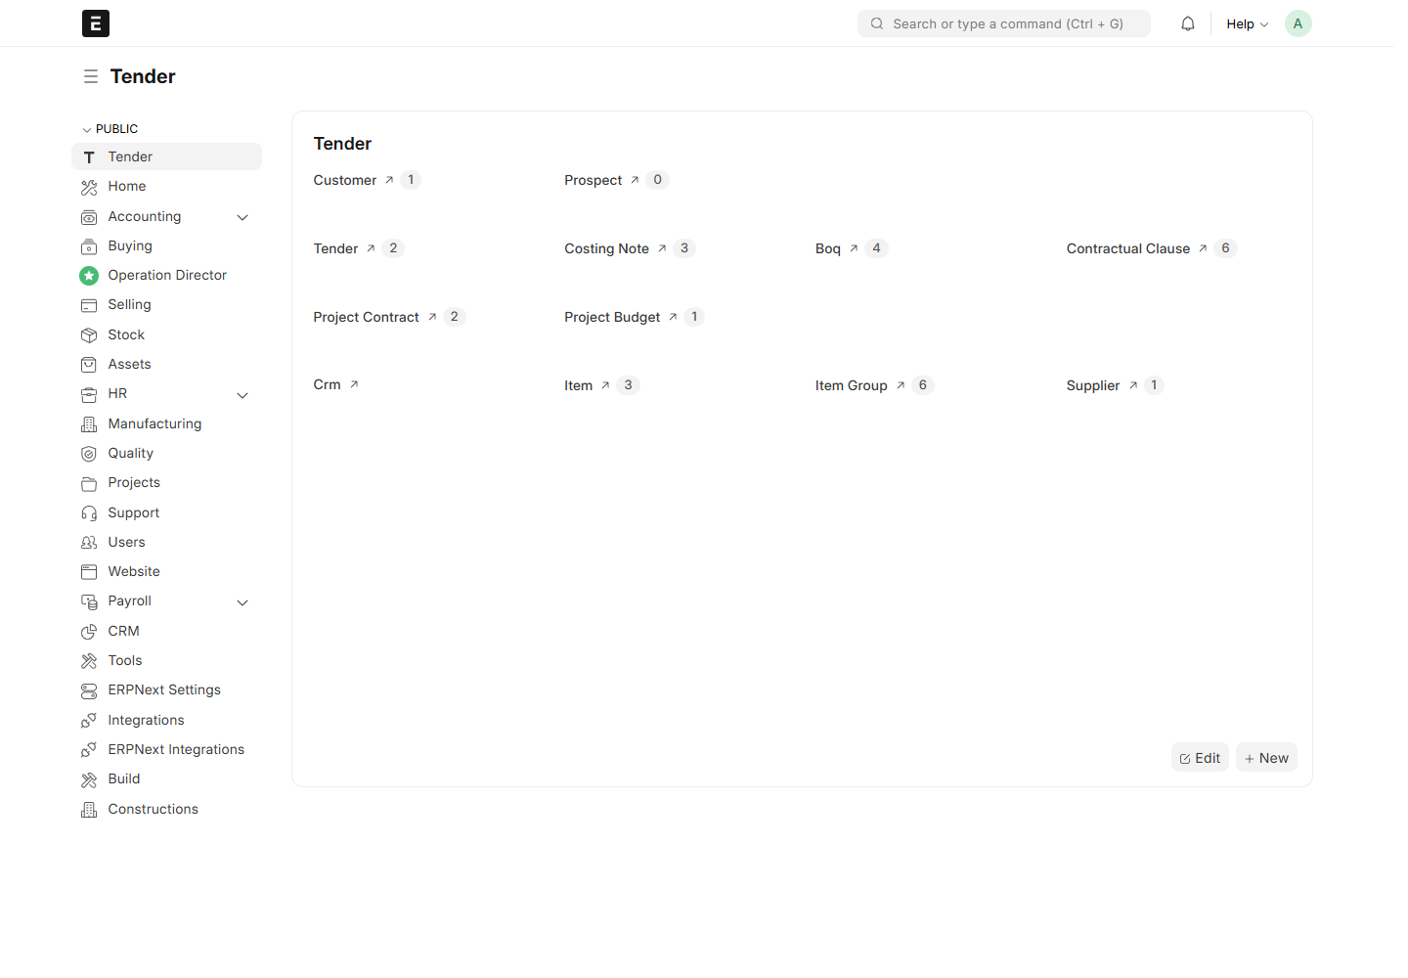
System screenshot: Desk

02. Prepare master data and Project Abbreviation
2.1 Ask the administrator to confirm Company, company abbreviation, default currency, Customer, Suppliers, Items and UOMs before starting.
2.2 Open Contract Type and check the available values: Arch, Civil, Elec, Mech and Service. CR uses this master, rather than Item Group.
2.3 Open Division to review construction divisions. Division has Title and Description; its name comes from Title. Division is not required on CR.
2.4 Open Cost Code and review the hierarchy and Cost Type. Cost Type links to Cost Center; it is not a separate custom DocType.
2.5 Open the operational Project, enter Project Abbreviation below Project Name, and Save. The technical field is custom_abbreviation. Use a short abbreviation such as TST.
2.6 If a field or newly added tab is missing, ask the administrator to check deployment/migration and refresh the browser. Do not create another field with the same purpose.
Check: Cost Type categories use the configured company abbreviation: Equipments, Labour, Material and Subcontractor. The workbook suffix C is not the required company abbreviation.

Prepare master data and Project Abbreviation
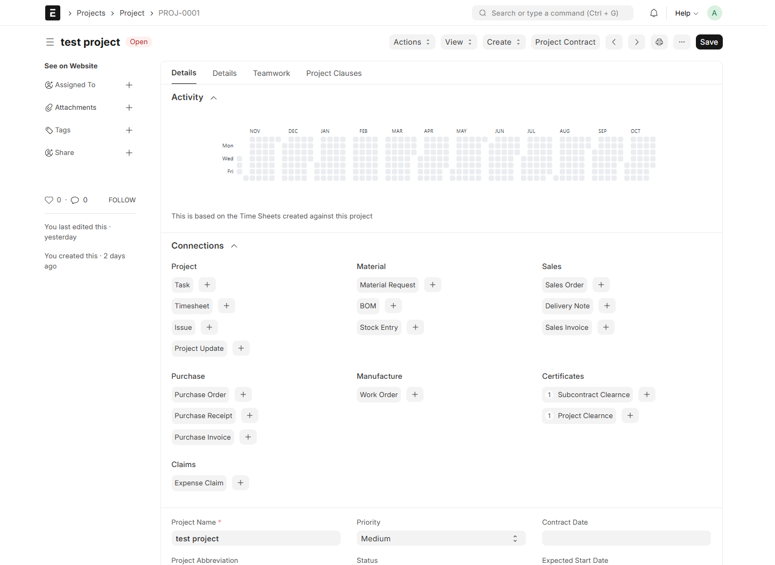
System screenshot: Project

Prepare master data and Project Abbreviation
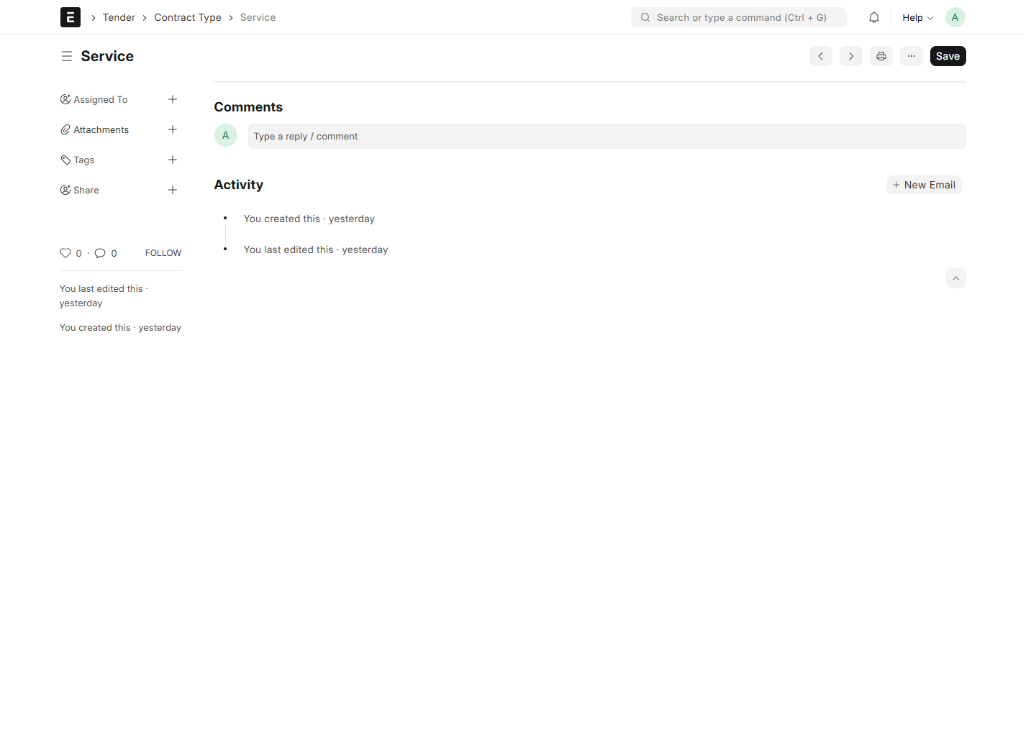
System screenshot: Contract Type

Prepare master data and Project Abbreviation
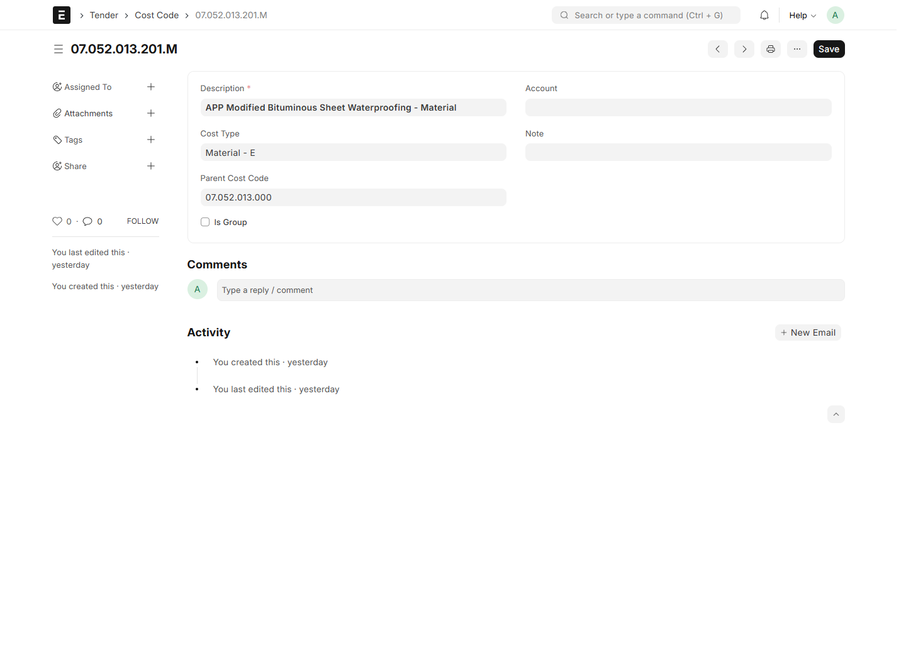
System screenshot: Cost Code

03. Create a Tender Analysis and its clauses
3.1 Search for Tender Analysis and choose New. Enter Company, Title, Tender Number, Date, Party Type, Party Name, Currency and the desired Project name.
3.2 Open Contractual Clauses. Add a group heading with Is Group selected, then add its detail rows below it.
3.3 For each detail, enter Clause Title, a positive Qty and its UOM. Do not use a heading as a payable work item.
3.4 Choose Automatic numbering for series such as 1, 1_1 and 1_2. Save to generate the series.
3.5 To import instead, download Excel Template, enter literal values in the template, save the tender and select Upload Excel. Review the preview and choose Apply Rows.
3.6 Review the completed table, then click Create Contractual Clauses. Each row receives its own linked clause. Repeating the action creates only missing links.
Check: Excel import replaces the tender table and is offered before creating Contractual Clauses. Imported numbering uses From Excel. Project at this stage is a name, not an existing operational Project link.

Create a Tender Analysis and its clauses
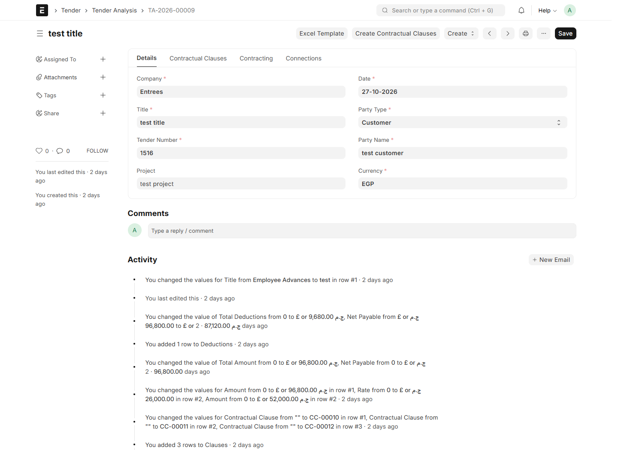
System screenshot: Tender Analysis

Create a Tender Analysis and its clauses
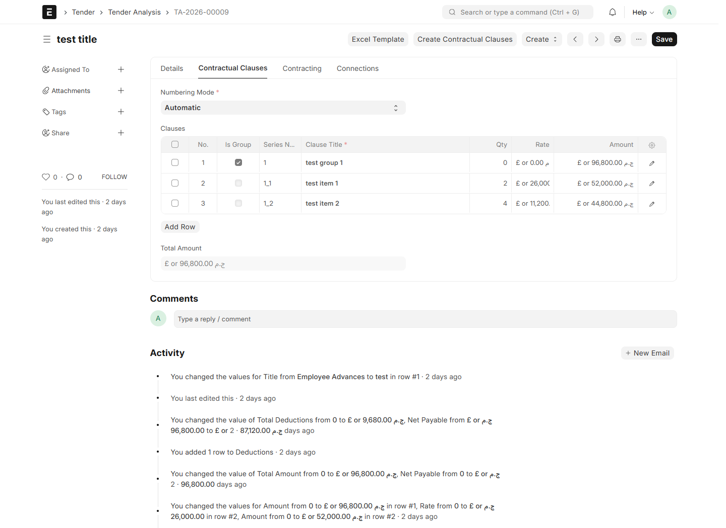
System screenshot: Tender Analysis Clauses

04. Create the Costing Note
4.1 Save the Tender Analysis after generating all Contractual Clauses.
4.2 Select Create > Costing Note. Check the source tender, currency, clauses, quantities and units.
4.3 Save the new Costing Note as a draft before creating BOQs.
4.4 Use the BOQ button on each detail row to open its matching BOQ. Group headings do not need resource pricing.
4.5 Return after submitting the BOQs and review each returned unit cost and total cost.
Check: Source rows and quantities follow the tender. If its structure or quantities change, recreate the affected draft Costing Note. Site review reproduced “field item not found” when opening an existing Costing Note; ask the administrator to resolve this compatibility issue before relying on its complete pricing cycle.

Create the Costing Note
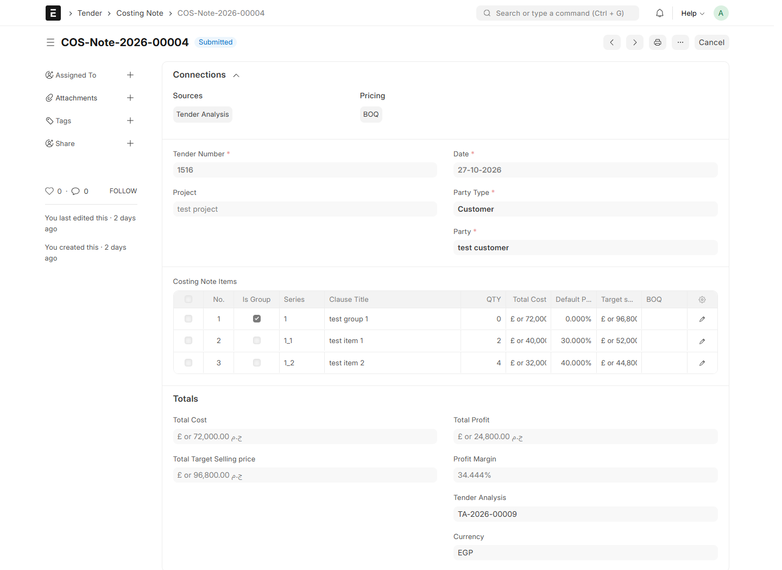
System screenshot: Costing Note

05. Price BOQ resources for the full Project Quantity
5.1 Open the BOQ from its Costing Note row. Check Clause Title, UOM and Project QTY. Tender-linked Project QTY follows the source row.
5.2 In Material, select each resource Item and UOM, enter the quantity required per clause unit and its cost rate.
5.3 Repeat for Labour, Contractors and Expenses. Review the calculated Project Quantity and Total Cost of each resource.
5.4 For example, Project QTY 100 and a resource coefficient of 2 give resource quantity 200. At rate 5 the resource total is 1,000.
5.5 Review Total Project Cost and Cost per Clause Unit. Save and Submit the BOQ to return its unit cost to the correct Costing Note row.
Check: Resource project quantity = quantity per clause unit × Project QTY. Total cost = resource project quantity × resource cost rate. Unit clause cost = total project cost ÷ Project QTY. Historical submitted BOQs may retain Per Unit basis.

Price BOQ resources for the full Project Quantity
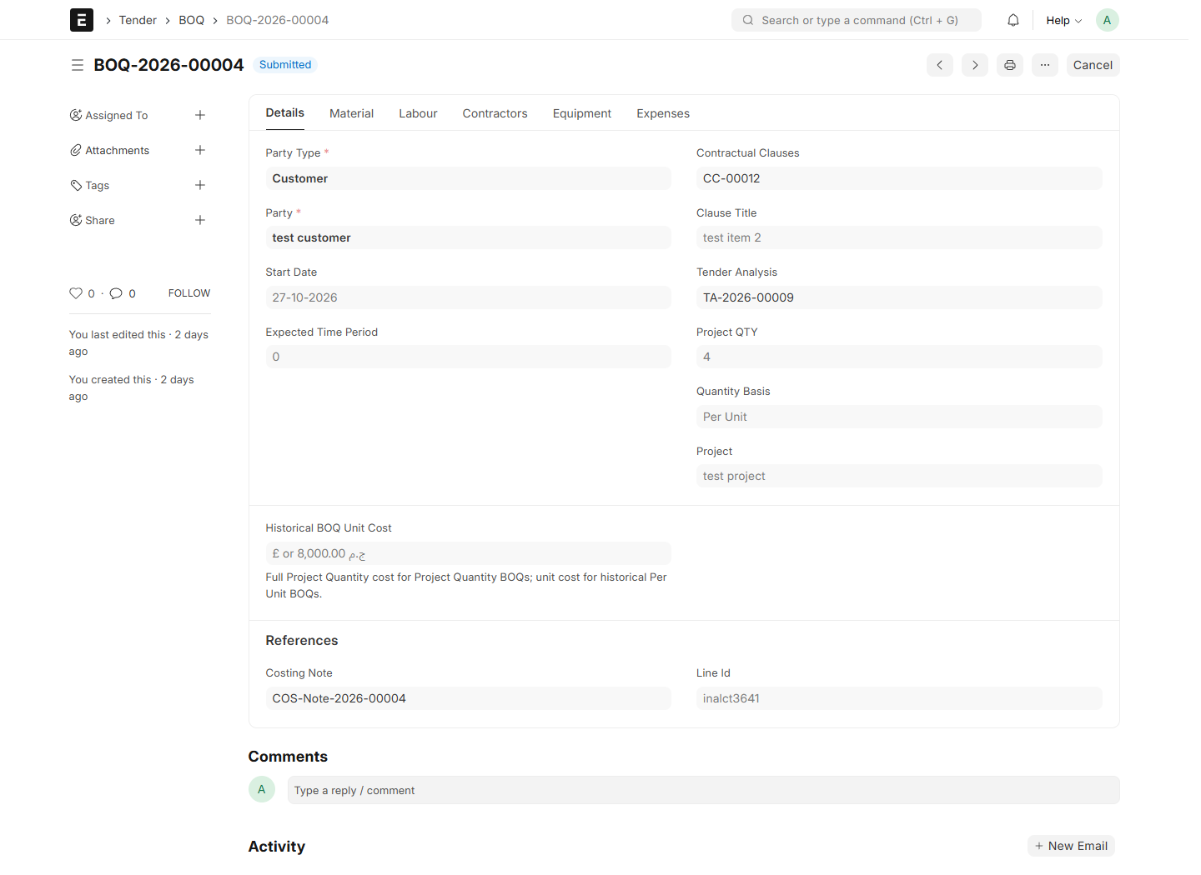
System screenshot: Boq

06. Add equipment and reuse a Template BOQ
6.1 Open the BOQ Equipment tab, located before Expenses in the updated form.
6.2 Add an Equipment Costs row. Select the Equipment Item and UOM, then enter quantity per clause unit and the cost rate.
6.3 Review the automatically calculated Project Quantity, row Total Cost and Total Equipment Costs.
6.4 To reuse a resource breakdown, prepare Template BOQ with resource quantities per clause unit, including Equipment Costs.
6.5 On a new/draft BOQ, select BOQ Template. Review every copied resource and rate before saving; applying a template replaces the resource breakdown.
Check: Equipment costs feed BOQ cost, Costing Note pricing and Project Budget. Older custom equipment rows are retained. If Equipment is absent on the site, the new metadata/assets need deployment; a screenshot of an older form does not prove the new tab is installed.

Add equipment and reuse a Template BOQ
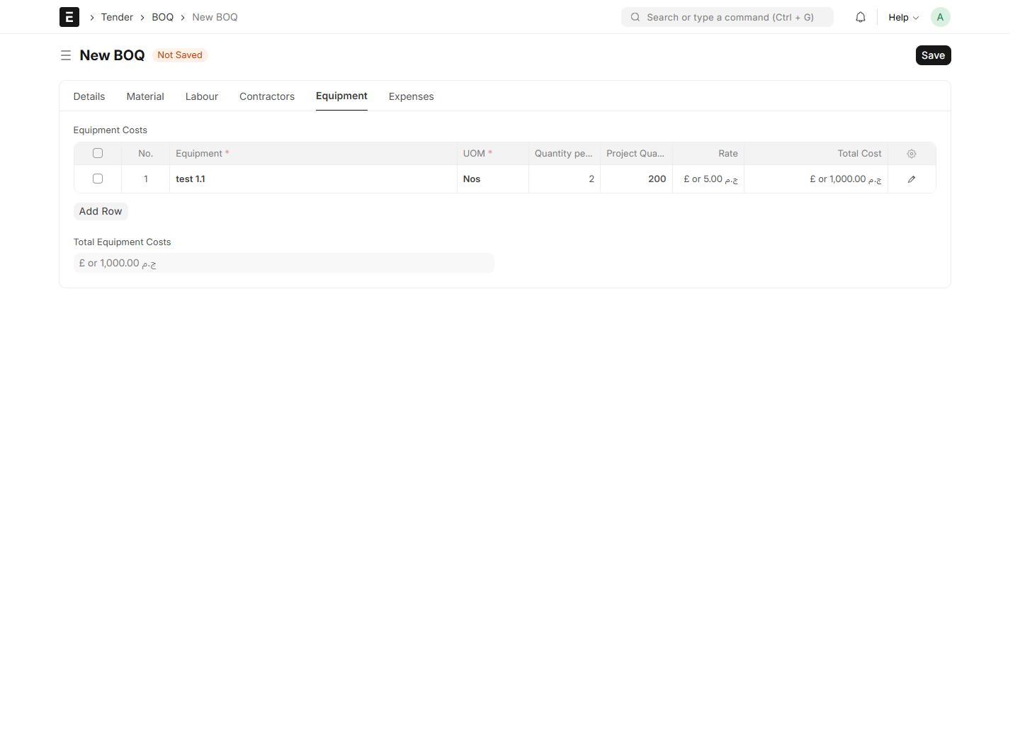
System screenshot: Boq Equipment Entry

Add equipment and reuse a Template BOQ
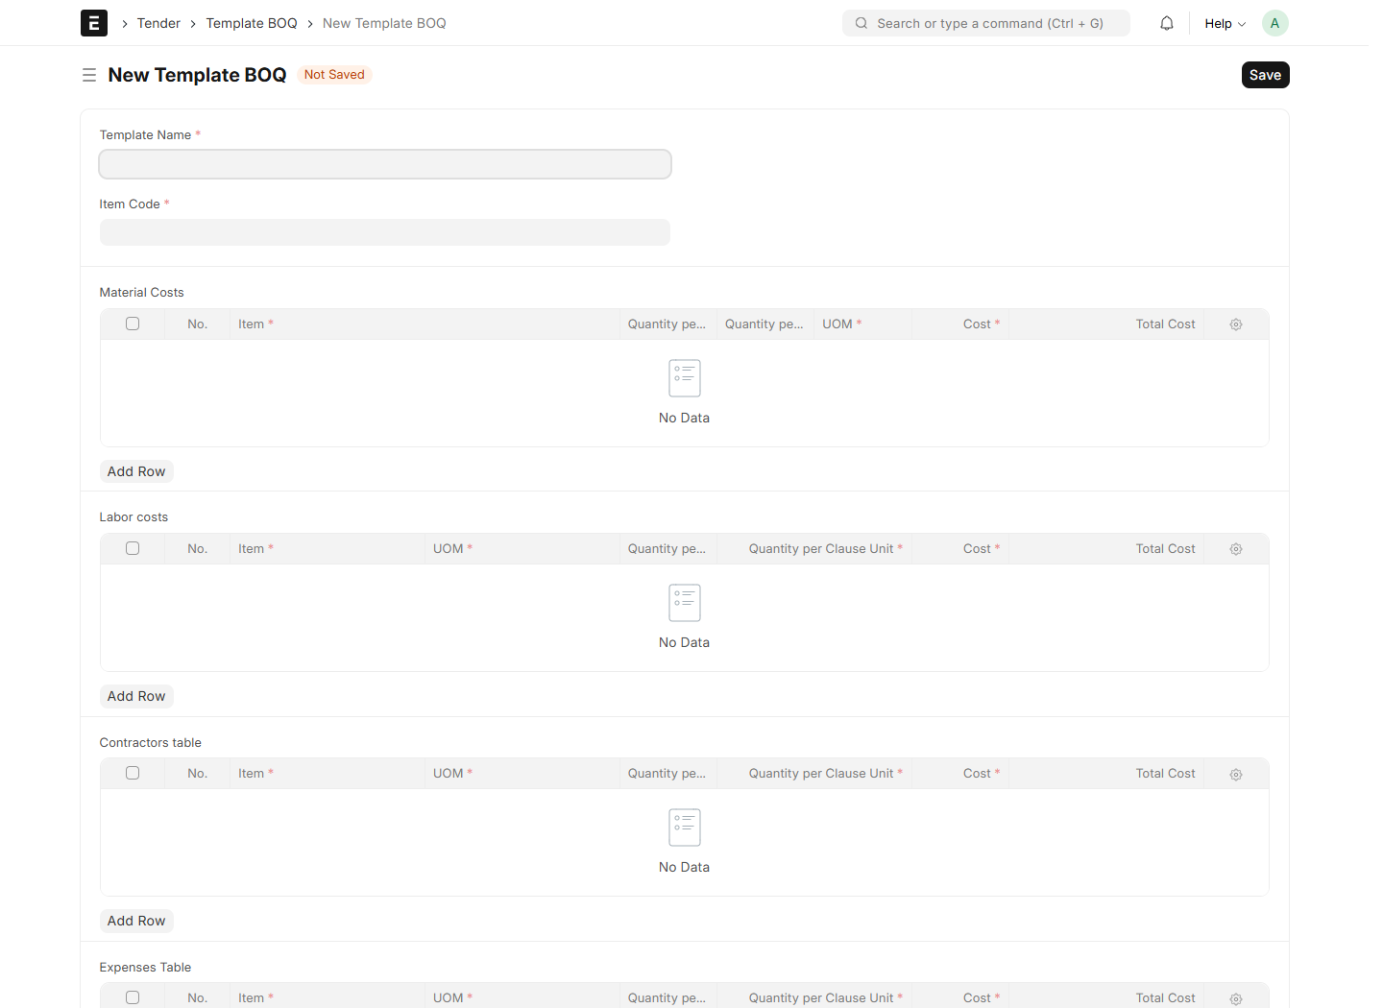
System screenshot: Template Boq

07. Apply selling margins and complete tender pricing
7.1 Return to the saved Costing Note after submitting all required BOQs.
7.2 Enter the required profit margin and review the detail selling values and group summaries.
7.3 Check that total cost equals unit cost × clause quantity, and selling amount equals total cost × (1 + margin / 100).
7.4 Save, then Submit the Costing Note. Open Tender Analysis and verify the resulting selling rates and amounts.
7.5 To reprice an applied clause, first cancel the owning Costing Note and resolve downstream dependencies. Prepare and approve revised costing through the same cycle.
Check: One applied Costing Note owns a clause’s pricing at a time. All active Costing Notes must be submitted before creating the commercial offer/contract.

Apply selling margins and complete tender pricing
System screenshot: Costing Note

Apply selling margins and complete tender pricing
System screenshot: Tender Analysis Clauses

08. Create the Project Offer and Project Contract
8.1 Save the fully priced Tender Analysis. Use Create > Project Offer when issuing an offer, or Create > Project Contract for the direct contract route.
8.2 Check Customer, Company, Currency, conversion rate, Project name, dates and copied clauses. Complete addresses, payment terms and other commercial terms.
8.3 Review agreed quantities and selling rates in Clauses. Complete Taxes and Totals and Contracting as described next.
8.4 Save and Submit the Project Offer. To convert it, choose Create > Project Contract and review the copied commercial values.
8.5 Save and Submit Project Contract after the agreed checks and workflow approvals. The Project name is used to create/link the operational Project.
8.6 Use Open Project or Created Project to open the result. Repeating conversion opens an existing active contract instead of creating another.
Check: The offer/contract is a commercial document and does not itself post revenue or move stock. The operational Project may require creation permissions. Project Budget is created from a submitted Project Contract.

Create the Project Offer and Project Contract
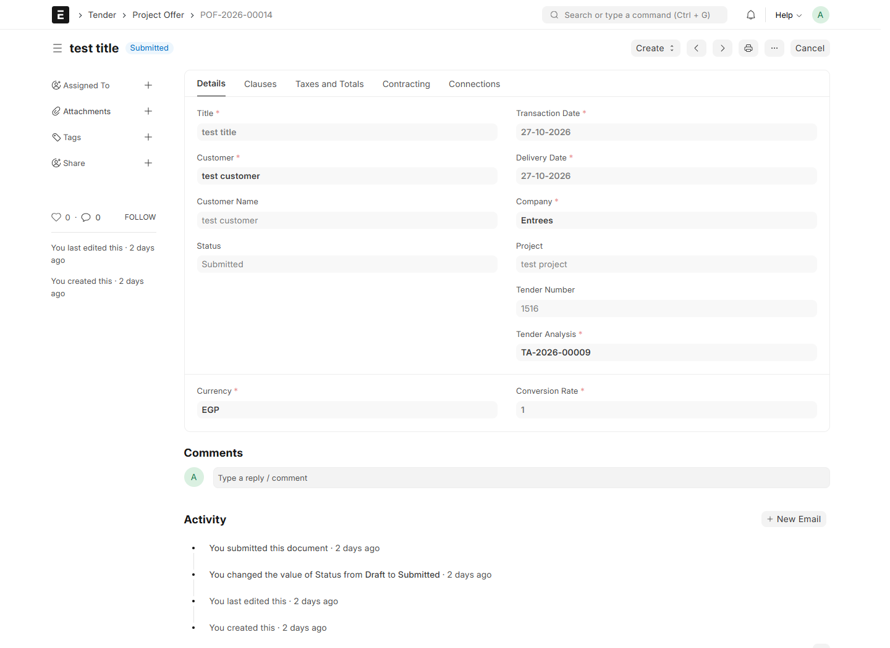
System screenshot: Project Offer

Create the Project Offer and Project Contract
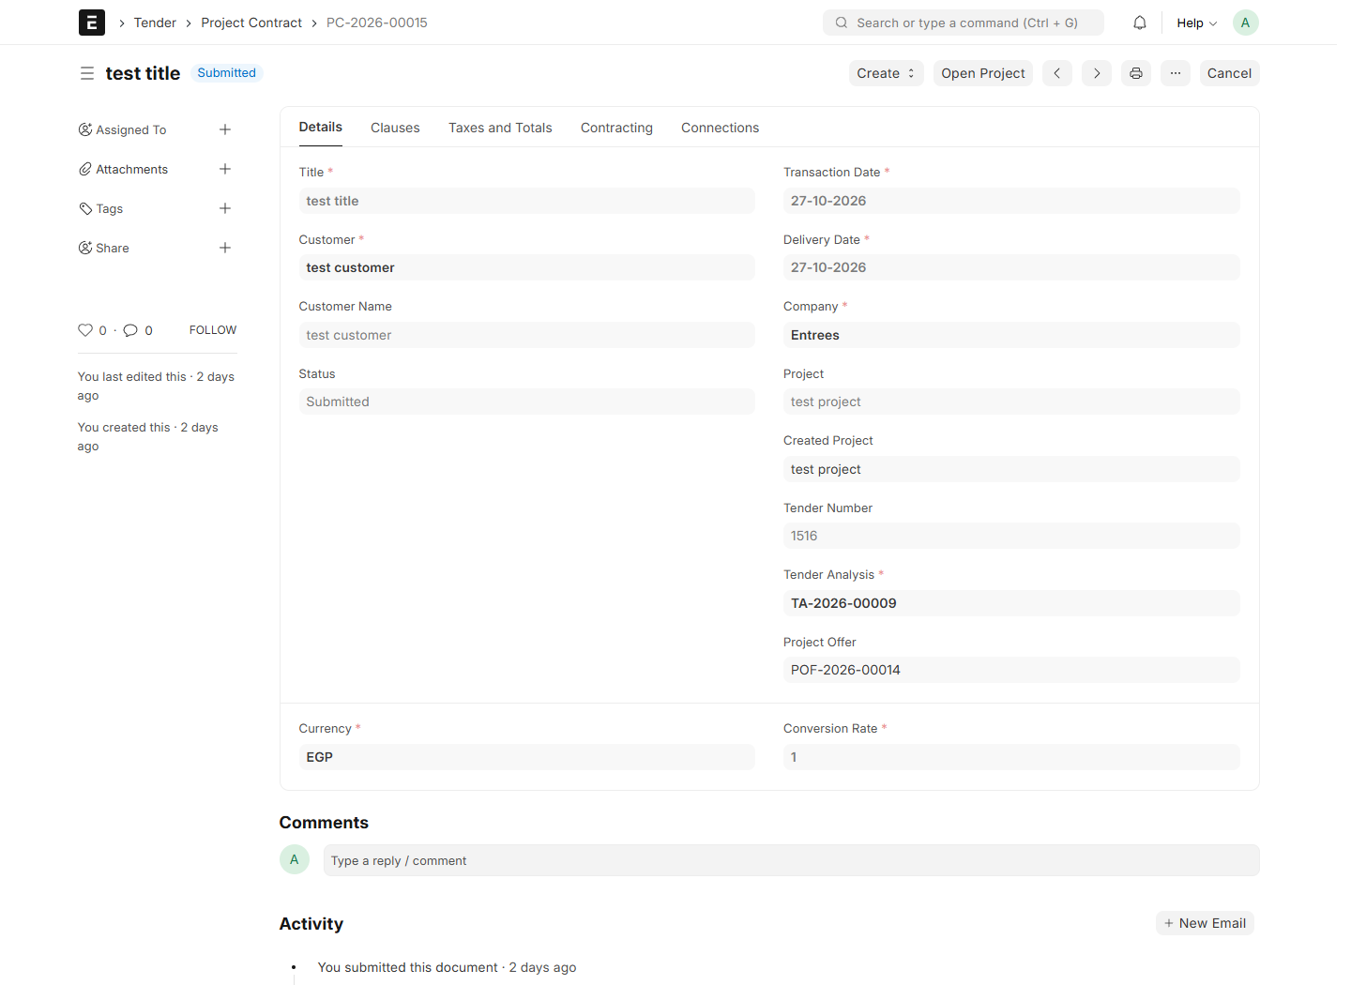
System screenshot: Project Contract

09. Set taxes, discounts and contracting deductions
9.1 Open Taxes and Totals. On customer documents choose Sales Taxes and Charges Template; on CR/subcontract documents choose Purchase Taxes and Charges Template.
9.2 Use a template belonging to the document Company. Review each tax row’s account, charge type, rate and included-in-rate setting.
9.3 If needed, choose the additional discount basis and enter the percentage or fixed discount. Check Net Total, tax totals and Grand Total.
9.4 Open Contracting. Select Selling Deductions Template for customer documents, or Purchasing Deductions Template for subcontract documents.
9.5 Review or edit each deduction Title, Account and Percent. Confirm Total Deductions and Net Payable, then Save.
Check: Deductions use the document Grand Total; Net Payable = Grand Total − Total Deductions. Templates populate editable draft rows. Later edits do not update the source template. Actual tax amounts and fixed discounts start at zero on a new period certificate and must be entered for that period.

Set taxes, discounts and contracting deductions
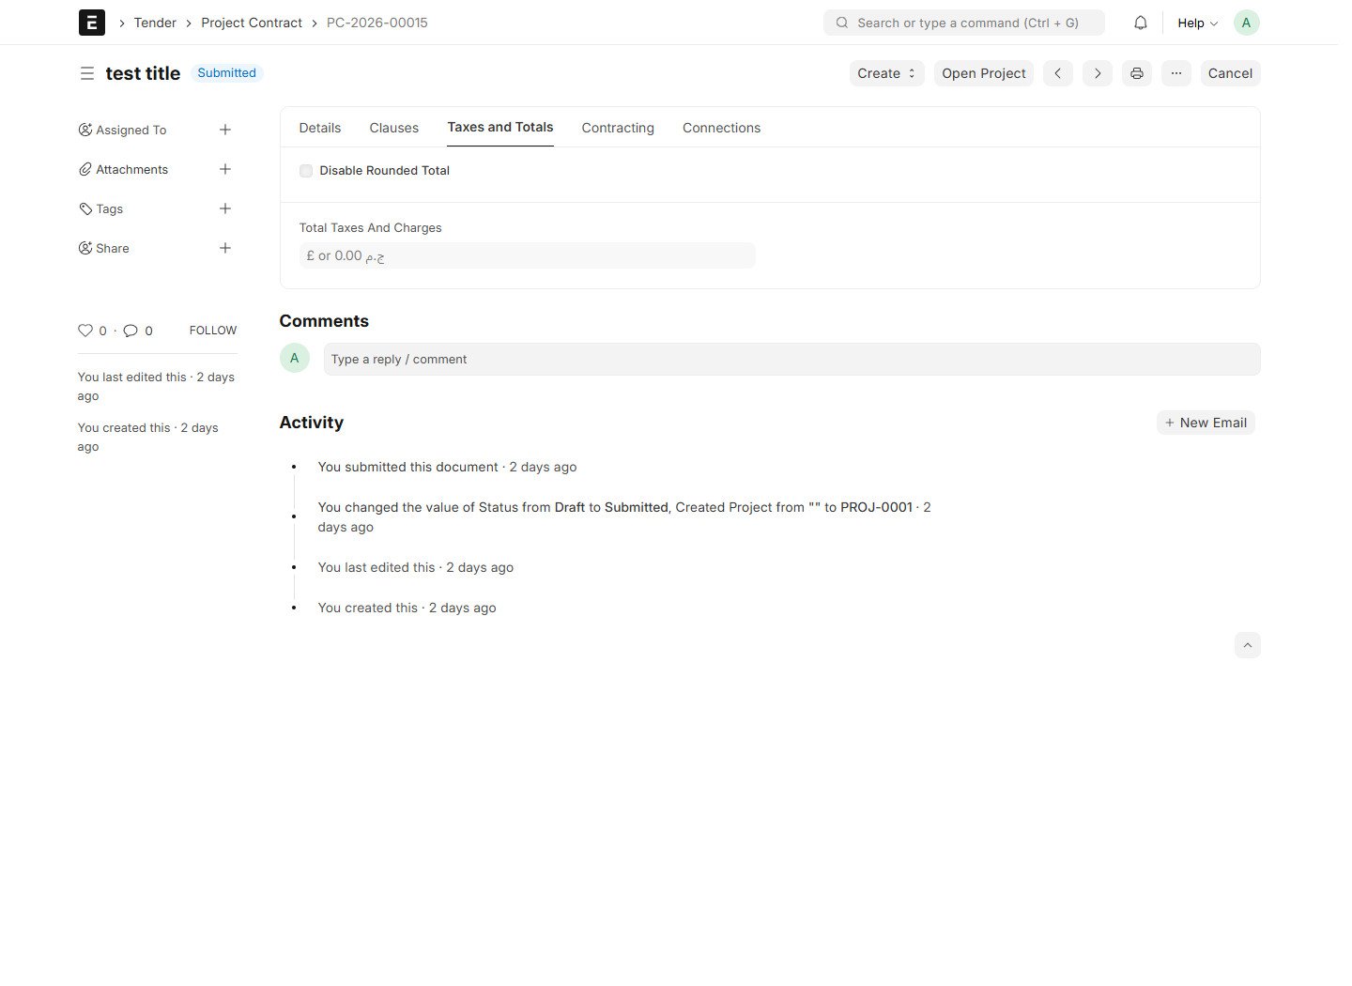
System screenshot: Project Contract Taxes

Set taxes, discounts and contracting deductions
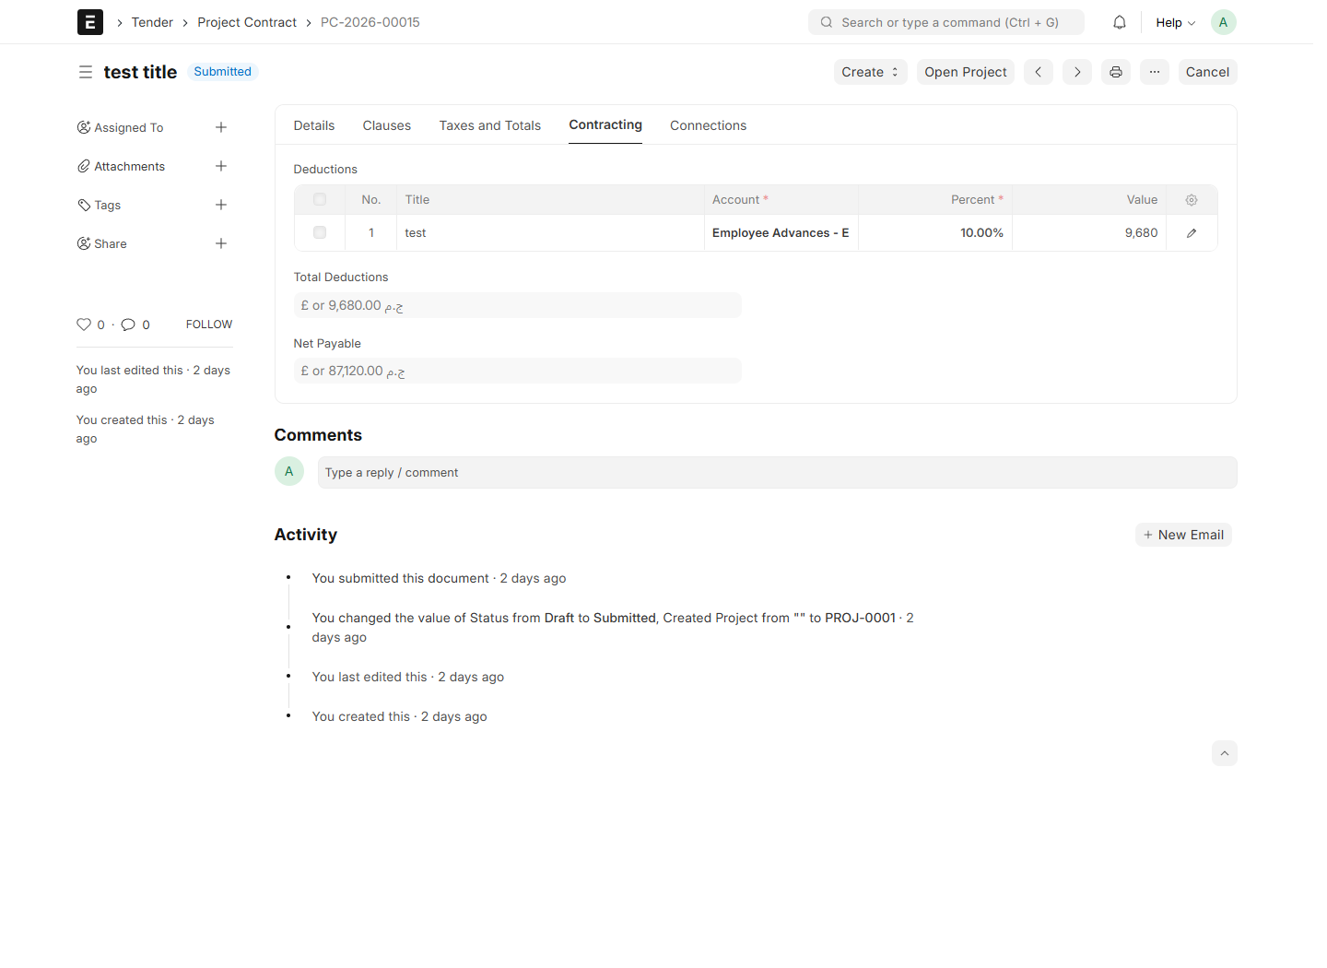
System screenshot: Project Contract Contracting

Set taxes, discounts and contracting deductions
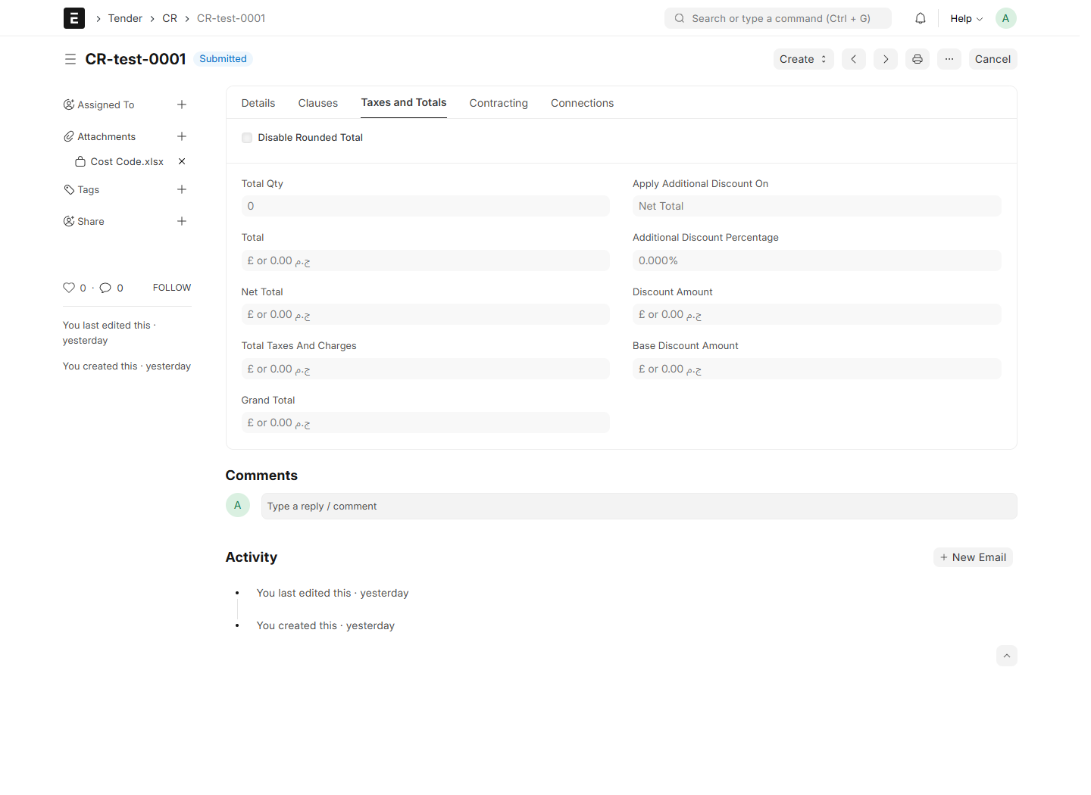
System screenshot: Cr Taxes

10. Create and approve the Project Budget
10.1 Open the submitted Project Contract and confirm that its operational Project exists.
10.2 Choose Create > Project Budget. The system opens a new draft or the existing active budget for that contract.
10.3 Check Details: Project Contract, Project, Tender Analysis, Company, Currency and Budget Date.
10.4 Open Total Budget and review Total Project Budget, Total Material, Total Labour, Total Subcontractor, Total Other Expenses and Total Equipment.
10.5 Open Contract Clauses Budget. Review each contract quantity, BOQ unit cost and total clause budget; expand rows for category amounts and source links.
10.6 Save and Submit after review. Source costs and quantities are verified by the server. A submitted budget is a snapshot, and does not post accounting entries.
Check: The budget is COST based. Clause budget = final contract quantity × normalized BOQ unit cost. Selling profit, taxes and deductions are excluded. Example: BOQ quantity 100 costs 2,300, unit cost 23; final contract quantity 150 produces budget 3,450, regardless of selling rate.

Create and approve the Project Budget
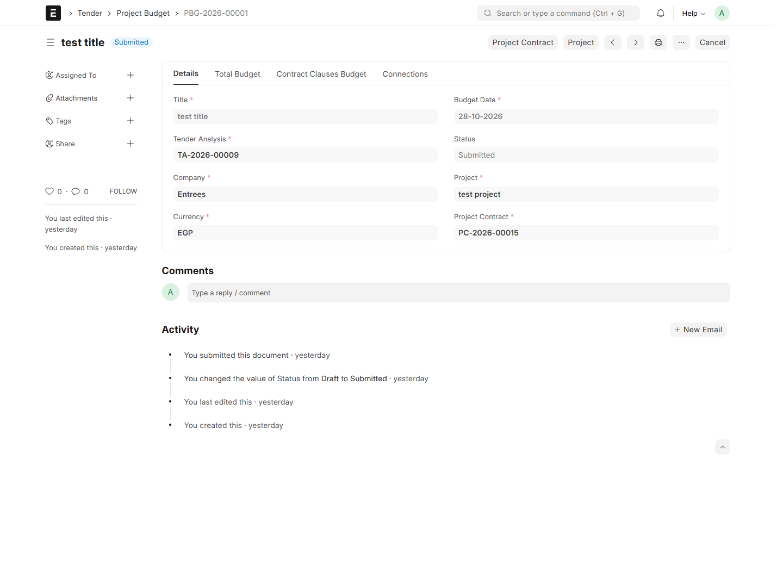
System screenshot: Project Budget

Create and approve the Project Budget
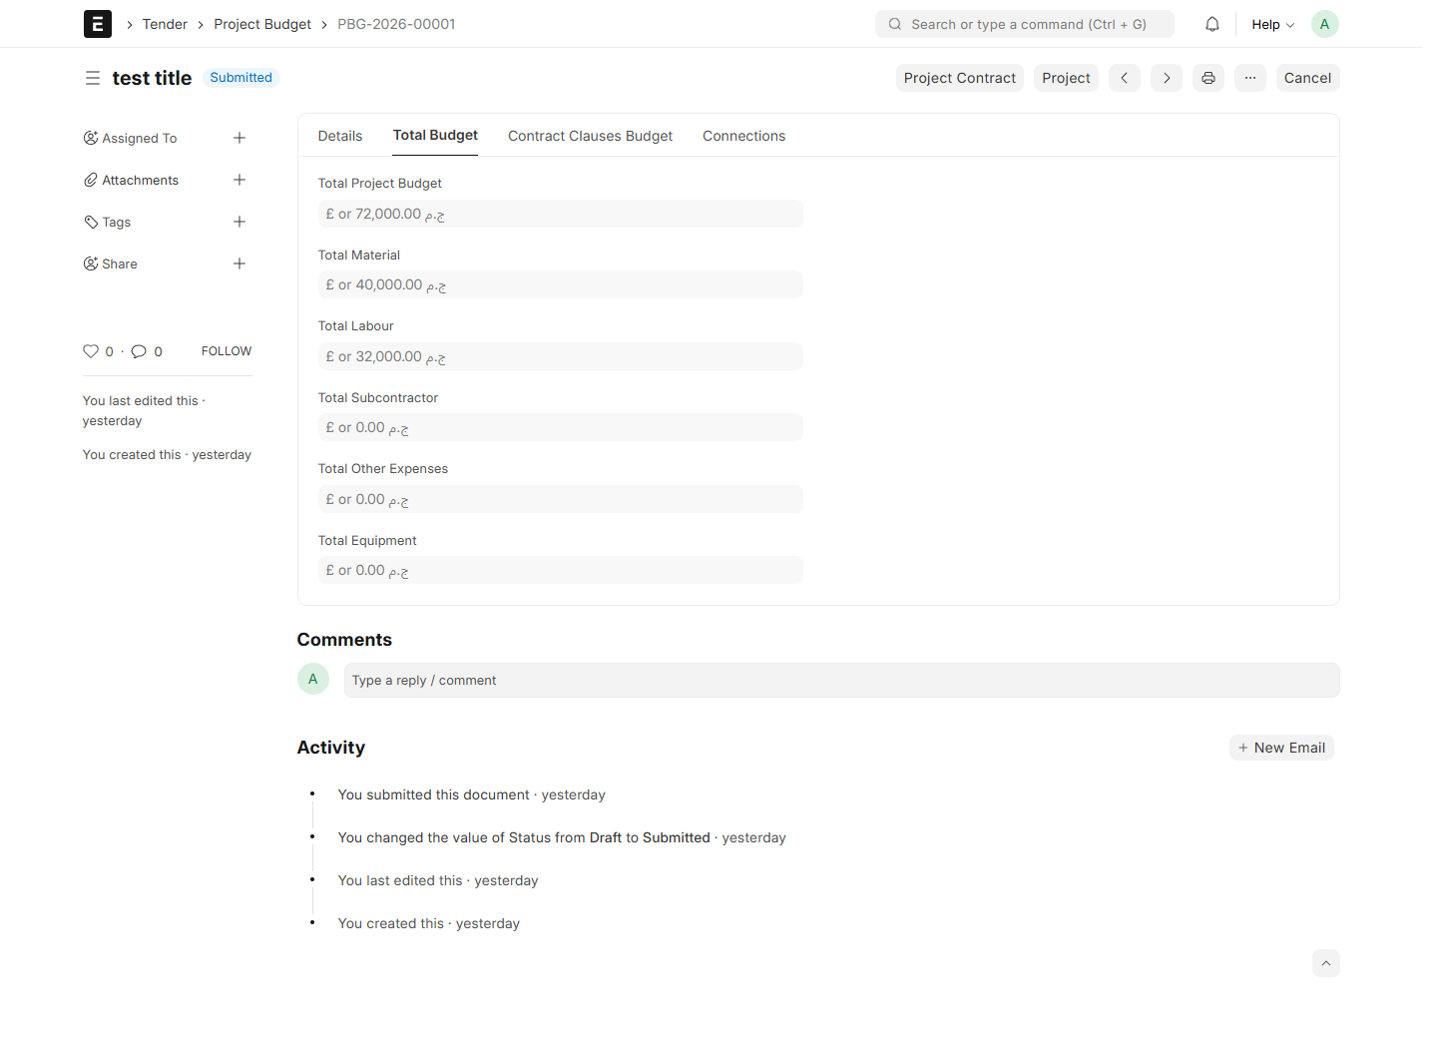
System screenshot: Project Budget Totals

Create and approve the Project Budget
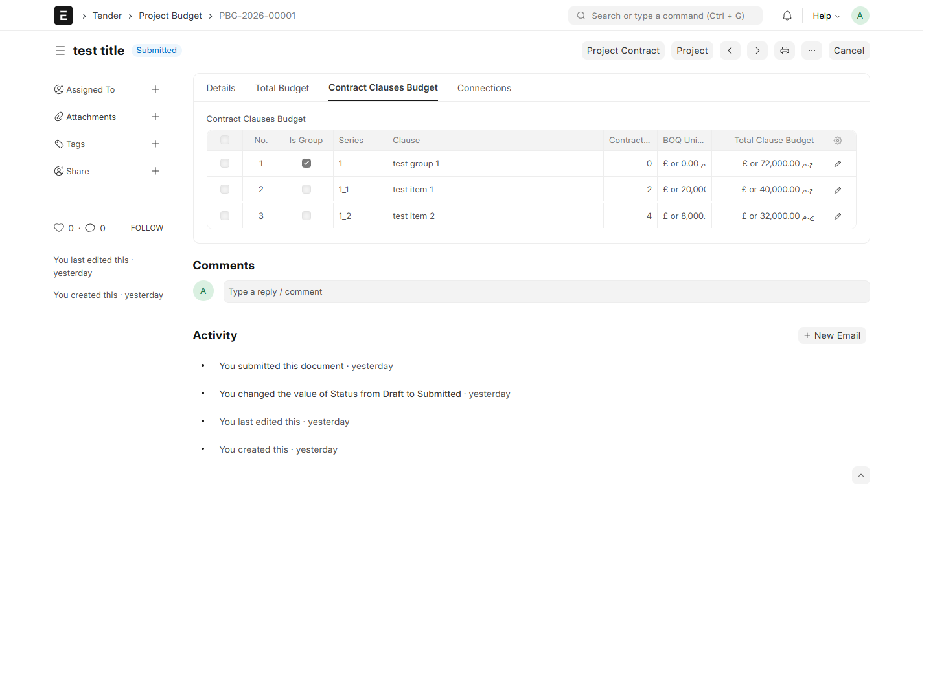
System screenshot: Project Budget Clauses Budget

11. Monitor Project quantities and progress
11.1 Open the operational Project from its Project Contract or the Project list.
11.2 Review Project Name, Company, Customer, dates and Project Abbreviation. Save any permitted changes before using Create actions.
11.3 Open Project Clauses and review contractual, executed and remaining quantities for each detail clause.
11.4 Review Clause Groups and Progress for group summaries by UOM. Customer progress and subcontractor progress are independent measures.
11.5 Use Connections and the linked contract to review commercial values. The Project clause tables show quantities/progress and do not expose contract prices.
Check: Only submitted, noncancelled certificates contribute to progress. Group headings are not payable quantities. Quantities with different UOMs are not added together as one physical quantity.

Monitor Project quantities and progress
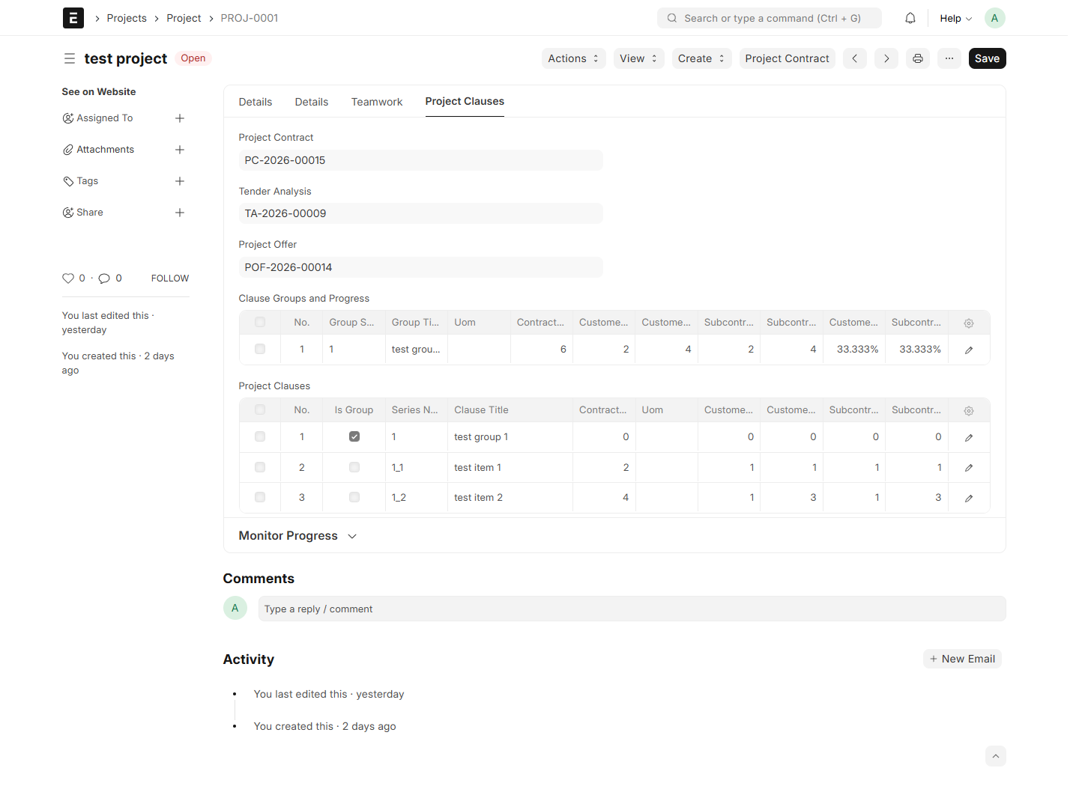
System screenshot: Project Progress

Monitor Project quantities and progress
System screenshot: Project

12. Create a CR and enter contract clauses
12.1 Search for CR and choose New. Select the operational Project and Supplier.
12.2 Select Contract Type: Arch, Civil, Elec, Mech or Service. Complete Posting Date, End Date, Attach CR and notes.
12.3 Check Company, Currency and conversion rate. Enter manual group/detail clauses, import the supplied Excel Template, or use Fetch from Project.
12.4 For detail clauses enter Qty, UOM and Rate. Amount is calculated; group amounts summarize their details.
12.5 Complete Taxes and Totals and Contracting, then Save. Review all clauses and attachments before the configured approval/submission process.
Check: The Project must have Project Abbreviation for project-based naming. CR does not require Division. Keep source Project references by fetching clauses when they must count toward Project progress.

Create a CR and enter contract clauses
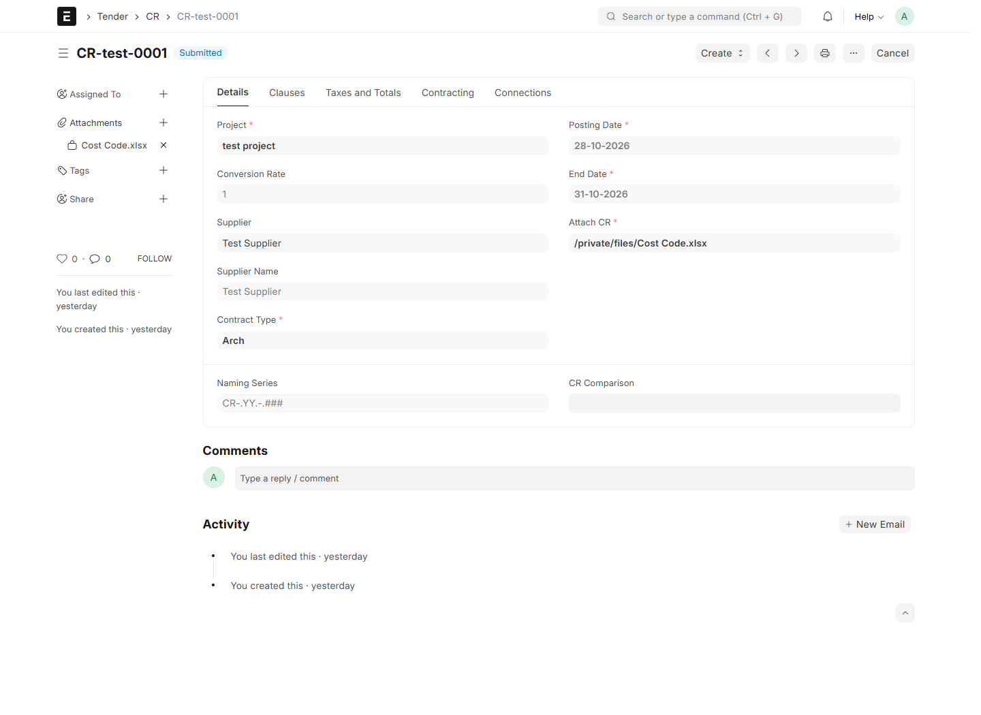
System screenshot: Cr

Create a CR and enter contract clauses
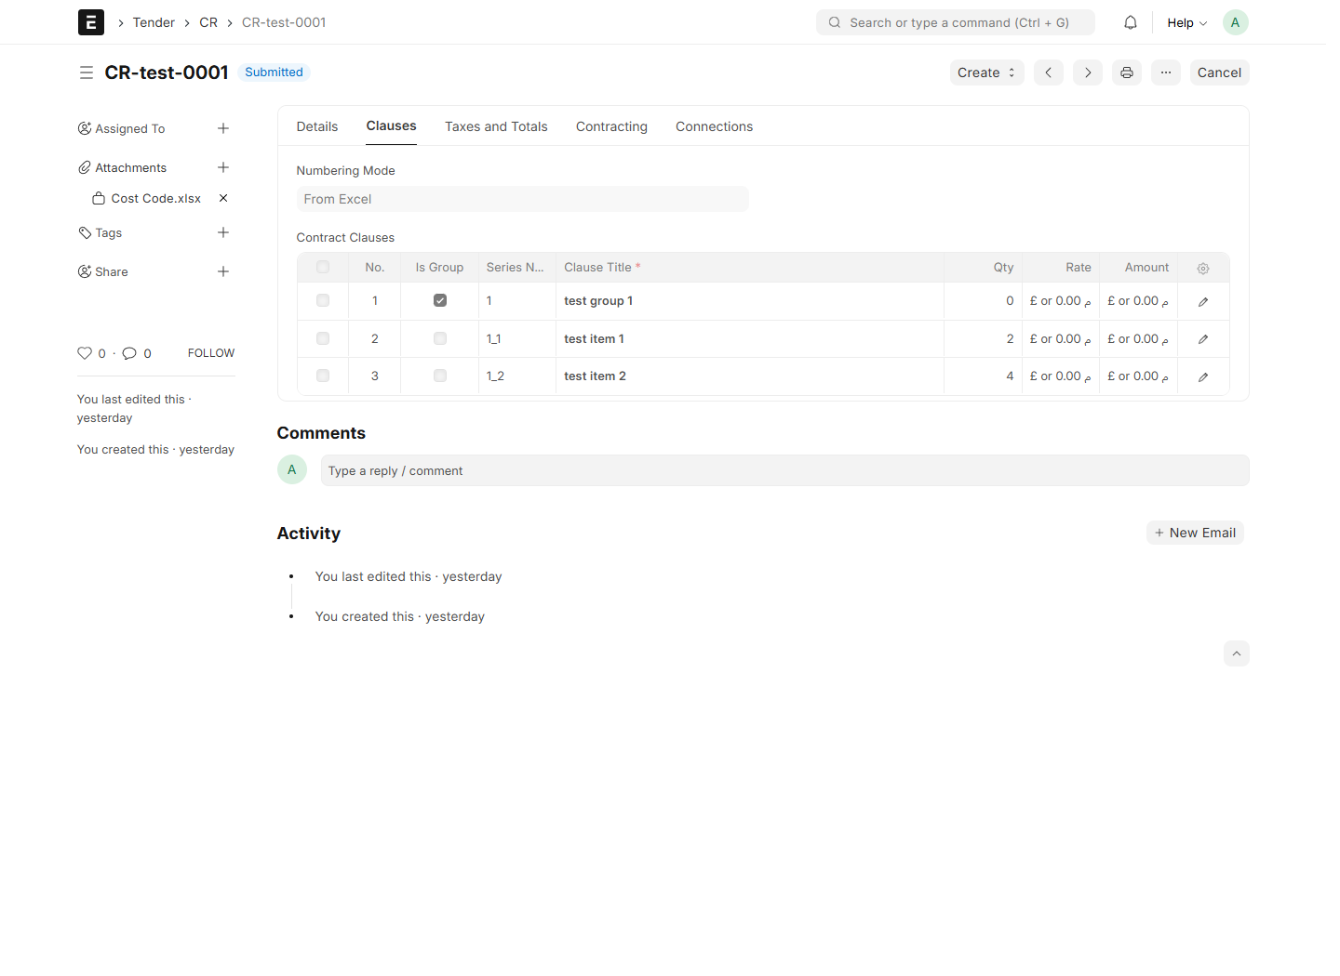
System screenshot: Cr Clauses

13. Fetch Project clauses repeatedly without losing rows
13.1 Save the CR draft with its selected Project, then click Fetch from Project.
13.2 Leave All Clauses selected to fetch the complete Project. Group Clause and group-selection controls are hidden in this mode.
13.3 For a specific group, clear All Clauses and select Group Clause.
13.4 Select Select All Clauses in This Group to fetch the whole group. Clear it to display the clause selection table.
13.5 In the table, tick the required clauses and enter their required quantities. You can switch groups to make further selections.
13.6 Click Insert Clauses. Review the appended rows, existing edits and quantities, then Save.
13.7 Repeat Fetch from Project whenever needed. Existing rows remain; already inserted source clauses are skipped rather than duplicated.
Check: Picker quantity changes affect the CR, not Project quantities. This additive Project fetch differs from Excel import replacement. Do not use the tender’s Excel replacement action as a way to append CR rows.

Fetch Project clauses repeatedly without losing rows
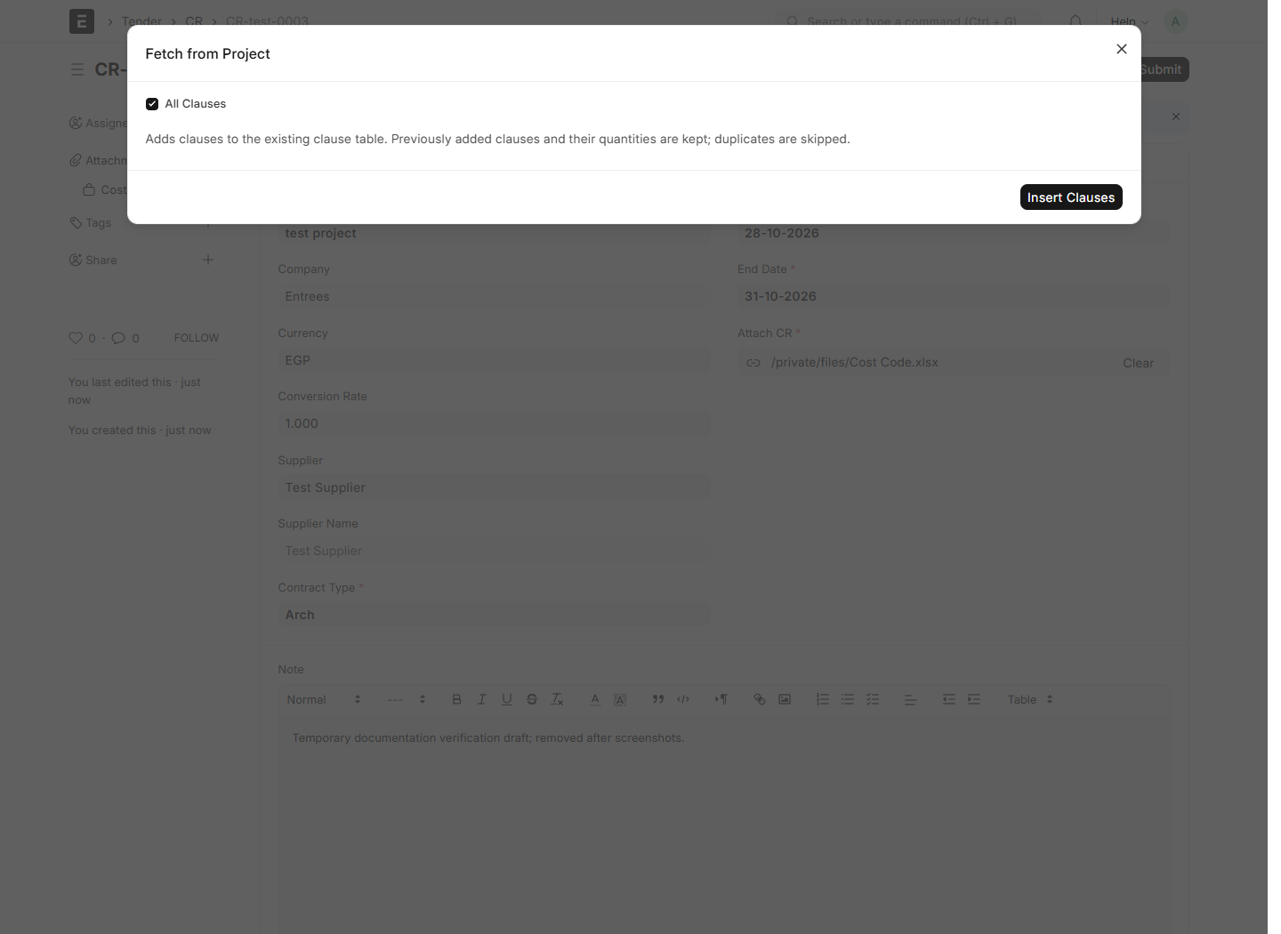
System screenshot: Cr Picker All

Fetch Project clauses repeatedly without losing rows
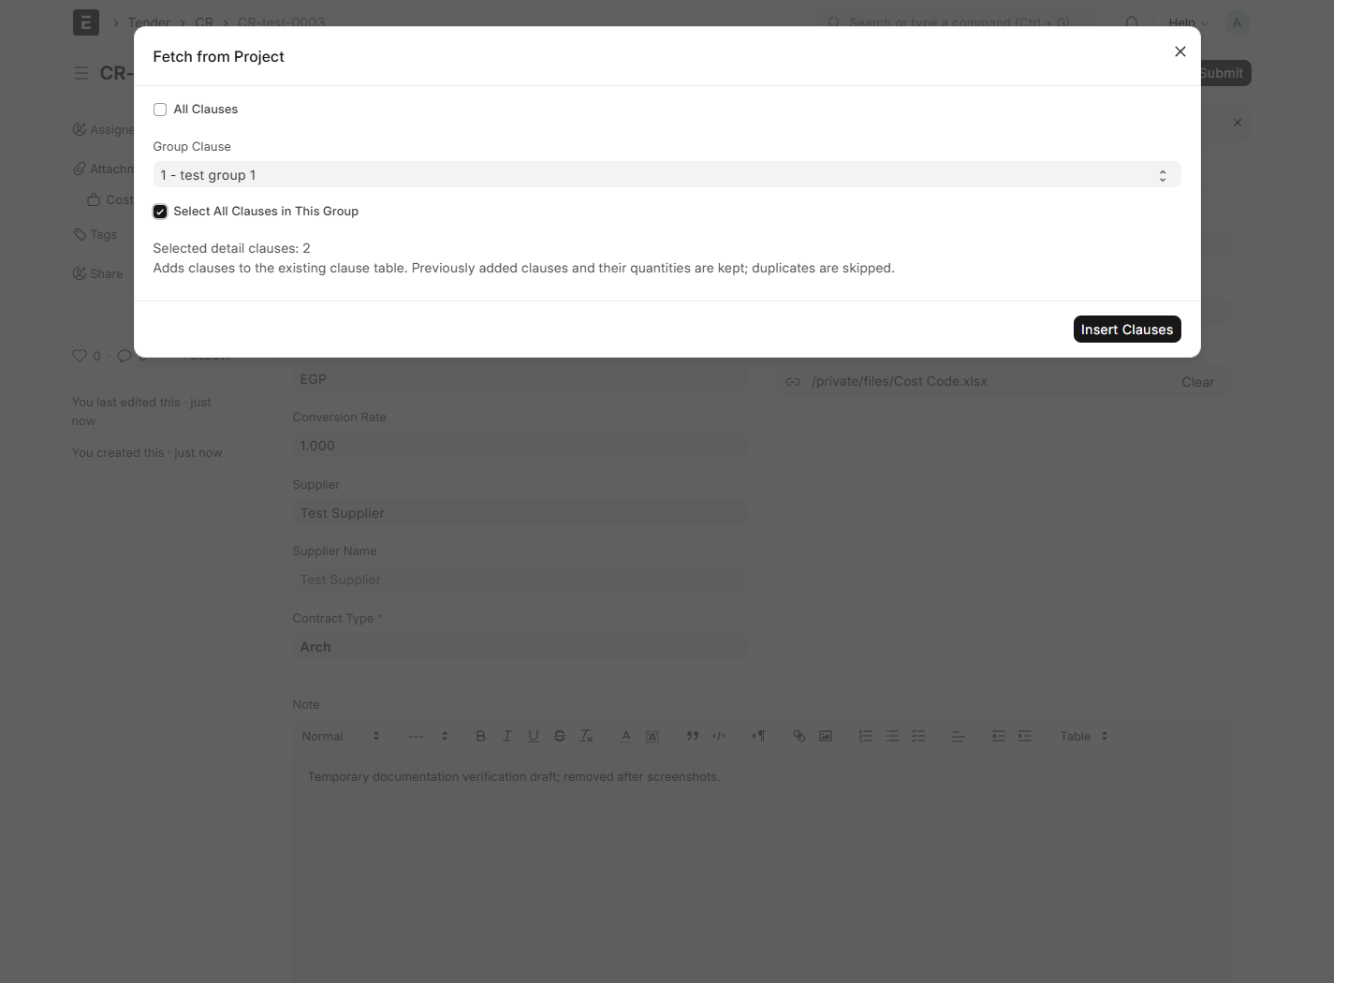
System screenshot: Cr Picker Group

Fetch Project clauses repeatedly without losing rows
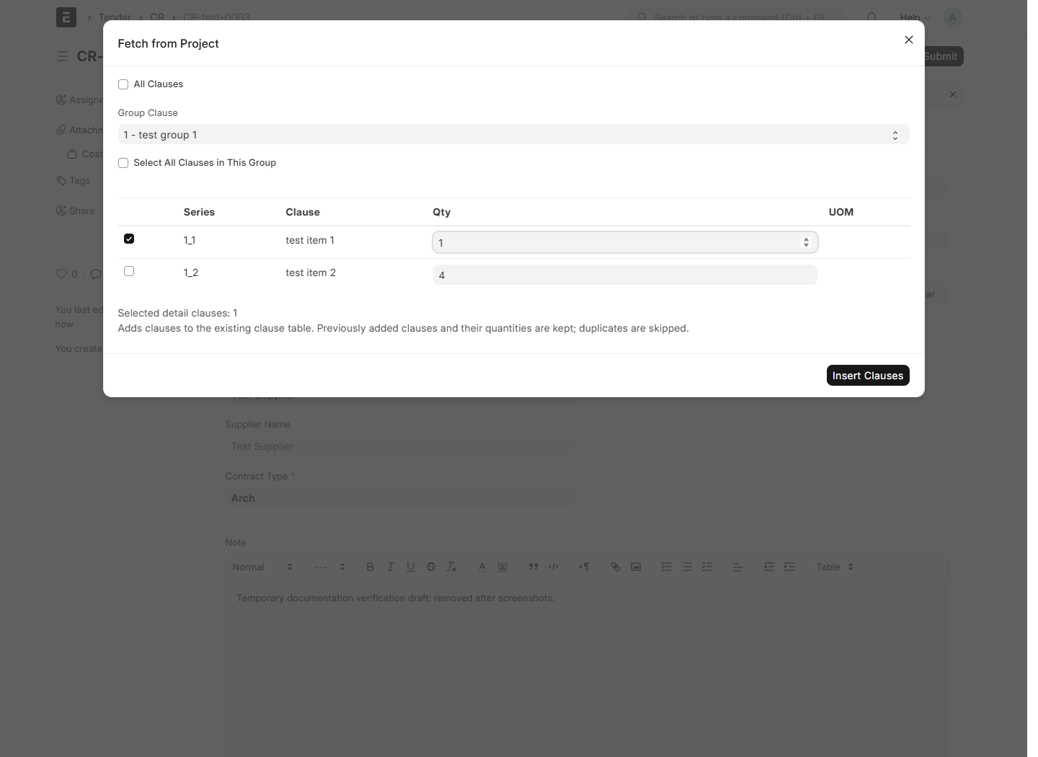
System screenshot: Cr Picker Table

14. Create the Subcontractor Contract
14.1 Open an approved/submitted CR and choose Create > Subcontractor Contract.
14.2 Review the copied Project, Supplier/Contractor, Contract Type, dates, clauses, rates, taxes, deductions and source CR link.
14.3 Upload the signed/agreed file to Attach Contract. Complete any remaining mandatory fields.
14.4 For a direct contract instead, create Subcontractor Contract from its list, fill the header and add clauses using the same manual, Excel or Project-fetch controls.
14.5 Review Taxes and Totals and Contracting. Confirm positive agreed rates for payable detail clauses, then Save and complete approval/Submit.
14.6 After submission, use Create > Subcontract Clearnce for the next period certificate. Repeated CR conversion opens its existing active contract.
Check: Contract-backed certificates retain the agreed rates and source row identities. Manually entered/imported contract rows use contract quantity limits, but do not create Project progress rows without the original Project links.

Create the Subcontractor Contract
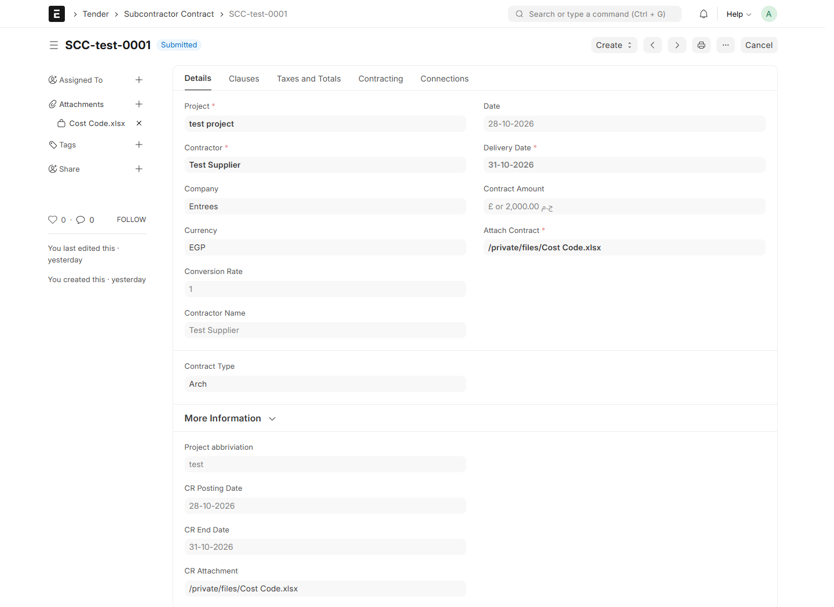
System screenshot: Subcontractor Contract

Create the Subcontractor Contract
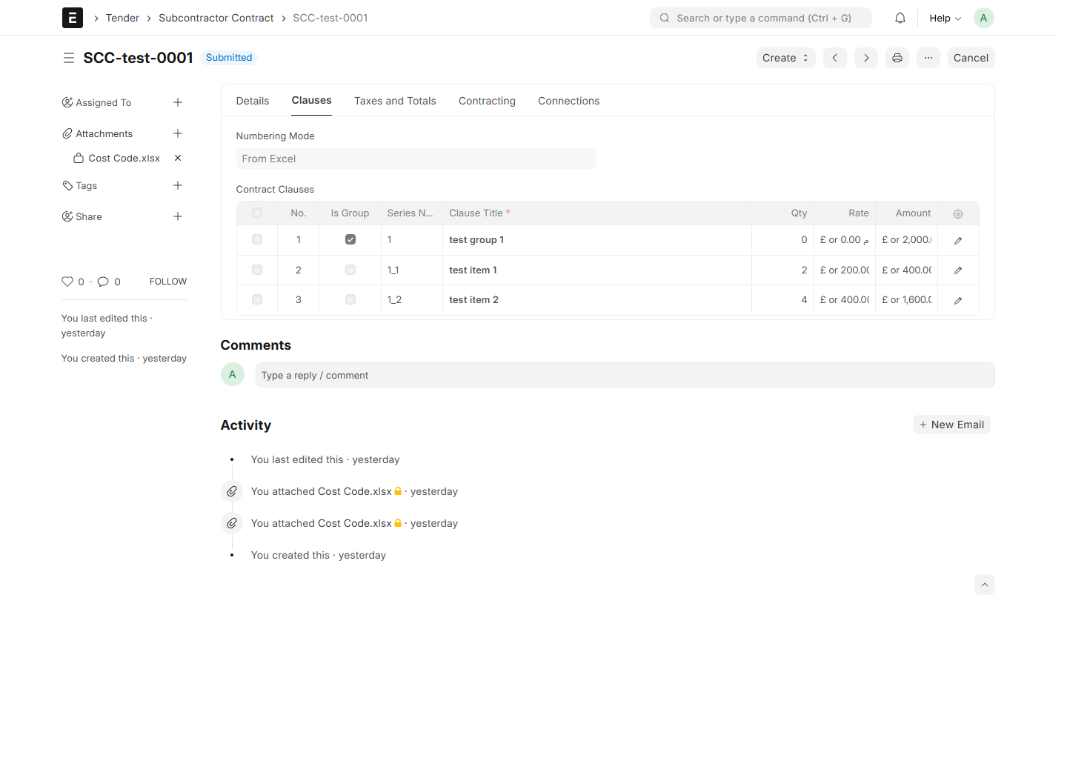
System screenshot: Subcontractor Contract Clauses

Create the Subcontractor Contract
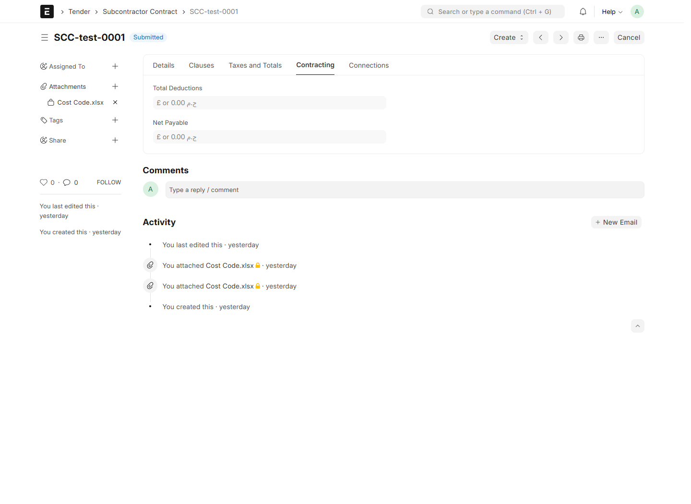
System screenshot: Subcontractor Contract Contracting

15. Issue a customer Project Clearnce
15.1 Save the operational Project, then choose Create > Project Clearnce.
15.2 Review Customer, Project Contract, currency, Posting Date and Cost Center.
15.3 Open Clauses. For each payable detail, review Total Required Qty, Previous Qty and Remaining Qty, then enter Current Qty for this period only.
15.4 Alternatively, use Current % of Remaining where appropriate. Do not enter the cumulative executed quantity as Current Qty.
15.5 Review contract rates, period amounts, taxes, period fixed charges and contracting deductions. Save the draft and obtain the required review.
15.6 Submit when ready to post. The system creates the Sales Invoice and, where applicable, the deduction Journal Entry, and updates Project progress.
Check: Submission is an accounting action. Rates come from Project Contract and quantities cannot exceed the contractual balance. A posting failure prevents completion of the certificate submission.

Issue a customer Project Clearnce
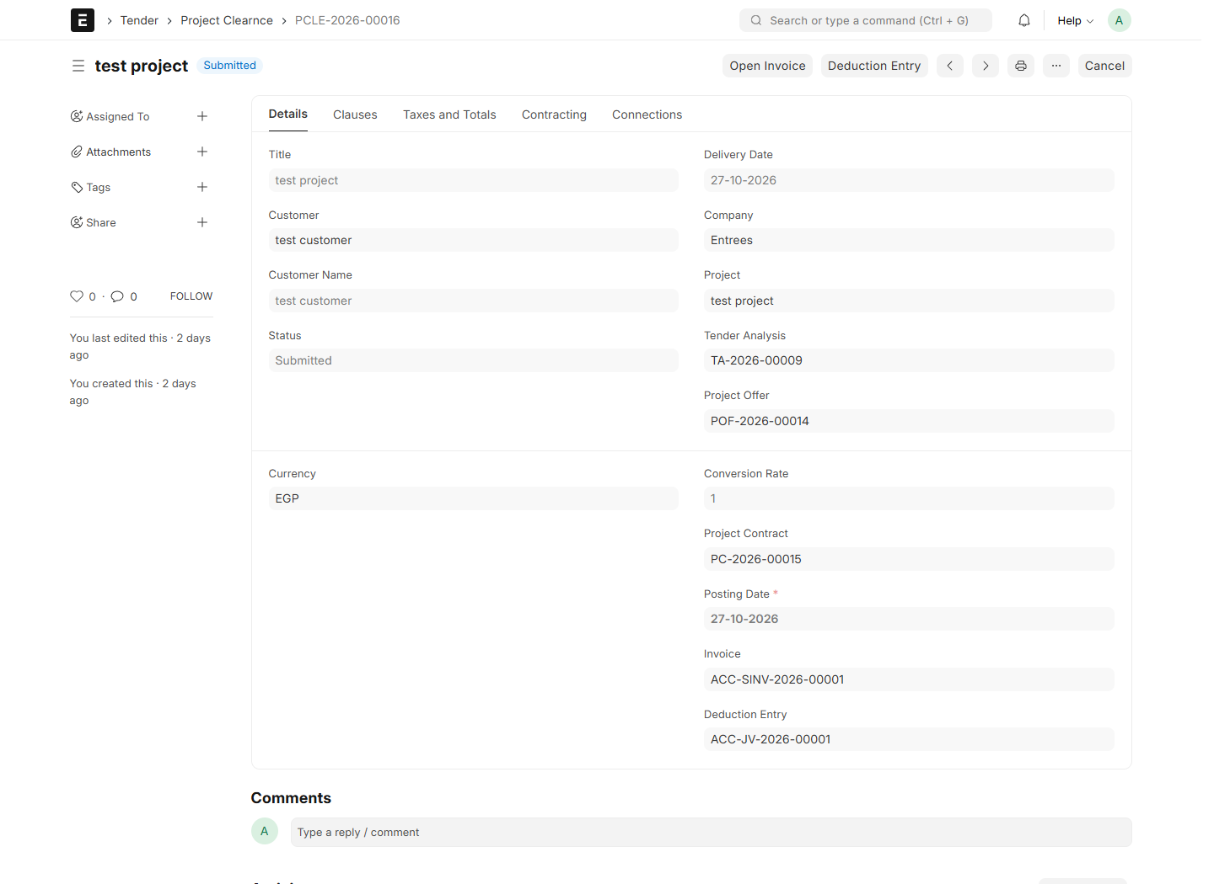
System screenshot: Project Clearnce

Issue a customer Project Clearnce
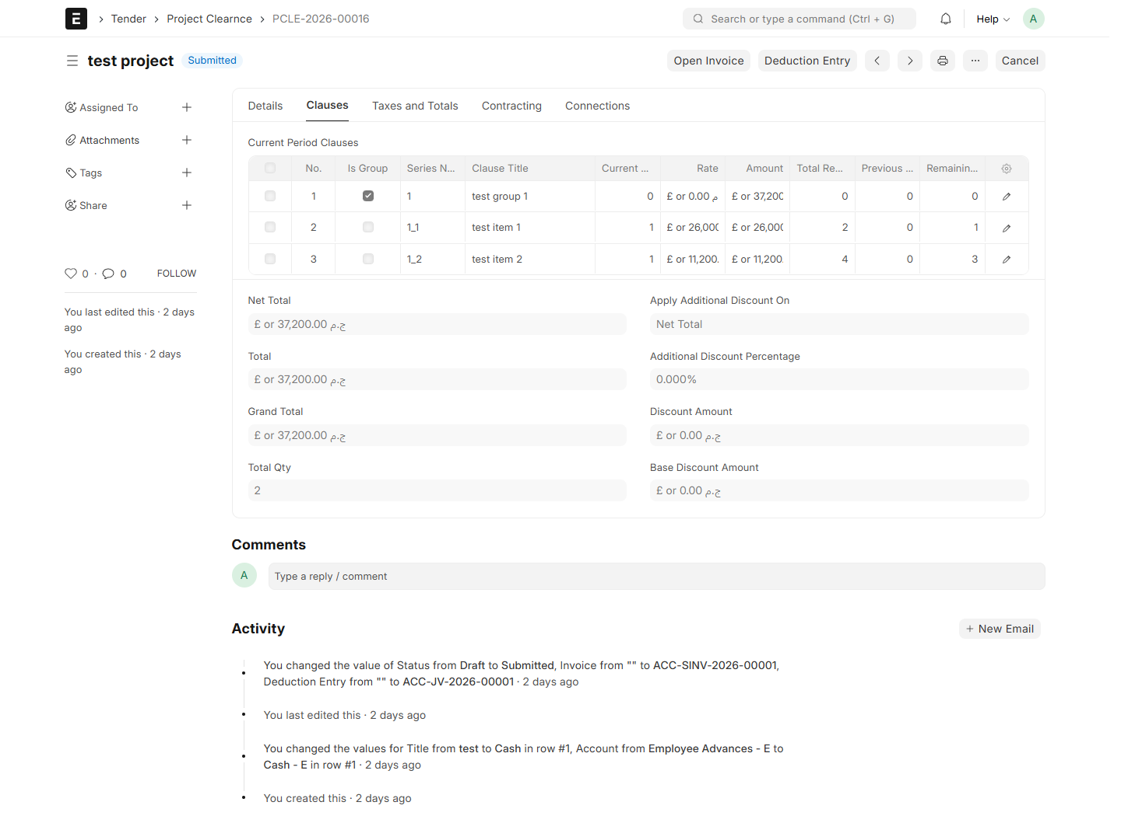
System screenshot: Project Clearnce Clauses

16. Issue a Subcontract Clearnce from Project
16.1 Save the Project and choose Create > Subcontract Clearnce.
16.2 Select Supplier first. The selector contains suppliers with submitted Subcontractor Contracts for this Project.
16.3 Select the required Subcontractor Contract for that Supplier and Project, then click Create Clearance.
16.4 Review the mapped document. Current-period quantities start at zero; enter only this period’s Current Qty. The selected contract supplies the agreed rates.
16.5 Check Previous Qty, Project Previous Qty and Remaining Qty. Review taxes, period Actual charges, discounts, deductions and Cost Center.
16.6 Save and review, then Submit. Open the resulting Purchase Invoice and Deduction Entry if present, and verify updated Project progress.
Check: The system enforces the contract’s cumulative quantity limit. For Project-linked clauses it also enforces the Project-wide subcontract limit across suppliers. Changing Supplier clears the selected contract.

Issue a Subcontract Clearnce from Project
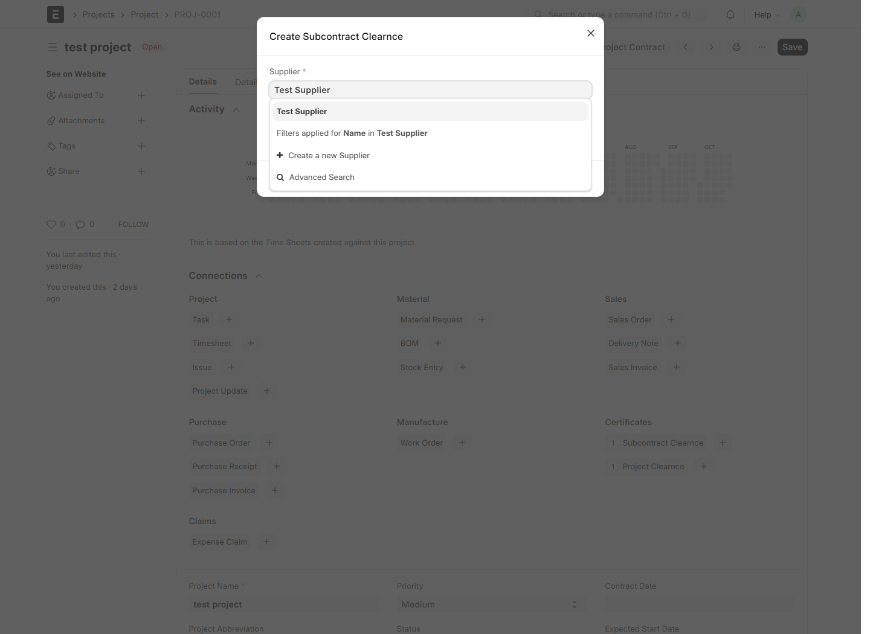
System screenshot: Project Subcontract Picker

Issue a Subcontract Clearnce from Project
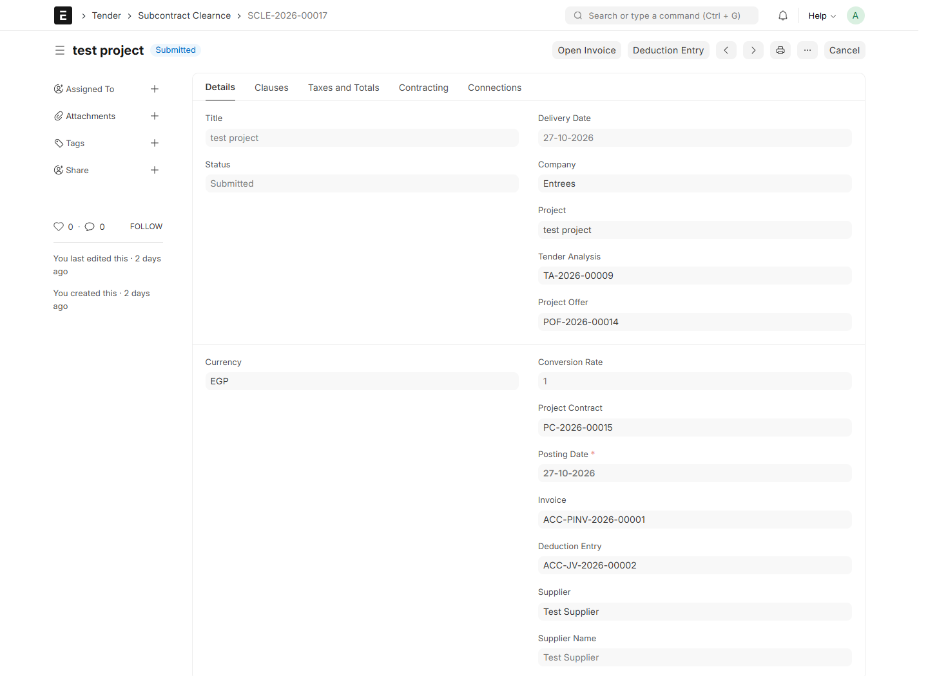
System screenshot: Subcontract Clearnce

Issue a Subcontract Clearnce from Project
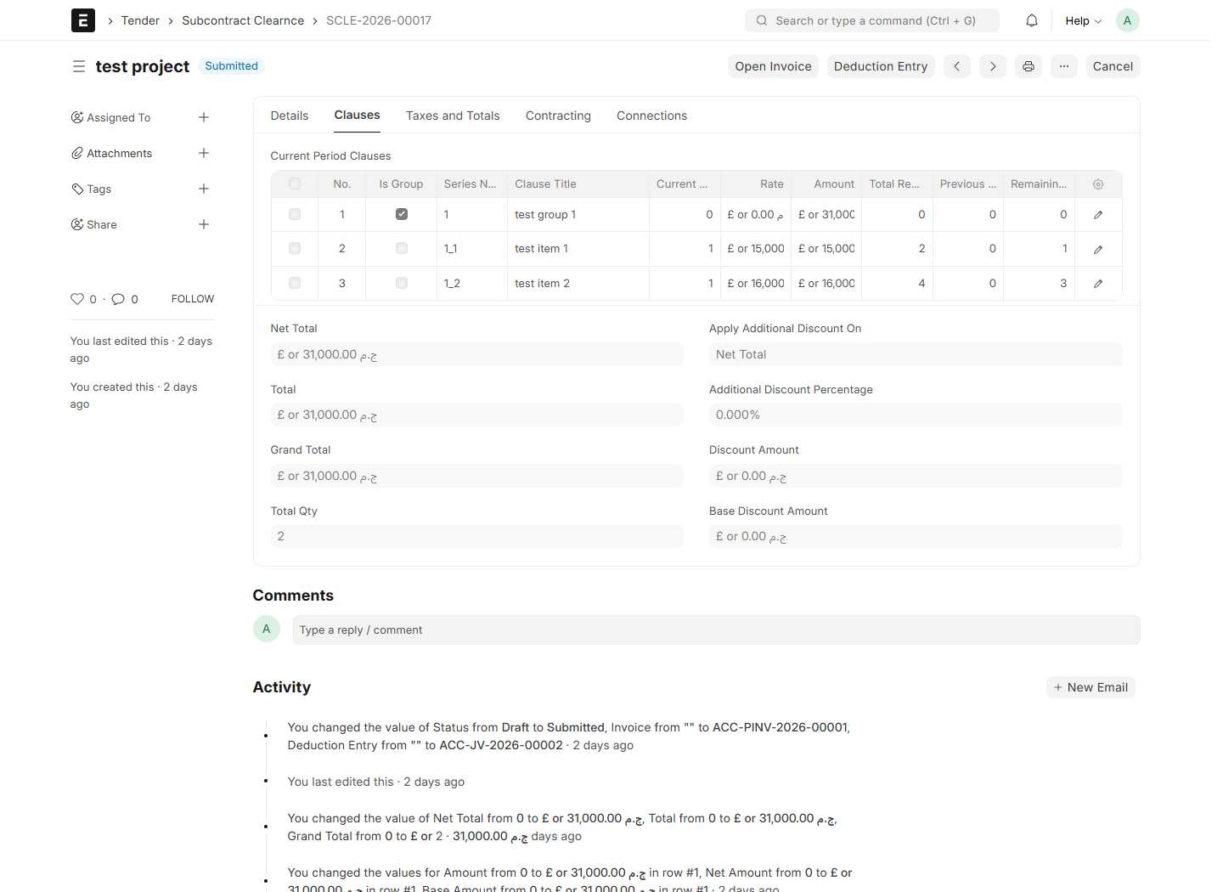
System screenshot: Subcontract Clearnce Clauses

17. Review invoices, deductions and payments
17.1 On a submitted certificate, choose Open Invoice and check the party, Project, currency, net work value, tax amounts and invoice total.
17.2 The invoice contains a single non-stock service item for the certified works. The detailed work measurement remains in the certificate clauses.
17.3 If deductions exist, open Deduction Entry and check its accounts and value. It settles the deduction against the party balance without posting the same work revenue/expense again.
17.4 Example without taxes: certified works 100 and deduction 10 produce invoice 100, deduction settlement 10 and net payable 90.
17.5 Record actual collection/payment using standard ERPNext Payment Entry against the appropriate outstanding invoice.
17.6 Use General Ledger and Accounts Receivable/Accounts Payable for balance reconciliation. Verify Company, party, date range and submitted transaction status.
Check: Company defaults, party accounts, income/expense accounts, Cost Center and rounding accounts must be configured before posting. The retained legacy Account Balances source is not a verified operational balance report.

Review invoices, deductions and payments
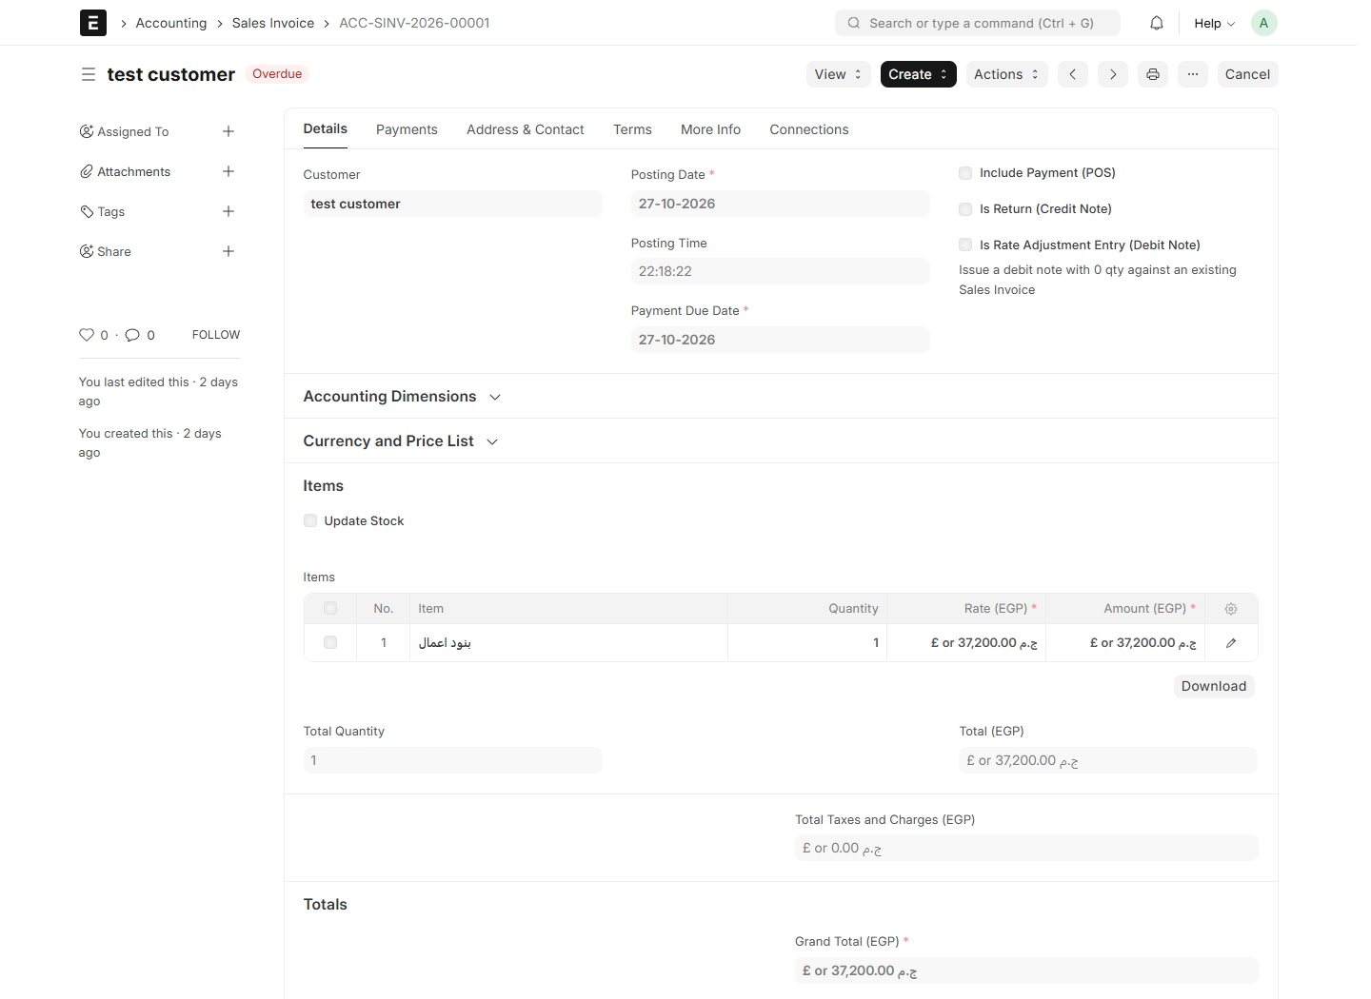
System screenshot: Sales Invoice Selling

Review invoices, deductions and payments
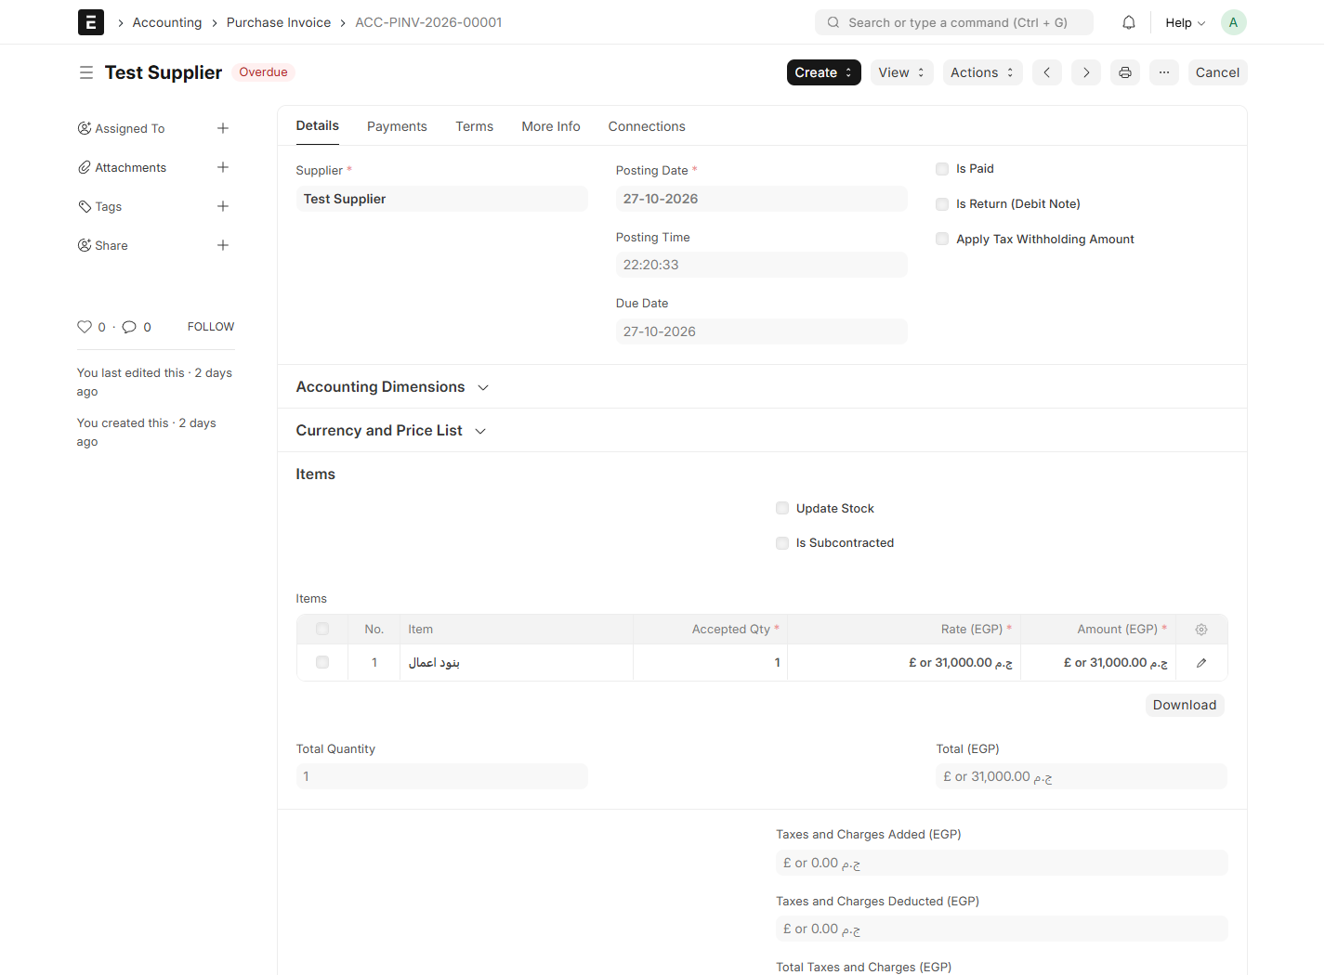
System screenshot: Purchase Invoice Buying

Review invoices, deductions and payments
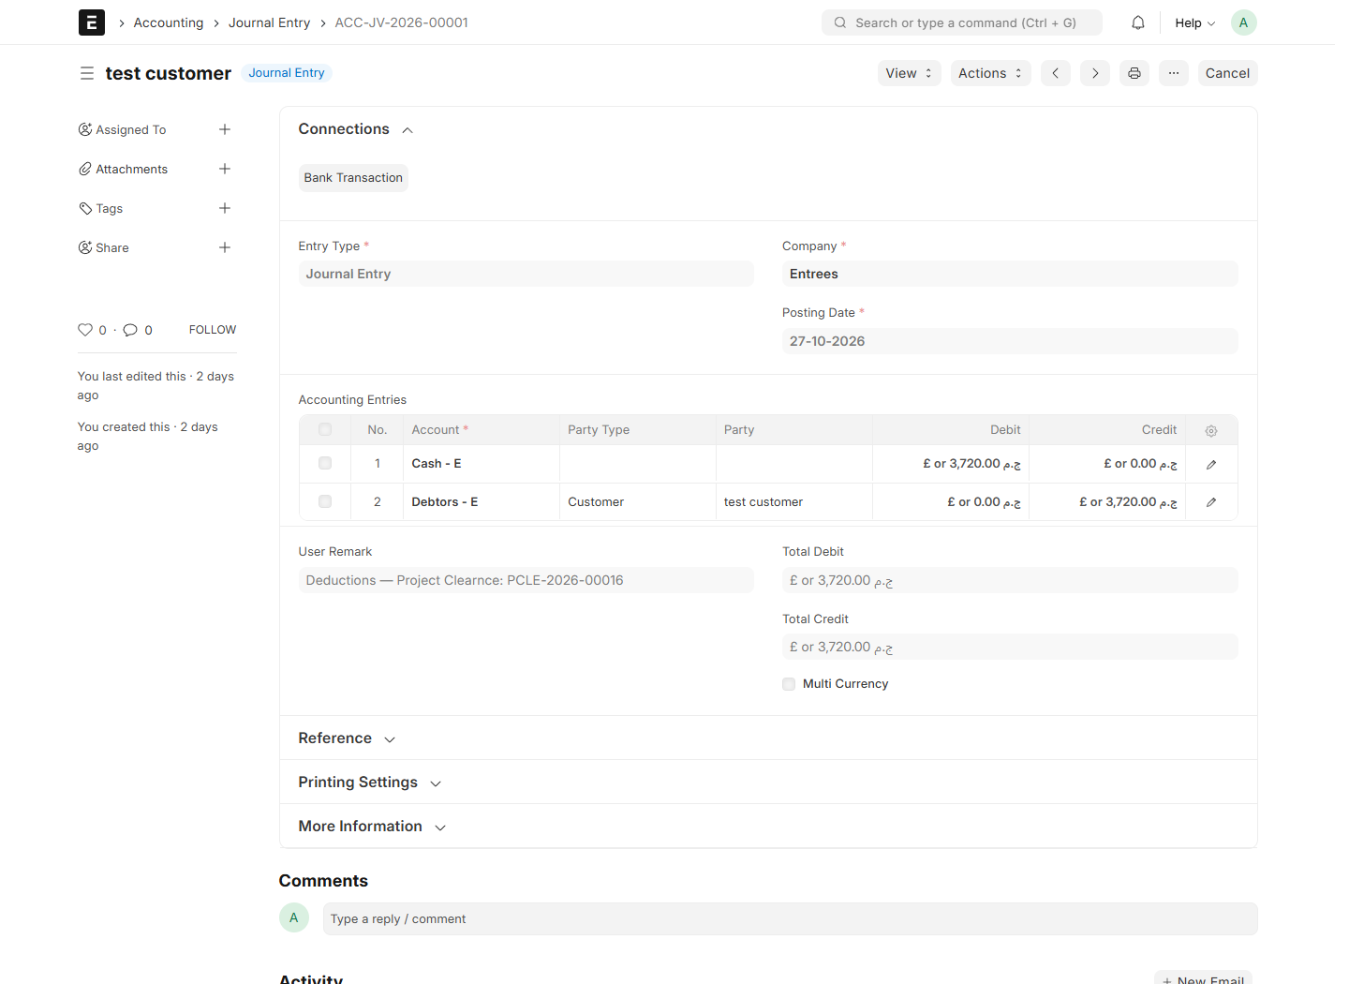
System screenshot: Journal Entry Selling

Review invoices, deductions and payments
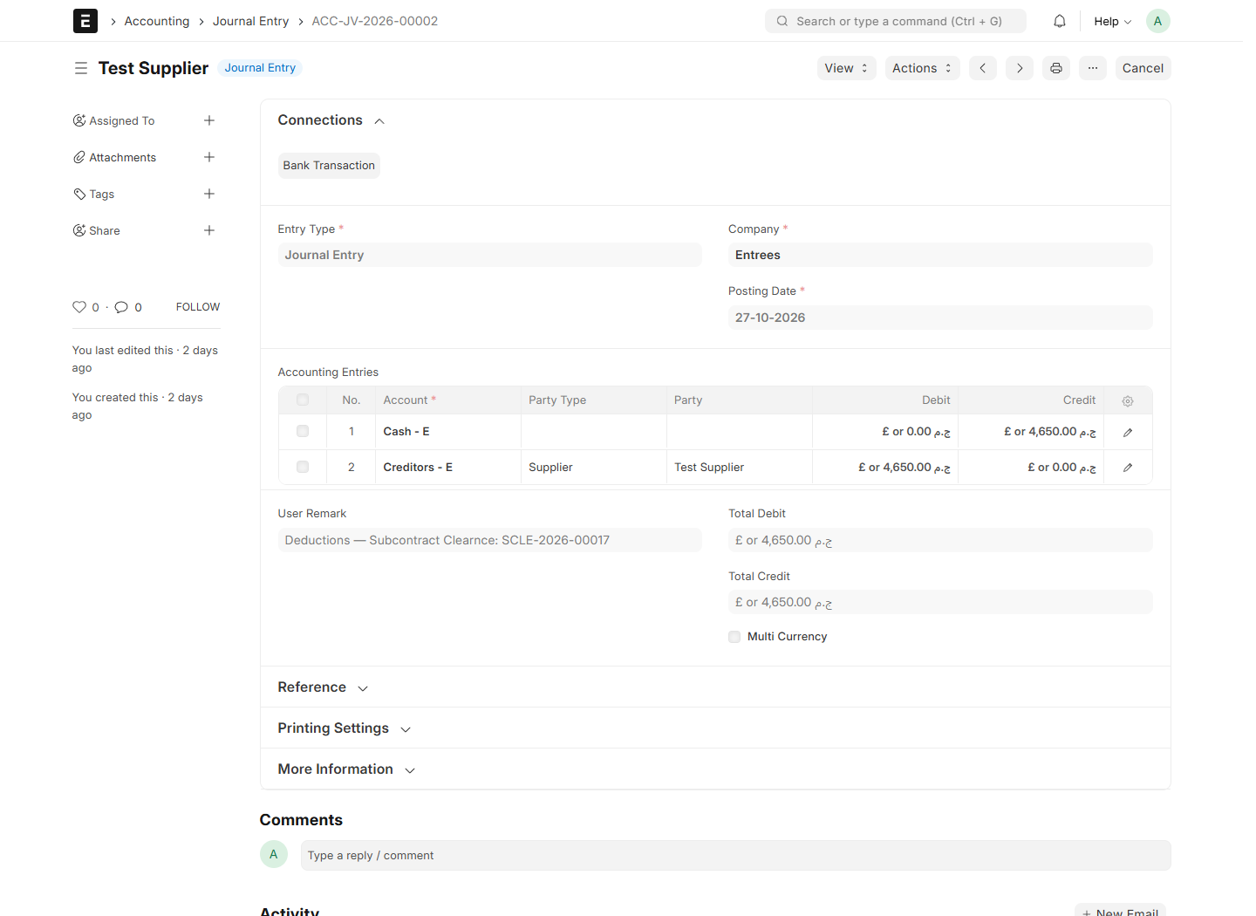
System screenshot: Journal Entry Buying

18. Use Purchase Comparison
18.1 Open Comparison directly. Where the Material Request workflow is configured, an approved/submitted Purchase request exposes Create Purchase Comparison to a Purchase User.
18.2 Review Project, Material Request and the requested items. In the comparison matrix, use Add Item for additional rows if needed.
18.3 Choose Attach Supplier for each supplier being compared. Enter each supplier rate for each item and review quantity × rate and supplier totals.
18.4 Enter technical ratings, attach supplier quotations and record Accepted Supplier, Amount and Notes as required.
18.5 Save and use the configured review/submission process. Export Excel downloads a CSV file; review it in Excel.
Check: The retained comparison feature depends on its site fields and configured Material Request workflow. Do not assume that approving Comparison automatically creates a Purchase Order.

Use Purchase Comparison
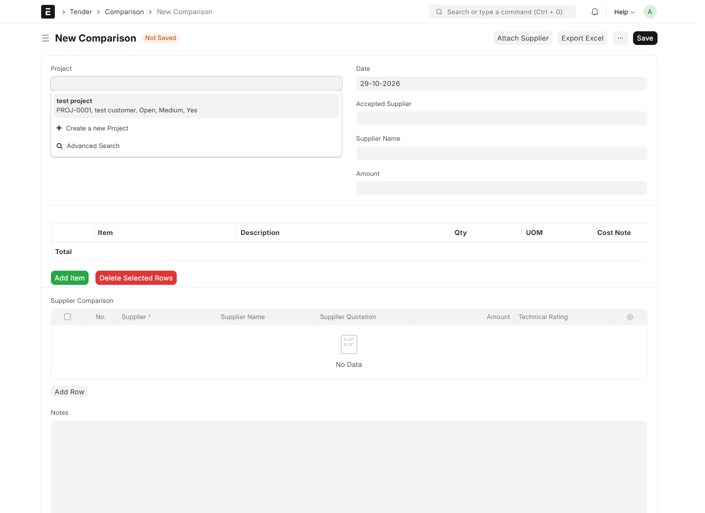
System screenshot: Comparison

19. Use Item Coding Request and Subcontractor Custody
19.1 For coding, open Item Coding Request, choose New, select Project and Date, and add item names, UOMs, descriptions and attachments in Items.
19.2 Save and send through the configured review process. Record the resulting Item Code links when the authorized master-data user has created the Items.
19.3 For custody, open Subcontractor Custody. Select Subcontractor, Project and Date, then choose Type Out for issue or Return for return.
19.4 Enter Items, positive quantities and correct UOMs; add a note. Check the Project warehouse and destination/source custody warehouse with the stock administrator.
19.5 Save and Submit only after stock review. The current custody controller creates and submits a Material Transfer Stock Entry.
Check: The current custody code uses Project custom_warehouse and the literal warehouse “Subcontractor - C”. Confirm this configuration before use; it is not the dynamic company-abbreviation logic used by Cost Type. Automatic Item creation is not implemented by the basic Item Coding Request controller.

Use Item Coding Request and Subcontractor Custody
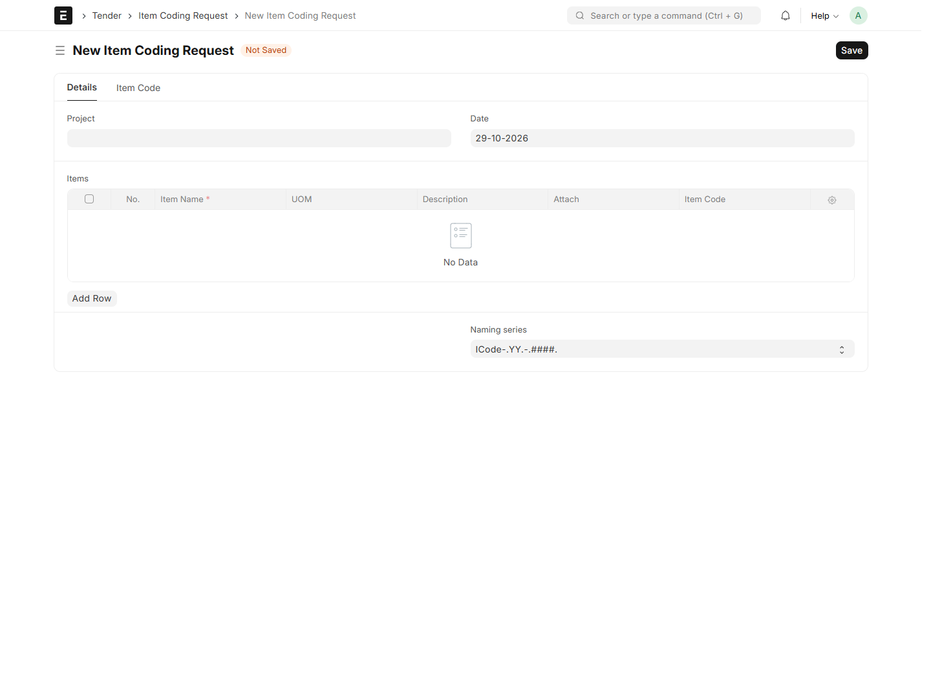
System screenshot: Item Coding Request

Use Item Coding Request and Subcontractor Custody
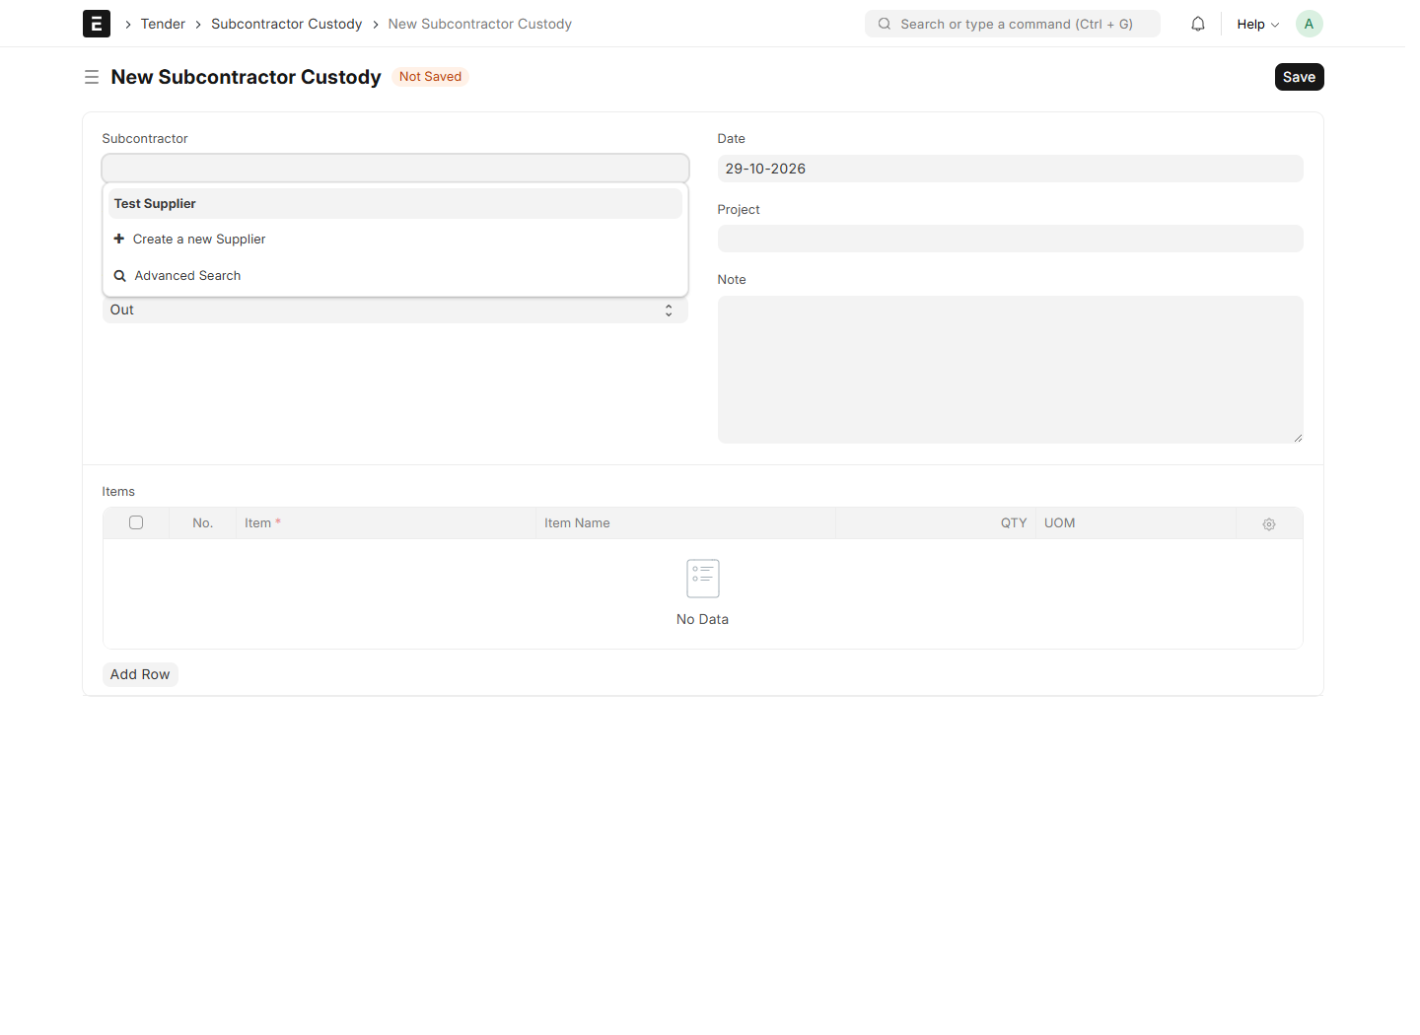
System screenshot: Subcontractor Custody

20. Use standard purchasing and project-based names
20.1 Create Opportunity, Quotation, Sales Order, Sales Invoice, Purchase Order, Purchase Invoice and Purchase Receipt through their standard ERPNext forms.
20.2 For a new Purchase Order, select the native Project field before saving and confirm the linked Project has Project Abbreviation.
20.3 Save to receive a name such as PO-TST-0001. Purchase Receipt uses PRE-TST-0001 for the same Project abbreviation.
20.4 Use standard ERPNext items, taxes, receipts and invoicing actions. There is no custom Purchase Order Type selector in this app’s current purchasing flow.
Check: Naming is the retained Purchase Order/Purchase Receipt exception. Company abbreviation on Cost Centers and Project Abbreviation on document names are separate settings.

Use standard purchasing and project-based names
System screenshot: Cost Code

21. Correct, cancel and amend documents
21.1 Edit and Save drafts before submitting. Review the document status and linked documents in Connections.
21.2 To correct a submitted document, follow the configured Cancel/Amend permissions and resolve downstream links first.
21.3 Before cancelling a certificate, reconcile any payments or downstream documents blocking its invoice. Certificate cancellation reverses its generated deduction entry/invoice through the application flow.
21.4 Cancel/delete active certificates before cancelling their Subcontractor Contract, then resolve linked contracts before cancelling CR.
21.5 For Project Contract cancellation, resolve active budgets and other downstream links and set the related Project status as required. Do not alter source database references manually.
21.6 After permitted cancellation, verify recalculated quantities and financial balances. Create an amendment or replacement through the normal document actions.
Check: Historical Legacy Record certificates retain their older behavior. Do not use them as examples of the new clause-based accounting cycle.

22. Troubleshooting and daily checks
22.1 Missing Project Abbreviation: open the linked operational Project, fill the abbreviation and Save. If the field itself is missing, ask for the migration/metadata repair.
22.2 Missing creation button: Save the source, check submitted status, complete source pricing and confirm create/read permissions. A draft Costing Note blocks offer/contract creation.
22.3 No picker table: clear All Clauses, choose a group and clear Select All Clauses in This Group. Confirm that the group contains detail clauses.
22.4 No Supplier/Contract in the Project clearance dialog: confirm there is a submitted contract for that exact Project/Supplier and that your account can read it.
22.5 Budget creation blocked: check exact submitted BOQ/Costing Note links, UOM, currency and active-budget uniqueness. Do not substitute another clause with the same title.
22.6 Posting failure: ask Accounts to check party, income/expense, deduction and tax accounts, Company, Cost Center and rounding defaults. Keep the failed certificate in draft until resolved.
22.7 At day end, compare submitted certificates, invoices, deduction entries, Project progress and party outstanding balances.

Site verification scope
20 of 20 document types opened during site review. All 172 local automated tests passed. These checks do not establish end-to-end accounting posting success. A JavaScript message observed during navigation needs separate investigation: field item not found
CR All Clauses hides group field — Passed
CR selected group shows detail selection table — Passed
CR Select All in Group hides detail table — Passed
Repeated Project fetch preserves existing CR row and quantity without duplication — Passed
Temporary CR draft cleanup — Passed
Unsaved BOQ equipment quantity and costs — Passed
Existing Project Budget category and detail reconciliation — Passed
Project Supplier/Contract selection dialog — Passed
Project Clearnce existing invoice/deduction reconciliation — Passed
Subcontract Clearnce existing invoice/deduction reconciliation — Passed

