Bradford Project Juypter Notebook

Step 1.

Follow the Link https://console.cloud.google.com/vertex-ai/workbench/user-managed?authuser=0&project=yhcr-prd-bradfor-bia-core

Step 2 :
Open the Assigned Workspace and start the service if not started.

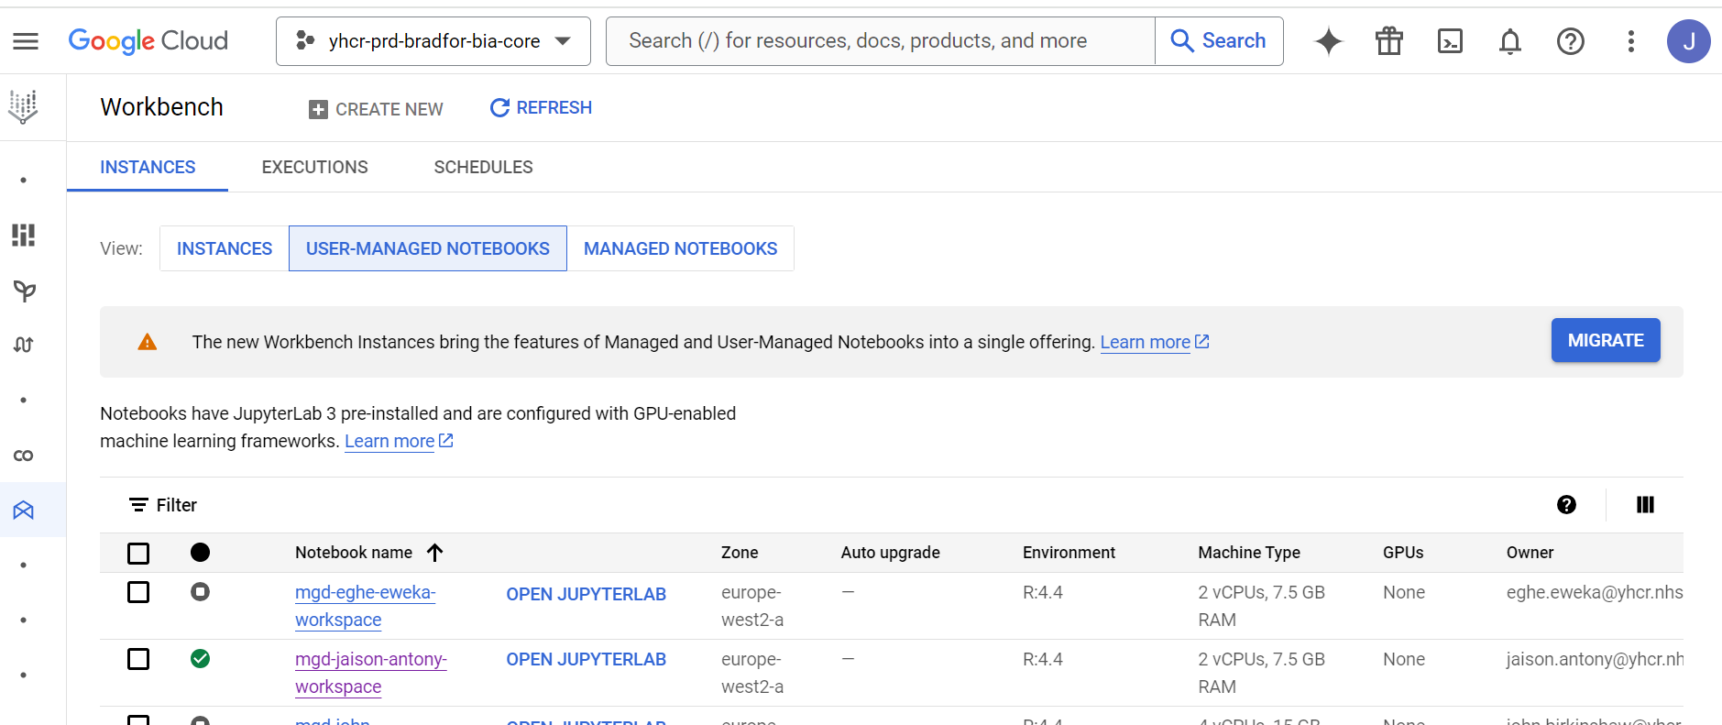
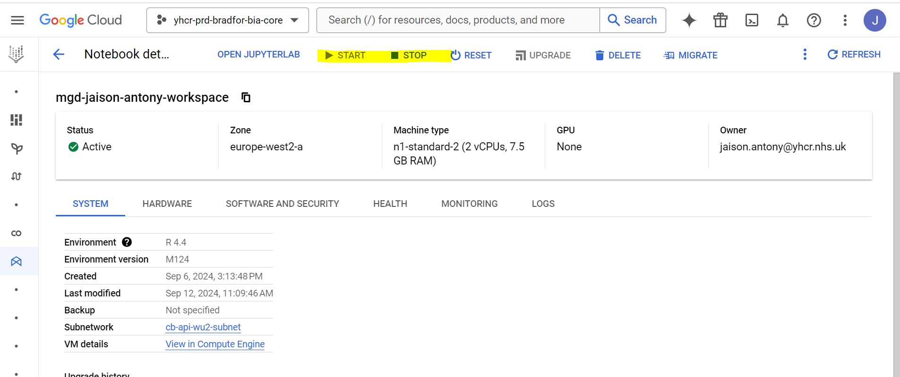

Step 3

Open the Jupter Notebook form the Notebook page.
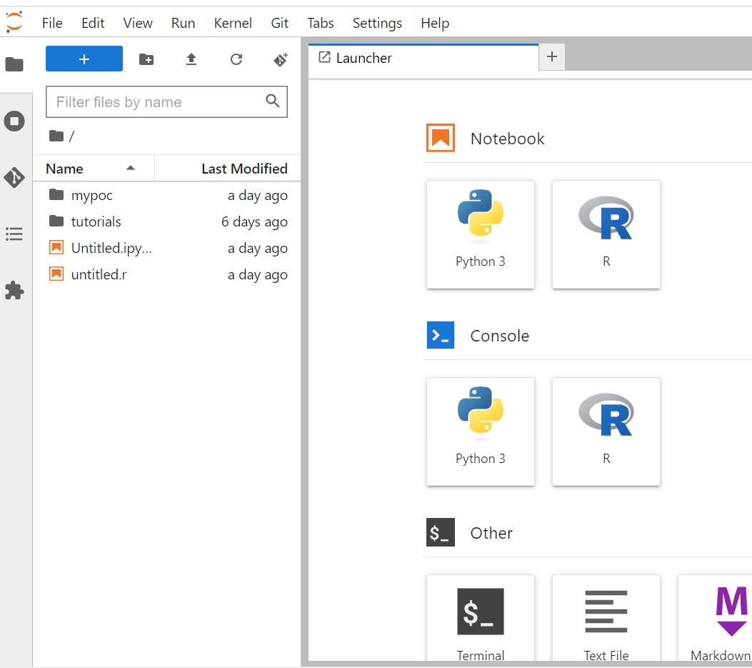

Step 4.
Open the Terminal from Notebook and run below code for authentication.

gcloud auth application-default login

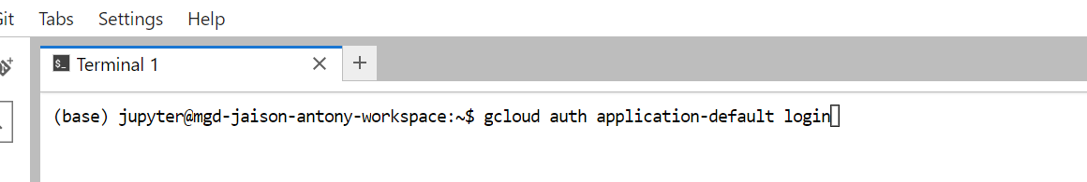

Step 5
Type Y for the response in Terminal for the above step.
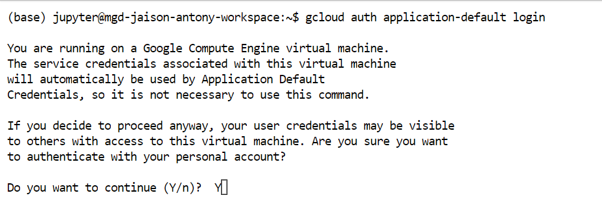

Step 6
The response of above step will be like below, copy the URL and past in another Tab where you have opened the Notebook

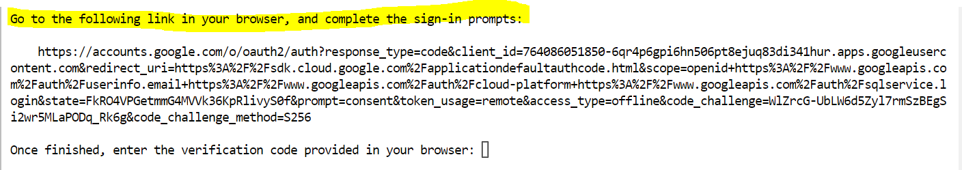

Step 7

Sign in with yhcr email.
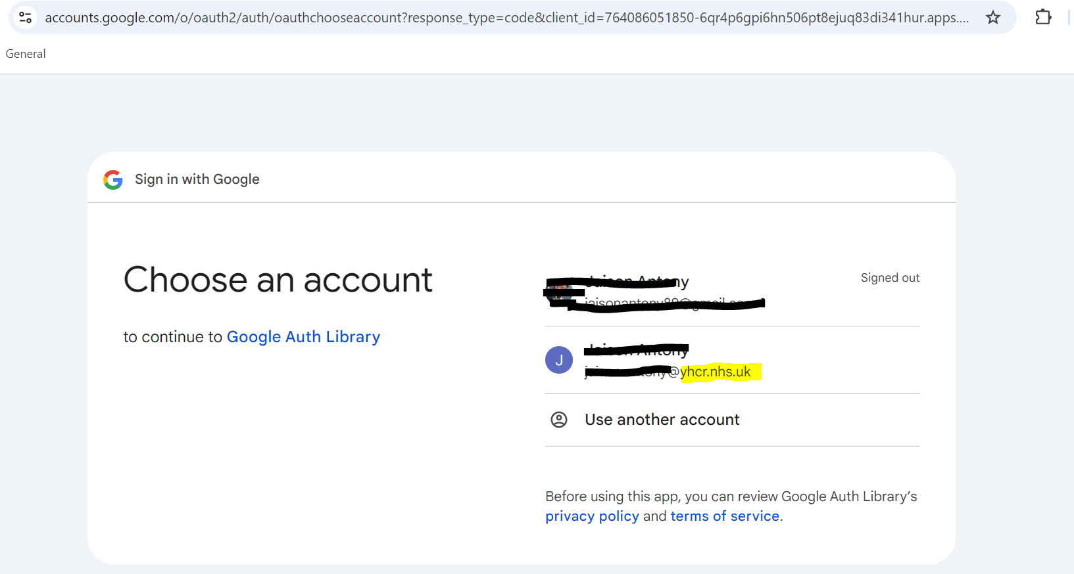

Click on Continoue
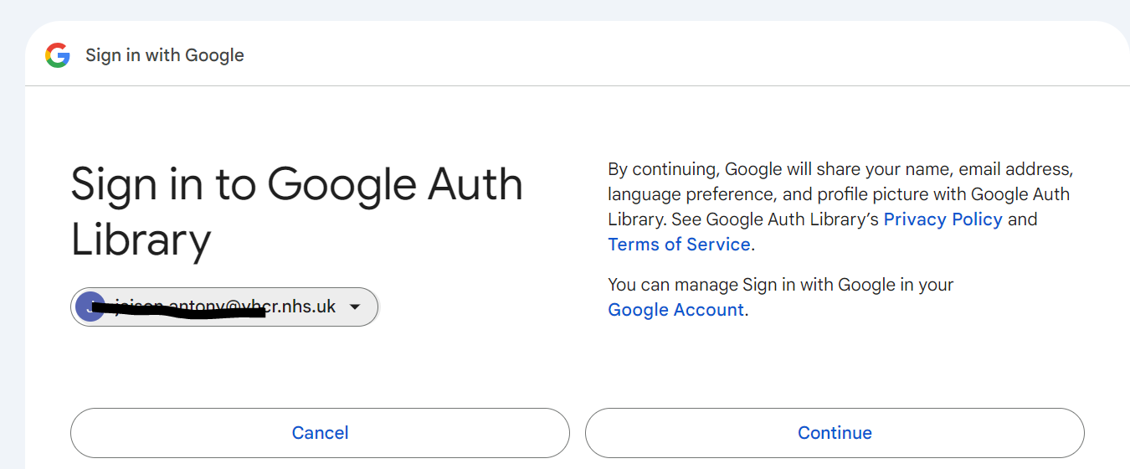
Allow access
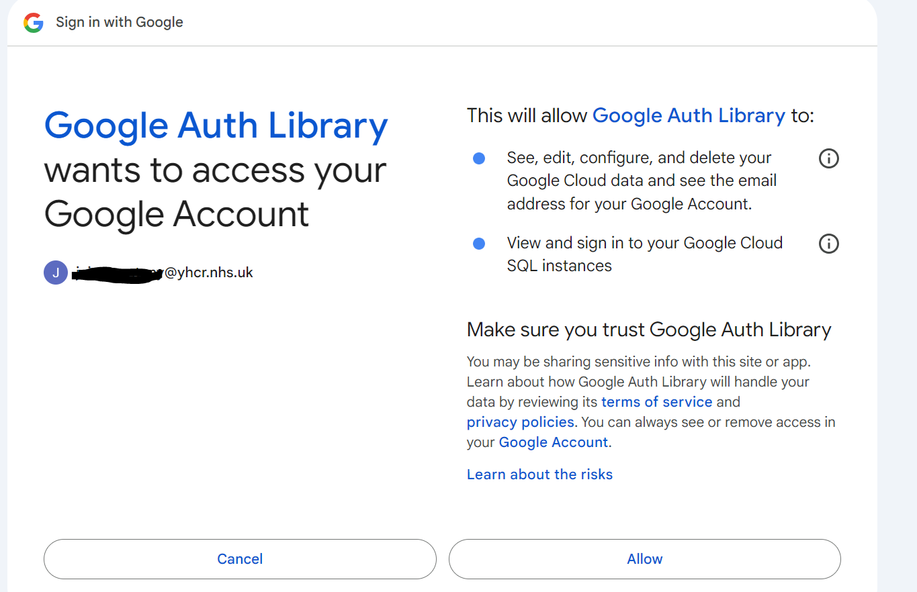
Click on Copy
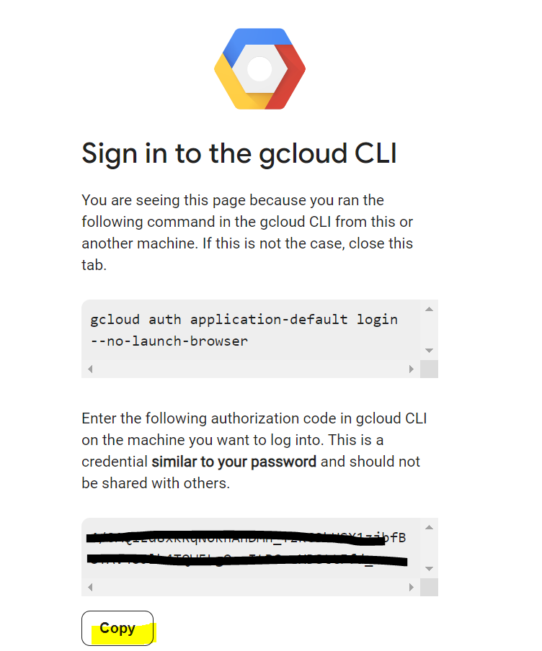

Step 8
Paste the key from above step to the terminal (Step 5 )
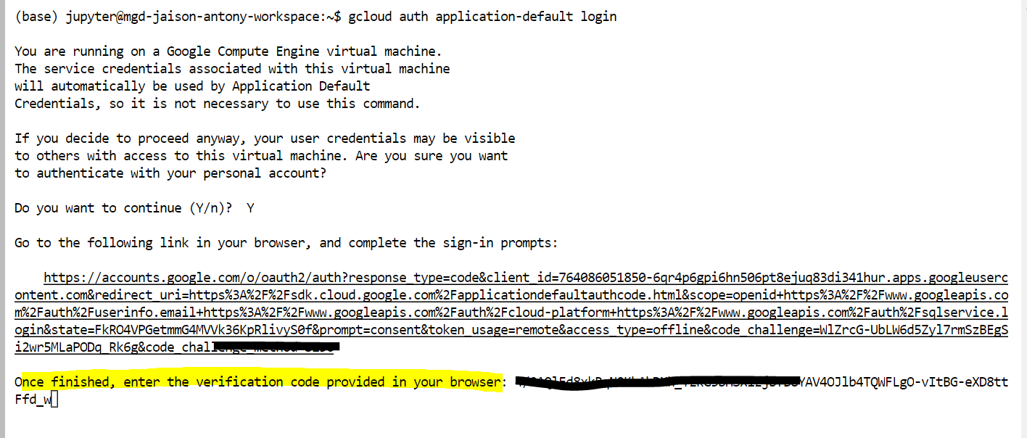

Paste the below to terminal.
export GOOGLE_APPLICATION_CREDENTIALS="[PATH]"

Step 9—Applicable if using R prog

Add below 2 lines start of R program you wish to run
library(bigrquery)
bq_auth()

This will take the default Authentication.

