Connected Bradford: Connecting Jupyter Notebooks with GitHub

Create a Personal Access Token:

1. Sign into GitHub
2. Click your profile picture in the upper-right corner and choose settings
3. Click developer settings at the bottom of the left side bar followed by Personal Access Tokens and Tokens (classic)
4. Generate a new token (copy and paste this Personal Access Token into a notepad and store privately on your H drive)

Jupyter Notebooks:

1. Open JupyterLab
2. Choose the Git symbol on the left side bar and select Clone a Repository

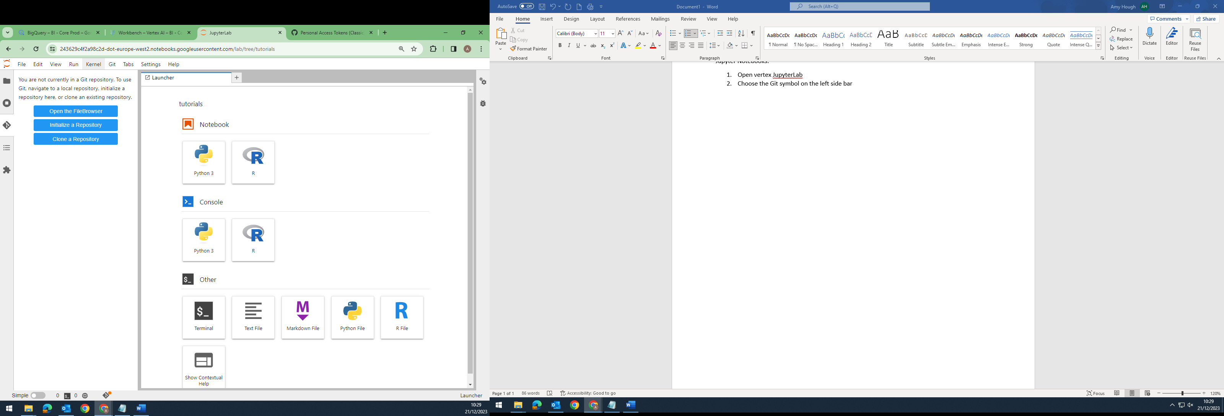

1. Copy and paste the HTTPS link to the Git repository
2. Enter GitHub username and Personal Access Token

Making changes to GitHub repository:

1. Ensure you are in the repo folder in JupyterLab and click the Git icon on the left side panel to open current repository
2. Ensure to pull from GitHub repo before making any changes (this can be done by selecting the cloud in the green circle in the image below)
3. Once changes have been made, this will appear in the ‘Untracked’ section of the current repository

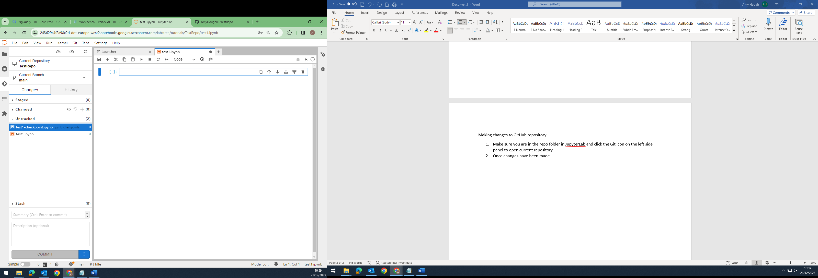

1. In order to commit and push these changes to GitHub, all untracked changes must be staged. This can be done by selecting the ‘+’ symbol within the ‘Untracked’ box
2. Type a summary of the changes made and select ‘Commit’
3. The changes can now be pushed to the GitHub repo (this can be done by selecting the cloud in the orange circle in the image above)