**Demographic analysis.**

Distinct people in the Vaccination dataset

TotalPeople

644,149

The vaccination dataset contains 644,149 distinct people.

**For gender slip/category**

gender_source_value_cleaned CategoryCount Percentage SortOrder

F 347412 53.93 1

M 296453 46.02 1

Other 5 0.00 1

Unknown 279 0.04 1

**Total**  644149 100.00 2

The above gender distribution shows:

1. Females make up the largest group at 53.93% (347,412 people).
2. Males account for 46.02% (296,453 people).
3. Very few records are recorded as Other (5 people) or Unknown (279 people).

This suggests gender data is well-recorded, with almost no missingness.

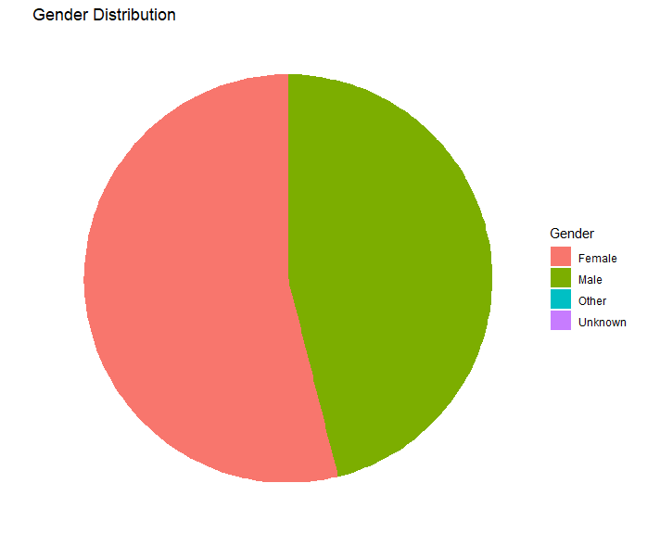

Simple count of age ranges for each type

gender_source_value_cleaned AgeRange CountPeople

F 0-17 76895

F 18-24 31530

F 25-34 47754

F 35-44 41622

F 45-54 27913

F 55-64 28103

F 65-74 29148

F 75+ 61635

F Unknown 2812

M 0-17 80427

M 18-24 30862

M 25-34 29546

M 35-44 22284

M 45-54 23297

M 55-64 27512

M 65-74 29130

M 75+ 50650

M Unknown 2745

Other 0-17 2

Other 18-24 1

Other 25-34 1

Other 35-44 1

Unknown 0-17 53

Unknown 18-24 7

Unknown 25-34 17

Unknown 35-44 6

Unknown 45-54 5

Unknown 55-64 12

Unknown 65-74 8

Unknown 75+ 28

Unknown Unknown 143

The above age distribution shows how many people fall into different age ranges, broken down by gender.

* Females
* Largest group is 75+ years (61,635 people, 17.7% of females).
* Next largest is 0–17 years (76,895 people, 22.1%).

Males

* Largest group is 0–17 years (80,427 people, 27.1% of males).
* Second largest is 75+ years (50,650 people, 17.1%).
* Other/Unknown gender
* Only a handful of people, so distributions are not meaningful.
* In short: the youngest (0–17) and the oldest (75+) are the biggest age groups, with an even spread across middle age ranges.

This reflects both childhood vaccination programmes and older populations receiving vaccines like flu and COVID-19.

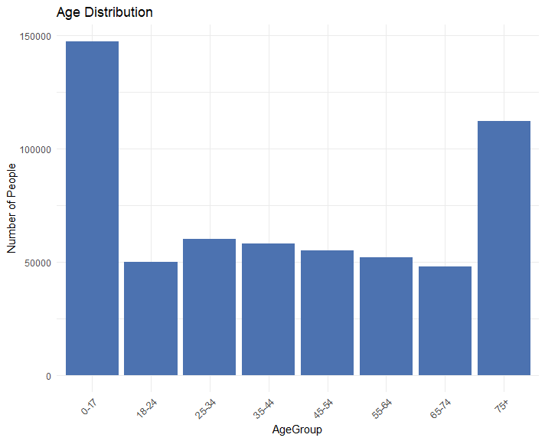

Detailed Output for age ranges by gender with percentages and totals

gender_source_value_cleaned AgeRange CountPeople PercentageWithinGender PercentageOfGrandTotal

F 0-17 76895 22.13 11.94

F 18-24 31530 9.08 4.89

F 25-34 47754 13.75 7.41

F 35-44 41622 11.98 6.46

F 45-54 27913 8.03 4.33

F 55-64 28103 8.09 4.36

F 65-74 29148 8.39 4.53

F 75+ 61635 17.74 9.57

F Unknown 2812 0.81 0.44

F Total 347412 100.00 53.93

M 0-17 80427 27.13 12.49

M 18-24 30862 10.41 4.79

M 25-34 29546 9.97 4.59

M 35-44 22284 7.52 3.46

M 45-54 23297 7.86 3.62

M 55-64 27512 9.28 4.27

M 65-74 29130 9.83 4.52

M 75+ 50650 17.09 7.86

M Unknown 2745 0.93 0.43

M Total 296453 100.00 46.02

Other 0-17 2 40.00 0.00

Other 18-24 1 20.00 0.00

Other 25-34 1 20.00 0.00

Other 35-44 1 20.00 0.00

Other Total 5 100.00 0.00

Unknown 0-17 53 19.00 0.01

Unknown 18-24 7 2.51 0.00

Unknown 25-34 17 6.09 0.00

Unknown 35-44 6 2.15 0.00

Unknown 45-54 5 1.79 0.00

Unknown 55-64 12 4.30 0.00

Unknown 65-74 8 2.87 0.00

Unknown 75+ 28 10.04 0.00

Unknown Unknown 143 51.25 0.02

Unknown Total 279 100.00 0.04

All Genders Total 644149 100.00 100.00

CumulativePercentageWithinGender CumulativePercentageGrandTotal PercentageOfAgeGroupAcrossGenders IsAgeUnknown

62.88 82.87 45.49 0

72.16 87.14 49.46 0

81.99 91.67 49.98 0

99.07 99.53 45.10 0

100.00 99.96 48.16 1

100.00 46.02 100.00 0

40.00 99.96 0.00 0

60.00 99.96 0.00 0

80.00 99.96 0.00 0

100.00 99.96 0.00 0

100.00 0.00 100.00 0

19.00 99.96 0.03 0

21.51 99.97 0.01 0

27.60 99.97 0.02 0

29.75 99.97 0.01 0

31.54 99.97 0.01 0

35.84 99.97 0.02 0

38.71 99.97 0.01 0

48.75 99.98 0.02 0

100.00 100.00 2.51 1

100.00 0.04 100.00 0

100.00 100.00 100.00 0

SortOrder SortGender SortAge

1 2 5

1 2 6

1 2 7

1 2 8

1 2 9

2 2 10

1 3 1

1 3 2

1 3 3

1 3 4

2 3 10

1 4 1

1 4 2

1 4 3

1 4 4

1 4 5

1 4 6

1 4 7

1 4 8

1 4 9

2 4 10

3 5 10

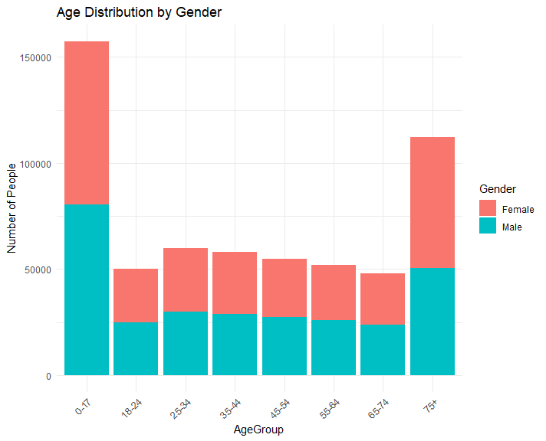

**Ethnicity distribution and statistics**

|  |  |  |  |  |  |
| --- | --- | --- | --- | --- | --- |
| Ethnicity | PersonCount | PercentageOfTotal | CumulativeCount | CumulativePercentage | GrandTotal |
| White: English or Welsh or Scottish or Northern Irish or British - England and Wales ethnic category 2011 census | 332036 | 51.55 | 332036 | 51.55 | 644149 |
| Asian or Asian British: Pakistani - England and Wales ethnic category 2011 census | 130822 | 20.31 | 462858 | 71.86 | 644149 |
| Unknown/Refuse to say | 79779 | 12.39 | 542637 | 84.24 | 644149 |
| White:Any other White background | 22992 | 3.57 | 565629 | 87.81 | 644149 |
| Asian or Asian British: Indian - England and Wales ethnic category 2011 census | 16260 | 2.52 | 581889 | 90.33 | 644149 |
| Asian or Asian British: any other Asian background - England and Wales ethnic category 2011 census | 11690 | 1.81 | 593579 | 92.15 | 644149 |
| Black or African or Caribbean or Black British: African - England and Wales ethnic category 2011 census | 10277 | 1.6 | 603856 | 93.74 | 644149 |
| Asian or Asian British: Bangladeshi - England and Wales ethnic category 2011 census | 9841 | 1.53 | 613697 | 95.27 | 644149 |
| Other ethnic group: any other ethnic group - England and Wales ethnic category 2011 census | 9765 | 1.52 | 623462 | 96.79 | 644149 |
| Mixed multiple ethnic groups: White and Asian - England and Wales ethnic category 2011 census | 4194 | 0.65 | 627656 | 97.44 | 644149 |
| Mixed multiple ethnic groups: any other Mixed or multiple ethnic background - England and Wales ethnic category 2011 census | 3937 | 0.61 | 631593 | 98.05 | 644149 |
| Mixed multiple ethnic groups: White and Black Caribbean - England and Wales ethnic category 2011 census | 2643 | 0.41 | 634236 | 98.46 | 644149 |
| Black or African or Caribbean or Black British: other Black or African or Caribbean background - England and Wales ethnic category 2011 census | 2126 | 0.33 | 636362 | 98.79 | 644149 |
| Mixed multiple ethnic groups: White and Black African - England and Wales ethnic category 2011 census | 1787 | 0.28 | 638149 | 99.07 | 644149 |
| White: Irish - England and Wales ethnic category 2011 census | 1736 | 0.27 | 639885 | 99.34 | 644149 |
| Black or African or Caribbean or Black British: Caribbean - England and Wales ethnic category 2011 census | 1690 | 0.26 | 641575 | 99.6 | 644149 |
| Asian or Asian British: Chinese - England and Wales ethnic category 2011 census | 1407 | 0.22 | 642982 | 99.82 | 644149 |
| Other ethnic group: Arab - England and Wales ethnic category 2011 census | 867 | 0.13 | 643849 | 99.95 | 644149 |
| White: Gypsy or Irish Traveller - England and Wales ethnic category 2011 census | 300 | 0.05 | 644149 | 100 | 644149 |

The ethnicity shows significant variation:

* White: English/Welsh/Scottish/NI/British – the largest group (51.6%).
* Asian: Pakistani – the second largest group (20.3%).
* Unknown/Refused to say – 12.4%, which is quite high, showing some missing data.
* Other sizeable groups include Indian (2.5%), Other White (3.6%), and Bangladeshi (1.5%).
* Smaller proportions (<1%) are seen in Chinese, Arab, Mixed, Black Caribbean, and Gypsy/Irish Traveller groups.

This suggests a diverse population, with particularly strong representation of Pakistani communities, consistent with demographics in some parts of the UK (e.g., Bradford, Birmingham, parts of London).

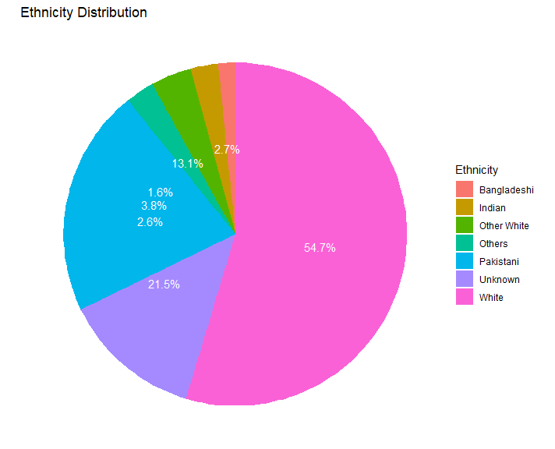

**Demographic breakdown script for ethnicity using ethnicity_source_value, gender_source_value_cleaned, and person_id.**

|  |  |  |  |  |  |  |  |  |  |
| --- | --- | --- | --- | --- | --- | --- | --- | --- | --- |
| Ethnicity | Gender | PatientCount | EthnicityTotal | GenderTotal | GrandTotal | PctWithinEthnicity | PctWithinGender | PctOfGrandTotal | CumulativePctOfGrandTotal |
| Asian or Asian British: any other Asian background - England and Wales ethnic category 2011 census | F | 6103 | 11690 | 347412 | 644149 | 52.21 | 1.76 | 0.95 | 0.95 |
| Asian or Asian British: any other Asian background - England and Wales ethnic category 2011 census | M | 5585 | 11690 | 296453 | 644149 | 47.78 | 1.88 | 0.87 | 1.82 |
| Asian or Asian British: any other Asian background - England and Wales ethnic category 2011 census | Unknown | 2 | 11690 | 279 | 644149 | 0.02 | 0.72 | 0 | 1.82 |
| Asian or Asian British: Bangladeshi - England and Wales ethnic category 2011 census | F | 5328 | 9841 | 347412 | 644149 | 54.14 | 1.53 | 0.83 | 2.65 |
| Asian or Asian British: Bangladeshi - England and Wales ethnic category 2011 census | M | 4512 | 9841 | 296453 | 644149 | 45.85 | 1.52 | 0.7 | 3.35 |
| Asian or Asian British: Bangladeshi - England and Wales ethnic category 2011 census | Unknown | 1 | 9841 | 279 | 644149 | 0.01 | 0.36 | 0 | 3.35 |
| Asian or Asian British: Chinese - England and Wales ethnic category 2011 census | F | 793 | 1407 | 347412 | 644149 | 56.36 | 0.23 | 0.12 | 3.47 |
| Asian or Asian British: Chinese - England and Wales ethnic category 2011 census | M | 614 | 1407 | 296453 | 644149 | 43.64 | 0.21 | 0.1 | 3.57 |
| Asian or Asian British: Indian - England and Wales ethnic category 2011 census | F | 8796 | 16260 | 347412 | 644149 | 54.1 | 2.53 | 1.37 | 4.94 |
| Asian or Asian British: Indian - England and Wales ethnic category 2011 census | M | 7462 | 16260 | 296453 | 644149 | 45.89 | 2.52 | 1.16 | 6.1 |
| Asian or Asian British: Indian - England and Wales ethnic category 2011 census | Unknown | 2 | 16260 | 279 | 644149 | 0.01 | 0.72 | 0 | 6.1 |
| Asian or Asian British: Pakistani - England and Wales ethnic category 2011 census | F | 70332 | 130822 | 347412 | 644149 | 53.76 | 20.24 | 10.92 | 17.02 |
| Asian or Asian British: Pakistani - England and Wales ethnic category 2011 census | M | 60480 | 130822 | 296453 | 644149 | 46.23 | 20.4 | 9.39 | 26.41 |
| Asian or Asian British: Pakistani - England and Wales ethnic category 2011 census | Other | 1 | 130822 | 5 | 644149 | 0 | 20 | 0 | 26.41 |
| Asian or Asian British: Pakistani - England and Wales ethnic category 2011 census | Unknown | 9 | 130822 | 279 | 644149 | 0.01 | 3.23 | 0 | 26.41 |
| Black or African or Caribbean or Black British: African - England and Wales ethnic category 2011 census | F | 5530 | 10277 | 347412 | 644149 | 53.81 | 1.59 | 0.86 | 27.27 |
| Black or African or Caribbean or Black British: African - England and Wales ethnic category 2011 census | M | 4746 | 10277 | 296453 | 644149 | 46.18 | 1.6 | 0.74 | 28.01 |
| Black or African or Caribbean or Black British: African - England and Wales ethnic category 2011 census | Unknown | 1 | 10277 | 279 | 644149 | 0.01 | 0.36 | 0 | 28.01 |
| Black or African or Caribbean or Black British: Caribbean - England and Wales ethnic category 2011 census | F | 879 | 1690 | 347412 | 644149 | 52.01 | 0.25 | 0.14 | 28.15 |
| Black or African or Caribbean or Black British: Caribbean - England and Wales ethnic category 2011 census | M | 811 | 1690 | 296453 | 644149 | 47.99 | 0.27 | 0.13 | 28.28 |
| Black or African or Caribbean or Black British: other Black or African or Caribbean background - England and Wales ethnic category 2011 census | F | 1146 | 2126 | 347412 | 644149 | 53.9 | 0.33 | 0.18 | 28.46 |
| Black or African or Caribbean or Black British: other Black or African or Caribbean background - England and Wales ethnic category 2011 census | M | 980 | 2126 | 296453 | 644149 | 46.1 | 0.33 | 0.15 | 28.61 |
| Mixed multiple ethnic groups: any other Mixed or multiple ethnic background - England and Wales ethnic category 2011 census | F | 2072 | 3937 | 347412 | 644149 | 52.63 | 0.6 | 0.32 | 28.93 |
| Mixed multiple ethnic groups: any other Mixed or multiple ethnic background - England and Wales ethnic category 2011 census | M | 1863 | 3937 | 296453 | 644149 | 47.32 | 0.63 | 0.29 | 29.22 |
| Mixed multiple ethnic groups: any other Mixed or multiple ethnic background - England and Wales ethnic category 2011 census | Unknown | 2 | 3937 | 279 | 644149 | 0.05 | 0.72 | 0 | 29.22 |
| Mixed multiple ethnic groups: White and Asian - England and Wales ethnic category 2011 census | F | 2169 | 4194 | 347412 | 644149 | 51.72 | 0.62 | 0.34 | 29.56 |
| Mixed multiple ethnic groups: White and Asian - England and Wales ethnic category 2011 census | M | 2023 | 4194 | 296453 | 644149 | 48.24 | 0.68 | 0.31 | 29.87 |
| Mixed multiple ethnic groups: White and Asian - England and Wales ethnic category 2011 census | Unknown | 2 | 4194 | 279 | 644149 | 0.05 | 0.72 | 0 | 29.87 |
| Mixed multiple ethnic groups: White and Black African - England and Wales ethnic category 2011 census | F | 1001 | 1787 | 347412 | 644149 | 56.02 | 0.29 | 0.16 | 30.03 |
| Mixed multiple ethnic groups: White and Black African - England and Wales ethnic category 2011 census | M | 785 | 1787 | 296453 | 644149 | 43.93 | 0.26 | 0.12 | 30.15 |
| Mixed multiple ethnic groups: White and Black African - England and Wales ethnic category 2011 census | Unknown | 1 | 1787 | 279 | 644149 | 0.06 | 0.36 | 0 | 30.15 |
| Mixed multiple ethnic groups: White and Black Caribbean - England and Wales ethnic category 2011 census | F | 1419 | 2643 | 347412 | 644149 | 53.69 | 0.41 | 0.22 | 30.37 |
| Mixed multiple ethnic groups: White and Black Caribbean - England and Wales ethnic category 2011 census | M | 1224 | 2643 | 296453 | 644149 | 46.31 | 0.41 | 0.19 | 30.56 |
| Other ethnic group: any other ethnic group - England and Wales ethnic category 2011 census | F | 5095 | 9765 | 347412 | 644149 | 52.18 | 1.47 | 0.79 | 31.35 |
| Other ethnic group: any other ethnic group - England and Wales ethnic category 2011 census | M | 4668 | 9765 | 296453 | 644149 | 47.8 | 1.57 | 0.72 | 32.07 |
| Other ethnic group: any other ethnic group - England and Wales ethnic category 2011 census | Unknown | 2 | 9765 | 279 | 644149 | 0.02 | 0.72 | 0 | 32.07 |
| Other ethnic group: Arab - England and Wales ethnic category 2011 census | F | 443 | 867 | 347412 | 644149 | 51.1 | 0.13 | 0.07 | 32.14 |
| Other ethnic group: Arab - England and Wales ethnic category 2011 census | M | 424 | 867 | 296453 | 644149 | 48.9 | 0.14 | 0.07 | 32.21 |
| Unknown/Refuse to say | F | 41012 | 79779 | 347412 | 644149 | 51.41 | 11.81 | 6.37 | 38.58 |
| Unknown/Refuse to say | M | 38601 | 79779 | 296453 | 644149 | 48.38 | 13.02 | 5.99 | 44.57 |
| Unknown/Refuse to say | Other | 2 | 79779 | 5 | 644149 | 0 | 40 | 0 | 44.57 |
| Unknown/Refuse to say | Unknown | 164 | 79779 | 279 | 644149 | 0.21 | 58.78 | 0.03 | 44.6 |
| White: English or Welsh or Scottish or Northern Irish or British - England and Wales ethnic category 2011 census | F | 181255 | 332036 | 347412 | 644149 | 54.59 | 52.17 | 28.14 | 72.74 |
| White: English or Welsh or Scottish or Northern Irish or British - England and Wales ethnic category 2011 census | M | 150696 | 332036 | 296453 | 644149 | 45.39 | 50.83 | 23.39 | 96.13 |
| White: English or Welsh or Scottish or Northern Irish or British - England and Wales ethnic category 2011 census | Other | 2 | 332036 | 5 | 644149 | 0 | 40 | 0 | 96.13 |
| White: English or Welsh or Scottish or Northern Irish or British - England and Wales ethnic category 2011 census | Unknown | 83 | 332036 | 279 | 644149 | 0.02 | 29.75 | 0.01 | 96.14 |
| White: Gypsy or Irish Traveller - England and Wales ethnic category 2011 census | F | 164 | 300 | 347412 | 644149 | 54.67 | 0.05 | 0.03 | 96.17 |
| White: Gypsy or Irish Traveller - England and Wales ethnic category 2011 census | M | 136 | 300 | 296453 | 644149 | 45.33 | 0.05 | 0.02 | 96.19 |
| White: Irish - England and Wales ethnic category 2011 census | F | 942 | 1736 | 347412 | 644149 | 54.26 | 0.27 | 0.15 | 96.34 |
| White: Irish - England and Wales ethnic category 2011 census | M | 792 | 1736 | 296453 | 644149 | 45.62 | 0.27 | 0.12 | 96.46 |
| White: Irish - England and Wales ethnic category 2011 census | Unknown | 2 | 1736 | 279 | 644149 | 0.12 | 0.72 | 0 | 96.46 |
| White:Any other White background | F | 12933 | 22992 | 347412 | 644149 | 56.25 | 3.72 | 2.01 | 98.47 |
| White:Any other White background | M | 10051 | 22992 | 296453 | 644149 | 43.72 | 3.39 | 1.56 | 100.03 |
| White:Any other White background | Unknown | 8 | 22992 | 279 | 644149 | 0.03 | 2.87 | 0 | 100.03 |

The above detailed tables show how ethnicity splits across gender:

* Example: Among Pakistani patients, 54% are female and 46% male, which matches the overall gender balance.
* Similar gender splits appear across most ethnicities, so there isn’t a strong gender bias in recording.

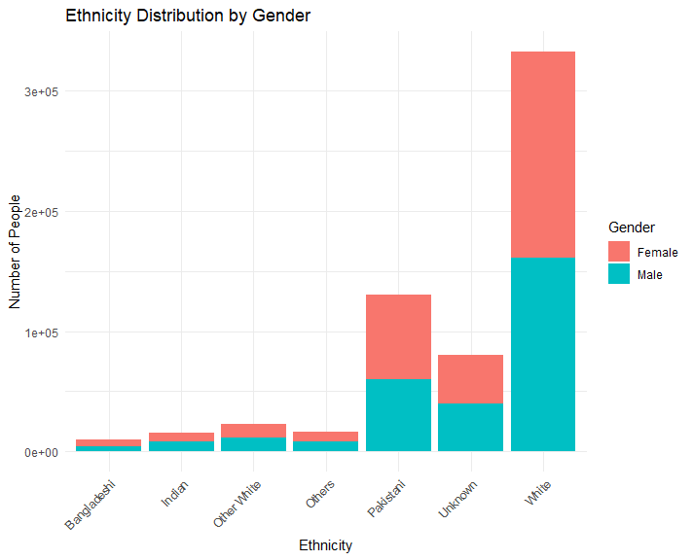

**Key Takeaways:**

1. Population size: Large dataset (644k), which is robust for analysis.

2. Gender: Well-recorded, with a near 54/46 female/male split.

3. Age: there are two peaks — children (0–17) and older adults (75+).

4. Ethnicity: Majority White British, but large South Asian community (particularly Pakistani).

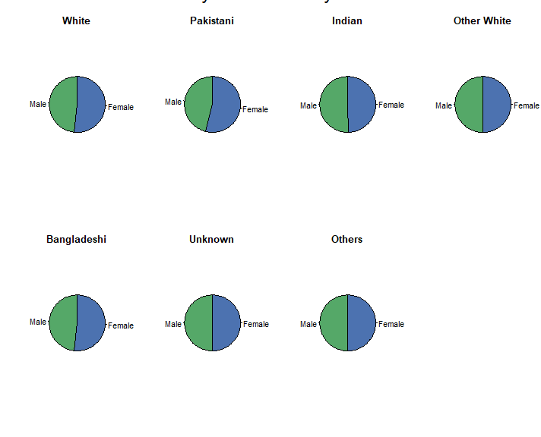

5. Data quality: There is low missingness for gender, but higher (12.4%) for ethnicity.