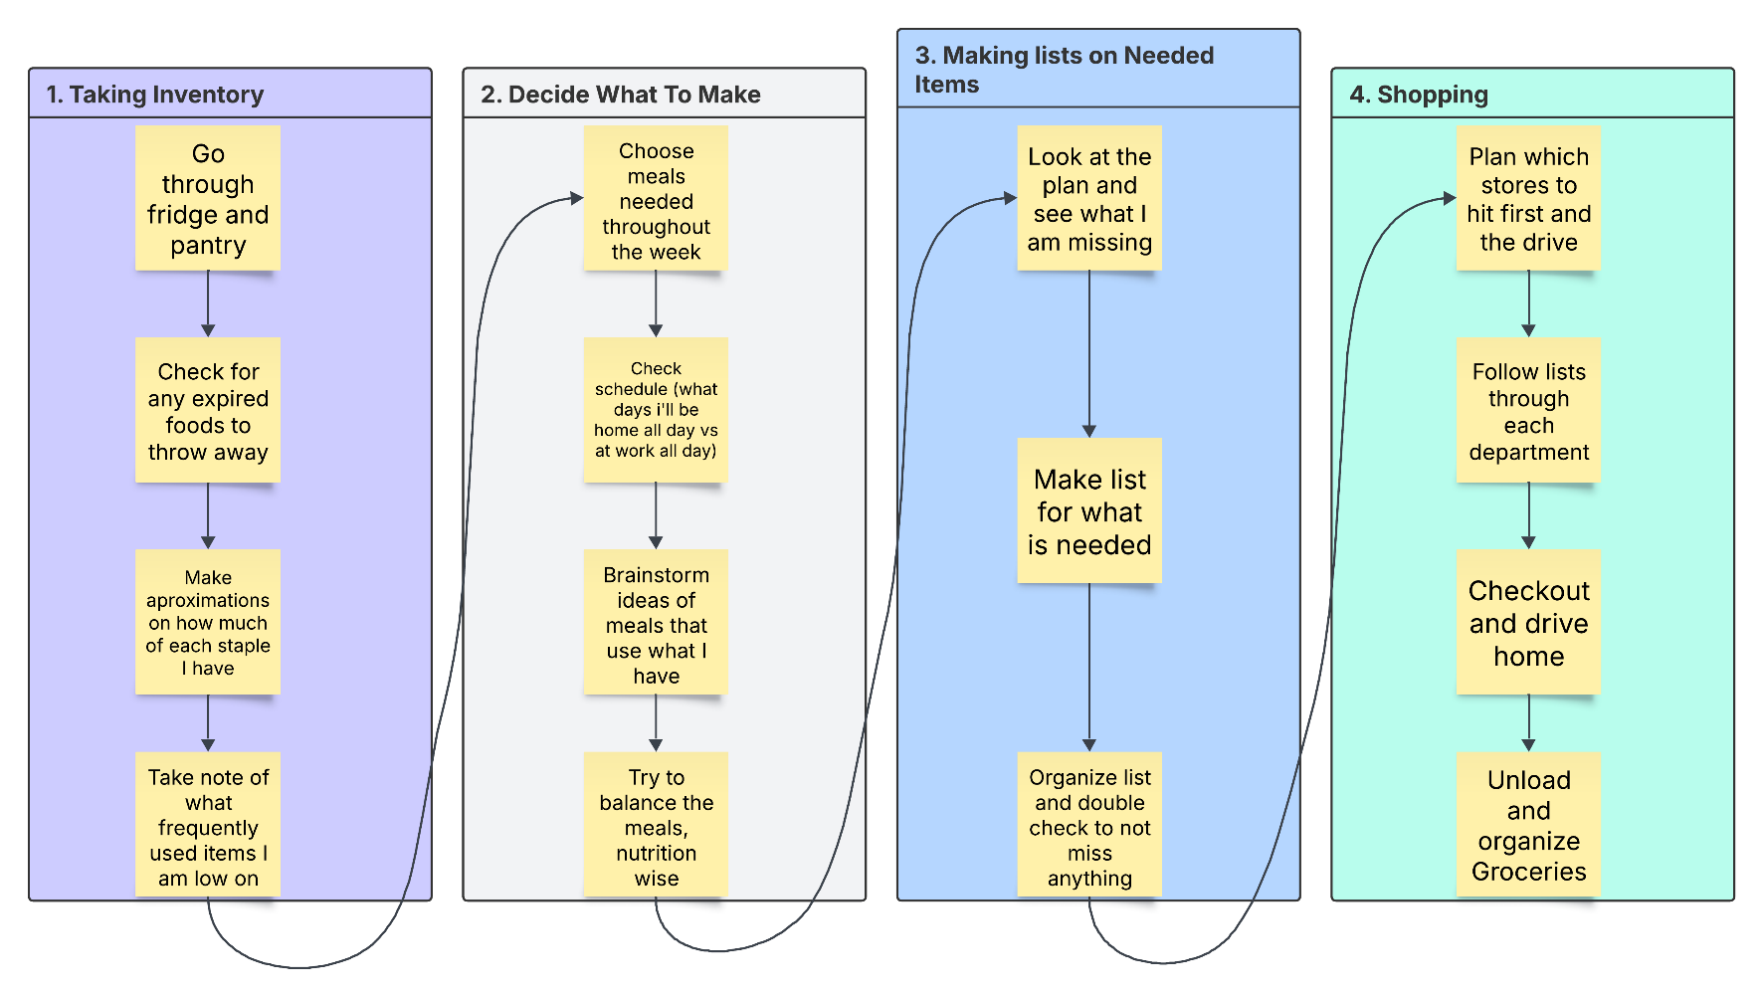

Estimated Average Flow Time

Taking Inventory | 15 – 20 minutes
Deciding What To Make | 15 – 25 minutes
Making Lists | 10 - 15 minutes
Shopping | 60 - 120 minutes

Estimated Cycle Time: 100 minutes – 180 minutes per week

By reducing the waste I have each week in my meal planning process, I could reduce the total time needed per trip. Instead of conducting a full pantry and refrigerator inventory each week, I could maintain a running grocery list that I update whenever I cook or notice an item running low. This could easily reduce or even negate the inventory time.

Currently, deciding what to make each week takes a moderate amount of time. Unless I adopt a more standardized or rotating meal plan, it may be difficult to reduce this portion significantly. However, implementing a consistent weekly meal rotation could save around 10 minutes or more per week.

Additionally, organizing my grocery list by store layout, planning purchases more efficiently, and avoiding unnecessary browsing in the store could reduce shopping time by an estimated 15–30 minutes per week. If I implement these efficiency improvements, I could potentially reduce my weekly cycle time from 100–180 minutes down to approximately 60–140 minutes per week.

