Project: Todo Application | Developer: Paul Fralix
Course: CSD380 DevOps
Description: Functional test cases for Todo Application
Date: 2026/02/06

TABLE OF CONTENTS
1. Test 1 – Verify website accessibility via URL
2. Test 2 – Add a new todo item
3. Test 3 – Mark todo item as complete
4. Test 4 – Delete a todo item
5. Test 5 – Persist todo items on refresh

TEST 1

Verify website accessibility via URL
 | Test Objective: Ensure users can access the Todo application using a standard URL | Developer: Paul Fralix Date tested: 2026/02/06 | Peer tester: Gabe Conner Date tested: 2026/02/08
Step | Action | Expected Results | Developer pass/fail | Tester pass/fail + Screenshot
1 | Open a web browser | Browser opens successfully | yes | Yes 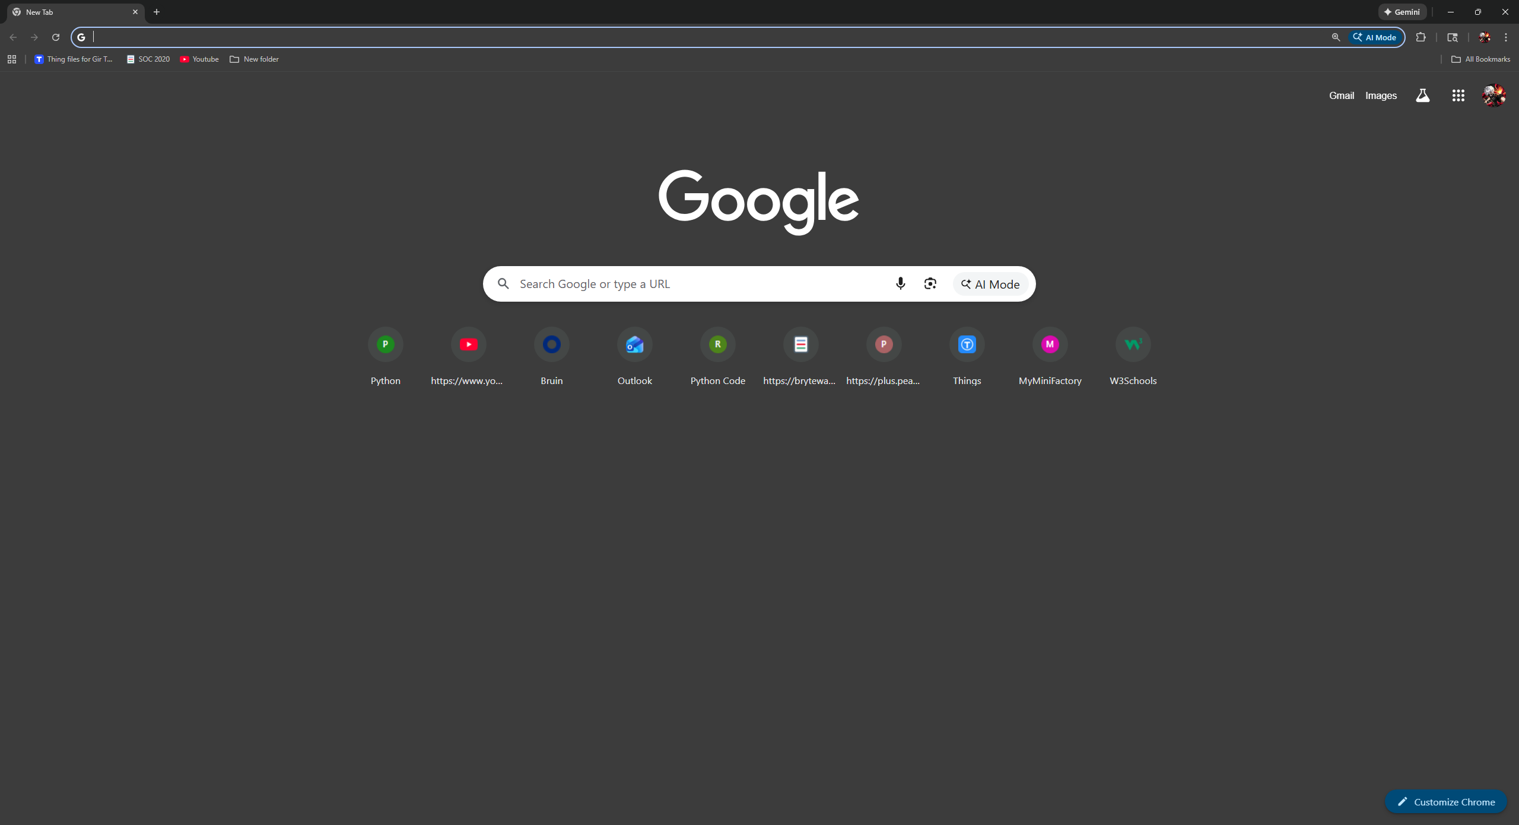
2 | Navigate to https://buwebdev.github.io/todo/ | Todo application loads | yes | Yes 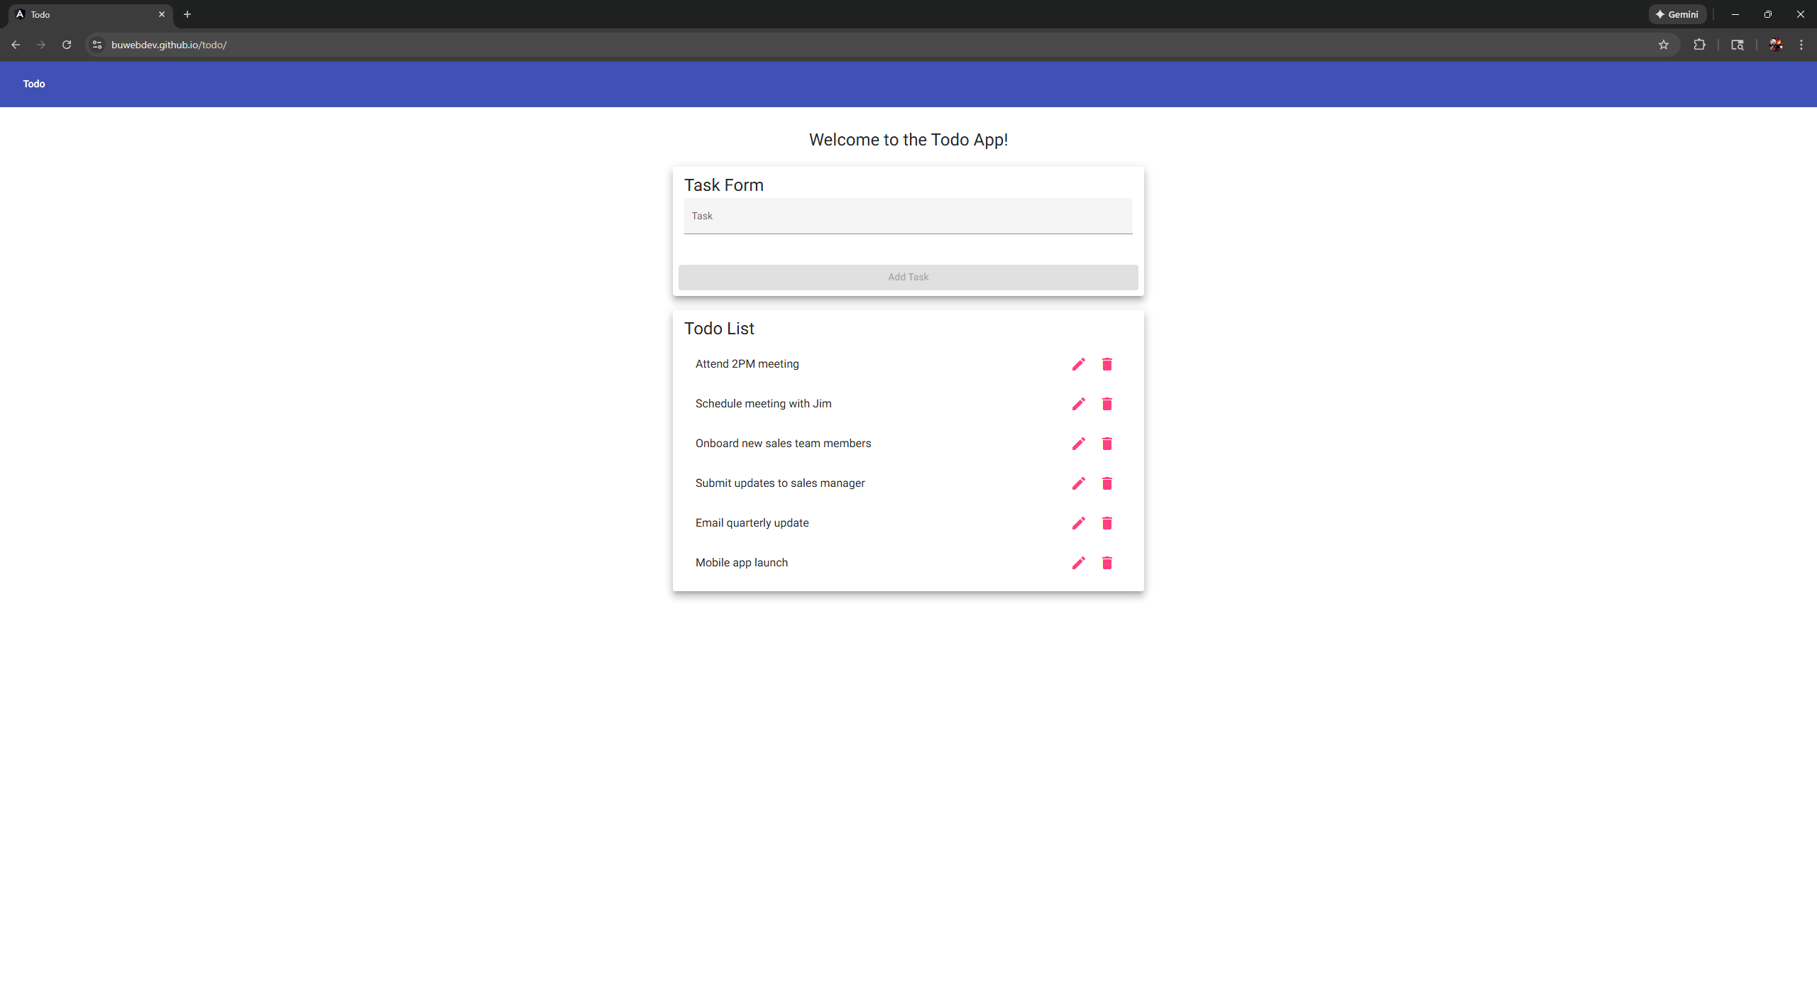
3 | Confirm the page loads | Page displays without errors | yes | yes
4 | Refresh the browser window | Page reloads successfully | yes | Yes  
Comments

TEST 2

Add a new todo item
 | Test Objective: Verify that users can add a new todo item | Developer: Paul Fralix Date tested: 2026/02/06 | Peer tester: Gabe Conner Date tested: 2026/02/08
Step | Action | Expected Results | Developer pass/fail | Tester pass/fail + Screenshot
1 | Open the Todo application | Application loads | yes | Yes 
2 | Enter a task in the input field | Text appears in input | yes | yes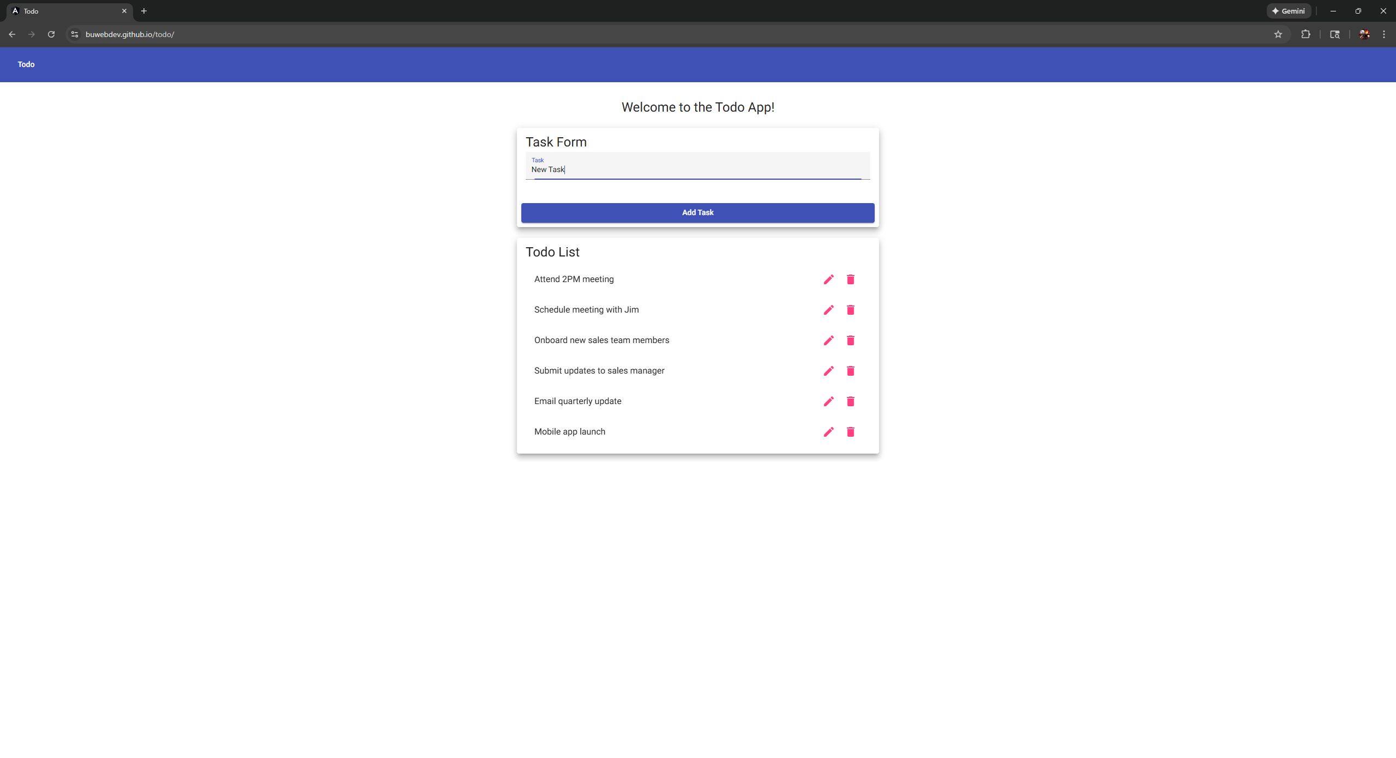
3 | Click the Add button | New todo item appears in the list | yes | yes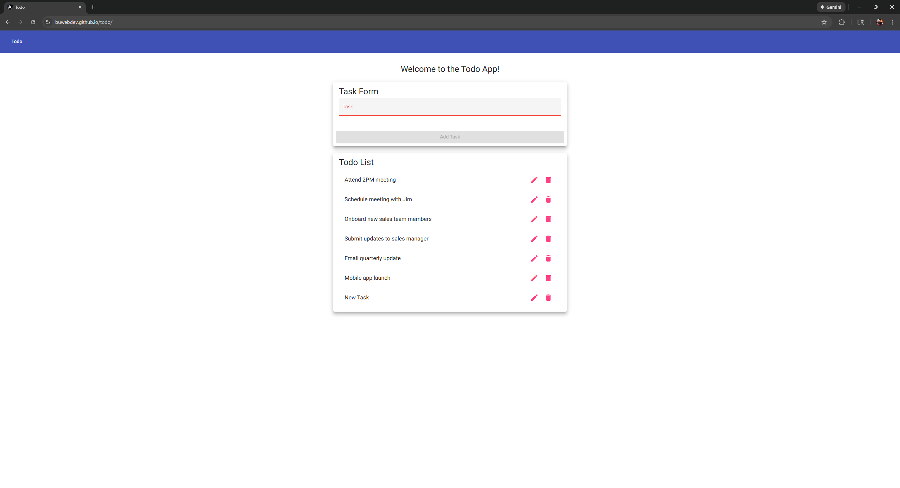
Comments

TEST 3

Edit todo item in list
 | Test Objective: Verify users can edit a todo item in list | Developer: Paul Fralix Date tested: 2026/02/06 | Peer tester: Gabe Conner Date tested: 2026/02/08
Step | Action | Expected Results | Developer pass/fail | Tester pass/fail + Screenshot
1 | Add a new todo item | Item appears in list | yes | Yes  
2 | Click the edit icon next to the item | The item opens on an edit form | yes | yes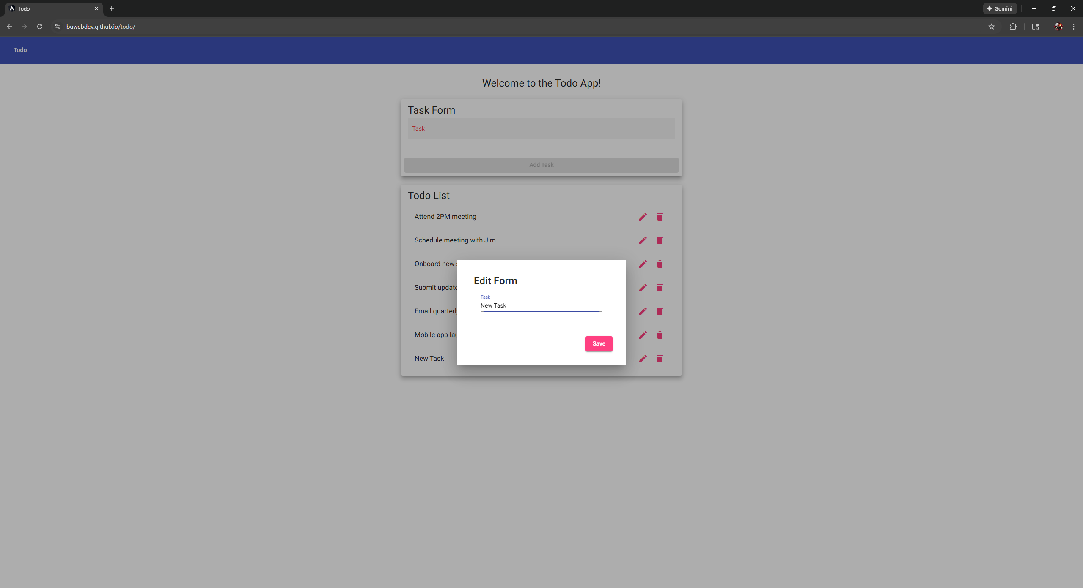
3 | Edit task and click save | The edited task will display on list | yes | yes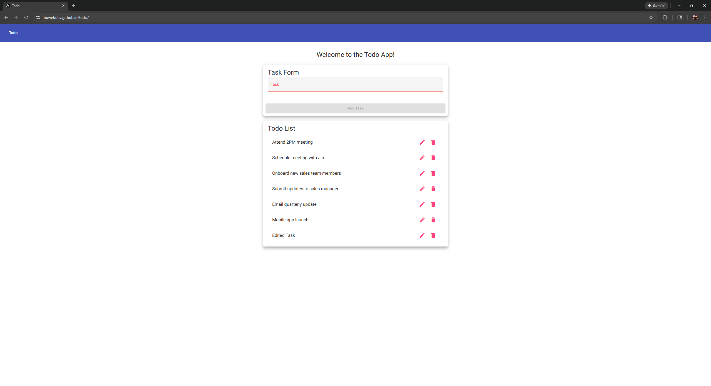
Comments

TEST 4

Delete a todo item
 | Test Objective: Verify users can delete an existing todo item | Developer: Paul Fralix Date tested: 2026/02/06 | Peer tester: Gabe Conner Date tested: 2026/02/08
Step | Action | Expected Results | Developer pass/fail | Tester pass/fail + Screenshot
1 | Add a new todo item | Item appears in list | yes | Yes 
2 | Click the delete/remove option | Item is removed from the list | yes | Yes  
Comments

TEST 5

Persist todo items on refresh
 | Test Objective: Verify todo items persist after page refresh | Developer: Paul Fralix Date tested: 2026/02/06 | Peer tester: Gabe Conner Date tested: 2026/02/08
Step | Action | Expected Results | Developer pass/fail | Tester pass/fail + Screenshot
1 | Add one or more todo items | Items appear in list | yes | Yes 
2 | Refresh the browser | Items remain displayed | no | No  
Comments

