Project: Moffat Bay Lodge
Course: CSD460 Capstone in Software Development
Description: These functional test plans check for valid reservation lookup and verify proper handling of missing or invalid lookup information.
Date: May 3, 2026
TABLE OF CONTENTS
Test 1 - Valid Reservation Lookup ..................................................................................................................................................................................2
Test 2 - Invalid/Missing Lookup Information.................................................................................................................................................................5

Test 1 - Valid Reservation Lookup
 | This test verifies that a user can successfully retrieve an existing reservation using valid reservation information.
 | Test Objective: Ensure the system displays the correct reservation details when valid data is entered. | Developer: Gabe and  James  Date tested: April 30,  2026 | Peer tester: Alexis Mitchell Date tested: May 3, 2026
Step | Action | Expected results: | Developer pass/fail | Tester pass/fail  + Screenshot
1 | Open the look-up reservation page | Look up the reservation page loads without errors | Pass | Pass  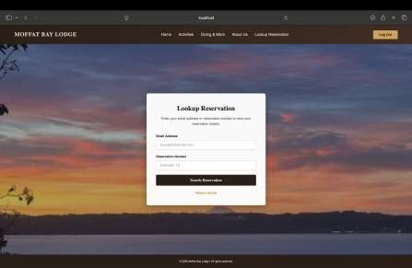

2 | Enter a valid reservation ID and email | Input fields accept valid user information | Pass | Pass  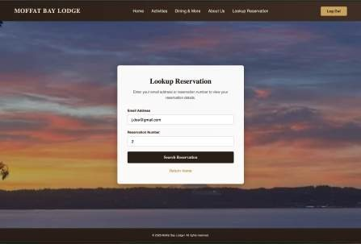
3 | Click search submit | Reservation page loads | Pass | Pass  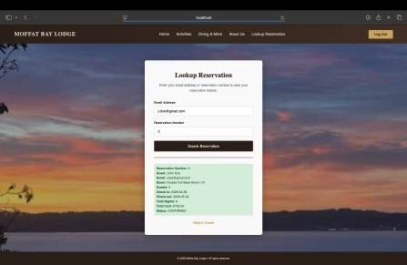

4 | Correct reservation details are displayed | Matching reservation information is shown accurately | Pass | Pass  
Comments | Look up the Reservation page to see if it works correctly when reservation information is entered. The system successfully loads the reservation details and displays correct information to the user.

Test 2 - Invalid/Missing Lookup Information
 | This test verifies that the system properly handles missing or incorrect reservation lookup information.
 | Test Objective: Ensure invalid searches don’t return data and proper error messages are shown | Developer: James and  Gabe  Date tested: April 30, 2026 | Peer tester: Alexis Mitchell Date tested: May 3, 2026
Step | Action | Expected results: | Developer pass/fail | Tester pass/fail
1 | Open Look Up Reservation page | Look Up Reservation page loads without errors | Pass | Pass  

2 | Leave fields blank or enter an invalid reservation ID | Fields remain blank, or invalid data is accepted for validation testing | Pass | Pass  
3 | Click search | Search doesn’t return reservation results | Pass | Pass  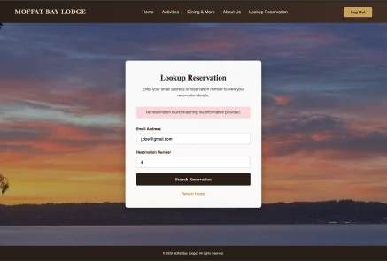

4 | An error message is displayed | Message appears  indicating or invalid reservation information | Pass | Pass    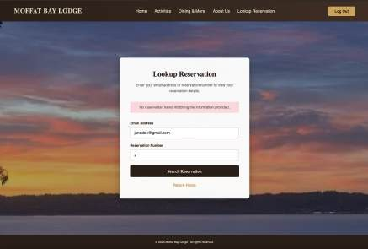
Comments | The Look Up Reservation page correctly handles missing or invalid information by preventing a successful search and displaying an error message. This shows that the validation system is working properly and helps prevent incorrect searches. The error message could be more specific about what information is incorrect.

