
DRAFT: Connie Staff Agent Instructions

1. Introduction
Connie serves as a tool to streamline communication and provide excellent service to your clients!
Connie is a digital communication platform built by the American Society on Aging and other nonprofits just like yours! It lets community-based organizations (CBOs) quickly deploy powerful contact center solutions that modernize CBO operations and improve access for the people and communities they serve.
Connie simplifies communication for your organization. As an omnichannel platform, it empowers you to connect with clients seamlessly from a single browser-based screen, regardless of whether they prefer phone calls, SMS, webchat, or popular messaging apps like WhatsApp or Facebook Messenger. It also gives you the ability to connect with other CBOs and/or partnering agencies seamlessly by centralizing inquiries/referrals, whether it’s via email, phone call, fax, etc.

2. Getting Started
- Access your account via the Connie web portal: https://portal.connie.team
- Enter your username and password in the designated fields.
- Your local Connie administrator should have provided you with temporary login credentials.
  - Username: Your business email address (this cannot be changed).
  - Password: This is a temporary password; you'll be prompted to create a new, secure password upon your first login and whenever you reset your password in the future.
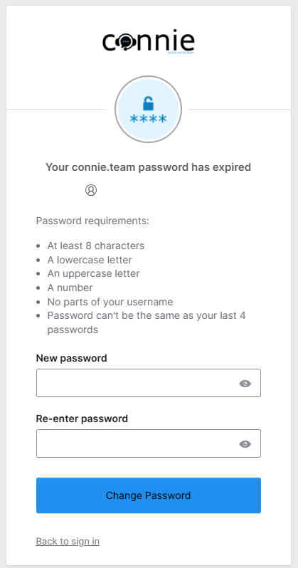

- Select “Keep me signed in” if you are on a personal device, this is not suggested for those using a shared device.
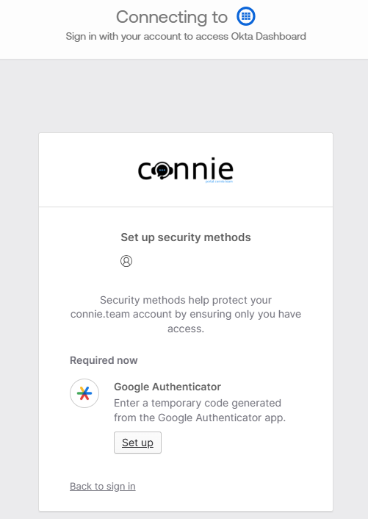
- Download + set up the Google Authenticator app on your mobile device.

- Upon opening the app, you will be met with a welcome screen – select “Get started.”
- You have the option to sign in to your Google account which will allow you to back up your codes. If you would like to opt out, select “Use Authenticator without an account.”
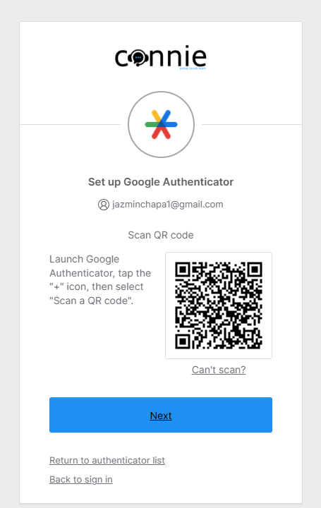
- Tap the “+” icon (located at the bottom right-hand corner within the Google Authenticator app), select “Scan a QR code”, then scan the QR code displayed via the Connie web portal.

- Click “Next” and enter the code displayed from the Google Authenticator app, you will then be taken to your Connie dashboard.
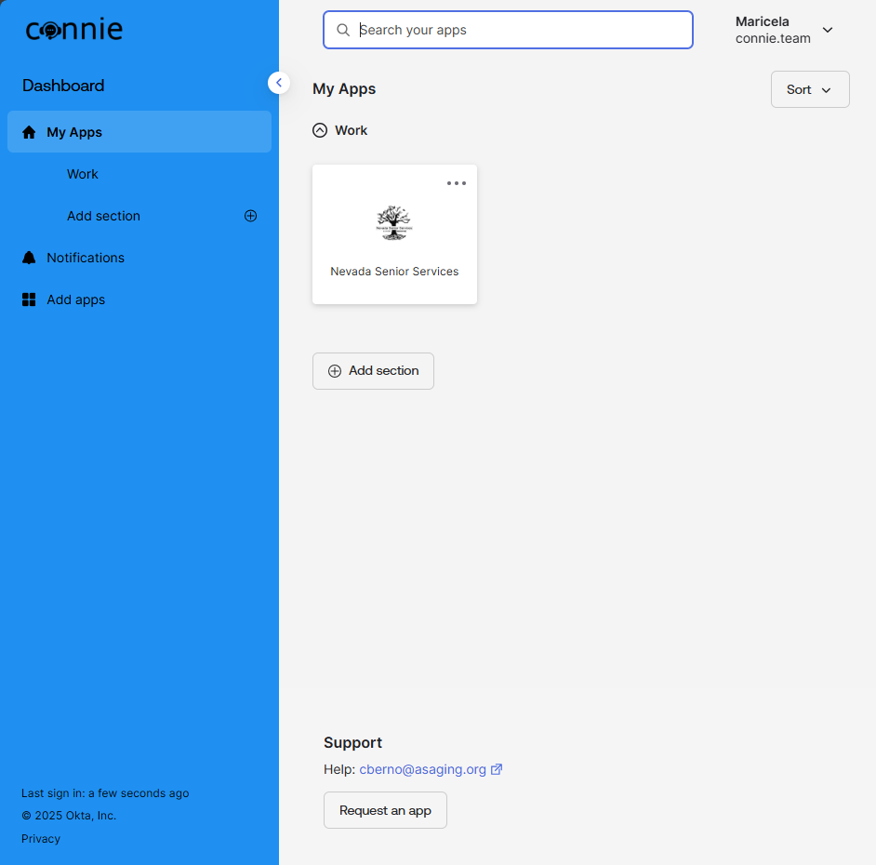
- From the Connie dashboard, select “My Apps”, then select the app associated with your CBO/agency. Congrats, you’re logged in!

- Update your status to “Available” via the dropdown user control menu at the top right-hand corner.
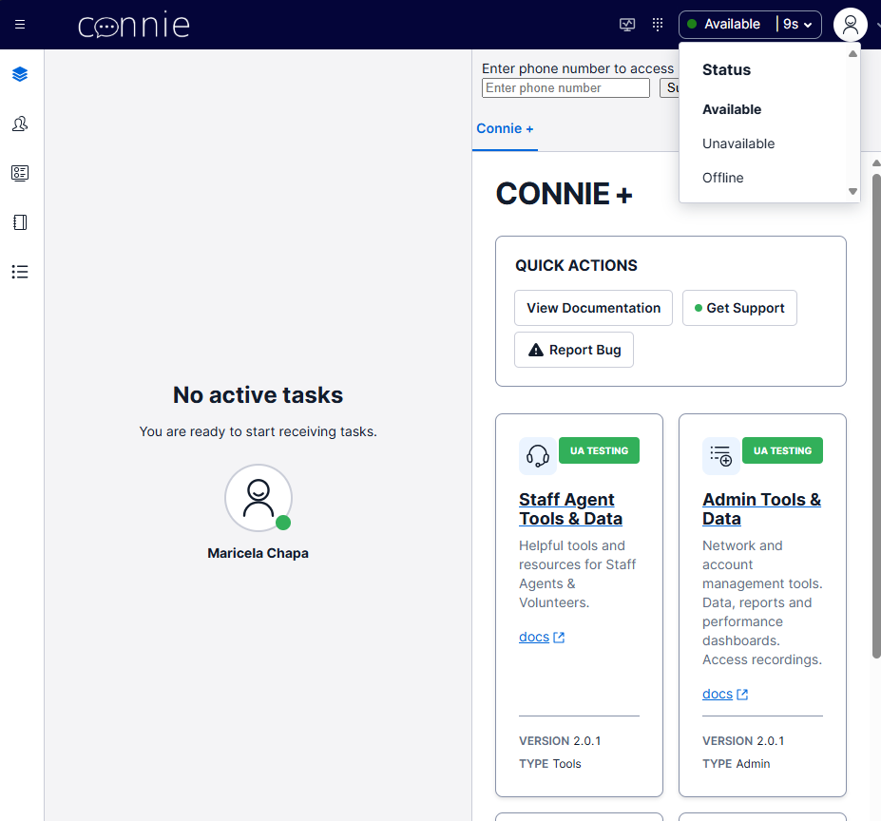

  - Your status must reflect “Available” to view + manage incoming tasks.
  - You also have the option to update your status to “Unavailable” or “Offline”. Your status will automatically update to “Offline” once you log out of Connie and “On a Task” when you accept a new task.

3. Handling Tasks (Referrals/Inquiries)
- Step 1: Locate New Inquiry
  - Go to the Inbox tab.
  - New inquiries are marked with [insert description].
- Step 2: Open and Review
  - Click on the inquiry.
  - Review the referral details: [list key fields].
- Step 3: Respond or Assign
  - To respond: Click Reply and type your message.
  - To assign: Select Assign to Staff and choose from the dropdown.

4. Recording Notes
- Click Add Note.
- Type your notes in the provided field.
- Click Save.

5. Troubleshooting
  - If you cannot log in: Check your password, then contact [support person/email].
  - If an inquiry looks duplicated: Follow the [Duplicate Handling] procedure.

6. FAQ
Q: How do I reset my password?
A: Click “Forgot Password” on the login screen.
Q: Can I reassign an inquiry after assigning it?
A: Yes, go to the inquiry record and click Reassign.

7. Support
- For help, contact: [name/email/phone].

