Project Plan – Connor Frank

Project Description
Name: Pacman++
Description: A remixed version of Pacman, the arcade classic, with some extra features added.

Structural Plan
I’ll add functions wherever is logical to help keep my code straightforward, readable, and reusable. As for files, my current plan is as follows:
- Main file to run
- File containing board objects
- File containing ghost objects and their respective algorithms
- File containing board generation logic
See below for more information on my visions for each one of these. I’m planning on using one object per board square type and one object per ghost. Ghost logic will likely be self-contained, while board logic will be spread between the main program (at the model and controller levels). This is because the user will be interacting with the board, but the code for generating the board will likely take up an appreciable number of sloc.

Algorithmic Plan
There are a few areas of my project where I can implement tricky algorithms. Here’s the order in which I’m planning on doing them:
- Ghost AI – first, I will implement greedy algorithms for all the ghosts (one aiming in front of the player, one directly at the player, one behind the player, and one moving based on where the other ghosts are)
- Maze generation – modified Kruskal’s algorithm without cul-de-sacs
- Better ghost AI – if I have enough time, I’m planning on implementing better ghost AIs (using mini-max, Dijkstra’s algorithm, and possibly more)
I’m planning on implementing these in this particular order because I want my game to be playable and enjoyable even if I can’t accomplish everything on this list.

Version Control Plan
I’m using git for version control, and I back up everything on my computer to an encrypted external drive every night.
I’ve also backed up the git repository to a private GitHub repo:
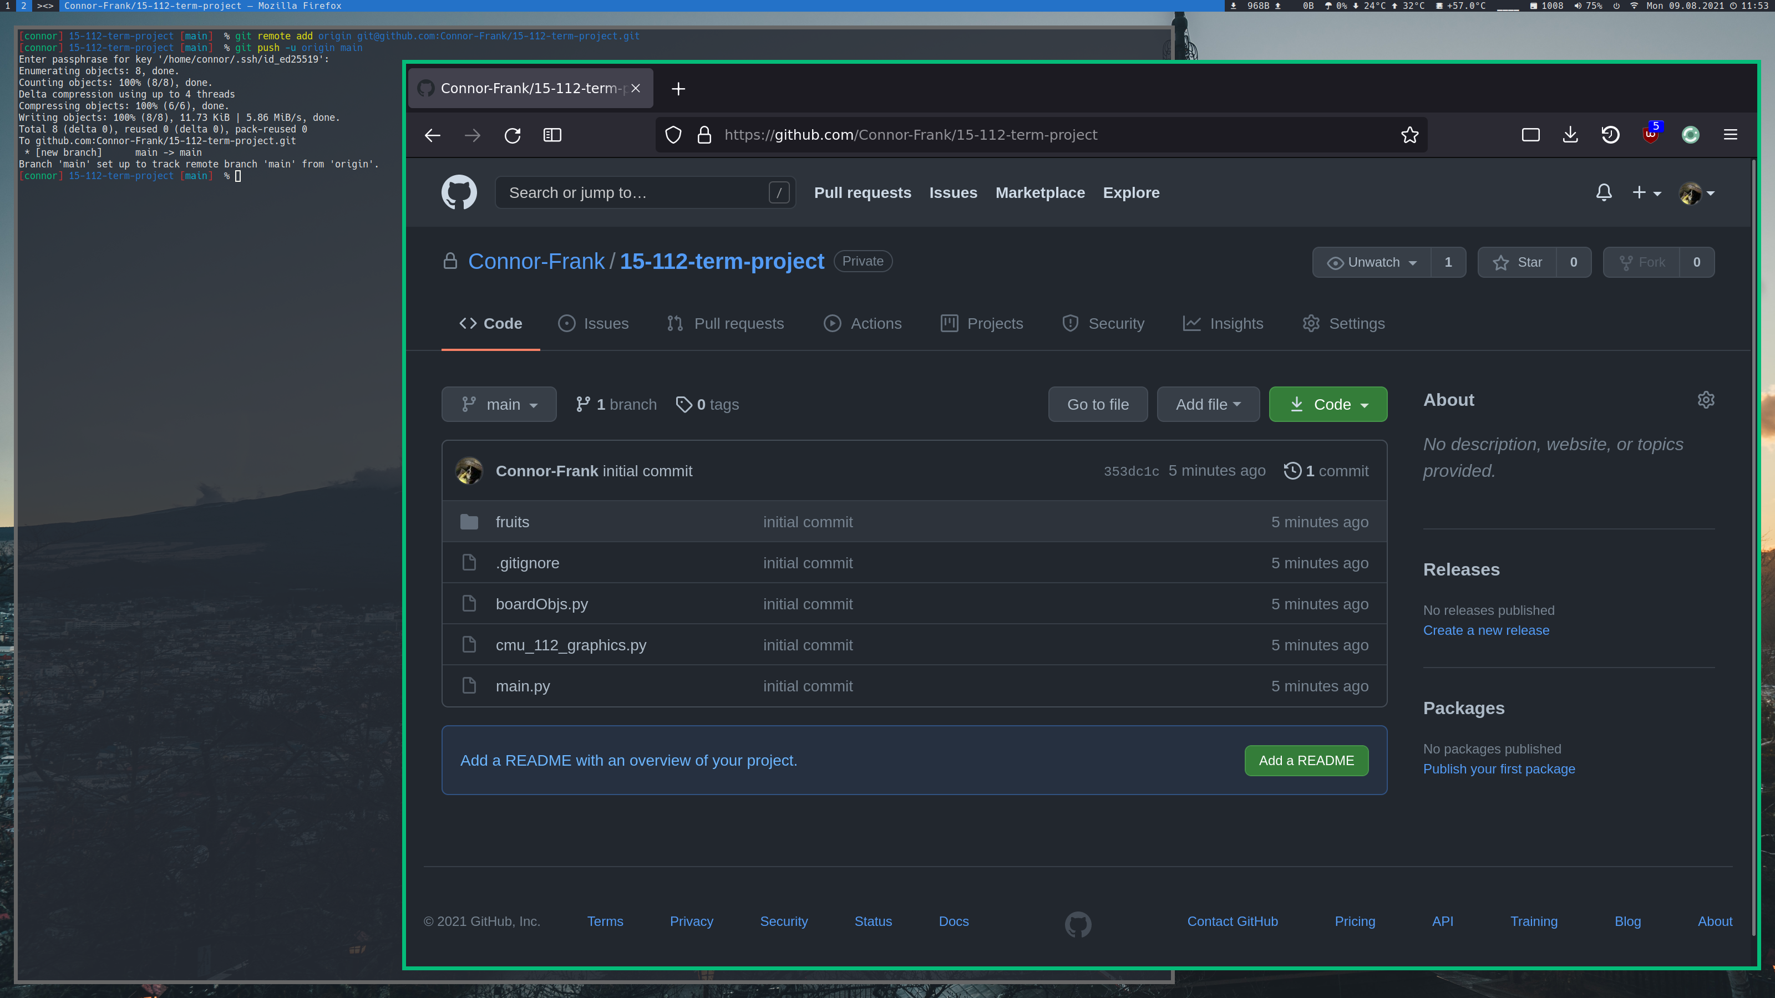

TP2 Update
No significant design changes were made since TP1. I’m currently working on step 2 of my original algorithmic plan.

TP3 Update
A start screen and a help screen were added since TP2. No significant changes were made to the design plan for the main part of the project.

