**Program Instructions**

1. Open Excel file and ensure that it is the only file open at the time.

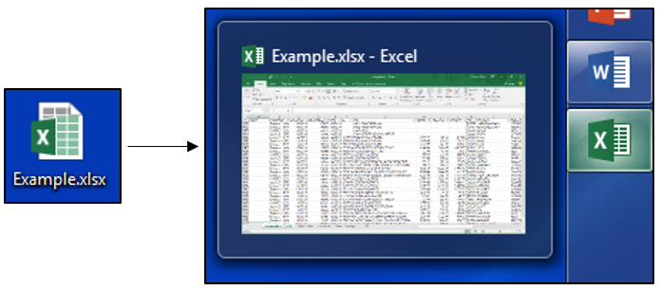

1. Run the program by double clicking the TANYR Healthcare program.

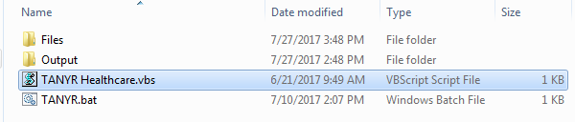

1. Press the “Select Sheet” button, select the sheet from the Excel file that has the unsorted data, and then press “OK.”

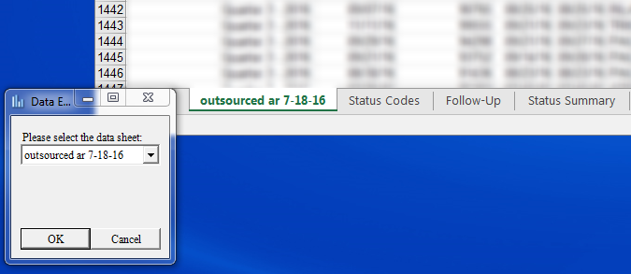

1. Click “Manage Rules.” This tab will house our custom filter rules.

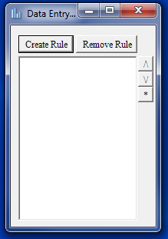

1. Click “Create Rule” to create a new rule for our filter. “Rule Name” will be the name listed in the rules list and “Assigned Name” will be the name inserted into the excel file.

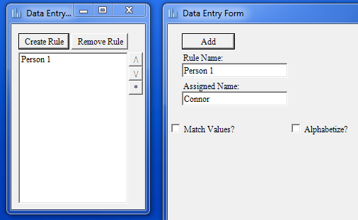

1. The “Match Values” check box will open the region where you can insert A, what column you want to search, and B, what items in that column you would like to give to Connor (Assigned Name).

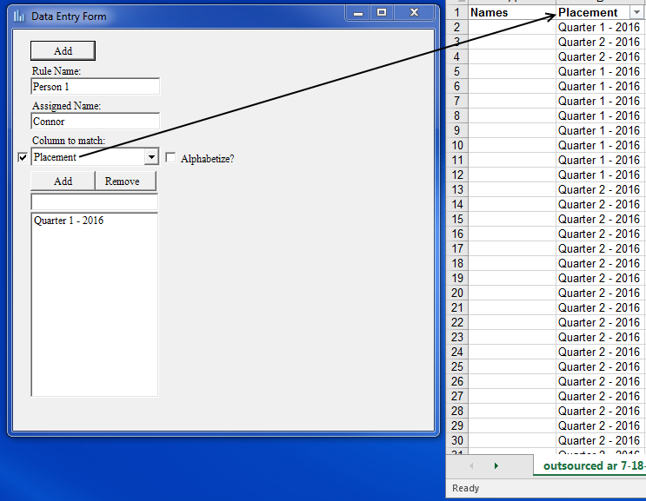

1. The “Alphabetize” check box will open the region where you can insert A, what column you would like to be searched alphabetically, and B, what range of letters you would like to give to Connor (Assigned Name).

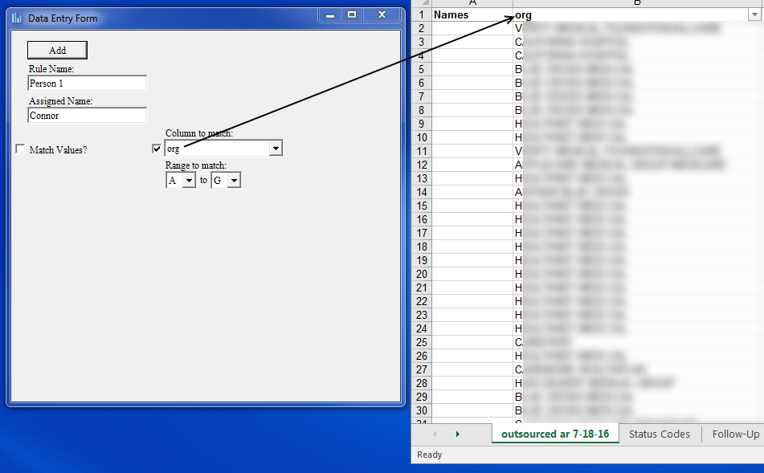

1. After a rule is finalized, press the “Add” button.

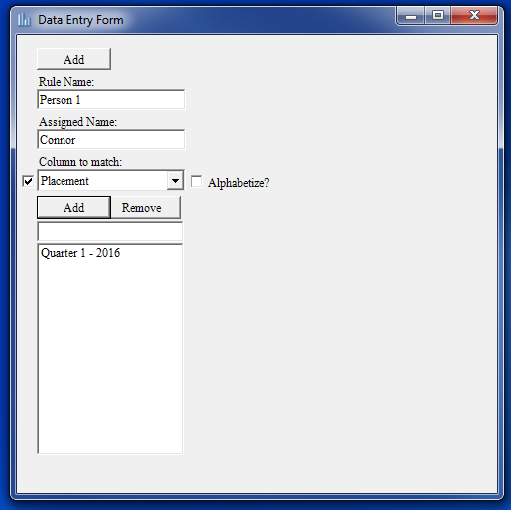

1. When your list of rules in finished, close the panel and then click the “Apply Rules” button.

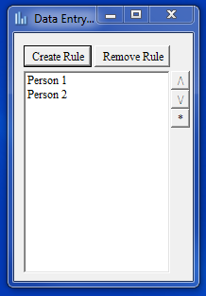

1. Now select the column that the names will go in and then press “OK.”

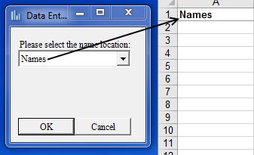

1. A new file has now been saved inside of the Program folder with the additional names inserted.

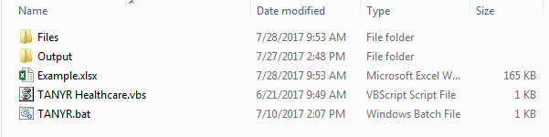

1. Below are a few examples of rules that can be applied.

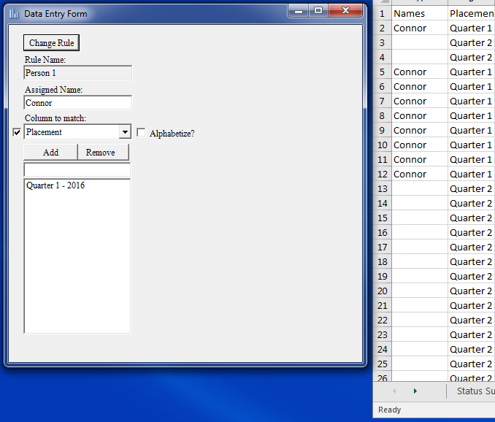

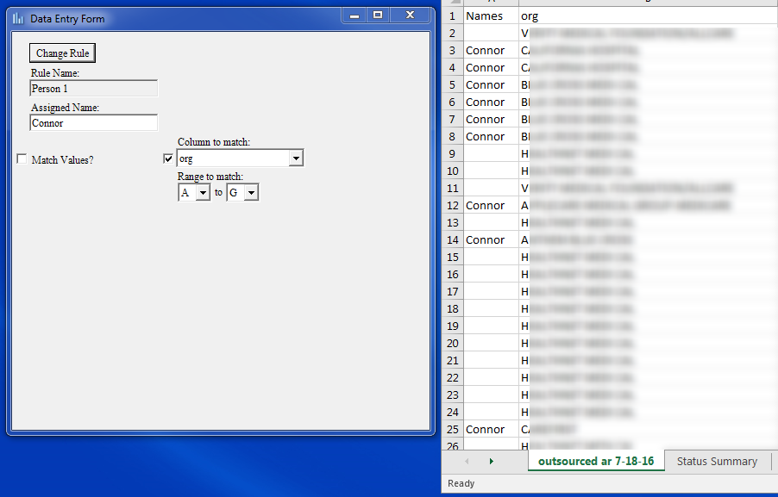

It’s important to take note on this rule; if both options are selected, the Assigned Name will only be placed on those entries that match ***both*** rules. For instance, in row 9, while the placement matches, the org column is not between A-G so it does not get the name Connor.

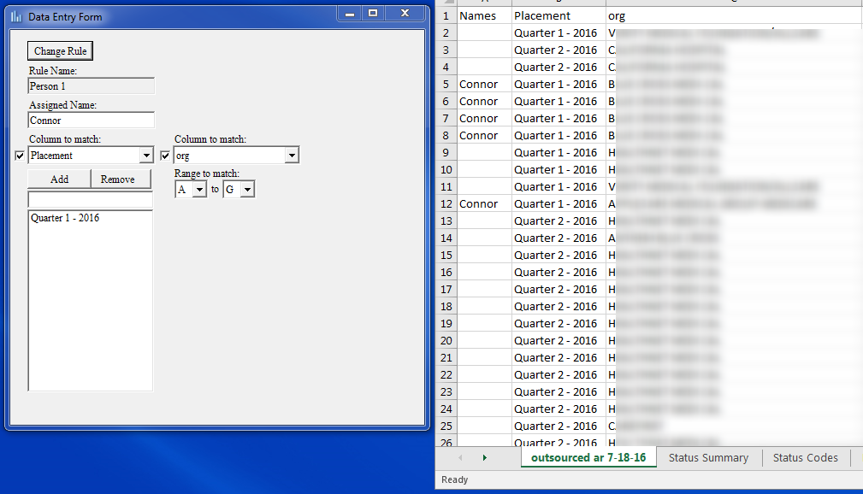

1. After you are satisfied with the designation of names in the excel file, press the “Sort Tabs” button. At the top, select the row where the names were assigned into the document. At the bottom, select all the columns you would like copied over to the new tabs. After these settings have been finalized, press “OK.”

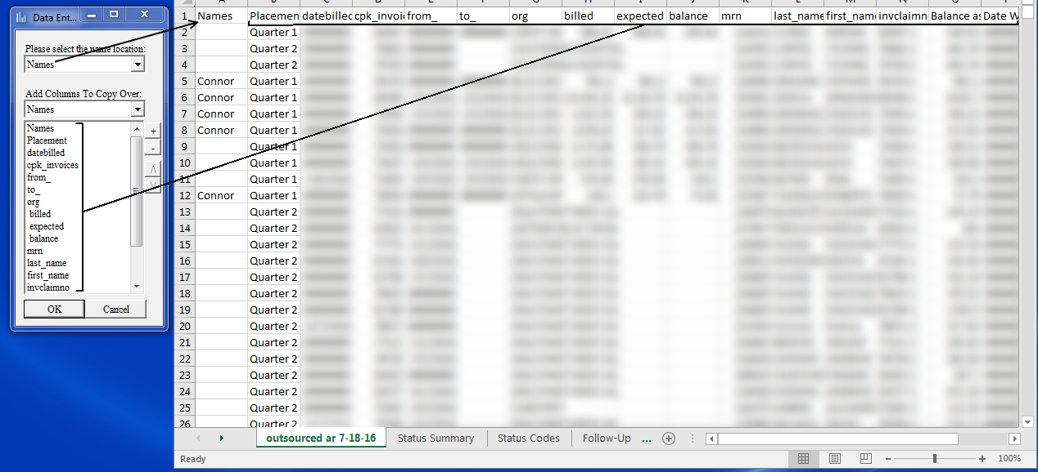

1. Afterwards, new tabs will be created with the names of the employees listed in the various rules.

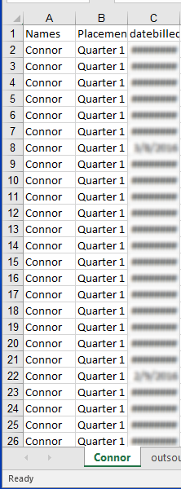

1. Later on, if you decide you want to change some of the rules, select the rule(s) in question and press the “*” button and an edit window will appear that can be manipulated and saved.

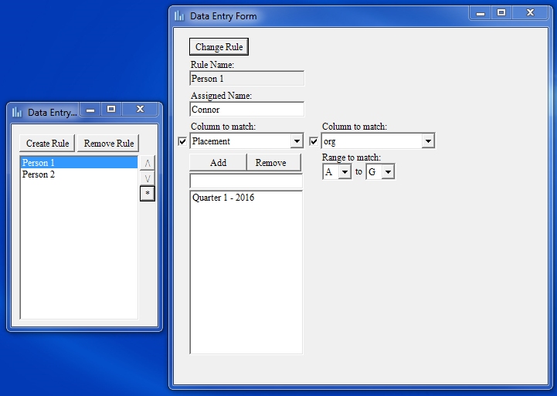

**P.S.** While I don’t see it being a problem, older versions of Powershell (windows’ programing application) may not function as quickly as the one that comes with Windows 10 (Version 5.0). If the program appears to be running slowly or breaking completely, first check that the input settings are correct and then if the problem persists, update Powershell to version 5.0 (<https://www.microsoft.com/en-us/download/details.aspx?id=50395>).