**Program Instructions**

1. Open Excel file and ensure that it is the only excel file open at the time.

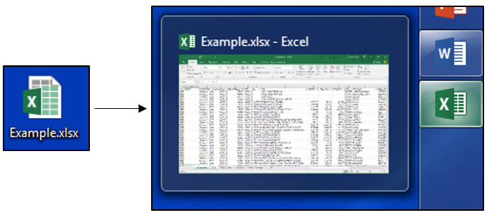

1. Run the program by double clicking the TANYR Healthcare program.

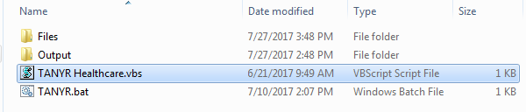

1. Press the “Select Date” button, choose the date you would like to pull, and then press enter.

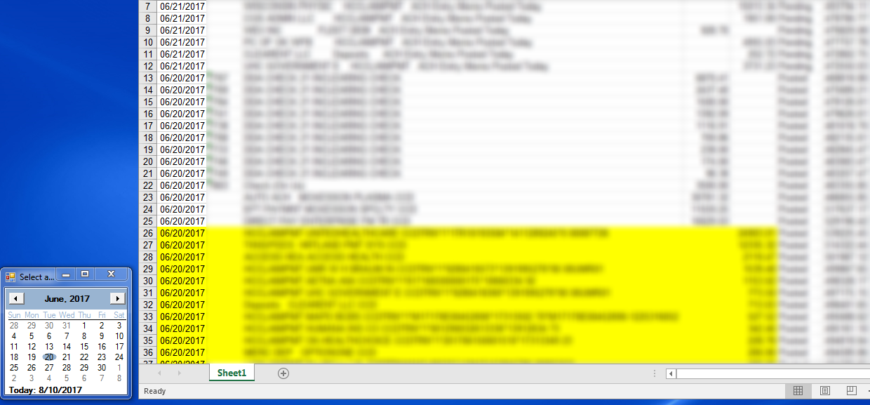

1. Press “Load Names” and wait for the program to scan the excel file.
2. Press “Download PDFs” and wait for the program to pull up all of the PDFs that are available.

(Sometimes it helps if you click the “Show Browser? box to follow the logic of the program. Internet Explorer has been known to have random pop-ups and it would help to run through the process once while watching it and choose the correct options to get to the PDFs such as “Always open in adobe”/etc.)

1. Once all of the PDFs have been opened, save them individually (they should open in the same order as in the Excel file).

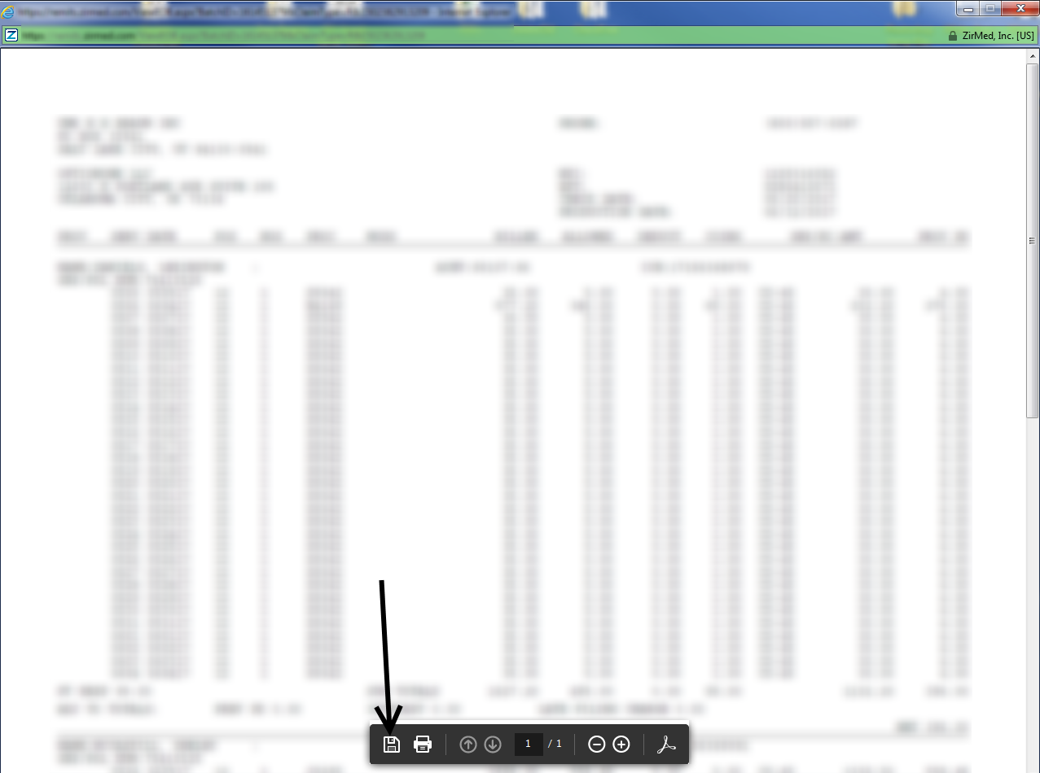

1. A dialog box will now appear with the names of any PDFs that were not available on the site.

