QuickStyle: An Exploration of Neural Architectures for Style Transfer

Connor Arnold  Northeastern University  360 Huntington Aver, Boston, MA  arnold.co@husky.neu.edu | Eric Liu  Northeastern University  360 Huntington Aver, Boston, MA  liu.che@husky.neu.edu

Abstract

Since Gatys et al. released their 2015 paper “A Neural Algorithm for Artistic Style” [1], Neural Style Transfer has become a highly explored field. By utilizing extensions to the original paper, we sought to design a network that is able to compare the effects that a neural architecture has on the performance of neural style transfer on images and videos. We were able to extend a PyTorch implementation of a VGG-19 based style transfer network to work with VGG-16 and RESNET-18. We then extended our network to utilize optical flow to create more consistent style transferred videos, while keeping the computation increase to a minimum. We finally implemented arbitrary style transfer [8] into our program to evaluate how well it can improve the time taken to perform style transfer using each architecture. Talk about results

Introduction
Neural style transfer was originally based around the fact that when convolutional neural networks are trained on object recognition, they are able to learn low and high-level features of objects. After training, the network is able to extrapolate these features extremely quickly given an input image. As Gatys et al. point out in their paper [1], these learned features give increasingly high-level information about the input image. As features are extracted from deeper layers of the network, they contain more information on the structure and content of the image. More shallow layers on the other hand have always been known to contain more information about the texture of the image and can actually capture the images style. A pre-trained networks ability to innately separate the style and content of an image is the most contributing factor as to why style transfer using CNNs is possible.
Since a pretrained CNN can separate style and content, we can utilize these features to generate an image that has an equal balance of content from a photo and style from a piece of art. In order to generate this image, gradient descent is utilized so as to limit the loss of content and style from the generated photo. In order to complete this task, a metric to evaluate the loss of content and loss of style must be used. Equation 1 shows the algorithm used to calculate the content loss of a generated image versus the original content image. In this equation, x is the generated image and p_{c} is the original content image. To find the content loss between these two images, the activation of the i^{th} filter at position j in layer l for the generated image and original image are subtracted and squared, summed over all filters and positions for layer l.
L_{content}(x,p,l) =0.5∑_{i,j}(F^{l}_{ij}-P^{l}_{ij})² (1)
This metric allows is used since it analyzes the content difference between the two images, as all layers in this equation hold information on content, not just pixel values.
Next, to calculate the style loss of a generated image, we analyze the difference in style features by calculating the gram matrix for the output at different layers for the images. To find the gram matrix, Equation 2 is used.
G^{l}_{ij} = ∑_{k} F^{l}_{ik}F^{l}_{jk} (2)
The gram matrix is calculated to find a better correlation between the style features. In order to find the style loss, Equation 3 and Equation 4 average the weighted difference in the generated image’s and original style image’s gram matrices over all style layers.
E_{l} = (4N²_{l}M_{l}²)⁻¹∑_{i,j}(G^{l}_{ij}-A^{l}_{ij})² (3)
L_{style}(x,a) = ∑^{L}_{l=0}(w_{l}E_{l}) (4)
With both content and style loss accounted for, we combine them to form the overall loss function in Equation 5, where α and β are the respective weights of each loss
L_{total}(p,a,x) = αL_{content}(p,x) + βL_{style}(a,x) (5)
Using this equation for loss allows us to evaluate how well the generated images style and image compare to the original images. In order to generate new images, we will use the given equations to also find the gradients between iterations so that we can use gradient descent to create the next iteration of the generated image. These gradients are calculated using Equation 6 and Equation 7.
δL_{content}/δF^{l}_{ij} = (F^{l} – P^{l})_{ij} (6)
δE_{l}/δF^{l}_{ij} = (N_{l}²M_{l}²)⁻¹((F^{l})(G^{l} – A^{l}))_{ij} (7)
Using these gradients, a new image is created ever iteration resulting in a lower total loss. This process is iterated several hundred times. This process can be used on either a noise image or the original content image and will result in an image containing a mix of the art style and image content.
A popular extension of style transfer is style transfer for videos. Generating videos with a certain style is not as easy as running style transfer on individual frames; it involves accounting for temporal consistency, which can incur a heavy computational cost. Instead of implementing a long- and short-term consistency solution, as is described by Ruder et al. [6], we will use a simplistic model which will use the previously generated frame, warped using the optical flow between the frames, as the initial input for the generated image.
Talk about math behind arbitrary style transfer

Related Work
This method of artistic style transfer was the first of its kind and yielded incredibly impressive results. Since it was so powerful, it quickly adopted and further improved upon by several papers. It has since been modified to work in real time [2][3], work on mobile platforms [3], utilize inception-based architectures [4], transfer style to videos [5], transfer an artist’s style instead of a single images style[6][7], and use GANs instead of CNNs to perform style transfer [6][7].

Performance Enhancements
One of the immediate improvements upon this method came from Johnson, Alahi, and Fei-Fei in their 2016 paper [2] which improved the clarity of stylized image and allowed it to perform style transfer in real time. They were able to accomplish this task by training a feedforward CNN on per-pixel loss between the generated image and the ground truth images, and by optimizing perceptual loss functions trained on high level image features. By using these two methods in parallel they were able to create stylized images on qualitatively on par, if not better than Gatys, running at 3 order of magnitudes faster. The results of this method can be seen in Figure 1.

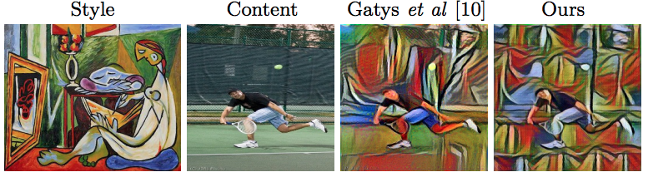
Figure 1: Gatys vs. Johnson (Ours)

The main distinction to be made between these two methods however is that Johnson et al. pretrained a feedforward CNN to learn how to transfer the style of a specific image in a supervised manner. The Gatys method doesn’t need to have this supervised training session in order to perform style transfer and can be considered to be faster in some ways, as pretraining the feedforward CNN could be costly. Even though this method did require training a CNN, its abilities are extremely impressive and demonstrate the capabilities of this method.
Talk about [8] here

Architecture Changes
Another major feature of Gatys et al.’s work was their use of VGG19 as a base architecture. Their rationale for this decision was that its outputs at various layers are clearly mapped to content or style features of the image. Since their work was published, people sought to utilize advances in object detection to create a faster and lighter style transfer method using a detection architecture with less parameters and better results than VGG-19. The hope was to find the correct layers which mapped to content and style, and thereby achieve similar results except faster without having to pretrain a feedforward CNN like Johnson et al. In “Exploring the Neural Algorithm of Artistic Style” [4], Nikulin et al. are able to extend Gatys’ work by implementing GoogLeNet, AlexNet, and VGG-16 as the base architectures.

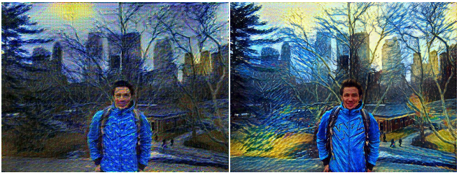
Figure 2: GoogLeNet (left) vs. VGG-19 (right)

As seen in Figure 2, GoogLeNet and AlexNet aren’t able to qualitatively perform as well as VGG, however no metric is recorded for how long it took for those networks to run. They speculate that the reason these two networks aren’t able to perform as well is because the first convolutions significantly compress the image since they use large kernels and stride.

Style Transfer for Video
As mentioned before, style transfer for video has been a highly explored extension of style transfer and has been most well done by Ruder et al. [5]. In order to achieve style transfer to video, they made sure to have temporal consistency between every frame, instead of having each frame generated independently. To achieve this, they utilized three forms of consistency. First, in order to keep short term consistency, they used the optical flow between the previous and current image to warp the previously generated image, which was then used as the initially generated image. Next, they add a temporal consistency loss with the content and style loss to ensure consistency between frames. Finally, they include long term consistency to ensure occluded or previously seen images appear the same way that they did before. The effects of these consistency constraints can be seen in Figure 3.

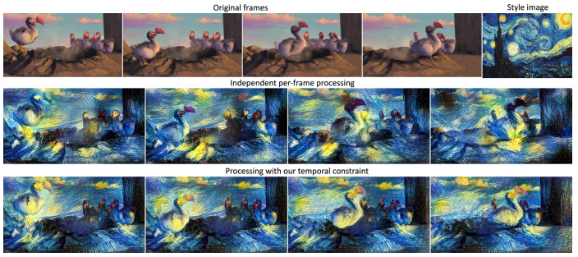
Figure 3: Temporal Consistency Effects

GANs
More recently, GAN’s have been utilized to perform style transfer, as their ability to generate realistic images allows them to easily achieve style transfer. The method used for style transfer using GANs is quite different than using CNNs, however. One state of the art method was proposed by Zhu et al. which utilized CycleGAN, an unpaired method for image to image translation. Using the ideas of cycle consistency and adversarial loss, they were able to train a GAN to classify paintings painted by an author and classify real world photos. Using cycle consistency, they were able to transform an image into a stylized version of the image in an artist’s style, and vice versa. This method however required much more training and is not as lightweight as using the traditional method, however it does yield better quality images in some cases.

Implementation
Since there have been numerous extensions to Neural Style Transfer, we sought to implement and evaluate various extensions. To begin, we implemented the baseline style transfer algorithm in PyTorch. In order to evaluate its performance, our program is optimized to run on either CPU or GPU, with the resolution of the output images being 128x128 and 512x512 respectively. Once we implemented the baseline method, we extended our program to work with the pretrained Pytorch VGG-16 and ResNet-18 architecture models. After working with the models to discover which layer features to use for content and style loss, we implemented a low-cost temporal consistency loss to allow our program to perform style transfer for video. Finally, we implemented arbitrary style transfer into our program in order to compare not only the qualitative results of the output images, but also compare how each architecture performed using this method, and how much faster it could perform style transfer.

VGG-19
For the baseline implementation,
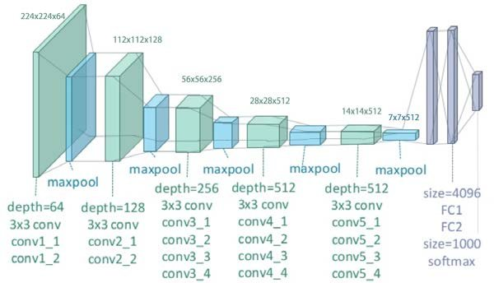

VGG-16
Next
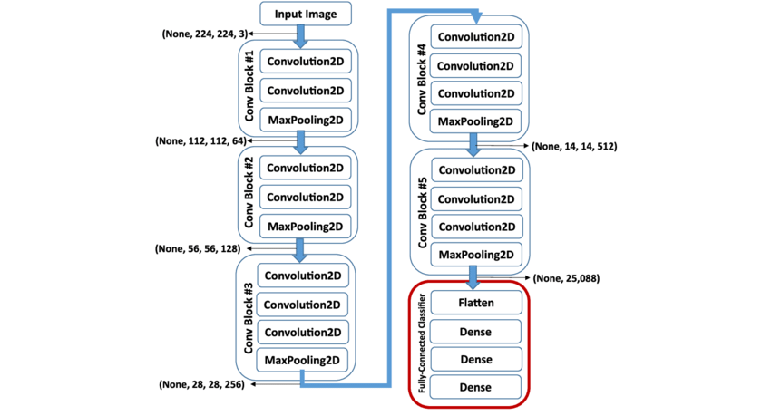

ResNet18
Finally
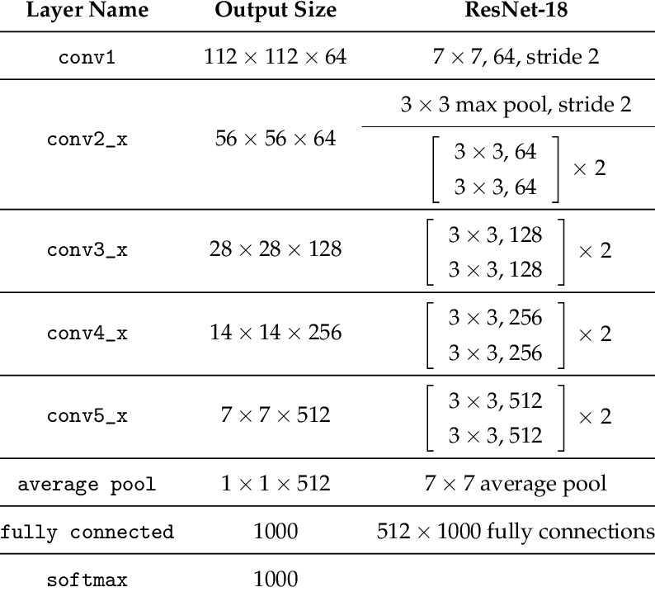

Temporal Consistency

Arbitrary Style Transfer
Talk about implementation

Experiments

Multi-Architecture

Video Sequences

Arbitrary Style Transfer

Conclusion

References
- L. Gatys, A. Ecker, M. Bethge, “A Neural algorithm of Artistic Style”, arXiv:1508.06576, 2015.
- J. Johnson, A. Alahi, L. Fei-Fei, “Perceptual Losses for Real-Time Style Transfer and Super-Resolution”, arXiv:1603.08155, 2016.
- K. Baumli, D. Diamont, J, Sigmon, “Real Time Video Neural Style”, Towards Data Science, December 15, 2018.
- Y. Nikulin, R. Novak, “Exploring the Neural Algorithm of Artistic Style”, arXiv:1602.07188, 2016
- Ruder M., Dosovitskiy A., Brox T, “Artistic Style Transfer for Videos” In: Rosenhahn B., Andres B. (eds) Pattern Recognition. GCPR 2016. Lecture Notes in Computer Science, vol 9796. Springer, Cham
- P. Isola, J. Zhu, T. Zhou, A. Efros, “Image-to-Image Translation with Conditional Adversarial Networks”
- J. Zhu, T. Park, P. Isola, “Unpaired Image-To-Image Translation Using Cycle-Consistent Adversarial Networks”, The IEEE International Conference on Computer Vision (ICCV), 2017, pp. 2223-2232
- Z. Huang, S. Belongie, “Arbitrary Style Transfer in Real-time with Adaptive Instance Normalization”, arXiv:1703.0686.

