S.I.1 Study Sites

To quantify the influence of wetting and drying regimes on biological communities in non-perennial streams, we analyzed macroinvertebrate, soft-bodied algae, and diatom data across 20 streams in Southern California (Table S.I.1). Data are available through the California Environmental Data Exchange Network (CEDEN, www.ceden.org).

Table S.I.1. Site locations for the 20 sites included in the study.
Station Code | Latitude | Longitude
901BELOLV | 33.64 | -117.55
901NP9FLC | 33.68 | -117.54
901NP9HJC | 33.68 | -117.52
901NP9LCC | 33.63 | -117.43
903ACPCT1 | 33.30 | -116.64
903CVPCT | 33.27 | -116.64
903NP9SLR | 33.35 | -116.67
903SLFRCx | 33.34 | -116.88
903WE0798 | 33.34 | -116.83
905DGCC1x | 33.16 | -116.84
905SDBDN9 | 33.09 | -116.90
909S00282 | 32.87 | -116.61
909SWCASR | 32.94 | -116.55
911COPPER | 32.56 | -116.83
911KCKCRx | 32.79 | -116.45
911NP9ATC | 32.77 | -116.42
911NP9UCW | 32.82 | -116.49
911S00858 | 32.90 | -116.49
911TJKC1x | 32.76 | -116.45
911TJLCC2 | 32.78 | -116.44

S.I.2 Example Hydrographs
We created a hydrograph for each event to correct for any “false starts” where water rewetted a stream for less than ten days before drying again. One event (site number 905DGCC1x) did not have a previous wet event that lasted longer than ten days, thus we did not calculate recession slope from this event. All other samples had enough logger data to calculate all hydrologic metrics. Presented here are examples of hydrographs with important dates highlighted showing different scenarios: a straight-forward hydrograph (Figure S.I.1), a hydrograph with no false starts during the dry period (Figure S.I.2), and a hydrograph that required a manually defined Rewet Date (Figure S.I.3).
Gray lines indicate the start date of the event, defined as the earliest day of the previous wet period captured by the loggers. Green lines represent the peak day of the previous wetting event and red lines indicate the Dry Date, the first day that the previous event went dry. The Recession Slope was calculated as the rate of change between the green (peak) and red lines (Dry Date). Light blue lines show the First Wet Date while dark blue lines represent the Rewet Date. Purple lines indicate the date where the Peak Depth was reached. Finally, the black lines show when the samples were taken. These dates were largely used to calculate the other metrics in Table 1. All plots demonstrate the water level in meters on the corresponding days.
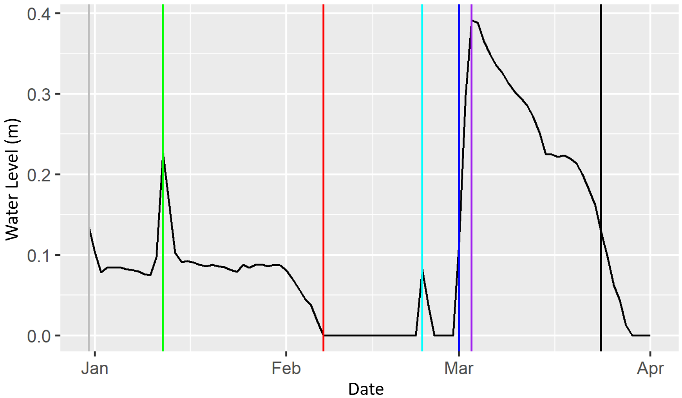Figure S.I.1. Hydrograph for site 911COPPER with a March sampling date. Example hydrograph with one “false start” during the dry duration.
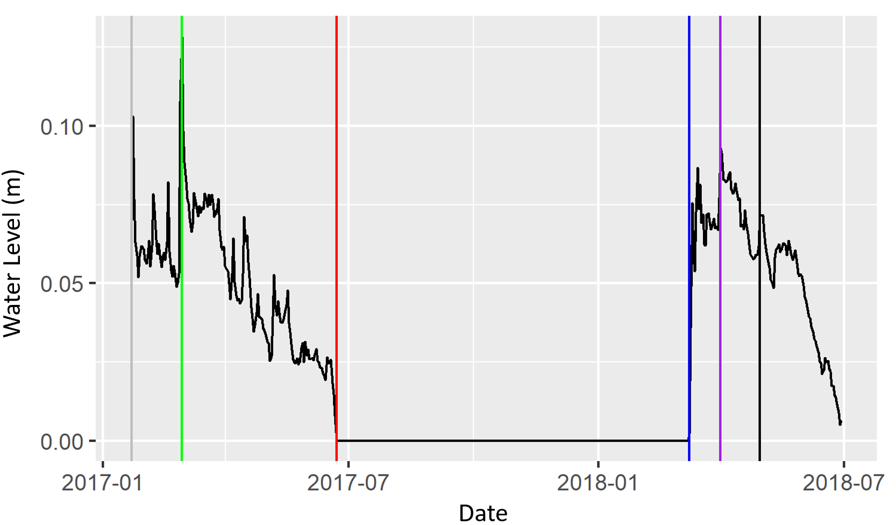Figure S.I.2. Hydrograph for site 903CVPCT with an August sampling date. Example hydrograph with no “false starts” during the dry duration, as shown by the absence of a light blue line.
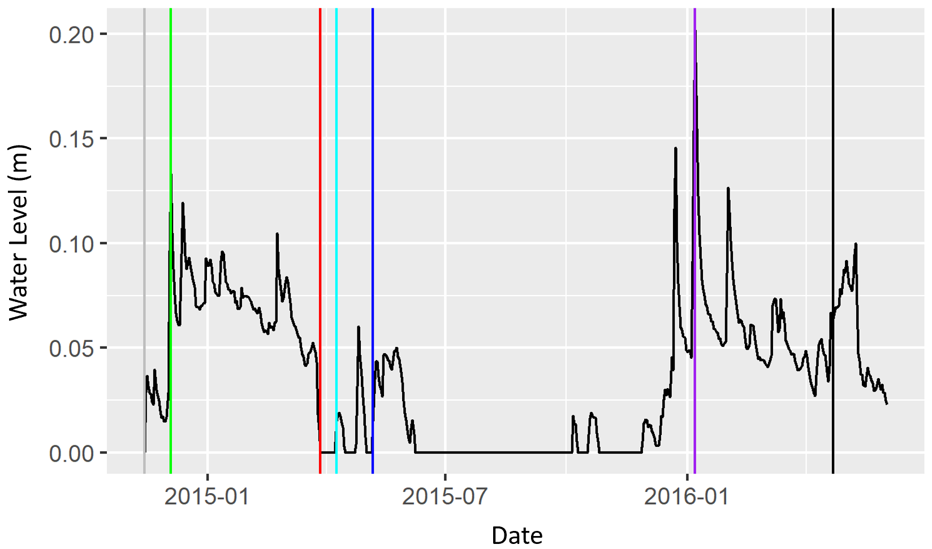Figure S.I.3. Hydrograph for site 901NP9FLC with an April sampling date. Example hydrograph that required a manual definition of the Rewet Date. Note that there was a period of wetting for at least ten days before the wetting event of interest (which contains the Sample Date) as noted by the position of the dark blue line. For these drying and subsequent wetting events, the Rewet Date was manually set as the first day of the wetting event of interest using the interactive “dygraphs” package. In this example, the dry period contained five false starts.

S.I.3 Correlated Variables

In total, we calculated 15 hydrologic variables to better understand what hydrologic variables influence BMI, algae, and diatom assemblages. We calculated the Dry Duration, Peak Depth, Peak to Sample Duration, Peak to Sample Slope, Proportion of Dry Days, Proportion of Wet Days, the Recession Coefficient (along with it’s modeled R² value, Recession R²), Recession Slope, False Starts per Duration, Time to Peak, Rewet Slope, and Wet Duration.
In addition to these hydrologic metrics, we included environmental data collected during the sampling collection: alkalinity (as CaCO3), pH, specific conductivity, temperature, percent canopy cover, station water depth, wetted width, and the percentage of the reach comprised of riffles, pools, and runs. Other water chemistry variables, such as nitrogen and phosphorus amounts, were excluded in 25% of the samples and were therefore excluded from all analyses.
For analyses, we checked Pearson correlations between all the variables listed above and removed variables that were >0.70 or <-0.70 correlated (Price et al. 2021) using the performance package (Lüdecke et al. 2022). Wet Duration was correlated with Peak to Sample Duration (0.79), Rewet Date (-0.90), and the Proportion of Dry (-0.70) and Wet (0.70) days. We chose to keep the Wet Duration in favor of the other three hydrologic variables as we hypothesized Wet Duration to have the largest influence on assemblages. In addition, the proportion of pools was correlated to station water depth (0.79). Because we calculated Peak Depth via the logger information, we removed station water depth prior to further analyses. In addition, of the 27 events, 12 of the R² values of the Recession Coefficient had a value < 0.10 (44.4% of all events). Due to the low explanatory value of the linear model, we removed Recession Coefficient (along with Recession R²) and used Recession Slope to assess how the rate of drying influenced biodiversity.
In total, ten hydrologic metrics were used in subsequent analyses: Dry Date, Dry Duration, False Starts per Duration, First Wet Date, Peak Date, Peak Depth, Peak to Sample Slope, Recession Slope, Rewet Date, Wet Duration, (Figure 1; Table 1).

S.I.4 Linear Models - Effects of Year, Repeated Samples

In total, we found 27 biological sampling events (including samples of benthic macroinvertebrates, algae, and diatoms) that overlapped with hydrologic data across 20 sites in southern California. Of these 27 events, 14 were repeated at 6 of the 20 sites (Figure S.I.4).

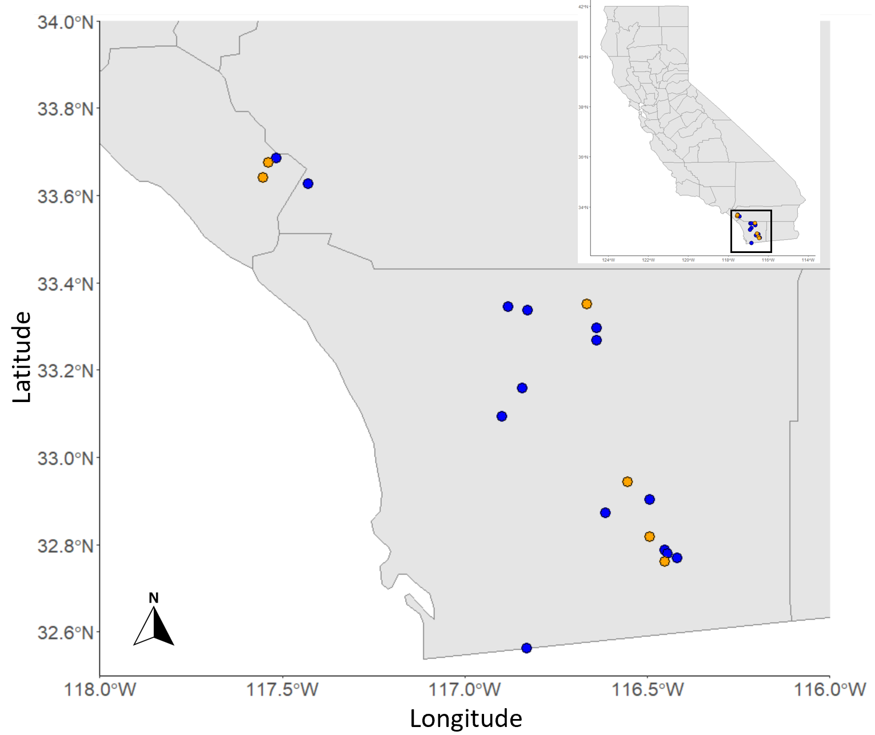
Figure S.I.4. Map of study sites within the State of California. Sites in orange are the six sites with repeated samples used to test for the impacts of year on biodiversity.

To test for sample independence, we selected only these six sites and ran the global linear models (which included all 10 hydrologic metrics as predictors) on this subset of data. We ran linear models without random effects in addition to linear models with site id as a random effect, although the models with site id as a random effect produced more warnings and errors. Year had a significant effect on algae Hill-Shannon diversity values, however, with the addition of site as a random effect, year no longer predicted algal Hill-Shannon diversity (Table S.I.2). The lack of significance of year within these models suggests some degree of independence year to year.

Table S.I.2. Summary table for linear models run for the six sites with repeated samples including p-values, R² values, AICc, and p-values for year within the global models for richness without a random effect, richness with site as a random effect, Hill-Shannon without a random effect, and Hill-Shannon with site as a random effect.

 | Macroinvertebrates |  |  | Soft-Bodied Algae |  |  | Diatoms
 | p-val | R² | AICc | p-val | R² | AICc | p-val | R² | AICc
Richness | 0.751 | -0.074 | 112.785 | 0.755 | -0.074 | 122.629 | 0.517 | -0.044 | 120.438
Richness (1|site) | 0.822 | 0.003 | 106.910 | 0.576 | 0.019 | 117.672 | 0.664 | 0.006 | 109.920
Hill-Shannon | 0.6911 | -0.069 | 104.21 | 0.379 | -0.013 | 94.869 | 0.041 | 0.070 | 90.829
Hill-Shannon (1|site) | 0.873 | 0.001 | 99.990 | 0.325 | 0.060 | 92.173 | 0.191 | 0.066 | 106.165

S.I.5 Effect of Year on Hydrologic Metrics and Environmental Variables
To explore how the 2012-2015 drought may have impacted the hydrology and environment, we ran linear models for each hydrologic metric and environmental variable with year as the predictor. We found year significantly predicted Peak Depth, Wet Duration, proportion of Riffle, and Wetted Width (Table S.I.3).
Table S.1.3. Summary of linear model results exploring the effects of year on each hydrologic metric (A) and environmental variable (B), sorted by p value. Significant results are bolded.
A. Hydrologic Predictor | p-val | R²
Dry Date | 0.42 | -0.01
Dry Duration | 0.22 | 0.22
False Starts Per Duration | 0.41 | -0.01
First Wet Date | 0.58 | -0.27
Peak Date | 0.82 | -0.04
Peak Depth | 0.00 | 0.55
Peak-to-Sample Slope | 0.80 | -0.03
Recession Slope | 0.32 | 0.00
Rewet Slope | 0.24 | 0.02
Wet Duration | 0.00 | 0.33

B. Environmental Variable | p-val | R²
Alkalinity | 0.67 | -0.03
Canopy Cover | 0.17 | 0.04
pH | 0.52 | -0.02
Pool | 0.27 | 0.01
Riffle | 0.00 | 0.32
Run | 0.40 | -0.01
Specific Conductivity | 0.49 | -0.02
Temperature | 0.42 | -0.01
Wetted Width | 0.01 | 0.20

S.I.6 Results - Biologic Diversity, Common and Rare Taxa
Across the 27 events sampled, we found 152 macroinvertebrate species. We found 12 taxa during at least 70% of all sampling events, 9 of which are in the family Chironomidae, 10 in the order Diptera, and 1 in the order Ephemeroptera (at least 19 sampling events; Corynoneura (family Chironomidae), 92.5% of all events; Parametriocnemus (family Chironomidae), 92.5%; Simulium (family Simuliidae), 88.9%; Eukiefferiella (family Chironomidae), 85.2%; Micropsectra (family Chironomidae), 85.5%; Zavrelimya-Paramerina (family Chironomidae), 85.2%; Baetis (family Baetidae), 81.5%; Orthocladinnae (family Chironomidae), 81.5%; Tanypodinae (family Chironomidae), 81.5%; Brillia (family Chironomidae), 81.5%, Oligochaeta, 81.5%, and Thienemanniella (family Chironomidae), 81.5%). Conversely, we found 51 taxa present at only 1 sampling event (3.7% of all sampling events). Across all samples, the maximum richness was 52 in 2016 and the minimum was 13 in 2015.

The final 27 events had 207 algal species. We found four taxa during at least 70% of all sampling events (Heteroleibleinia sp1 (family Pseudanabaenaceae), 96.3%; Chroococcus minmus (family Chroococcaceae), 77.8%; Aphanocapsa delicatissima (family Merismopediaceae), 70.4%; and Aphanothece minutissima (family Aphanothecaceae), 70.4%) and 89 taxa present during only one sampling event. The maximum number of species found in the quantitative samples was 62 in 2016 and the minimum was 5 species in 2017.

Finally, we found 225 diatom species across all samples. We found 10 taxa during at least 70% of all sampling events (at least 19 sampling events; Planothidium frequentissimum (family Achnanthidiaceae), 92.6%; Planothidium lanceolatum (family Achnanthidiaceae), 92.6%; Achnanthidium minutissimum (family Achnanthidiaceae), 85.2%; Ulnaria ulna (family Fragilariaceae), 85.2%; Nitzschia linearis (family Bacillariaceae), 77.8%; Nitzschia palea (family Bacillariaceae), 77.8%; Cocconeis placentula (family Cocconeidaceae), 74.1%; Halamphora veneta (family Amphipleuraceae), 74.1%; Gomphonema micropus (family Gomphonemataceae), 74.1%; and Navicula veneta (family Naviculaeceae), 74.1%). We found 100 taxa during only one sampling event (3.7%). Maximum richness was 69 (2016) and minimum richness was 16 (2016).

S.I.7 Results - Hill-Shannon Diversity Linear Models
Algal linear models for Hill-Shannon diversity included only quantitative samples, but linear models for algal richness included both quantitative and qualitative samples.

As with richness models, the Null model was the most significant for all assemblages (Table S.I.4). Richness (Table 5) and Hill-Shannon model results were similar, with Dry Date predicting diatom Hill-Shannon Diversity and no significant predictors of macroinvertebrate or algal richness.

Table SI.4. Results from linear models of hydrologic metrics and assemblage Hill-Shannon Diversity. Columns indicate p-values (p-val), R², and AICc. Bolded values with p < 0.05.
 | Benthic Macroinvertebrates |  |  | Soft-Bodied Algae |  |  | Diatoms
Hydrologic Predictor | p-val | R² | AICc | p-val | R² | AICc | p-val | R² | AICc
Dry Date | 0.82 | -0.04 | 180.09 | 0.57 | -0.03 | 163.45 | 0.01 | 0.22 | 197.32
Dry Duration | 0.52 | -0.02 | 179.69 | 0.49 | -0.02 | 163.28 | 0.09 | 0.08 | 201.80
False Starts Per Duration | 0.21 | 0.03 | 178.39 | 0.74 | -0.04 | 163.67 | 0.86 | -0.04 | 205.03
First Wet Date | 0.21 | 0.02 | 178.45 | 0.75 | -0.04 | 163.68 | 0.29 | 0.01 | 203.82
Peak Date | 0.30 | 0.00 | 178.97 | 0.37 | -0.01 | 162.92 | 0.65 | -0.03 | 204.84
Peak Depth | 0.50 | -0.02 | 179.65 | 0.82 | -0.04 | 163.74 | 0.33 | 0.00 | 204.01
Peak-to-Sample Slope | 0.91 | -0.04 | 180.13 | 0.59 | -0.03 | 163.48 | 0.24 | 0.02 | 203.55
Recession Slope | 0.31 | 0.00 | 173.56 | 0.90 | -0.04 | 159.00 | 0.51 | -0.02 | 198.24
Rewet Date | 0.57 | -0.03 | 179.78 | 0.32 | 0.00 | 162.71 | 0.11 | 0.06 | 202.64
Wet Duration | 0.63 | -0.03 | 179.88 | 0.88 | -0.04 | 163.77 | 0.35 | 0.00 | 204.09
Global | 0.64 | -0.09 | 204.55 | 0.97 | -0.39 | 195.13 | 0.21 | 0.19 | 220.97
Null | 0.00 |  | 177.60 | 0.00 |  | 161.25 | 0.00 |  | 202.52

References
Lüdecke D, Makowski D, Ben-Shachar MS, Patil I, Waggoner P, Wiernik BM, Arel-Bundock V, Thériault R, Jullum M. 2022. performance: Assessment of Regression Models Performance. https://CRAN.R-project.org/package=performance

