Figma link: https://www.figma.com/file/HdK33thFitfHxqZuXibG2C/Omcoin-Landing-Page

Omcoin.cash Changes:

* Update website title to “Omcoin” and Favicon image
  + Not working on mobile and my buddy’s browser (might be an issue of the webclip change I mention below)

* Fix top nav bar not showing on mobile
* Remove static image for mobile + Get video working on mobile
  + Try gif video I sent you OR
  + Might have to add play button for iOS (top right corner)

* Update the Home phone screen mockup image to the new one I sent you

* Remove white square border around YouTube video (happens sometimes)



* Make “Omcoin” completely white like picture below
* Make space between “Omcoin” and logo 25 pixels

* When you highlight over JustSwap remove the extra underline space before the J



* Change “Smart Contract” link in footer to: https://tronscan.org/#/token20/TJjoep8pFxBwMzQPa2HSP2fauq8EH3peJB/code
* Make space below the footer equal to the space above the footer (I think it is 30px of space)

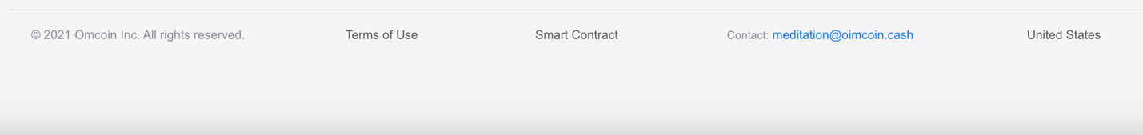

Terms of Use page:

* Update ToU page to the HTML doc I sent to you
* Align the title to the center like shown below

* Match the heading (h1, h2, etc.) sizes and font weights (bold, etc.) with Apple’s ToU page (found here: https://www.apple.com/legal/internet-services/terms/site.html)
* 150px space between bottom of Terms of Use body text and footer (match the space here)

* + Currently looks like this

Extra:

* Change the Meta Description for Google when people search to:
  + Omcoin | Cryptocurrency Rewards | Meditation
* Change the Meta Keywords to: Meditation, Cryptocurrency, TRON

* Add web clip icon image to the Omcoin logo (same as Favicon)

* Update the social sharing thumbnail to the one I sent you

