**Changes for** [**www.omcoin.cash**](http://www.omcoin.cash)**:**

* Change all blue text to purple: #6B26FF
  + Don’t forget the email color

* Update connection for S3 bucket for background video
* Remove Google play store and App store images
* Update first phone Home screen image to the one I sent you

* Change YouTube video URL to:
* Replace the second and third cards under “Earning crypto is this easy.” to the ones I sent you
* Make sure email form is working with new email domain
* Change this image to the one I sent you

* Completely change this section below to the new screenshot

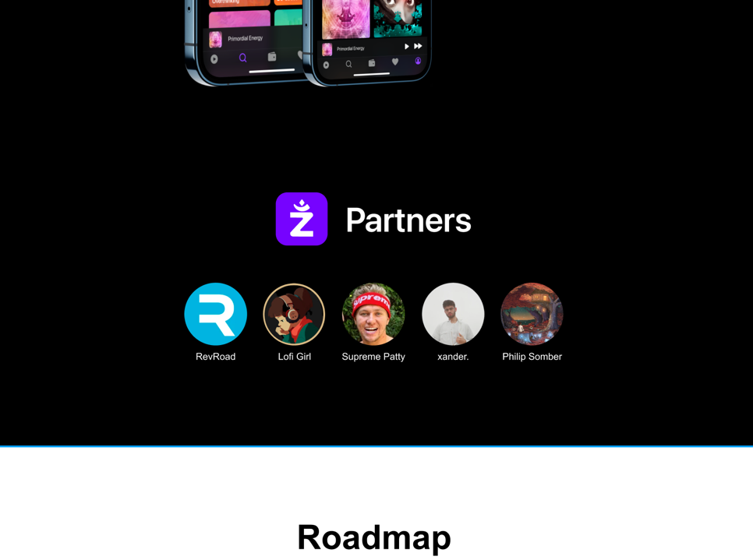

* Update cards images for Roadmap section to the ones I sent
* Update all social media links
  + Instagram: https://www.instagram.com/zenbase.us/
  + Facebook:
  + Twitter: https://twitter.com/zenbase_us
  + YouTube: https://www.youtube.com/channel/UCyAD6cWAE2BQuopLMrxjadw
  + LinkedIn: https://www.linkedin.com/company/zenbase-us/
  + Reddit: https://www.reddit.com/user/zenbase
  + TikTok: https://www.tiktok.com/@zenbase.us?
  + Discord: https://discord.gg/6dUrJEHxKp
  + Telegram: https://t.me/zenbase_us
  + Remove CoinGecko logo
  + Remove Coinpaprika logo
  + Medium: https://zenbase-us.medium.com/
  + Github: https://github.com/zenbase
* Center social media icons
* Use this link for Meet the Team: https://www.linkedin.com/company/zenbase-us/people/
* Replace “United States” (in footer) to “Careers”
  + We are using Typeform. Make Careers page open in a new tab: <https://uos65me7hsg.typeform.com/to/WMfeOXa4>

**General**

* Copy website over to new Github repo
* Switch domain to zenbase.us
* Link our new email address
* Update Favicon image to one I sent you
* Update Google Search title to ZenbaseGraphical user interface, text

  Description automatically generated
* Update this to just say Zenbase

* Update social sharing thumbnail to the image below

* Utilize Cloudflare’s free DNS service
* Update Google analytics
* Register website on the .US directory (32789.US)

**Other Pages**

* Update White paper (I’ll do this)
  + How do we simplify the URL to omcoin.cash/Zenbase_White_Paper
  + Currently looks like this:

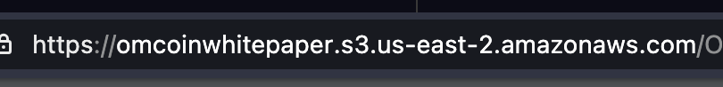

* Update ToS HTML doc to the one I sent you